National Blood Research and Development Strategic Priorities 2022-27
december 2021

Acknowledgements
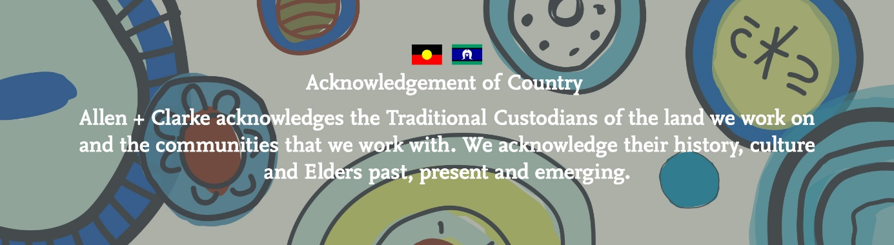

Allen + Clarke has been independently certified as compliant with ISO9001:2015 Quality Management Systems

Art acknowledgement | The original artwork in our Acknowledgement of Country was produced by Emma Walke. Emma is a Bundjalung Aboriginal woman from northern NSW.

CONTENTS

Acknowledgements ii
Tables & Figures iv
Executive Summary 1
Introduction 7
Context of the blood research and development sector 9
2022-27 National BLOOD RESEARCH AND DEVELOPMENT strategic PRIORITIES 18
Monitoring plan 33
Appendix A - Background 38
Appendix B - Methodology 40
Appendix C - References 44

Tables & Figures

Tables
Table 1: Examples of universities funded to undertake research 13
Table 2: Research projects undertaken by Lifeblood, as stated in their Research Annual Report 2019-20 14

Figures
Figure 1: 2022-27 Priorities 1
Figure 2: National Blood Research and Development Strategic Priorities Review Questions 2
Figure 3: 2022-27 Priorities and Enablers, and research activities 4
Figure 4: National Blood Research and Development Sector 9
Figure 5: Research funders 9
Figure 6: Questionnaire: Support for retaining, amending, retiring Priority 1 20
Figure 7: Support for retaining, amending, retiring Priority 2 22
Figure 8: Support for retaining, amending, retiring Priority 3 24
Figure 9: Support for retaining, amending, retiring Priority 5 27
Figure 10: Issues relating to data sharing and linkages 28
Figure 11: Support for retaining, amending, retiring Priority 4 30
Figure 12: National Blood Research and Development Strategic Priorities Review Questions 39
Figure 13: Committees engaged during the Review 41

Executive Summary

National Blood Research and Development Strategic Priorities 2022-27
In consultation with the sector, the National Blood Authority (NBA) is establishing three Priorities and three key Enablers for research and development in the Australian blood sector for 2022-27 (2022-27 Priorities). This change is intended to make clearer the distinction between the research and development priorities and the enabling systems and infrastructures that support them. The 2022-27 Priorities aim to enhance the wellbeing of patients and donors, by directing research and development efforts in the blood sector toward improving the sustainability, provision, and safety of Australia’s blood supply. A set of research and development activities within each priority, along with descriptors and context for the enablers, provides further guidance to the national blood research and development sector on how they can contribute to enhance the ongoing wellbeing of patients and donors in Australia.
Figure 1: 2022-27 Priorities
Priorities
Optimise the use of blood and blood products
Optimise supply including product innovation and supply chain efficiencies
Reduce donor and patient adverse events
Improved data collection, accuracy and sharing
Optimised health service delivery to best meet patient needs
1
2
3
1
2
Enablers
3
Strengthening workforce capability

Developing the 2022-27 Priorities
The 2022-27 Priorities and supporting enablers, and accompanying research and development activities, are informed by a review of the previous 2013-16 National Blood Research and Development Strategic Priorities (2013-16 Priorities).
The review of the 2013-16 Priorities was made with reference to six questions regarding the National Blood Research and Development Strategic Priorities (the Review). The Review questions, set out in Figure 2, included questions which focused on understanding the status of the 2013-16 Priorities, the context of the blood research and development sector and what should be included in the future research and development priorities. It is noted the Review questions were framed in reference to the new priorities being finalised in 2021. However, the priorities were finalised in 2022, creating a new reporting period for the priorities - 2022-27.
The 2013-16 Priorities set five priorities for research and development in Australia’s blood sector which similarly focused on the sustainability, provision and safety of Australia’s blood supply. The 2022-27 Priorities maintain this focus but create an emphasis on action and delivering for the Australian community. This includes creating a more targeted set of research and development activities against each priority along with descriptors and context regarding the enablers, to ensure the finite resources of the sector can be mobilised effectively and efficiently to deliver outcomes, better patient and donor outcomes and ensure value-for-money for the Australian community.
The 2022-27 Priorities are informed by a document review, which included assessing legislation, government agreements, frameworks and guidance, academic journals, web-based information about domestic research funding programs and research projects and international blood research and development programs. The document review provided the domestic and international context for the 2022-27 Priorities and highlighted the gaps in existing research or development in the blood sector.
Figure 2: National Blood Research and Development Strategic Priorities Review Questions
National Blood Research and Development Strategic Priorities (review questions)
What is the current status, and what has the progress been, against the 2013-16 Priorities?
To what extent has the 2013 strategy been used or useful by the sector? What was or would have been realistic to expect in the period 2013 to now in terms of progress against the strategy, and its use?
What if any, other main items of relevance have been undertaken and achieved in the period 2013 to now, not noted in the strategy?
What is the relevant context of the blood ‘research and development’ sector?
What should the 2021 document include and focus on?
What can usefully and pragmatically be put in place in 2021 to enable monitoring of progress in relation to the new version?

The Review sought to answer the above questions by undertaking a document review and scanning blood sector research and development strategic frameworks in international jurisdictions, including New Zealand, Canada, United Kingdom, Germany, and the Netherlands.
Further background to the Review is set out at Appendix A. Detailed information about the Review’s document review and international scan is set out in Appendix B.

Voices of Australia’s national blood research and development sector
The voices of Australia’s national blood research and development sector also shaped the 2022-27 Priorities. Throughout April to May 2021, over 150 stakeholders had the opportunity to contribute to the development of the 2022-27 Priorities. These stakeholders, which included Australian, state and territory governments, researchers, clinicians, medical professional colleges and societies, blood manufacturers, patient advocacy groups, and community representatives, shared their views on what the future priorities should look like. For example:
A state government agency representative said the ‘appropriate immunoglobulin use in particular should be a priority’ towards ensuring the optimal use of blood and blood products (Priority 1).
A researcher said we need further research and development to answer the question ‘how do we ensure sustainability of a secure and cost-effective blood supply’ (Priority 2).
Members of an NBA Advisory Committee supported further work towards a ‘better understanding of what adverse reactions are, and what people know about adverse reactions’, to reduce donor and patient adverse events (Priority 3).
Most stakeholders also wanted data collection, accuracy and sharing to be a focus for the national blood research and development sector in the future. One manufacturer saying they wanted ‘improved data collection and cross-sector sharing’ as a key priority moving forward (Enabler 1).
To optimise health and service delivery to best meet patient needs (Enabler 2), a research funding body said, ‘health services research should be enhanced in this area, particularly effective strategies to implement evidence-based strategies in different settings.’
A mix of primary research and research translation activities were recommended across these stakeholder groups. This has been reflected in the 2022-27 Priorities, and activities (as set out in Figure 3).

Monitoring plan
The 2022-27 Priorities are accompanied by a proposed monitoring plan. The monitoring plan would enable the NBA to measure and communicate progress against the 2022-27 Priorities and Enablers. The plan proposes a monitoring framework which is efficient, proportionate, and transparent. It has three key elements which include, targeted information collection and annual stakeholder engagement, regular reporting and proactive communication and continuous monitoring and improvement.

The 2022-27 Priorities and research activities
Figure 3: 2022-27 Priorities and Enablers, and research activities
2022-27 Priorities and research activities
Priority 1: Optimise the use of blood and blood products
Research activities that:
- Identify strategies to optimise the use of immunoglobulin, including aligning immunoglobulin provision with individual patient needs, cost-effectiveness, and the minimum effective dose to achieve the desired clinical outcomes.
- Develop strategies that reduce reliance on donated blood products, including identification and analysis of alternative treatment pathways.
- Undertake effective and efficient horizon scanning and surveillance of international best practice trends in blood and blood product use.
Research translation activities that:
- Evaluate models empowering patients to understand when the use of blood and blood products is appropriate, and the risks and benefits.
- Identify and evaluate strategies aimed at improving collection and the appropriate use of plasma and plasma derived products.
- Identify and evaluate approaches to promoting patient blood management including increasing the uptake of PBM clinical guidelines, and analysis of barriers to implementation.
- Identify characteristics of the different needs of different patient demographics in relation to blood and blood products, particularly for Aboriginal and Torres Strait Islander, migrant and refugee and ageing people and communities.
Priority 2: Optimise supply including product innovation and supply chain efficiencies
Research activities that:
- Develop and report evidence related to activities aimed at promoting sustainable donor rates by improving understanding of donor behaviour and motivation.
- Identify opportunities and modelling to improving blood demand and supply forecasting.
- Undertake systematic examinations of global innovations in therapies and products to reduce demand on blood products, including a focus on new treatments and emerging conditions, haemophilia, subcutaneous products and gene therapies.
Research translation activities that:
- Identify and evaluate characteristics of strategies to improve the quality of blood and blood products during storage, such as packaging, storage and handling processes.
- Assess the potential application of novel technology related to new and emerging blood technologies/ components/ substitutes.

Priority 3: Reduce donor and patient adverse events
Research activities that:
- Develop evidence and strategies related to systematic and timely monitoring of adverse events following transfusion.
- Identify and analyse characteristics of human factors, technology changes, physiological and product characteristics which contribute to adverse events, and identification of opportunities for improvement.
- Undertake systematic examination and review of blood sector strategies related to reducing, recognising and responding to adverse events.
Research translation activities that:
- Develop and evaluate models aimed at empowering patients and donors to understand and respond to an adverse event.
- Identify and analyses changes in blood characteristics following multiple blood donations related to the development of iron deficiency in donors, and strategies to reduce its occurrence.
- Identify and evaluate treatment protocols for bleeding disorders that most effectively reduce the risk of, and manage the development of, inhibitory antibody responses.
Enabler 1: Improved data collection, accuracy and sharing
Look for strengthened data linkages with relevant health systems to improve the management and use of blood and blood products promoting timely and efficient data access and consistent data collection practices across Australia.
- Develop and promote platforms and forums to share data insights and trends, ensuring that this will be accessible and engaging for the intended audience.
Enabler 2: Optimised health service delivery to best meet patient needs
Design and application of frameworks to promote patient and donor engagement in research with a focus on improving patient and donor experience and outcomes.
- Improved understanding of how to align blood-related services with community expectations, particularly for Aboriginal and Torres Strait Islander, diverse cultural and older people and communities.
- Analysis of different ways of providing blood and blood products to patients, such as home administration of treatments, impact the effectiveness and efficiency of the health system and on patient treatment, outcomes and quality of life.
- Engage with donors to identify and evaluate current models to inform strategies for increasing supply and improving donor experience.
Enabler 3: Strengthening workforce capability
- Develop and regularly review clinical education in undergraduate and postgraduate curricula and liaison between accrediting bodies including universities, colleges, societies, workplace, and prevocational trainers to determine and provide core skills required by the workforce.
- Develop and maintain clinical guidelines to support treatment decisions relating to blood and blood products and alternatives.
- Support for the development of training courses, conferences, and education materials for the continuing professional development of the workforce.

INTRODUCTION

Introduction

Purpose
This report sets out the 2022-27 Priorities and outlines a framework to monitor progress against the 2022-27 Priorities.

Report structure
The remainder of this report is set out as follows:
- Context of the blood research and development sector
This section outlines the context of the blood research and development sector. It sets out the main funders, main resources, main organisations doing and translating the research, and main organisations updating and implementing research findings.
- 2022-27 Priorities
This section sets out the 2022-27 Priorities, including the research activities for each priority along with descriptors and context for the enablers. The section also explains what aspects of the document review and consultation process informed the development of the relevant priority or enabler.
- Monitoring Plan
This section outlines a proposed monitoring plan for the 2022-27 Priorities, setting out what could be put in place in 2022 and beyond to enable monitoring of progress.
- Appendices
  - Appendix A – Background
Appendix A outlines the background to the development of the 2022-27 Priorities. This includes outlining the NBA’s research and development role, the 2013-16 Priorities and the services the NBA engaged to support its development of the 2022-27 Priorities.
  - Appendix B – Methodology
Appendix B outlines the methodology used by the Review. This section describes the document review and stakeholder engagement process. It summarises who was engaged to inform the Review, including the number of and types of stakeholders. It also outlines when and how stakeholders were engaged and describes how their feedback has been used to inform the Review.
  - Appendix C – References
Appendix C sets out the references used to inform the 2022-27 Priorities.

CONTEXT OF THE NATIONAL BLOOD RESEARCH AND DEVELOPMENT SECTOR

Context of the blood research and development sector
- The 2022-27 Priorities will be delivered within the context of the blood research and development sector. This sector comprises funders, research and translation organisations, and organisations which implement the research findings. A sector overview of the blood research and development sector is provided in Figure 4 below.
Figure 4: National Blood Research and Development Sector

- 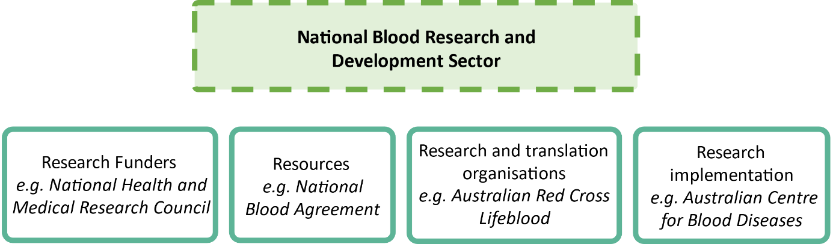

Main funders
- There are multiple sources of funding for blood-related research and development in Australia. These include Australian governments, hospitals, higher education, business, not-for-profit organisations and donations from individuals or organisations. An overview of funders is provided in Figure 5 below.
Figure 5: Research funders

Hospitals
e.g. Royal Melbourne Hospital
Not for profit
e.g. Haemophilia Foundation Australia
State and territories governments
e.g. Victorian Medical Acceleration Fund
Commonwealth government
e.g. NHMRC
Business
e.g. blood manufacturers
- Research
- funders
Higher education
Donations
- Commonwealth bodies and programs which fund blood-related research include the National Health and Medical Research Council (NHMRC), Medical Research Future Fund, Australian Research Council (ARC) and Research Block Grants. For example, from 2013 to 2020, the NHMRC funded $190.3 million in research projects relating to blood diseases. There was also $1.25 billion spent on research relating to infectious diseases during the same period, which included $2.5 million allocated to Monash University in June 2021 to research preventing infections in patients with blood cancer through evidence-based use of immunoglobulin or alternatives. Research block grants are also provided by the Department of Education, Skills and Employment to higher education providers for research and training. In 2021, the Commonwealth Government provided $2.99 billion in block grants to 42 providers, including $1.9 billion to support the systemic costs of university research. Health and medical research accounts for almost one third of research and development in the higher education sector.
- The NBA also delivers funding through its National Blood Sector Research and Development Program. Through its latest round of funding (round 5), the NBA is providing $1.5 million for seven research projects relating to immunoglobulin and patient blood management. This included projects focused on personalised blood product therapy after cardiopulmonary bypass in neonates and infants and evaluating vaccine responses in specific antibody deficient patients receiving immunoglobulin treatment.
- State governments also fund medical research, including the Victorian Government’s $3 million Victorian Medical Acceleration Fund. While data is limited on the quantum of funds directed towards blood-related research projects, the latest Australian Bureau of Statistics data on research and development expenditure shows state and territory governments spent $457 million on research and development in higher education in 2018.
- Hospitals make funding available for blood-related research too. For example, the Royal Melbourne Hospital made $24,914 available in 2018 for a research project into the assessment of a novel blood separator device as a sample collection approach for the diagnosis of infectious diseases.
- The higher education sector also funds health and medical research and development activities in Australia. For example, the University of Sydney has their own internal grants and fellowships. This includes funding available to researchers whose NHMRC fellowship has finished. The Review was unable to ascertain the financial amount of internal university funds spent on blood-related research in the Australian higher education sector.
- Medical research is also funded by business, including blood manufacturers such as Sanofi or CSL Behring. It is noted that in 2018 businesses spent $106 million on medical related research and development, although not specifically focussed on blood-related research projects.
Several not-for-profit organisations in the blood sector have research grant programs, including Haemophilia Foundation Australia (HFA) and the Australian and New Zealand Society of Blood Transfusion (ANZSBT). The HFA has a Haemophilia Foundation Research Fund that has provided $630,000 in funding for research projects over 22 years focused on the care and treatment of people with haemophilia and related bleeding disorders, such as von Willebrand disease (VWD)., Projects the HFA Research Fund has focused on include quality of life in haemophilia, a cure for haemophilia, von Willebrand factor and causes of bleeding and issues for people with bleeding disorders and hepatitis C. The ANZBT also facilitates research by providing grants on research in transfusion medicine and science. This includes funding research into improving access to Ambulance Service blood product transfusions and alternatives to red cell transfusion to treat anaemia.
Research can also be funded from individual financial donations. For example, the Heart Research Institute in New South Wales received over 72,000 individual funding donations for research purposes in 2020. Among other areas, the Health Research Institute undertakes haematology research to develop efficient and safe antithrombotic drugs. The Australian Red Cross also received $316.681M in donations from the Australian and international public.

Main resources
The main resources guiding research and development in the Australian blood sector are legislative frameworks, policy agreements and strategic guidance documents from key blood authorities and organisations in Australia.
The National Blood Authority Act 2003 establishes a statutory obligation on the NBA to ‘carry out national blood arrangements relating to the facilitation and funding of research…relating to blood products and services.’ This means it is a required function of the NBA to facilitate and fund blood-related research in Australia. Funding is discussed in the section above.
The National Blood Agreement, signed by Australian governments during 2002 and 2003, is a federal agreement which establishes a policy framework for the governance and administration of the Australian blood sector. This includes providing for a research and development focus for the NBA.
Apart from the 2013-16 Priorities, other direction setting resources within Australia’s blood research and development sector include the Australian Red Cross Lifeblood’s published research program and funding guidelines from main funders, including the NHMRC.
Further detail is set out in Appendix B.

Main organisations doing the research and the translation
In Australia, the main organisations doing the research and its translation, are higher education, business, and not-for-profit organisations.
Higher education institutions, such as universities, undertake most of the health and medical research in Australia. Research Australia states over 50 per cent of Australian health and medical research is undertaken in higher education institutions. A range of universities undertake blood-related research including the University of Sydney, University of Queensland, RMIT University and Monash University. For example, Monash University’s Transfusion Unit delivers Blood Synergy, which is a NHMRC funded program focused on studies and trials relating to blood transfusion practice and patient outcome.
Table 1, on the following page, provides further examples of universities undertaking blood-related research under NHMRC funding.

Table 1: Examples of universities funded to undertake research
Year | Higher Education Institution | Project
2018 | RMIT University | Development of a microfluidic blood platelet analyser
2019 | University of Sydney | A multi-pronged approach for the development of effective and safe anticoagulants
2020 | University of Queensland | Overcoming the barriers to treatment of multi-drug resistant Gram-negative bloodstream infections in Australian children
2021 | Monash University | Preventing infections in patients with blood cancer through evidence-based use of immunoglobulin or alternatives: The RATIONALISE trial
Private businesses associated with the blood sector also undertake blood-related research and development in Australia. Blood product manufacturer, CSL Behring, undertakes blood-related research relating to plasma fractionation, recombinant technology and gene and cell therapy. Sanofi, another blood product manufacturer, has a rare blood disorders research program.
Not-for-profit organisations, including medical research institutes and health service delivery organisations are involved in delivering blood-related research in Australia.
Medical research institutes, such as the Florey Institute of Neuroscience and Mental Health (the Florey Institute) and Burnet Institute received funding from the NHMRC to undertake blood-related research in 2017 and 2020, respectively. The Florey Institute was funded by the NHMRC to develop blood-based biomarkers for the early detection of brain amyloid and the investigation of the natural history of Alzheimer’s Disease. The Burnet Institute was funded to undertake blood related research regarding developing novel anti-malaria drugs and eliminating viral hepatitis and HIV/AIDS as global health threats. The NHMRC is also supporting the Kirby Institute to undertake research to understand what people know about the blood donation eligibility criteria, and what motivates or deters people from giving blood.
Not-for-profit health service delivery organisations, such as Lifeblood, also deliver a blood-related research and development program.

Their program focuses on five areas including:
- donor behaviour
- donor health and wellbeing
- product development
- product safety
- product usage.
In the financial year ending 30 June 2020, Lifeblood received $9.8 million from the NBA for its research and development program. In the same year, they delivered seven research projects. These included research projects focused on understanding why donors lapse and return and mosquito‐borne virus threats to blood safety. Table 2 summarises the seven research projects undertaken by Lifeblood during 2019/20.
Table 2: Research projects undertaken by Lifeblood, as stated in their Research Annual Report 2019-20
Project | Learning
Why do donors lapse? Developing an understanding of what predicts plasma donors and testing tailored reactivation strategies | Women were at higher risk of lapsing from plasma donation, as were donors under 40 years old, O negative donors and those with fewer prior donations. People stop donating plasma for a range of reasons, such as: they’re no longer eligible; their circumstances change; they’ve a negative donation experience; or they have concerns about the apheresis procedure. Lifeblood learned that most would like to return, so we’re working with our operational colleagues at Lifeblood to create strategies to reactivate these lapsed donors.
Analysis of donor return pattern by age at first recruitment in Australia | Donors who started to donate after their 30th birthday were more likely to return and provided more donations compared with younger donors. Under existing recruitment strategies, fewer than half of our new donors are aged over 30, suggesting that we could explore opportunities to target this specific group of donors for recruitment.
Comparison of X-irradiation and gamma irradiation on blood components (EXGAM study) | X-irradiation of blood components can replace gamma irradiation to inactivate lymphocytes without affecting product quality. This study was a major component of a successful application to the Therapeutic Goods Administration, requesting a manufacturing process change from gamma to X-irradiation. As a result, Lifeblood will implement X-irradiation at Lifeblood, increasing safety for our staff while maintaining the safety and quality of our products
Exotic mosquito‐ borne virus threats to Australia (including WNV, CHIKV, LNV, etc.): disease burden and consequences for blood supply safety | Viruses spread by mosquitoes (such as West Nile virus, chikungunya virus, dengue virus and Liao Ning virus) pose a low risk to blood safety in Australia. Lifeblood’s current donor management strategies are appropriate to manage the risks associated with these viruses.
The efficacy of anti-D prophylaxis in obstetric cohorts with high body mass index | This research aimed to provide evidence for whether we need to adjust the dose of anti-D for pregnant women who are overweight. Lifeblood tried several approaches but couldn’t find an assay that was both sensitive and reliable enough for the project to proceed. At this time, there isn’t a reliable method to monitor the levels of anti-D immunoglobulin in the circulation of women after they receive injections of anti-D to help prevent haemolytic disease of the fetus and newborn.
Inactivation of Japanese encephalitis virus following treatment with THERAFLEX pathogen inactivation technologies | The THERAFLEX pathogen inactivation systems can inactivate Japanese encephalitis virus in platelets and plasma. This study adds to our previous work using this system and contributes to a business case if Lifeblood decides to introduce pathogen inactivation in the future.
An alternative to cryoprecipitate (The FEISTY trial) | For bleeding trauma patients, treatment with fibrinogen concentrate resulted in a much shorter time to administration of the fibrinogen replacement therapy than when cryoprecipitate was used. Since completing this pilot study, our clinical research collaborators have obtained funding to support two follow-on trials, one in paediatric trauma patients and the other an extended trial in adults.

Main organisations to uptake and implement the research findings
Health organisations, including hospitals and clinician bodies, implement blood-related research findings and outcomes. For example, the George Institute for Global Health and Neuroscience Research Australia developed ‘BRuCE’, a calculator for children with haemophilia and their families. This tool is now being promoted and distributed by the Australian Haemophilia Centre Directors’ Organisation. The Australian Centre for Blood Diseases (ACBD) is a national and international centre with research, treatment, and educational programs for blood diseases. Its evidence-based clinical programs are delivered in association with The Alfred, Monash University, Eastern Health and Southern Health. There are also Australian clinicians which apply the NBA-developed Patient Blood Management Guidelines. Research shows the Patient Blood Management Guidelines has been associated with a reduction in blood transfusions and hospital length of stay for cardiac surgery patients in Australia.

2022-27 National BLOOD RESEARCH AND DEVELOPMENT strategic PRIORITIES

2022-27 National BLOOD RESEARCH AND DEVELOPMENT strategic PRIORITIES
The 2022-27 Priorities aim to enhance the wellbeing of patients and donors, by directing research efforts in the blood sector toward improving the sustainability, provision, and safety of Australia’s blood supply. The 2022-27 Priorities are:
- optimise the use of blood and blood products
- optimise supply including product innovation and supply chain efficiencies
- reduce donor and patient adverse events.
The 2022-27 Enablers are:
- improved data collection, accuracy and sharing
- optimised health service delivery to best meet patient needs
- strengthening workforce capability.
To support the achievement of each priority and enabler, there are a set of more specific research and research translation activities. By identifying these activities, the NBA is signalling to the national blood research sector what they can contribute to promote the ongoing wellbeing of patients and donors in Australia.
This section sets out the 2022-27 Priorities, and their research activities. It also identifies how the assessment of the 2013-16 Priorities, stakeholder consultation and document review informed their development.

Priority 1: Optimise the use of blood and blood products
Priority 1 of the 2022-27 Priorities is to optimise the use of blood and blood products. This represents a change for Priority 1 from the 2013-16 Priorities, which was ‘To ensure the use of blood and blood products is appropriate.’
The following research and research translation activities are required to achieve Priority 1.
Research activities that:
- Identify strategies to optimise the use of immunoglobulin, including aligning immunoglobulin provision with individual patient needs, cost-effectiveness, and the minimum effective dose to achieve the desired clinical outcomes.
- Develops strategies that reduce reliance on donated blood products, including identification and analysis of alternative treatment pathways.
- Undertake effective and efficient horizon scanning and surveillance of international best practice trends in blood and blood product use.
Research translation activities that:
- Evaluate models empowering patients to understand when the use of blood and blood products is appropriate, and the risks and benefits.
- Identify and evaluate strategies aimed at improving collection and the appropriate use of plasma and plasma derived products.
- Identify and evaluate approaches to promoting patient blood management including increasing the uptake of PBM clinical guidelines, and analysis of barriers to implementation.
- Identify characteristics of the different needs of different patient demographics in relation to blood and blood products, particularly for Aboriginal and Torres Strait Islander, migrant and refugee and ageing people and communities.
Assessment of 2013-16 Priorities
Since 2013, research and development activities have been funded or undertaken to ensure the use of blood and blood products is appropriate including the development of patient blood management and immunoglobulin frameworks. However, there remain research and development opportunities to strengthen the effectiveness of patient blood management and to better target the supply of immunoglobulin.
Consultation
The consultation process showed strong support for retaining the current/previous wording of Priority 1 (To ensure the use of blood and blood products is appropriate), with some amendments and updates.
Figure 6 summarises the questionnaire responses.

Figure 6: Questionnaire: Support for retaining, amending, retiring Priority 1
- Retain: 73% (34)
- Retain with amendment: 27% (13)
- Retire: 0
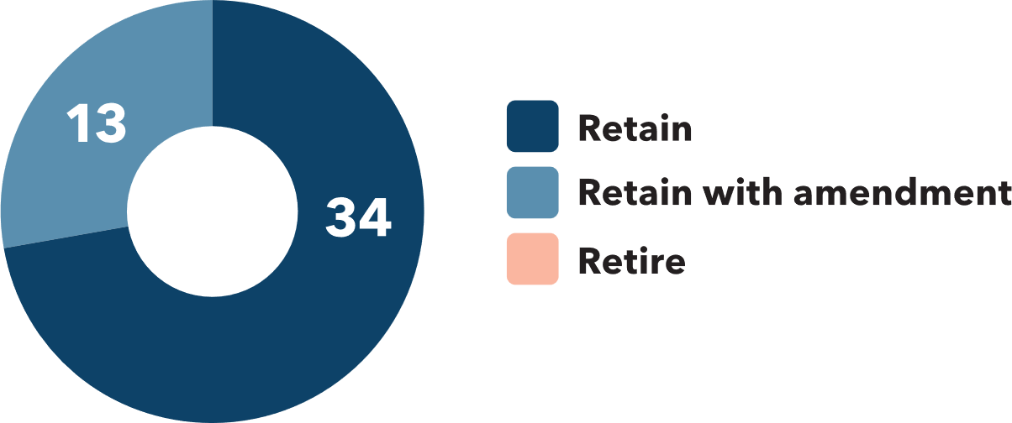
One internal stakeholder commented that ‘We have to make sure that what we’re spending money on is appropriately utilised. We look at what drugs are issued, and to who and where. This will help optimisation, value for money and ensuring we’re making the right investment.’
Other stakeholders suggested that ‘appropriate’ be replaced with ‘optimal’, to make the priority more aspirational and that ‘To’ be removed to make the priority more action oriented. For example, one NBA grant recipient stated ‘I think it is moving to optimal use rather than appropriate use. We need to test the current accepted thresholds, consider the use of alternate products etc.’
In terms of current activities to be actioned under Priority 1, the importance of optimising the use of immunoglobulin and reducing reliance on blood products came through strongly in the consultation process. One state government agency recommended ‘Appropriate Immunoglobulin use in particular should be a priority.’
Document review
The document review identified the need to maintain a focus on the ‘appropriate’ or optimal use of blood is also founded in regulation. The Australian Commission on Safety and Quality in Health Care (the Commission) establishes standards to promote safe outcomes for people who receive health care. These are accreditation standards which must be implemented in certain settings, including all hospitals and day procedures. The Commission has published a suite of National Safety and Quality Health Service (NSQHS) Standards to provide a nationally consistent statement of the level of care consumers can expect from health service organisations. For example, there is a Blood Management Standard, which seeks to ensure that any blood or blood product that a patient receives is appropriate.

Priority 2: Optimise supply including product innovation and supply chain efficiencies
Priority 2 of the 2022-27 Priorities is to ‘Optimise supply including product innovation and supply chain efficiencies. This represents a change for Priority 2 from the 2013-16 Priorities, which was ‘To ensure adequacy and sustainability of supply, realise supply chain efficiencies and improve performance.’
The following research and research translation activities are required to achieve Priority 2.
Research activities that:
- Develop and report evidence related to activities aimed at promoting sustainable donor rates by improving understanding of donor behaviour and motivation.
- Identify opportunities and modelling to improving blood demand and supply forecasting.
- Undertake systematic examinations of global innovations in therapies and products to reduce demand on blood products, including a focus on new treatments and emerging conditions, haemophilia, subcutaneous products and gene therapies.
Research translation activities that:
- Identify and evaluate characteristics of strategies to improve the quality of blood and blood products during storage, such as packaging, storage and handling processes.
- Assess the potential application of novel technology related to new and emerging blood technologies/ components/ substitutes.
Assessment of the 2013-16 Priorities
Research and development activities (including those led by the NBA and Monash University through the Blood Synergy program) have been funded or undertaken to ensure adequacy and sustainability of supply, realise supply chain efficiencies and improve performance. However, two NBA governance committee members and a researcher have said further research and development should be undertaken to promote the sustainability of supply.
Consultation
The consultation process showed strong support for retaining the current/previous wording of Priority 2 (To ensure adequacy and sustainability of supply, realise supply chain efficiencies and improve performance), with some amendments and updates.
One manufacturer of blood products stated that ‘Maintenance of an adequate and secure supply of blood and blood products should remain a key goal of the NBA – it is essential to provision of public health solutions that involve treatment with these products.’
This view was also supported internally within the NBA, with one internal stakeholder stating, ‘The priority for the core business of the NBA is supply. Guaranteeing safe, supply [of] appropriate blood.’
Figure 7 summarises the response from questionnaire respondents.

Figure 7: Support for retaining, amending, retiring Priority 2
- Retain: 74% (35)
- Retain with amendment: 26% (12)
- Retire: 0
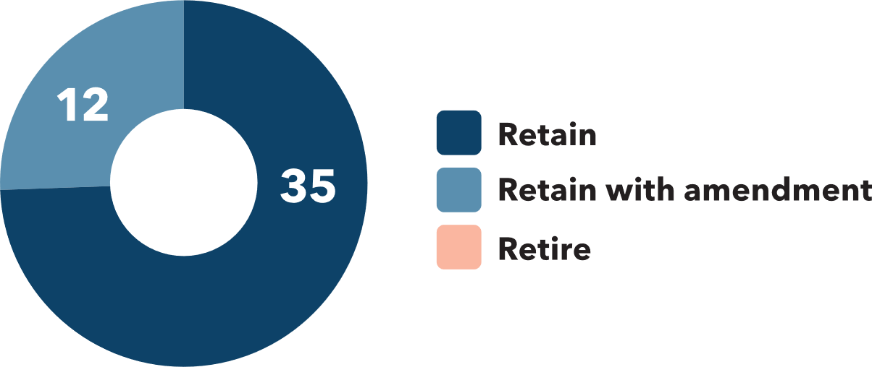
Stakeholders suggested that the words ‘adequacy’ and ‘improved performance’ make the wording more aspirational and specific.
‘It is unclear what the term performance means in this setting. Performance of staff? Or of governance measures to audit process?’ (clinician/researcher)
Several stakeholders reflected on the current global context, also reinforcing the need to prioritise contingency planning and demand forecasting under this priority going forward:
‘Focus on contingencies if shortages occur e.g. pandemic’ (researcher)
‘Development of further enhanced demand forecasting capability that will further enhance the NBA's ability to support suppliers' work in ensuring adequate and sustained supply, and thereby further enhance management of Australia's blood and blood products supply.’ (manufacturer)
Document review
The primary policy objective for the Australian blood sector, set out in the National Blood Agreement, includes delivering an adequate and secure supply of blood and blood related products and services.
Ensuring sufficient donor levels is a critical input towards achieving an adequate blood supply, noting the research and development of artificial blood products. Understanding donor behaviour is a key focus for blood authorities in other countries. For example:
- A focus area of the Canadian Blood Service’s research and development program is to build and deepen relationships with the donors of the future, by developing a deeper understanding of their future donors.
- The United Kingdom’s National Health Service Blood and Transplant Research and Development Program establishes eight strategic goals for improving outcomes for patients and donors. This includes a strategic goal to establish a behavioural research program to identify behavioural change interventions which significantly increase donation and consent rates.
In Australia, research is being undertaken to strengthen donor engagement. Lifeblood’s research program includes a focus on donor behaviour and donor health and wellbeing. However, research into donor behaviour since the onset of COVID-19 is limited and it is unclear to what extent the pandemic will impact the adequacy of supply.
Climate change may also impact the adequacy and sustainability of blood supply. This is because it will enable disease carrying-species, such as mosquitos, to survive in more regions across the globe due to new warmer climatic conditions. With more people carrying infectious diseases, particularly as global travel picks up, the supply of safe blood supplies may be compromised.
Within this context, a continued focus on adequacy and sustainability of supply is necessitated by governmental agreements and demanded by evolving environmental conditions.

Priority 3: Reduce donor and patient adverse events
Priority 3 of the 2022-27 Priorities is to ‘Reduce donor and patient adverse events.’ This represents a change for Priority 3 from the 2013-16 Priorities, which was ‘To reduce donor and patient adverse events.’
Research activities that:
- Develop evidence and strategies related to systematic and timely monitoring of adverse events following transfusion.
- Identify and analyse characteristics of human factors, technology changes, physiological and product characteristics which contribute to adverse events, and identification of opportunities for improvement.
- Undertake systematic examination and review of blood sector strategies related to reducing, recognising and responding to adverse events.
Research translation activities that:
- Develop and evaluate models aimed at empowering patients and donors to understand and respond to an adverse event.
- Identifies and analyses changes in blood characteristics following multiple blood donations related to the development of iron deficiency in donors, and strategies to reduce its occurrence.
- Identifies and evaluates treatment protocols for bleeding disorders that most effectively reduce the risk of, and manage the development of, inhibitory antibody responses.
Assessment of the 2013-16 Priorities
Since 2013, research and development activities funded or undertaken to reduce donor and patient adverse events include national haemovigilance reporting and research by the Australian Red Cross Lifeblood. However, several researchers say there needs to be a greater focus on haemovigilance data collection to enhance monitoring of adverse events.
Consultation
The consultation process showed strong support for retaining the current/previous wording of Priority 3 (To reduce donor and patient adverse events), with some amendments and updates.
Figure 8 summarises the questionnaire responses.
Figure 8: Support for retaining, amending, retiring Priority 3
- Retain: 73% (30)
- Retain with amendment: 22% (9)
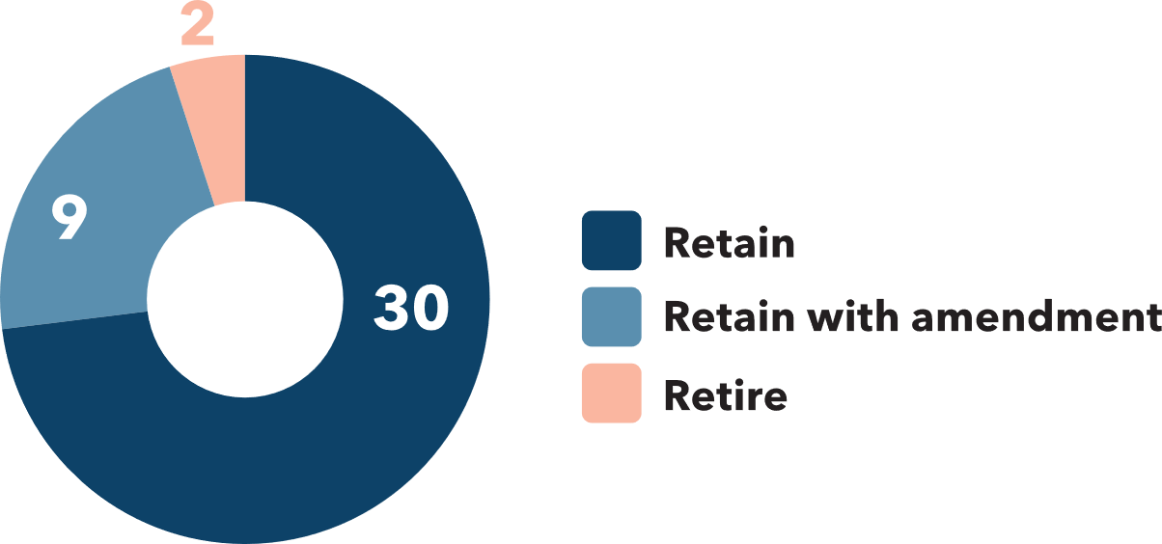
- Retire: 5% (2)

Representatives from state government agencies supported the continuation of this priority. One state government agency said that ‘Donor adverse events relate to the priorities of Lifeblood and should be reported to the NBA. Patient adverse events continue as a priority for all jurisdictions’ - recommending that data collection be expanded to include procedural events and ‘near misses.’ One state government agency wished to ‘Emphasise the importance to health services of appropriate recognition of adverse events.’
Internal stakeholders supported this view, with a focus on patient outcomes: ‘Optimising delivery for the patient. Got to be a priority.’ Members of an NBA Advisory Committee also supported work towards a ‘Better understanding of what adverse reactions are, and what people know about adverse reactions.’
Document review
The National Safety and Quality Health Service (NSQHS) Standards Blood Management Standard and the National Blood Agreement establish a focus on promoting safe blood and blood product-related services for patients and donors. Specifically, the National Blood Agreement seeks to promote safe, high-quality management and use of blood related products and blood related services in Australia.
Monitoring and reporting on unsafe outcomes, or adverse events, in patients and donors is a key mechanism which is used by researchers, clinicians and policy makers to design strategies to minimise adverse events.
To some extent, this reporting occurs through the regular publication of the National Haemovigilance Report and jurisdictional adverse transfusion reporting process such as Victoria’s Serious Transfusion Incident Reporting System. However, some gaps remain, with the absence of a national haemovigilance data registry being reported by some researchers as materially impacting their ability to closely monitor haemovigilance in Australia. These researchers, along with state government officials, consider haemovigilance must be a priority for research and development in the blood sector to reduce patient adverse events.

Enabler 1: Improved data collection, accuracy and sharing
Enabler 1 is ‘Improved data collection, accuracy and sharing.’ This represents a change from how data collection was addressed in the 2013-16 Priorities. Addressed by Priority 5, the 2013-16 Priorities sought ‘To improve data collection, availability, accuracy and sharing across the sector.’ The change primarily reflects NBA’s desire to be outcomes focused through their priorities and enablers.
The purpose of this enabler is to promote strengthened data linkages with relevant health systems to improve the management and use of blood and blood products promoting timely and efficient data access and consistent data collection practices across Australia. This includes the development and promotion of platforms and forums to share data insights and trends, ensuring that this will be accessible and engaging for the intended audience.
Assessment of the 2013-16 Priorities
Information and communication technology (ICT) platforms and data frameworks have been established or enhanced to promote appropriate blood use (Priority 1) and data access (Priority 5). However, several stakeholders across the blood sector community expressed frustration to the Review regarding their inability to efficiently access data. They considered barriers to data made it difficult for them to undertake research in an effective and timely way, potentially impacting future outcomes for patients and donors.
Consultation
Improving data collection, sharing, and monitoring also emerged as a key focus of the consultation process, with almost universal support for retaining this priority in some form, (with some support for minor amendments). Support for amending (or in one instance retiring) this priority tended to focus on making it more ‘output’ oriented, or more specific.
Figure 9 summarises the response from questionnaire respondents.
Figure 9: Support for retaining, amending, retiring Priority 5
- Retain: 81% (28)
- Retain with amendment: 16% (6)
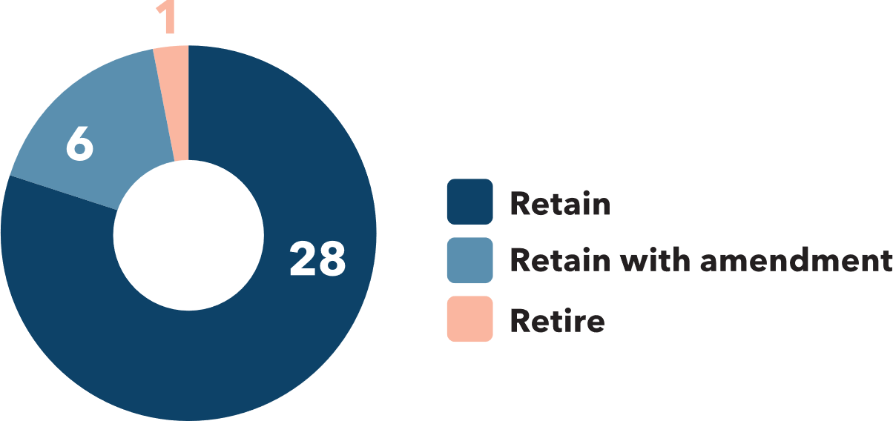
- Retire: 3% (1)

‘Strengthen’ has been changed to ‘improved’ and ‘across the sector’ has been removed, as this is considered to be implied. ‘Availability’ has been replaced with ‘sharing’ to encourage more active collaboration on the part of the NBA and others.
During the consultation, internal NBA stakeholder spoke of the need to focus on data. They said, ‘focus on using data to effect outcomes. We need a greater focus on the ‘so what’ aspect of data.’ Another internal NBA stakeholder said, ‘there hasn’t been sufficient progress…It is so important when we look at world class haemovigilance systems. We need buy in from all the jurisdictions – fed and state. Needs to have a governmental solution.’
Several NBA Committee members also noted the significant barriers of data not being collected consistently across Australia, and that the data that is collected is stored across multiple platforms. One NBA Committee member commented, ‘People having finally realised there is an ocean of data. No easy solution. There are barriers, including privacy, state-based laws.’
External stakeholders consulted in relation to this priority also strongly supported continued investment and prioritisation of this priority. When asked what they saw as the future research priorities for the blood sector, a considerable proportion of respondents highlighted issues related to data sharing and linkages
Figure 10 sets out comments on data issues raised by stakeholders during the consultation.

Figure 10: Issues relating to data sharing and linkages
- ‘Data - Clinical practice and outcomes’
- ‘Data collection harmonisation’
- ‘Data Linkage enabled research’
- ‘Better availability of administrative data to facilitate research by external parties’
- ‘Improved data collection and cross-sector sharing’
- ‘Data - national standards’
- ‘Collection at a national level of useful and meaningful data and sharing to the jurisdictions’
- ‘Real time/near real time access to transfusion data across hospitals’
- ‘Develop and influence data systems in primary care to inform research activities’
- ‘Data - performance/compliance against guidelines’
- ‘Better access to and use of data across the sector’
The need for a national haemovigilance data registry and/or reporting system was specifically identified by four stakeholders.
A state government agency stated that, ‘Data collection needs to be national, consistent, relevant and mandatory and easily collected.’ Another state government agency said that ‘Improving data collection, availability, accuracy and sharing across the sector will continue to be of paramount importance to success of the research and development program going forward. This also applies to improving the availability and additional avenues of data linkage between the national blood sector data and other domains of health data more broadly.’
Document review
The Australian Government identifies making better use of health data is a health system challenge which is set to continue in the coming decades. These challenges are relevant to the use of data in Australia’s blood sector, particularly relating to data access and linkages of information.
The Australian Government considers ‘comprehensive data can help us to improve health policy, programs and services’, which means ‘linking different health information across the health system’ is an important part of their work.
The Australian blood sector has a number of data platforms including BloodSTAR and the Australian Bleeding Disorders Registry. BloodSTAR was created by the NBA in 2016 to support health providers in managing their Immunoglobulin (Ig) Governance obligations. The Australian Bleeding Disorder Registry (ABDR) is a database which holds the treatment details of people with bleeding disorders.
Both platforms have enabled the NBA to gather information about matters relating to blood products and services, consistent with their legislative functions. Haemovigilance data, however, remains relatively fragmented with no national haemovigilance data registry in place.
There are also limited linkages of databases, which is impacting on the ability to measure the effectiveness of blood-related health programs. One hospital-based researcher stating, ‘Current hospital systems and processes and the inability to link data across databases result in the inability to provide evidence of the value of Patient Blood Management measures to business managers and hospitals.’
Consistent with the Australian Government’s health data focus, the blood sector must retain a continued focus on developing tools to realise the value of the right data.

Enabler 2: Optimised health and service delivery to best meet patient needs and Enabler 3: Strengthening workforce capability
Enabler 2 is ‘Optimised health and service delivery to best meet patient needs.’ This represents a slight change from how service delivery was addressed in the 2013-16 Priorities. Addressed then by Priority 4, the 2013-16 Priorities sought ‘To optimise health service delivery to best meet patients’ needs.’ The change primarily reflects NBA’s desire to be outcomes focused through their priorities and enablers.
Enabler 2 promotes the design and application of frameworks to promote patient and donor engagement in research with a focus on improving patient and donor experience and outcomes. This includes:
- Improved understanding of how to align blood-related services with community expectations, particularly for Aboriginal and Torres Strait Islander, diverse cultural and older people and communities.
- Analysis of different ways of providing blood and blood products to patients, such as home administration of treatments, impact the effectiveness and efficiency of the health system and on patient treatment, outcomes and quality of life.
- Engage with donors to identify and evaluate current models to inform strategies for increasing supply and improving donor experience.
Enabler 3 is ‘Strengthening workforce capability.’ This represents a new focus for the NBA’s research priorities because stakeholders expressed support for strengthening workforce capability to enable the delivery of research priorities.
This enabler promotes the development and regular review of clinical education in undergraduate and postgraduate curricula and liaison between accrediting bodies including universities, colleges, societies, workplace, and prevocational trainers to determine and provide core skills required by the workforce. This includes:
- Development and maintenance of clinical guidelines to support treatment decisions relating to blood and blood products and alternatives.
- Support for the development of training courses, conferences, and education materials for the continuing professional development of the workforce.
Assessment of the 2013-16 Priorities
Since 2013, research and development activities funded or undertaken to optimise health service delivery to best meet patient needs include research and development funded by the NBA and by the NHMRC through Blood Synergy. However, a broad cross-section of stakeholders, including from clinicians, colleges and societies, consumer representatives and researchers, suggested development around education and capability building was needed to ensure health services were delivered in a way that aligned with patients’ needs.
Consultation
The consultation process showed strong support for retaining the current/previous wording of Priority 4 (To optimise health service delivery to best meet patients’ needs), with some amendments and updates. Four respondents to the questionnaire supported retiring this priority, with a researcher feeling it lacked clarity and specificity.
Figure 11 summarises the response from questionnaire respondents.
Figure 11: Support for retaining, amending, retiring Priority 4
- Retain: 65% (24)
- Retain with amendment: 24% (9)
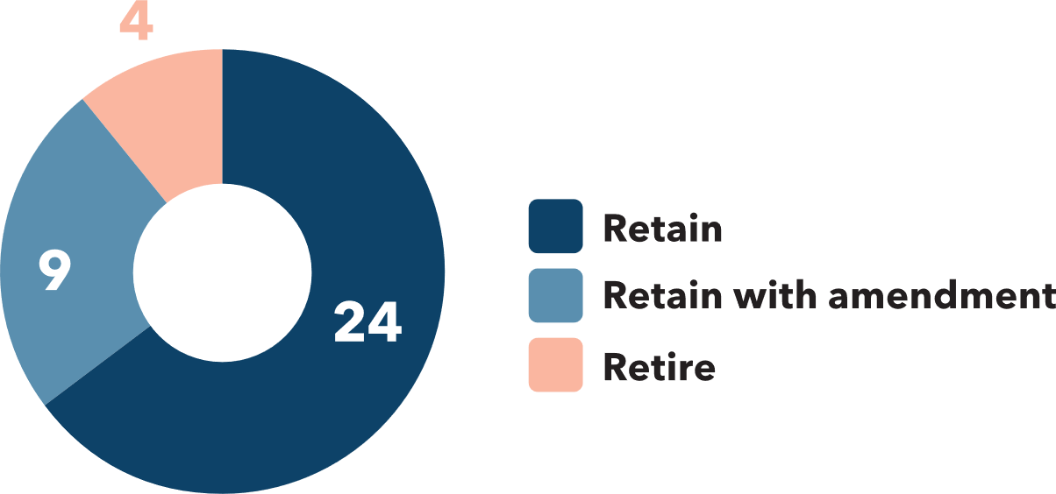
- Retire: 11% (4)

There was strong support for developing frameworks and tools to better support and educate the health workforce to apply the learnings from blood-related research, with a particular focus on delivering patient centred-care. One research funding body recommended that ‘Health services research should be enhanced in this area, particularly effective strategies to implement evidence-based strategies in different settings.’ An internal NBA stakeholder said, ‘There should be a patient-focus. Always should be front and centre. The research should be accompanied with a strong engagement strategy with the patient.’
Document review
Maintaining a patient focus in health service delivery is critical for ensuring value for money for the Australian community. Without a patient focus, health services are unlikely to align with patient needs causing an inefficient allocation of resources within the health economy.
For example, a study of junior doctors in 2016 found:
‘There is a need for improved education to ensure best transfusion practice and patient outcomes. Australian junior doctors want immediate, practical, reliable transfusion information from credible sources to support them in practicing safely and confidently. Their educational needs are driven by real-time patient management.’
Work is now needed to build on the foundations laid by the NBA’s 2013 National Blood Sector Education and Training Strategy 2013-16 and Patient Blood Management Implementation Strategy 2017-21, to harness the learnings from blood-related research to strengthen capabilities of Australia’s blood sector workforce to best meet patient needs. The Patient Blood Management Implementation Strategy 2017-21 is currently being reviewed.

Monitoring plan

Monitoring plan
The proposed monitoring plan seeks to measure and communicate progress toward the 2022-27 Priorities. It has three key elements which include targeted information collection, annual stakeholder engagement, regular reporting, proactive communication and continuous monitoring and improvement.
Consultation
The Review of the 2013-16 Priorities found the development of an outcomes monitoring framework is critical for ensuring the NBA is able to measure progress against the new Priorities. Furthermore, such a framework would provide the opportunity for the NBA to ‘role model’ to the blood sector good practice in relation to data and information sharing at the national level. The need for improved monitoring and outcomes measured was highlighted by the NBA Board. Members of the NBA Board said:
‘Going forward, the Board would like to see – a disaggregation of funds by topic and by grant. What are we funding? How does this funding align with priorities?’
‘I want to see greater value for money from the NBA’s investment in research. In terms of meaningful findings and results that will make a real difference for the community’
External stakeholders also supported the development of a high-level monitoring plan to track and measure progress toward the 2022-27 Priorities. One blood product manufacturer asked for ‘More insight into what initiatives are linked to them [the NBA National Blood Research and Development Strategic Priorities] and the progress made against these initiatives.’
Assessment of 2013-16 Priorities
There was no reporting framework to track, capture and communicate progress, impacts and outcomes from the 2013-16 Priorities. This means indicators of progress, such as knowledge translation, increased sector capacity, enhanced community awareness, improved clinical practice and outcomes for patients and cost efficiencies, have not been effectively measured against since 2013.
Document review
The Australian National Audit Office considers effective monitoring is achieved by collecting timely and relevant information that allows progress to be tracked towards outcomes, and adjustments made, as necessary. The Commonwealth Performance Framework provides that where reasonably practicable, performance measures should comprise a mix of qualitative and quantitative performance measures.

Guiding principles for the 2022-27 Monitoring Plan
The proposed monitoring plan is underpinned by the following guiding principles - efficient, proportionate, and transparent.
Efficient
The monitoring plan should promote an efficient reporting framework, by fostering clarity in reporting roles and responsibilities and streamlining reporting requirements to minimise implementation costs for the NBA and stakeholders.
Proportionate
The monitoring plan should impose reporting requirements for NBA funded research organisations and be informed by consultation with the wider national blood research and development sector, proportionate to the benefits and costs associated with its implementation, including the level of administrative burden that is placed on NBA funded research organisations to report their progress against the 2022-27 Priorities.
Transparent
The monitoring plan should develop outputs which can be used by the blood sector and broader community to understand the status of blood research and development and what it means for patients and donors.
Key elements of the proposed monitoring plan
The proposed monitoring plan comprises three elements, including targeted information collection, annual stakeholder engagement, regular reporting, proactive communication and continuous monitoring and improvement.
Targeted information collection and annual stakeholder engagement
Under the proposed plan, the NBA would annually collect information from the national blood research and development sector to ascertain progress against the 2022-27 Priorities. This would include two elements:
- requiring its research and development grant recipients to provide a project status update every year.
- seeking information from the broader Australian blood research and development sector via stakeholder questionnaire including research funded by NHMRC the Medical Research Future Fund and the Australian Research Council. This information would be collected on a voluntary basis.
It is proposed that the NBA would require its research and development grant recipients to annually report the progress it has made in delivering the research or development project it has been funded to deliver. The information would be collected from grant recipients using a template status report form to promote consistency in the way information is delivered, and to ensure there is clarity in what is expected from the person or organisation filling out the form.
In addition, the NBA would conduct an annual stakeholder questionnaire seeking information from the wider blood research and development sector about its progress against the 2022-27 Priorities. The questionnaire would ask respondents to identify key research developments, emerging needs, and assess whether these are appropriately reflected under each of the five overarching strategic priorities, and whether updates are required. Although participation in the questionnaire for this group will be entirely optional, the level of engagement from the sector throughout the consultation process indicates that there would be uptake and that consultation with the wider sector provides valuable contextual information to the NBA.
Regular reporting and proactive communication
It is proposed that the NBA would annually report on progress made against the 2022-27 Priorities and Enablers, using the information collected from its research and development grant recipients and its annual stakeholder questionnaire to the national blood research and development sector (as described above).
Continuous monitoring and improvement
The NBA could use the information collected to review the research and development activities identified under the 2022-27 Priorities on a continual basis to ensure ongoing relevance and currency.
Any revisions to the research and development activities would be published on the NBA’s website and communicated broadly to stakeholders.
Implementation approach
The proposed monitoring plan would be implemented in two phases.
- The first phase would focus on developing the tools and resources to collect information from NBA grant recipients and the national blood research and development sector.
- The second phase would commence once the NBA was able to collect the information from the sector.
Phase 1 (2022)
The NBA would:
- amend its research and development grant guidelines to clarify reporting requirements for recipients (before next grant round). This would capture research and development:
        - initiated
        - underway
        - completed.
- provide for the reporting of information or evidence of translated outcomes (if any), with a suggested emphasis on knowledge translation and capacity building outcomes
- develop a template form for NBA grant recipients to report against annually to measure progress against the 2022-27 Priorities and Enablers
- develop a stakeholder questionnaire for the purpose of ascertaining progress against the 2022-27 Priorities and Enablers.
Phase 2 (2023-27)
The NBA would:
- collect information from NBA grant recipients and the national blood research and development sector
- develop and publish a report on the progress against 2022-27 Priorities and Enablers
- utilise the information collected to review and update the research and development activities under each of the five overarching strategic priorities on an annual basis.

APPPENDICES

Appendix A - Background

Background
The NBA was established in 2003 by Commonwealth legislation to carry out national blood arrangements relating to the funding, supply, distribution and management of blood products, blood related products and blood related services in Australia. It was also established to facilitate and fund research and policy development regarding national blood arrangements.
In 2013, the NBA published the 2013-16 Priorities. The 2013-16 Priorities were endorsed by the Jurisdictional Blood Committee, which was formed under the National Blood Agreement comprising membership from senior government officials across Australia.
The 2013-16 Priorities set out five priority areas for research and development in the blood sector. These areas included the appropriate use of blood and blood products, ensuring the adequacy and sustainability of the blood supply, reducing donor and patient adverse events, optimising health service delivery to meet patient needs and improving data collection and access across the sector. The 2013-16 Priorities were informed by the NBA’s work in 2010-11 to identify information gaps in the blood sector as commissioned by the then Department of Health and Ageing.
In addition to outlining the priorities, the 2013-16 Priorities document identified what was needed from the research community to address information gaps in the blood sector. For example, this included research relating to the characterisation of how blood and blood products are used in Australia and the development of strategies to increase the donor population.
In March 2021, the NBA engaged Allen + Clarke Consulting (Allen + Clarke) to support them in reviewing the 2013-16 Priorities and to propose research and development strategic priorities for 2021-27 (2021-27 Priorities). Specifically, Allen + Clarke was asked to undertake this project with reference to six questions regarding the National Blood Research and Development Strategic Priorities (the Review). These Review questions, set out in Figure 12, included questions focused on understanding the status of the 2013-16 Priorities, the context of the blood research and development sector and what should be included in the future research and development priorities.

Figure 12: National Blood Research and Development Strategic Priorities Review Questions
National Blood Research and Development Strategic Priorities (review questions)
What is the current status, and what has the progress been, against the 2013-16 Priorities?
To what extent has the 2013 strategy been used or useful by the sector? What was or would have been realistic to expect in the period 2013 to now in terms of progress against the strategy, and its use?
What if any, other main items of relevance have been undertaken and achieved in the period 2013 to now, not noted in the strategy?
What is the relevant context of the blood ‘research and development’ sector?
What should the 2021 document include and focus on?
What can usefully and pragmatically be put in place in 2021 to enable monitoring of progress in relation to the new version?

Appendix B - Methodology

Methodology
The Review sought to answer the Review questions by undertaking consultation with the blood sector, undertaking a document review, and scanning blood sector research and development strategic frameworks in international jurisdictions, including New Zealand, Canada, United Kingdom, Germany, and the Netherlands.

Consultation
The Review implemented a multi-faceted consultation program seeking to understand Australia’s blood sector views on the existing 2013-16 Priorities and their views on future
2021-27 Priorities.
The Review consulted internal and external stakeholders in three different ways – through interviews, workshops, and a questionnaire.

Interviews
The Review conducted 11 interviews with key stakeholders, including with senior staff from the NBA, national research and operational organisations, consumer advocates, researchers, and clinicians.
The Review asked interviewees questions on what research and development areas Australia’s blood sector should focus on in 2021-27. Interviewees were also asked whether there should be a focus on specific population groups, to what extent COVID-19 has or is likely to affect blood research and development in Australia and how the NBA should approach assessing the blood sector’s performance against the future priorities.

Workshops
The Review held six workshops, including with senior staff from the NBA, NBA board members and members of the National Immunoglobulin Governance Advisory Committee (and its Specialist Working Groups), Patient Blood Management Advisory Committee, Haemovigiliance Advisory Committee and the NBA’s 2020 Research and Development Program Expert Review Panel. A summary of these committees and panels are set out in Figure 13.

Figure 13: Committees engaged during the Review
- The National Immunoglobulin Governance Advisory Committee and its Specialist Working Groups are appointed by the NBA. The National Immunoglobulin Governance Advisory Committee is responsible for providing advice and making recommendations to the NBA to support the Immunoglobulin Governance Program. This includes advice to ensure Immunoglobulin product use and management promotes appropriate clinical practice and government expenditure
- The Patient Blood Management Advisory Committee and Haemovigilance Advisory Committee are also NBA committees. The Patient Blood Management Advisory Committee is responsible for providing advice and guidance to the NBA regarding the implementation of PBM in Australia, particularly regarding the NBA’s responsibilities specified in legislation and government agreement.
- The Haemovigilance Advisory Committee provides advice to the NBA on adverse event reporting from health service organisations and transfusion safety priorities.
- The Research and Development Program Expert Review Panel is a time-limited panel formed by the NBA to consider applications for grants from the NBA’s National Blood Sector Research and Development Program. It comprises of stakeholders including clinicians, researchers and representatives from the community, national operational and research organisations.
- Blood Synergy Group is a research program focused on blood transfusion practice and patient outcomes. The program includes clinical studies, trials, and patient registries. It is run by the Transfusion Research Unit in the School of Public Health and Preventive Medicine at Monash University. It is funded by the National Health and Medical Research Council (NHMRC). The Review engaged with staff delivering this research program.
At these workshops, participants were asked the following questions:
- What will make the future research and development strategic priorities useful for your organisation? e.g., funding, reporting or engagement.
- What research gaps still exist in the blood sector, and how is this impacting the supply, management and use of blood products and blood-related products and services?
- What role should the NBA have in addressing the research gaps of the blood sector over the coming six years?

Questionnaire
The Review provided a questionnaire to 150 stakeholders to generate qualitative and quantitative data. Respondents were asked about their engagement with the 2013-16 Priorities and their views on what should constitute the future 2021-27 research and development strategic priorities.
There were 71 responses to the questionnaire (a 47 per cent response rate) including responses from each state and territory. Respondents represented researchers, health services and clinicians, professional bodies, consumer and advocacy groups, suppliers, and jurisdictional government health agencies (with significant overlap between these groups).
In relation to the 2021-27 Priorities, questionnaire respondents were invited to reflect on:
- What should the future research priorities for the blood sector be?
- What will make the future research and development strategic priorities useful for your organisation?
- Which information gaps still exist in the blood sector?
- What role in addressing the research gaps of the blood sector do you think the NBA should have over the coming six years (and why)?
- What role do you envisage your organisation having in the blood research sector over the coming six years?
A data framework was also developed to assist with analysing the questionnaire results. This included a summary of quantitative data related to the 2013-16 priorities, thematic analysis of suggested future priorities, and opportunities to improve the usefulness of the strategic priorities to stakeholders and identification of current information gaps for the blood sector.

Document review
The document review included an assessment of documents and websites. These materials included legislation, government agreements, frameworks and guidance, academic journals, information about domestic and international research funding programs and projects. A list of key references used in this report is provided in Appendix C.

Legislative instruments and government agreements, frameworks, and guidance
The Review assessed relevant legislative instruments and government agreements, frameworks, and guidance. This included the National Blood Authority Act 2003, the National Blood Agreement and NBA governance documents, including committee terms of references and guidelines relating to patient blood management and immunoglobulin. The Review also assessed regulation and policy statements from relevant government agencies, including the Blood Management Standard from National Safety and Quality Health Service (NSQHS) Standards and the Department of Health’s policy on health data usage.

Academic journals
The Review also looked at a sample of academic journals, including Vox Sanguinis, Transfusion Medicine Reviews, Transfusion and The Journal of Thoracic and Cardiovascular Surgery. Articles in these journals helped inform the Review’s understanding of progress which has been made in blood research and development, and where opportunities remain.

Domestic research funding providers and research organisations
An important source of information was web-based material about domestic research funding providers and research organisations. The Review looked closely at the research and development programs led by Australian governments, higher education, business, hospitals, and the not-for-profit sector. This included the National Health and Medical Research Council (NHMRC), the Medical Research Future Fund (MRFF), the Australian Research Council (ARC), Department of Education, Skills and Employment‘s Research Block Grants program and the Victorian Medical Acceleration Fund. It also included hospitals such as the Royal Melbourne Hospital and The Alfred, blood manufacturers such as Sanofi and CSL Behring Australia and medical research institutes, such as the Burnet Institute. Several higher education blood-related research and development programs were also reviewed, including from Monash University, University of Sydney, University of Queensland and RMIT University. The Review also looked at not-for-profit organisations in the blood sector who have research grant programs, including Haemophilia Foundation Australia, the Australian and New Zealand Society of Blood Transfusion and, significantly, Australian Red Cross Lifeblood (Lifeblood). This included an assessment of Lifeblood’s research framework and previous and current research projects and helped inform the Review’s understanding of the context of the blood sector.

International jurisdictions
The Review also scanned five international jurisdictions to understand their blood research and development programs. The information about these jurisdictions, which included New Zealand, Canada, United Kingdom, Germany, and the Netherlands, informed the Review on what their strategic research and development focus has been in the blood sector.

Appendix C - References
Alfred Health. (2021). Clinical Haematology research. Retrieved from: https://www.alfredhealth.org.au/research/research-areas/clinical-haematology-research
Australian and New Zealand Society of Blood Transfusion. (2021). Research. Retrieved from: https://anzsbt.org.au/education-research/research/
Australian Bureau of Statistics. (2019). Research and experimental development, businesses, Australia. Retrieved from: https://www.abs.gov.au/statistics/industry/technology-and-innovation/research-and-experimental-development-businesses-australia/latest-release
Australian Bureau of Statistics. (2020). Research and Experimental Development, Higher Education Organisations, Australia. Retrieved from: https://www.abs.gov.au/statistics/industry/technology-and-innovation/research-and-experimental-development-higher-education-organisations-australia/latest-release
Australian Commission on Safety and Quality in Health Care. (2021). About us. Retrieved from: https://www.safetyandquality.gov.au/about-us
Australian Haemophilia Centre Directors’ Organisation. (2021). Australian Haemophilia Centre Directors’ Organisation. Retrieved from: https://www.ahcdo.org.au
Australian National Audit Office. (November 2020). Performance Measurement and Monitoring — Developing Performance Measures and Tracking Progress. Australian Government. Retrieved from: https://www.anao.gov.au/work/audit-insights/performance-measurement-and-monitoring-developing-performance-measures-and-tracking-progress
Australian Red Cross Lifeblood. (2019). Our research program. https://www.donateblood.com.au/research/our-research-program
Australian Red Cross Lifeblood. (2021). Product Safety. Retrieved from: https://www.donateblood.com.au/research/product-safety
Australian Red Cross Lifeblood. (2021). Our research program. Retrieved from: donateblood.com.au/research/our-research-program
Australian Red Cross Lifeblood. (2021). Product safety. Retrieved from: https://www.blood.gov.au/document/national-blood-sector-education-and-training-strategy-2013-2016-docx
Australian Red Cross Lifeblood. (2020). Research Annual Report 2019-20. Retrieved from: https://www.donateblood.com.au/sites/default/files/J20515_2019_20_RDAnnualReport-Public_5.0.pdf, p.5, 14, 15
Blood Synergy. (2021). Blood Synergy. Monash University. Retrieved from: https://bloodsynergy.org/.
Blood Synergy. (2021). Research. Monash University. Retrieved from: https://bloodsynergy.org/research/
Canadian Blood Service. (2019). Keeping the Promise: Strategic Plan 2019-2024, Retrieved from: https://www.blood.ca/sites/default/files/CBS_Strat_Plan_2019_ENGLISH_April_5_2019.pdf
Commonwealth, State and Territory Governments. (2002). National Blood Agreement. pp.4-6, Retrieved from: https://www.blood.gov.au/system/files/documents/nba-national-blood-agreement.pdf
CSL Behring. (2021). R&D Capabilities. Retrieved from: https://www.cslbehring.com.au/research-and-development/research-and-development-capabilities
Department of Education, Skills and Employment. (2021). Research Block Grants. Retrieved from: https://www.dese.gov.au/research-block-grants
Department of Finance. (2017). Commonwealth Grants Rules and Guidelines 2017. Retrieved from: https://www.finance.gov.au/government/commonwealth-grants/commonwealth-grants-rules-and-guidelines
Department of Finance. (2019). Commonwealth Performance Framework. Developing good performance information (RMG 131) Retrieved from:
https://www.finance.gov.au/government/managing-commonwealth-resources/developing-good-performance-information-rmg-131
Department of Health (Cth). (2021). The Australian health system. Australian Government. Retrieved from: https://www.health.gov.au/about-us/the-australian-health-system
Department of Health Victoria. (2021). Victorian Medical Research Acceleration Fund. Retrieved from: https://www2.health.vic.gov.au/about/clinical-trials-and-research/victorian-medical-research-acceleration-fund
Flores, C, Quested, B, Spigiel, T, Thomson, A & Saxon, B. (2018). ‘Junior doctors’ perspectives on transfusion education in Australia.’ Vox Sanguinis. International Society of Blood Transfusion. Volume 113. Page 441
Haemophilia Foundation Australia. (2021). Research Fund. Retrieved from: https://www.haemophilia.org.au/research/research-fund
Haemophilia Foundation Australia. (2020). Von Willebrand Disease. Retrieved from: https://www.haemophilia.org.au/about-bleeding-disorders/von-willebrand-disease#splash-timed
Heart Research Institute. (2021). Navigating 2020: Without skipping a beat. Retrieved from: https://dvl2h13awlxkt.cloudfront.net/general-downloads/HRI_Annual_Review_2020.pdf?mtime=20210527095756&focal=none, p.38
Kirby Institute. (2021). The Blood Donor Survey. UNSW – Medicine. Retrieved from: https://kirby.unsw.edu.au/project/blood-donor-survey
Medical Research Future Fund. (2017). Medical Research Future Fund – Funding Principles. Retrieved from: https://www.health.gov.au/sites/default/files/mrff-funding-principles.pdf
National Blood Authority Act 2003 (Cth)
NBA. (2018). Ig Governance: What is BloodSTAR, Commonwealth of Australia. Retrieved from:https://www.blood.gov.au/system/files/What%20is%20bloodstar4_Jul2018.pdf
NBA. (2021). Patient Blood Management. Commonwealth of Australia. Retrieved from: https://www.blood.gov.au/patient-blood-management-pbm#pbmc
NBA. (2021). Haemovigilance, Commonwealth of Australia. Retrieved from: https://www.blood.gov.au/haemovigilance
NBA. (2021). Haemovigilance Reporting. Commonwealth of Australia. Retrieved from: https://www.blood.gov.au/haemovigilance-reporting
National Health and Medical Research Council. (2021). Outcomes of funding rounds. Australian Government. Retrieved from: https://www.nhmrc.gov.au/funding/data-research/outcomes#download
NHS Blood and Transplant. (2015). Research and Development Strategic Plan 2015-2020: Improving outcomes for patients and doctors. Retrieved from: https://nhsbtdbe.blob.core.windows.net/umbraco-assets-corp/1435/strategic_plan_june_2015.pdf
Research Australia. (2021). Australian Health and Medical Research Facts. Retrieved from: https://researchaustralia.org/category/hmr-facts/#
The Royal Melbourne Hospital. (2019). Outcome of funding rounds. Retrieved from: https://www.thermh.org.au/research/researchers/grants/rfp/outcome
Sanofi. (2021). Grant funding. Retrieved from: www.sanofi.com.au/en/corporate-responsibility/grant-funding
Sanofi. (2021). Rare blood disorders. Retrieved from: https://www.sanofi.com.au/en/healthcare-solutions/rare-blood-disorders
Stanford University. (2021). How does climate change affect disease? Retrieved from: https://earth.stanford.edu/news/how-does-climate-change-affect-disease#gs.40i05j
State of Victoria. (2021). Serious transfusion incident reporting system. Retrieved from: https://www2.health.vic.gov.au/hospitals-and-health-services/patient-care/speciality-diagnostics-therapeutics/blood-matters/serious-transfusion-incidents
University of Sydney. (2021). Internal Grants and Fellowships. Retrieved from: https://www.sydney.edu.au/research/research-funding/research-fellowships.html

National Health and Medical Research Council. (2021). Outcomes of funding rounds. Australian Government. Retrieved from: https://www.nhmrc.gov.au/funding/data-research/outcomes#download
ibid
Department of Education, Skills and Employment. (2021). Research Block Grants. Retrieved from: https://www.dese.gov.au/research-block-grants
ibid
Australian Bureau of Statistics. (2020). Research and Experimental Development, Higher Education Organisations, Australia. Retrieved from: https://www.abs.gov.au/statistics/industry/technology-and-innovation/research-and-experimental-development-higher-education-organisations-australia/latest-release
Department of Health Victoria. (2021). Victorian Medical Research Acceleration Fund. Retrieved from: https://www2.health.vic.gov.au/about/clinical-trials-and-research/victorian-medical-research-acceleration-fund
Australian Bureau of Statistics. (2020). Research and Experimental Development, Higher Education Organisations, Australia. Retrieved from: https://www.abs.gov.au/statistics/industry/technology-and-innovation/research-and-experimental-development-higher-education-organisations-australia/latest-release
The Royal Melbourne Hospital. (2019). Outcome of funding rounds. Retrieved from: https://www.thermh.org.au/research/researchers/grants/rfp/outcome
University of Sydney. (2021). Internal Grants and Fellowships. Retrieved from: Internal grants and fellowships - The University of Sydney
Sanofi. (2021). Grant funding. Retrieved from: www.sanofi.com.au/en/corporate-responsibility/grant-funding
Australian bureau of statistics. (2019). Research and experimental development, businesses, Australia. Retrieved from: https://www.abs.gov.au/statistics/industry/technology-and-innovation/research-and-experimental-development-businesses-australia/latest-release
Haemophilia Foundation Australia. (2021). Research Fund. Retrieved from: https://www.haemophilia.org.au/research/research-fund
People with VWD, the most common bleeding disorder, have problems controlling their bleeding due to a problem with a protein in their blood called von Willebrand factor
Australian and New Zealand Society of Blood Transfusion. (2021). Research. Retrieved from: https://anzsbt.org.au/education-research/research/
Heart Research Institute. (2021). Navigating 2020: Without skipping a beat. Retrieved from: https://dvl2h13awlxkt.cloudfront.net/general-downloads/HRI_Annual_Review_2020.pdf?mtime=20210527095756&focal=none, p.38
Australian Red Cross. (2021). ‘Where the money came from.’ 2019-20 Annual Report. Retrieved from: https://www.redcross.org.au/annual-reports/annual-report-2019-20/finances/income
s.8(1)(h) National Blood Authority Act 2003
Commonwealth, State and Territory Governments. (2002). National Blood Agreement. pp.4-6, Retrieved from: https://www.blood.gov.au/system/files/documents/nba-national-blood-agreement.pdf
Australian Red Cross Lifeblood. (2019). Our research program.https://www.donateblood.com.au/research/our-research-program
Research Australia. (2021). Australian Health and Medical Research Facts. Retrieved from: https://researchaustralia.org/category/hmr-facts/#
Blood Synergy. (2021). Research. Monash University. Retrieved from: https://bloodsynergy.org/research/
CSL Behring. (2021). R&D Capabilities. Retrieved from: https://www.cslbehring.com.au/research-and-development/research-and-development-capabilities
Sanofi. (2021). Rare blood disorders. Retrieved from: https://www.sanofi.com.au/en/healthcare-solutions/rare-blood-disorders
National Health Medical Research Council. (2021). Outcomes from funding rounds. Retrieved from: https://www.nhmrc.gov.au/funding/data-research/outcomes
ibid
ibid
Kirby Institute. (2021). The Blood Donor Survey. UNSW – Medicine. Retrieved from: https://kirby.unsw.edu.au/project/blood-donor-survey
Australian Red Cross Lifeblood. (2020). Research Annual Report 2019-20. Retrieved from: https://www.donateblood.com.au/sites/default/files/J20515_2019_20_RDAnnualReport-Public_5.0.pdf, p.5
NBA. (2020). National Blood Authority Annual Report 2019-20. September. Commonwealth of Australia. Retrieved from: https://www.blood.gov.au/document/nba-annual-report-2019-20, p.47
Australian Red Cross Lifeblood. (2020). Research Annual Report 2019-20. Retrieved from: https://www.donateblood.com.au/sites/default/files/J20515_2019_20_RDAnnualReport-Public_5.0.pdf, p.14
ibid, p.15
Australian Haemophilia Centre Directors’ Organisation. (2021). Australian Haemophilia Centre Directors’ Organisation. Retrieved from: https://www.ahcdo.org.au
Alfred Health. (2021). Clinical Haematology research. Retrieved from: https://www.alfredhealth.org.au/research/research-areas/clinical-haematology-research
Irving, A, Harris, A, Petrie, D, Higgins, A, Smith, J and McQuilten, Z. (2019). ‘Impact of patient blood management guidelines on blood transfusions and patient outcomes during cardiac surgery’. The Journal of Thoracic and Cardiovascular Surgery. The American Association for Thoracic Surgery. Volume 160. Number 2. Page 437.
Australian Commission on Safety and Quality in Health Care. (2021). About us. Retrieved from: https://www.safetyandquality.gov.au/about-us
Commonwealth, State and Territory Governments. (2002). National Blood Agreement. Page.2
Canadian Blood Service. (2019). Keeping the Promise: Strategic Plan 2019-2024, Retrieved from:https://www.blood.ca/sites/default/files/CBS_Strat_Plan_2019_ENGLISH_April_5_2019.pdf
NHS Blood and Transplant. (2015). Research and Development Strategic Plan 2015-2020: Improving outcomes for patients and doctors. Retrieved from: https://nhsbtdbe.blob.core.windows.net/umbraco-assets-corp/1435/strategic_plan_june_2015.pdf
Australian Red Cross Lifeblood. (2021). Our research program. Retrieved from: donateblood.com.au/research/our-research-program
Stanford University. (2021). How does climate change affect disease? Retrieved from: https://earth.stanford.edu/news/how-does-climate-change-affect-disease#gs.40i05j
Australian Red Cross Lifeblood. (2021). Product Safety. Retrieved from: https://www.donateblood.com.au/research/product-safety
Commonwealth, State and Territory Governments. (2002). National Blood Agreement. P.2
NBA. (2021). Haemovigilance Reporting. Commonwealth of Australia. Retrieved from: https://www.blood.gov.au/haemovigilance-reporting
State of Victoria. (2021). Serious transfusion incident reporting system. Retrieved from:https://www2.health.vic.gov.au/hospitals-and-health-services/patient-care/speciality-diagnostics-therapeutics/blood-matters/serious-transfusion-incidents
Department of Health. (2021). The Australian health system. Australian Government. Retrieved from: https://www.health.gov.au/about-us/the-australian-health-system
ibid
NBA. (2018). Ig Governance: What is BloodSTAR, Commonwealth of Australia. Retrieved from:https://www.blood.gov.au/system/files/What%20is%20bloodstar4_Jul2018.pdf
Flores, C, Quested, B, Spigiel, T, Thomson, A & Saxon, B. (2018). ‘Junior doctors’ perspectives on transfusion education in Australia.’ Vox Sanguinis. International Society of Blood Transfusion. Volume 113. Page 441.
Australian Red Cross Lifeblood. (2021). Product safety. Retrieved from: https://www.blood.gov.au/document/national-blood-sector-education-and-training-strategy-2013-2016-docx
Australian National Audit Office. (November 2020). Performance Measurement and Monitoring — Developing Performance Measures and Tracking Progress. Australian Government. Retrieved from: https://www.anao.gov.au/work/audit-insights/performance-measurement-and-monitoring-developing-performance-measures-and-tracking-progress
Department of Finance. (2019). Commonwealth Performance Framework. Developing good performance information (RMG 131) Retrieved from: https://www.finance.gov.au/government/managing-commonwealth-resources/developing-good-performance-information-rmg-131
s.8 (1), National Blood Authority Act 2003 (Cth)
s.8(1)(h), National Blood Authority Act 2003 (Cth)
Commonwealth, State and Territory Governments. (2002). National Blood Agreement. pp.4-6
Due to timing of release of this document, it has become the 2022-27 Priorities and Enablers.
NBA. (2021). Patient Blood Management. Commonwealth of Australia. Retrieved from: https://www.blood.gov.au/patient-blood-management-pbm#pbmc
NBA. (2021). Haemovigilance, Commonwealth of Australia. Retrieved from: https://www.blood.gov.au/haemovigilance
Blood Synergy. (2021). Blood Synergy. Monash University. Retrieved from: https://bloodsynergy.org/.

