Adding Products to Order Templates
Users must have Facility Administrator access to edit facility templates.
BloodNet allows facilities to have ordering templates which provide product limits and guides based on the facility preferences. These templates can be edited to reflect changes to the products that need to be ordered at a particular facility.
Examples include:
- You have a patient requiring a new product that you will be ordering regularly
- There is a new product available, and you would like to order this regularly.

Perform the following procedure to edit an existing order template in BloodNet:
Step | Action
 | Navigate to www.blood.gov.au/bloodportal if not already there and access your facility in BloodNet.
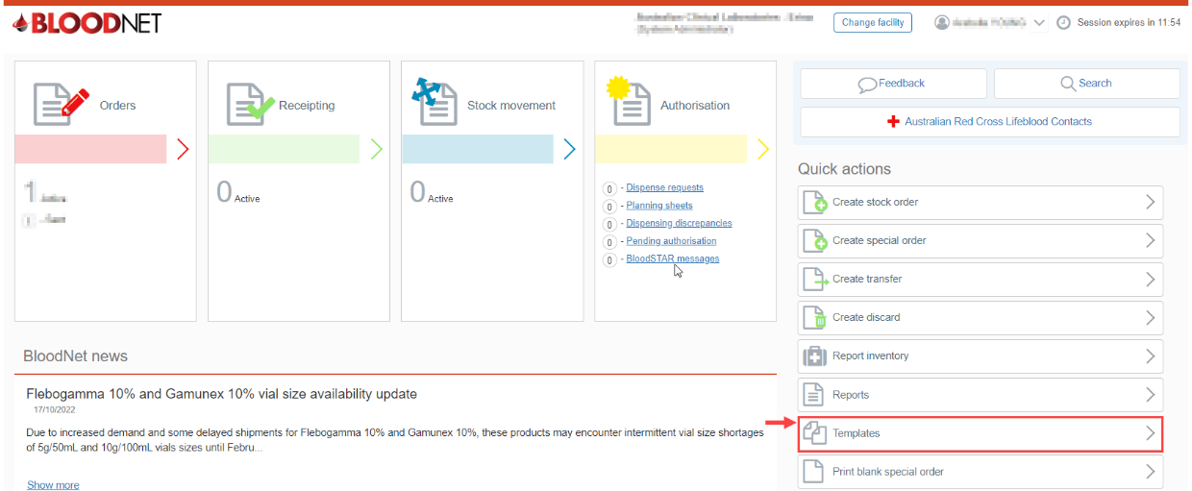
On the BloodNet home screen, click on Templates.
You will navigate to the ‘Templates’ screen.
Click Edit on the Template you wish to alter. 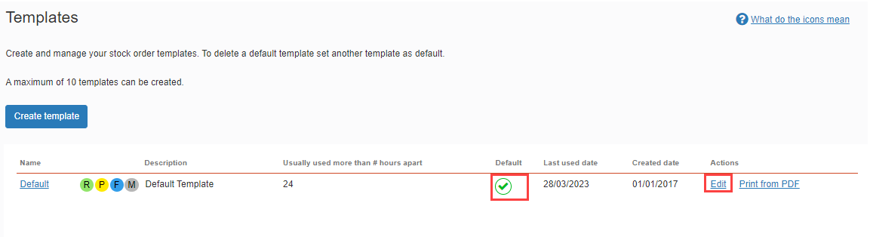
You will navigate to the ‘Edit template’ screen.
To select the Default template, select the template with a tick in the ‘Default’

Select the relevant Category of the product which you wish to add e.g. Immunoglobulins. 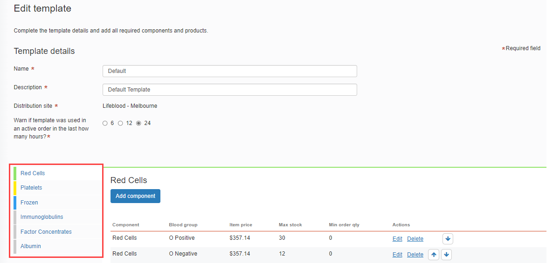
You will navigate to the selected category of components or products.
To add a component or product click Add component or Add product.
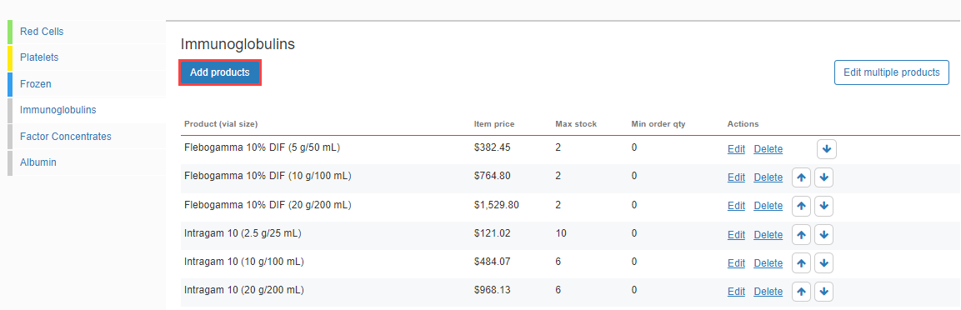
Make sure you click Save products and then Save template after you have changed this.

Select the relevant product or component from the drop-down menu. Click Show products.
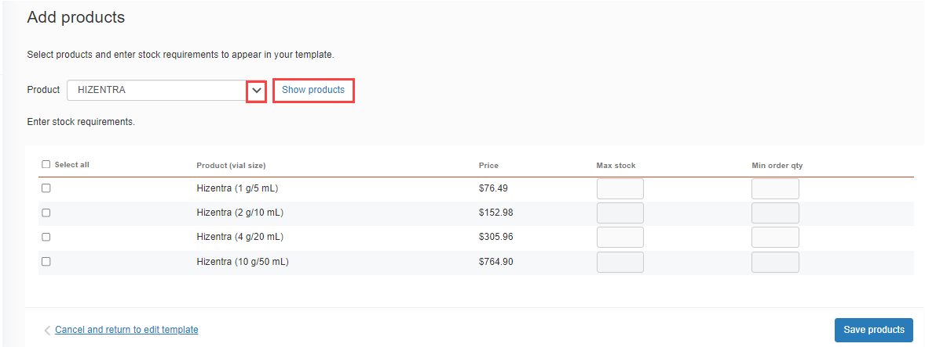
Enter your stock requirements by selecting the tickbox of the desired product and enter your maximum stock. Click Save products.
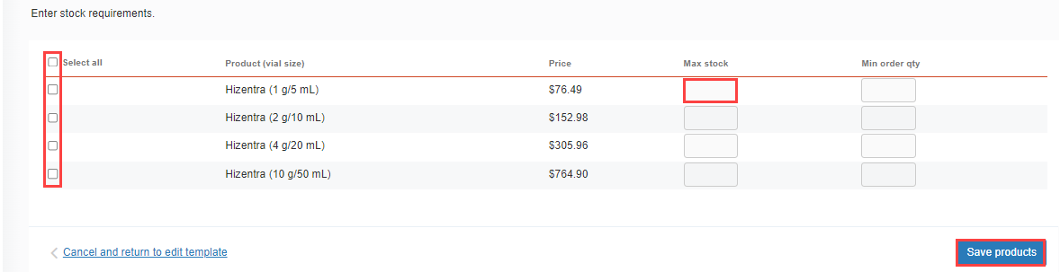
Once all of the desired products or components have been added to the Template using the above steps, click Save template. 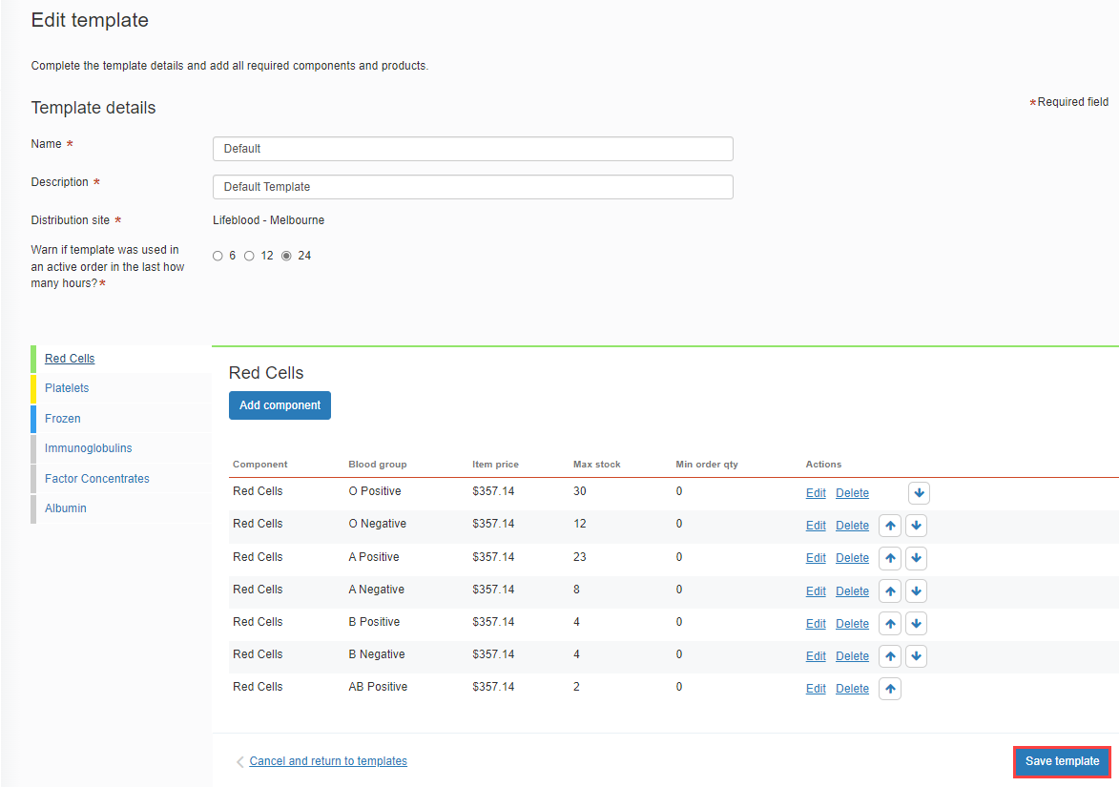
Your template has now been updated.

