Reporting Inventory

Report Inventory is to record the amount of inventory on hand in a facility at any given time so it can be used for reporting, pre-activation and or during an activation of the National Blood Supply Contingency Plan.

Inventory levels from BloodNet-LIS interfaced sites are sent to the National Blood Authority automatically every 15 minutes. If your facility is BloodNet-LIS interfaced, you do not need to report your inventory manually.

Inventory Reporting is to be completed as requested by the National Blood Authority.

Perform the following procedure to report your inventory in BloodNet:
Step | Action
Navigate in a web browser to https://portal.blood.gov.au to log in and once logged in select BloodNET.
If you do not know have a BloodPortal Account, click the link for instructions on registering bloodnet5-registration-tipsheet-Jul2018.pdf

Click on the Report Inventory under the ‘Quick Actions’.
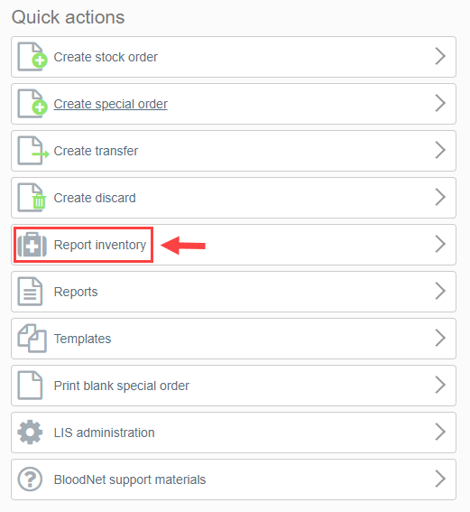
Report Inventory page opens.

Enter the quantity on hand at the blood group level for the correct component and the vial size for manufactured products. You can select different products and components from the top left hand side of the screen.

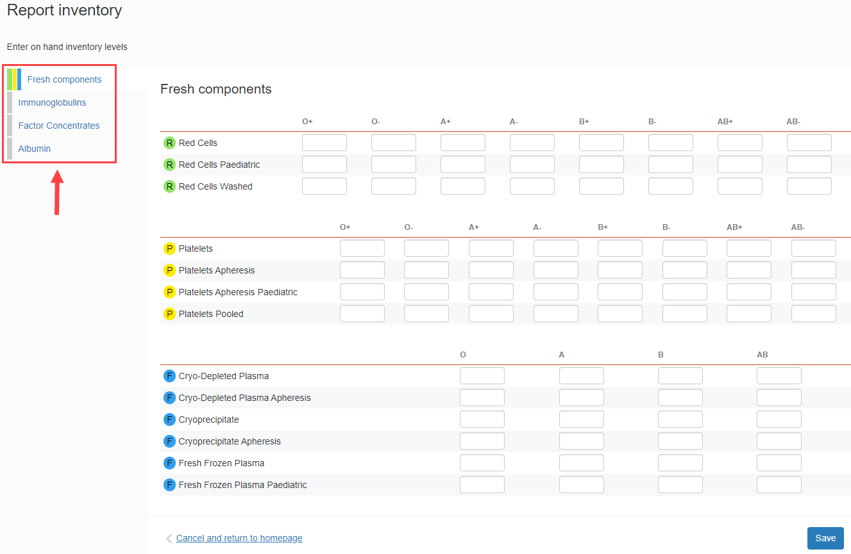

1.Inventory levels can only be entered by the Facility Administrator and the Facility User.
2. It is not mandatory to complete all fields; however, at a minimum one field must be entered to save.

 | Once you have entered all quantity on hand specified at the group levels for components and vial size for manufactured products, Click SAVE.

For Further Assistance
If you need further assistance, please contact the National Blood Authority support line on 1300 025 663, or via email support@blood.gov.au

