Cancelling an Order – Tip sheet
Perform the following procedure to Cancel an Order in BloodNet:
Please note: Only active orders with a status of Sent (Awaiting confirmation), Sent or Sent (Failed) can be cancelled.
- Click on the ‘Orders’ tile located on the left of the home page.
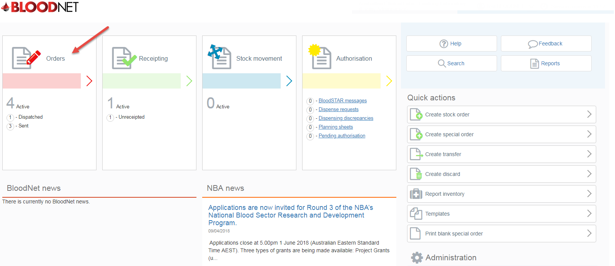
- Orders can be located using one of four ways:
- ‘Orders’ page - if it is one of the 20 most recent orders created by your facility
- ‘All active orders’ – by searching with the ‘Order number’ or ‘Sent date’ range
- The ‘Quick search’ tool on the ‘Orders’ page
- By clicking the ‘Search’ button on the home page.

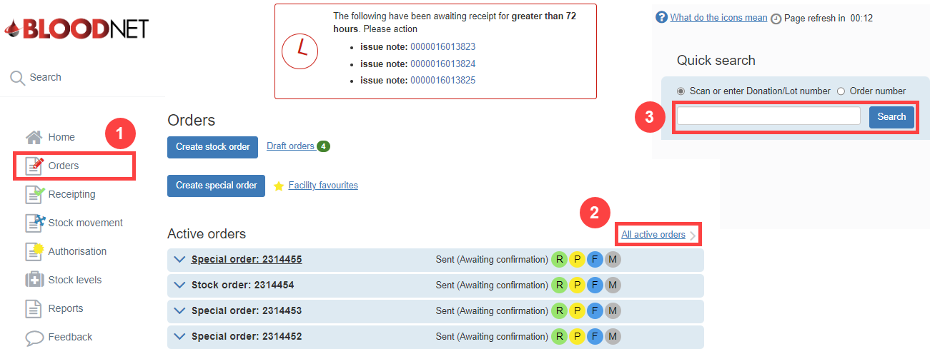
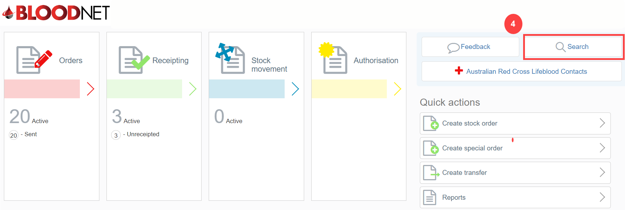

Cancelling an order from the Orders homepage
- Locate your order and click the drop-down arrow to the left of the order number to expand the order details. Then click the ‘Cancel order’ button.
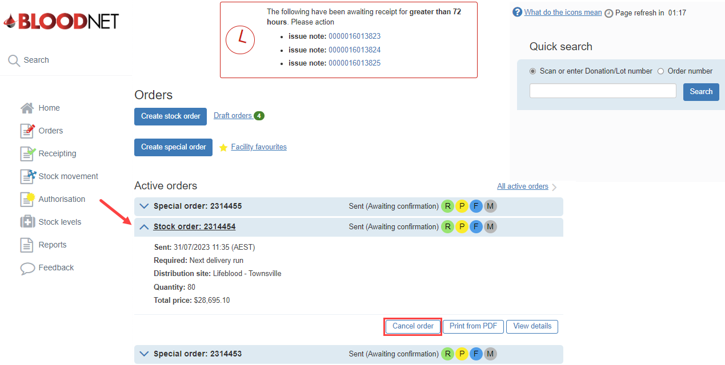
- Select the ‘Cancellation reason’ from the drop-down and confirm the cancellation by clicking ‘Cancel order’ on the ‘Cancel Order’ confirmation pop up box.
Please Note: If choosing ‘Other’ as the ‘Cancellation reason’ you must enter a legitimate reason in the mandatory ‘Other reason’ text box.
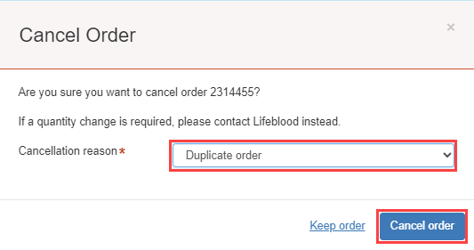

When cancelled, the Order will be removed from the ‘Active orders’ list and relocated to the ‘Recent cancelled orders’ list at the bottom of the Orders page.

Cancelling an order from the ‘All active orders’ page
- Search for the specific order that you wish to cancel by entering the ‘Order number’, ‘Type’ and ‘Sent date’ (optional) in the search fields.
Important: The ’Status’ must be set to ‘All active’.
- Click the ‘Search’ button.
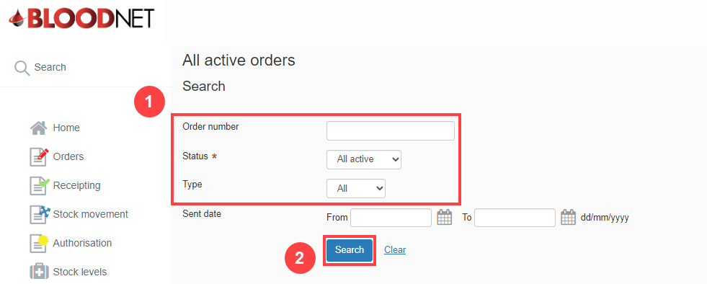
- Click on the ‘Cancel order’ hyperlink to cancel it.
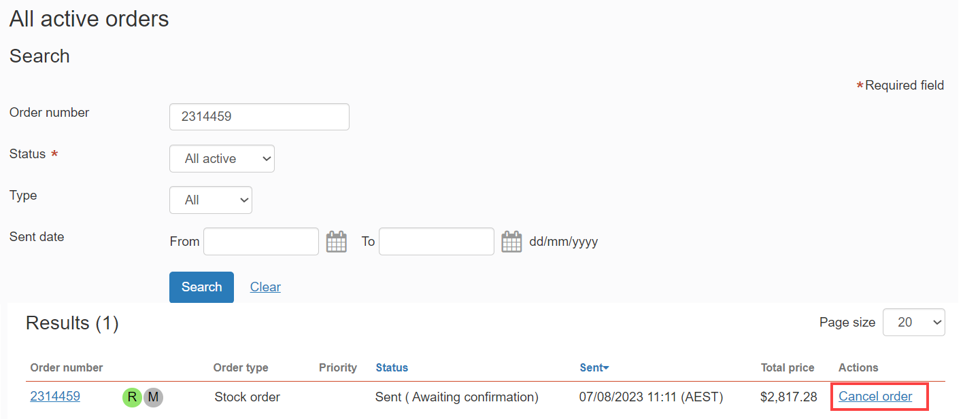

- Select the ‘Cancellation reason’ from the drop-down and confirm the cancellation by clicking ‘Cancel order’ on the ‘Cancel Order’ confirmation pop up box.
Please Note: If choosing ‘Other’ as the ‘Cancellation reason’ you must enter a legitimate reason in the mandatory ‘Other reason’ text box.

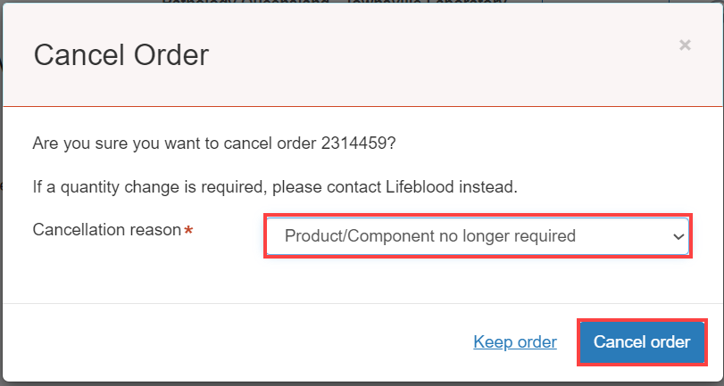
When cancelled, the Order will be removed from the ‘Active orders’ list and relocated to the ‘Recent cancelled orders’ list at the bottom of the ‘Orders’ page.

Cancelling an order from the Quick search tool
- From the ‘Quick Search’ tool on the Orders home page select the ‘Order number’ option, enter the order number in the search field and click ‘Search’.
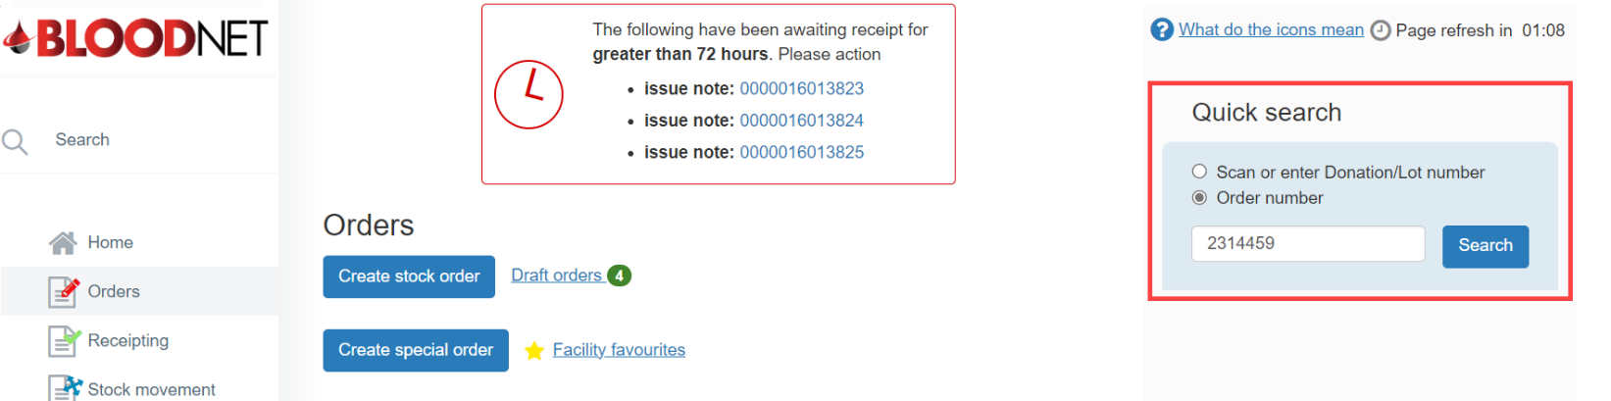
- Click the ‘View’ button and this will display the stock/special order details page.
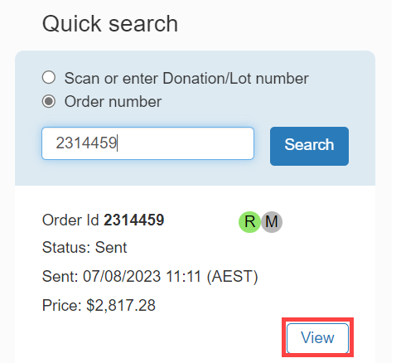
- Click the ‘Cancel Order’ button on the top right of the ‘order details’ page.
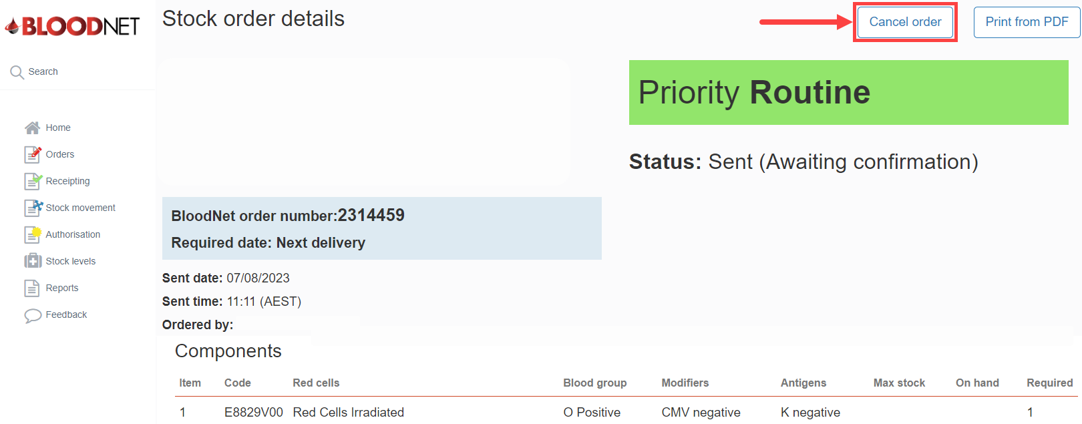

- Select the ‘Cancellation reason’ from the drop-down and confirm the cancellation by clicking ‘Cancel order’ on the ‘Cancel Order’ confirmation pop up box.
Please Note: If choosing ‘Other’ as the ‘Cancellation reason’ you must enter a legitimate reason in the mandatory ‘Other reason’ text box.

When cancelled, the Order will be removed from the ‘Active orders’ list and relocated to the ‘Recent cancelled orders’ list at the bottom of the ‘Orders’ page.

Cancelling an order from the BloodNet homepage
- Click the ‘Search’ button on the BloodNet home page.
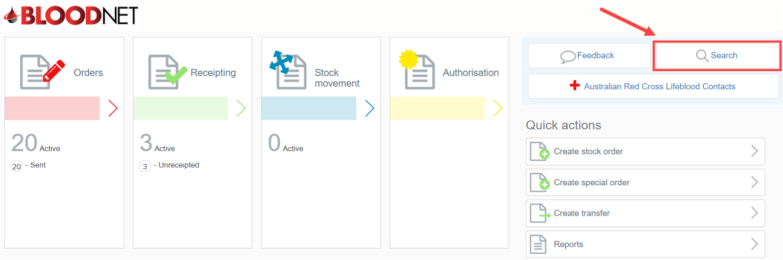
- From the ‘Search’ page search by ‘Order’ and enter the order number in the ‘Search for’ field or alternatively by ‘Date Range’ available for ‘Order’ and ‘Issue note’ searching.
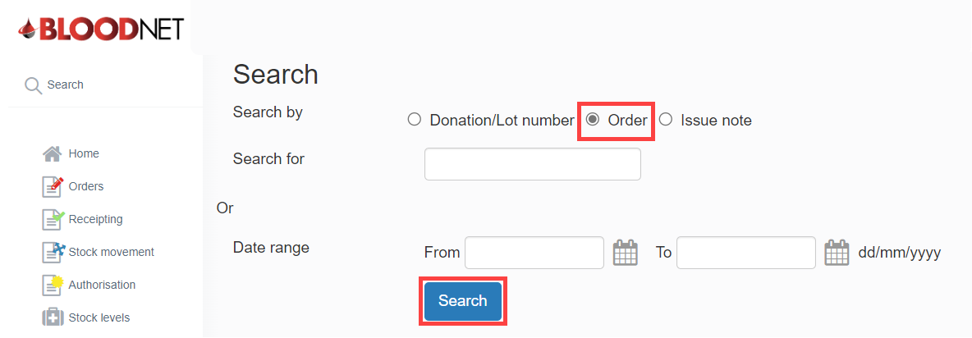
- Click the ‘Order number’ hyperlink to open the order details page.
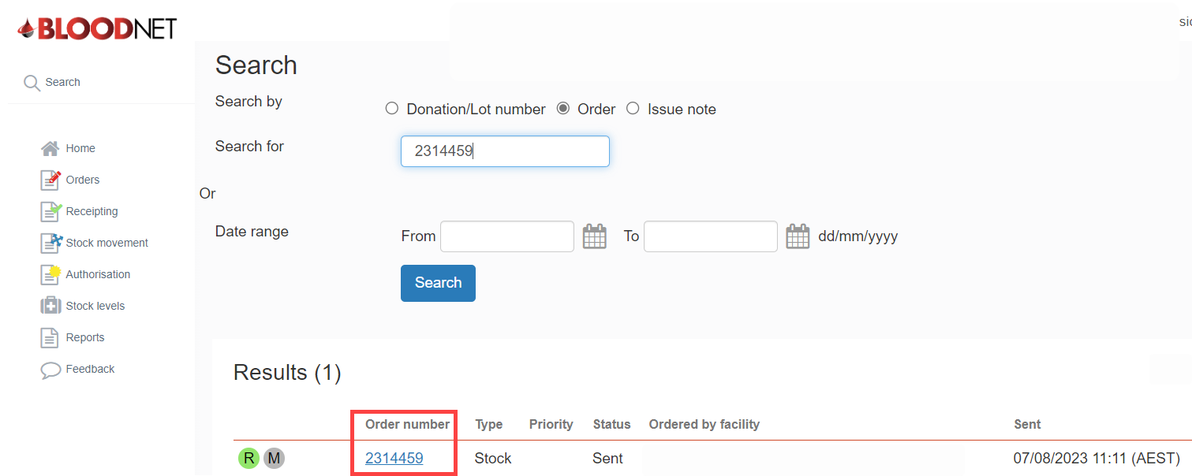

- Click the ‘Cancel Order’ button on the top right of the ‘order details’ page.
- Select the ‘Cancellation reason’ from the drop-down and confirm the cancellation by clicking ‘Cancel order’ on the ‘Cancel Order’ confirmation pop up box.
Please Note: If choosing ‘Other’ as the ‘Cancellation reason’ you must enter a legitimate reason in the mandatory ‘Other reason’ text box.

When cancelled, the Order will be removed from the ‘Active orders’ list and relocated to the ‘Recent cancelled orders’ list at the bottom of the ‘Orders’ page.

