Dispensing from a Dispense Request
This tip sheet outlines how to dispense a dose of immunoglobulin (Ig) in BloodNet directly from a dispense request. All Ig dispenses must be recorded in BloodNet.
- From the BloodNet homepage, click the ‘Dispense requests’ link in the ‘Authorisation’ tile.
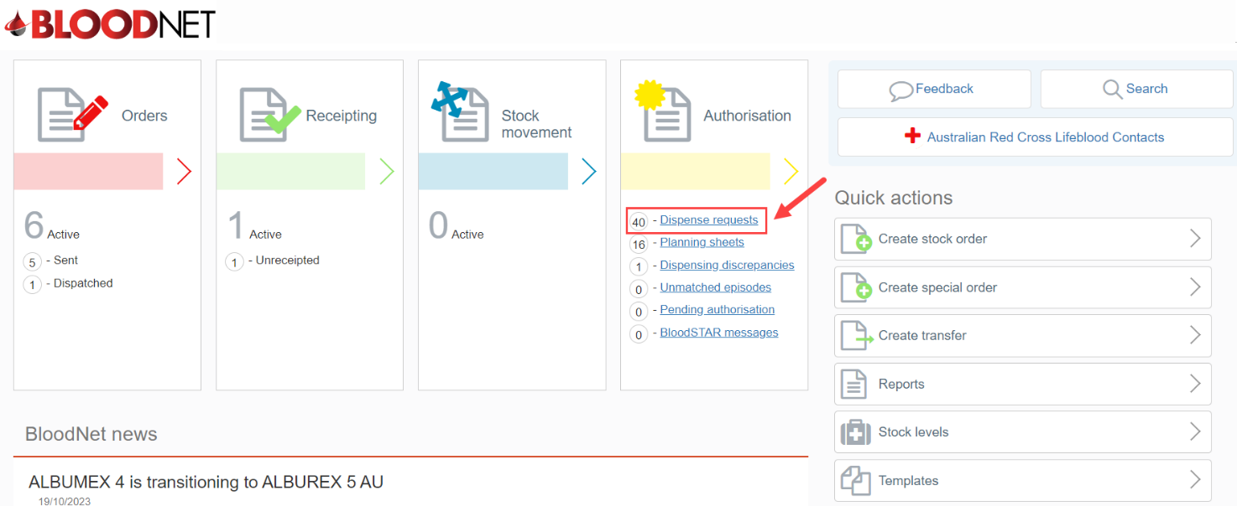
- A page will open with a list of ‘All dispense requests’ available for actioning by the dispensing facility.
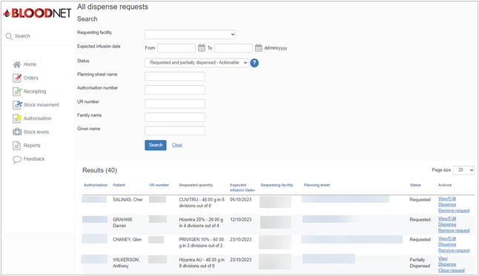

- Either:
  - Search for the dispense request by entering the patient details into the search fields and clicking the ‘Search’ button. Once the patient has been located, click the ‘Dispense’ link, or
  - Click the ‘Dispense’ link directly from the ‘All dispense requests’ page.
Please Note: There are also links to ‘View/Edit’ the request or ‘Remove request’.
Please Note: If there is no dispense request available, refer to the BloodNet tip sheet ‘Create a dispense from an authorisation record’.
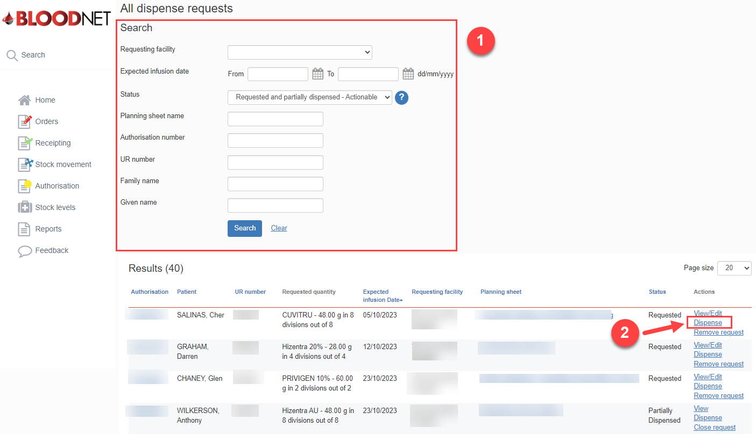
- On the ‘New dispense episode’ page, enter the ‘Dispense Date’ and ‘Dispense time’.
- Scan or enter the lot number/s and Quantity of product being dispensed in the blue box on the right side of the page and click the ‘Add item’ button.
- Enter the ‘Expected infusion date’. This is the date the patient is expected to receive the infusion.
Please note: It is important the ‘Expected infusion date’ is as accurate as possible as the patient’s next Planned Date will be calculated from this date.
- Click the ‘Save Dispense episode’ button at the bottom right of the page to record the dispense.
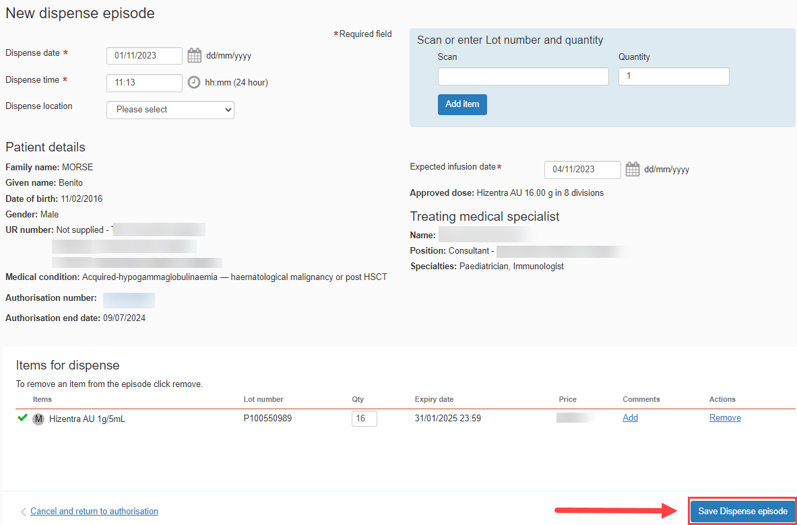
Please note: A warning message will appear if the ‘Dispensed product does not match authorised product.’ If the incorrect product is dispensed, this will cause a Dispense Discrepancy.
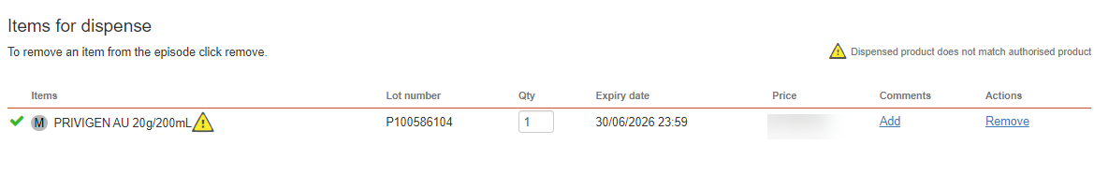

- The dispense episode has now been saved.
Please note: A receipt of the dispense episode can be printed by clicking the ‘Print from PDF’ button on the right of the page.
