Care pathway for the prophylactic use of Rh D immunoglobulin in pregnancy care

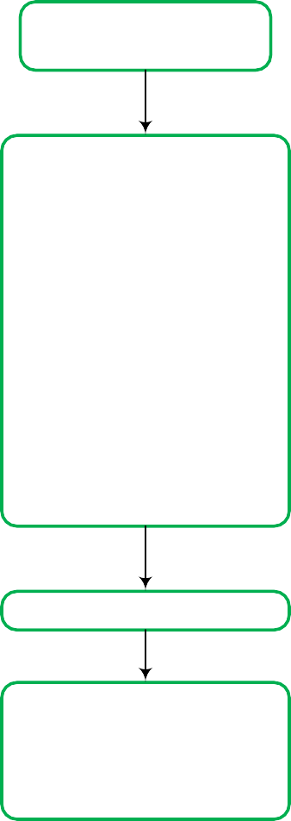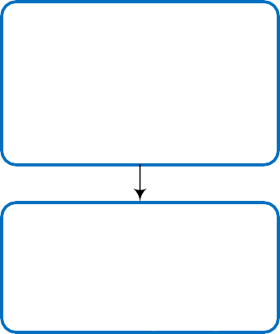

(excluding non-invasive prenatal testing (NIPT))

# Woman’s blood group and antibody screen in

**Woman’s blood group and antibody screen in**

**pregnancy confirms Rh D negative**

**pregnancy confirms Rh D positive**

**Antibody screen positive for anti-D**

**Antibody screen negative for anti-D**

**Rh D Ig not required**

Clinical history of:

* Previous pregnancy
* Transfusion
* IV drug use/needle sharing
* Recent Rh D Ig administration

Discuss with your laboratory to

**At 28 weeks of pregnancy** Retest antibody screen and administer first dose of Rh D Ig 625 IU. Dose can be given before results are available.

Negative

Positive

Consider clinical history and discuss with your laboratory whether likely to be passive or preformed antibody

Rh D Ig not required.

determine whether likely to be passive or preformed antibody

If weak or variant Rh D type, consult a haematopathologist for result interpretation and management

No

Likely preformed anti-D

Yes

## At 34 weeks of pregnancy No

Administer second dose of

Rh D Ig 625 IU

## After birth

Cord blood or neonatal testing to determine neonate(s) Rh D type

One or more neonates Rh D positive.

If neonate has a weak or No

Likely preformed anti-D

Yes

Seek specialist

obstetric advice and manage as Rh D

sensitised.

Rh D Ig not required. Seek specialist obstetric advice and manage as Rh D sensitised.

Consider NIPT for fetal *RHD*

status.

variant Rh D type consult a haematopathologist for result interpretation and management

Yes

**Additional Rh D Ig for sensitising events in singleton and multiple pregnancies**

**First 12** Administer Rh D Ig 250 IU as soon as practical. If **weeks of** delayed beyond 72 hours the dose should be **pregnancy** given up to 10 days from the sensitising event,

but may have lower efficacy.

Administer Rh D Ig 625 IU as soon as practical,

**Between 13** unless testing has confirmed that they are not

**and 20** carrying an Rh D positive fetus. If delayed **weeks of** beyond 72 hours the dose should be given up to **pregnancy** 10 days from the sensitising event, but may

have lower efficacy.

* Maternal blood sample for volume of FMH.
* Administer Rh D Ig 625 IU as soon as practical (without waiting for result of test for FMH). If

**After 20** delayed beyond 72 hours the dose should be **weeks of** given up to 10 days from the sensitising event, **pregnancy** but may have lower efficacy.

* If large FMH ≥6 ml of fetal red cells (12ml of whole blood) confirmed, follow laboratory advice regarding additional Rh D Ig to be given.

Maternal blood sample for volume of FMH

Administer Rh D Ig 625 IU to woman as soon as practical (without waiting for result of test for FMH). If delayed beyond 72 hours the dose should be given up to 10 days

Rh D Ig not required

If large FMH ≥6 ml of fetal red

cells (12 ml of whole blood) confirmed, follow laboratory or medical advice regarding

additional Rh D Ig to be given

FMH, fetomaternal haemorrhage; Ig, immunoglobulin; IU, international units; IV, intravenous

anti-D - refers to circulating antibodies; Rh D positive/negative - refers to blood type.

This care pathway is from the *Guideline for the prophylactic use of Rh D immunoglobulin in pregnancy care.* Access the full guideline at [www.blood.gov.au/anti-d-0](http://www.blood.gov.au/anti-d-0)

Adapted from NSW Health. 2015. Maternity – Rh (D) Immunoglobulin (Anti D) guideline. https://www1.health.nsw.gov.au/pds/Pages/doc.aspx?dn=GL2015_011