Care pathway for the prophylactic use of Rh D immunoglobulin in pregnancy care

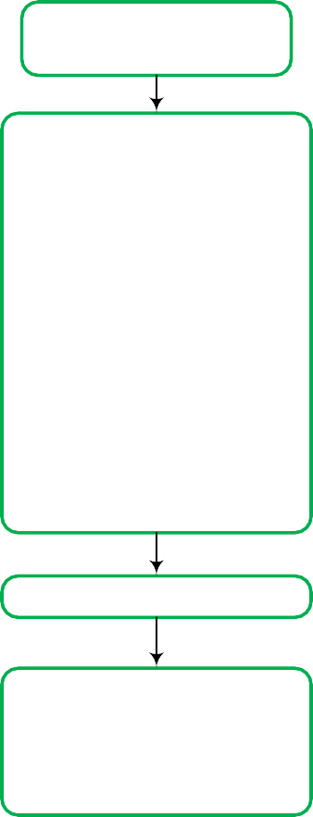

(including non-invasive prenatal testing (NIPT))

# Woman’s blood group and antibody screen in

**Woman’s blood group and antibody screen in**

**pregnancy confirms Rh D negative**

**pregnancy confirms Rh D positive**

**Antibody screen positive for anti-D**

**Antibody screen negative for anti-D**

**Rh D Ig not required**

Clinical history of:

* Previous pregnancy
* Transfusion
* IV drug use/needle sharing
* Recent Rh D Ig administration

Discuss with your laboratory to

determine whether likely to be

passive or preformed antibody.

If weak or variant Rh D type,

consult a haematopathologist for

result interpretation and

management

No

Likely preformed anti-D

Yes

Rh D Ig not required. Seek

Specialist obstetric advice and

manage as Rh D sensitized.

Consider NIPT for fetal *RHD*

status **From 11+0 weeks of pregnancy**

Determine fetal *RHD* status via

NIPT of maternal blood sample

from 11+0 weeks

* Fetus predicted to be Rh D positive, or
* Test inconclusive, or
* Results unavailable or

uncertain

**At 28 weeks of pregnancy** Retest antibody screen and administer first dose of Rh D Ig 625 IU. Dose can be given before results are available

Negative

**At 34 weeks of pregnancy**

## Administer second dose of

Rh D Ig 625 IU

**After birth**

Cord blood or neonatal testing to

Determine neonate(s) Rh D type

**Additional Rh D Ig for sensitising events in singleton and multiple pregnancies**

**First 12** Administer Rh D Ig 250 IU as soon as practical. If **weeks of** delayed beyond 72 hours the dose should be **pregnancy** given up to 10 days from the sensitising event,

but may have lower efficacy.

Administer Rh D Ig 625 IU as soon as practical,

**Between 13** unless testing has confirmed that they are not

**and 20** carrying an Rh D positive fetus. If delayed **weeks of** beyond 72 hours the dose should be given up to **pregnancy** 10 days from the sensitising event, but may

have lower efficacy.

* Maternal blood sample for volume of FMH.
* Administer Rh D Ig 625 IU as soon as practical (without waiting for result of test for FMH). If

**After 20** delayed beyond 72 hours the dose should be **weeks of** given up to 10 days from the sensitising event, **pregnancy** but may have lower efficacy.

* If large FMH ≥6 ml of fetal red cells (12ml of whole blood) confirmed, follow laboratory advice regarding additional Rh D Ig to be given.

Positive

All fetuses predicted to be Rh D

negative – no antenatal

immunoprophylaxis required

Consider clinical history and discuss with your laboratory whether likely to be passive or preformed antibody

No Likely preformed Yes

anti-D

Rh D Ig not required.

Seek specialist obstetric

advice and manage as

Rh D sensitised

|  |  |  |
| --- | --- | --- |
| No | One or more neonates Rh D positive  If neonate has a weak or variant Rh D type consult a haematopathologist for result interpretation and management | |
|  |
|  | | es |

Rh D Ig not

required

Maternal blood sample for volume of FMH

Administer Rh D Ig 625 IU to woman as soon as practical (without waiting for result of test for FMH). If delayed beyond 72 hours the dose should be given up to 10 days

If large FMH ≥6 ml of fetal red cells (12 ml of whole blood) confirmed, follow laboratory or medical advice regarding additional Rh D Ig to be given

FMH, fetomaternal haemorrhage; Ig, immunoglobulin; IU, international units; IV, intravenous; NIPT, non-invasive prenatal test

anti-D - refers to circulating antibodies; *RHD -* refers to genotype; Rh D positive/negative - refers to blood type.

This care pathway is from the *Guideline for the prophylactic use of Rh D immunoglobulin in pregnancy care.* Access the full guideline at [www.blood.gov.au/anti-d-0](http://www.blood.gov.au/anti-d-0)

Adapted from NSW Health. 2015. Maternity – Rh (D) Immunoglobulin (Anti D) guideline. https://www1.health.nsw.gov.au/pds/Pages/doc.aspx?dn=GL2015_011