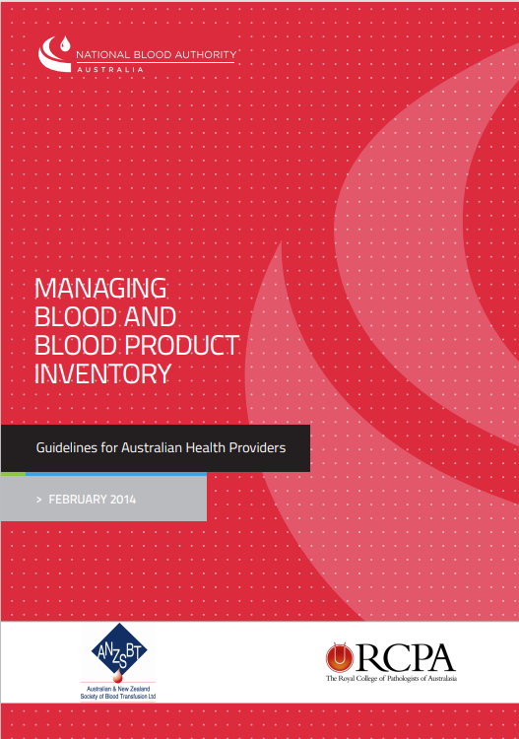

© National Blood Authority, 2014.

With the exception of any logos and registered trademarks, and where otherwise noted, all material presented
in this document is provided under a Creative Commons Attribution 3.0 Australia (http://creativecommons.org/
licenses/by/3.0/au/) licence.

The details of the relevant licence conditions are available on the Creative Commons website (accessible using the links provided) as is the full legal code for the CC BY 3.0
AU license (http://creativecommons.org/licenses/by/3.0/au/legalcode).

The content obtained from this document or derivative of this work must be attributed as the Managing Blood and Blood Product Inventory: Guidelines for Australian Health Providers.

ISBN 978-0-9873687-7-5 (Print Edition)
ISBN 978-0-9873687-6-8 (Electronic Edition)

This publication is available online at www.blood.gov.au/inv-mgt-guideline

For more information: Inventory Management
National Blood Authority
Locked Bag 8430
Canberra ACT 2601

Phone: 13 000 BLOOD (13 000 25663) Email: support@blood.gov.au www.blood.gov.au


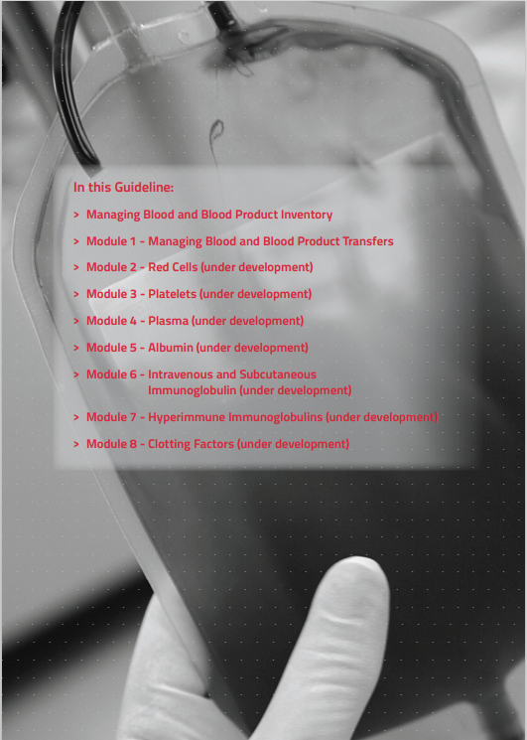
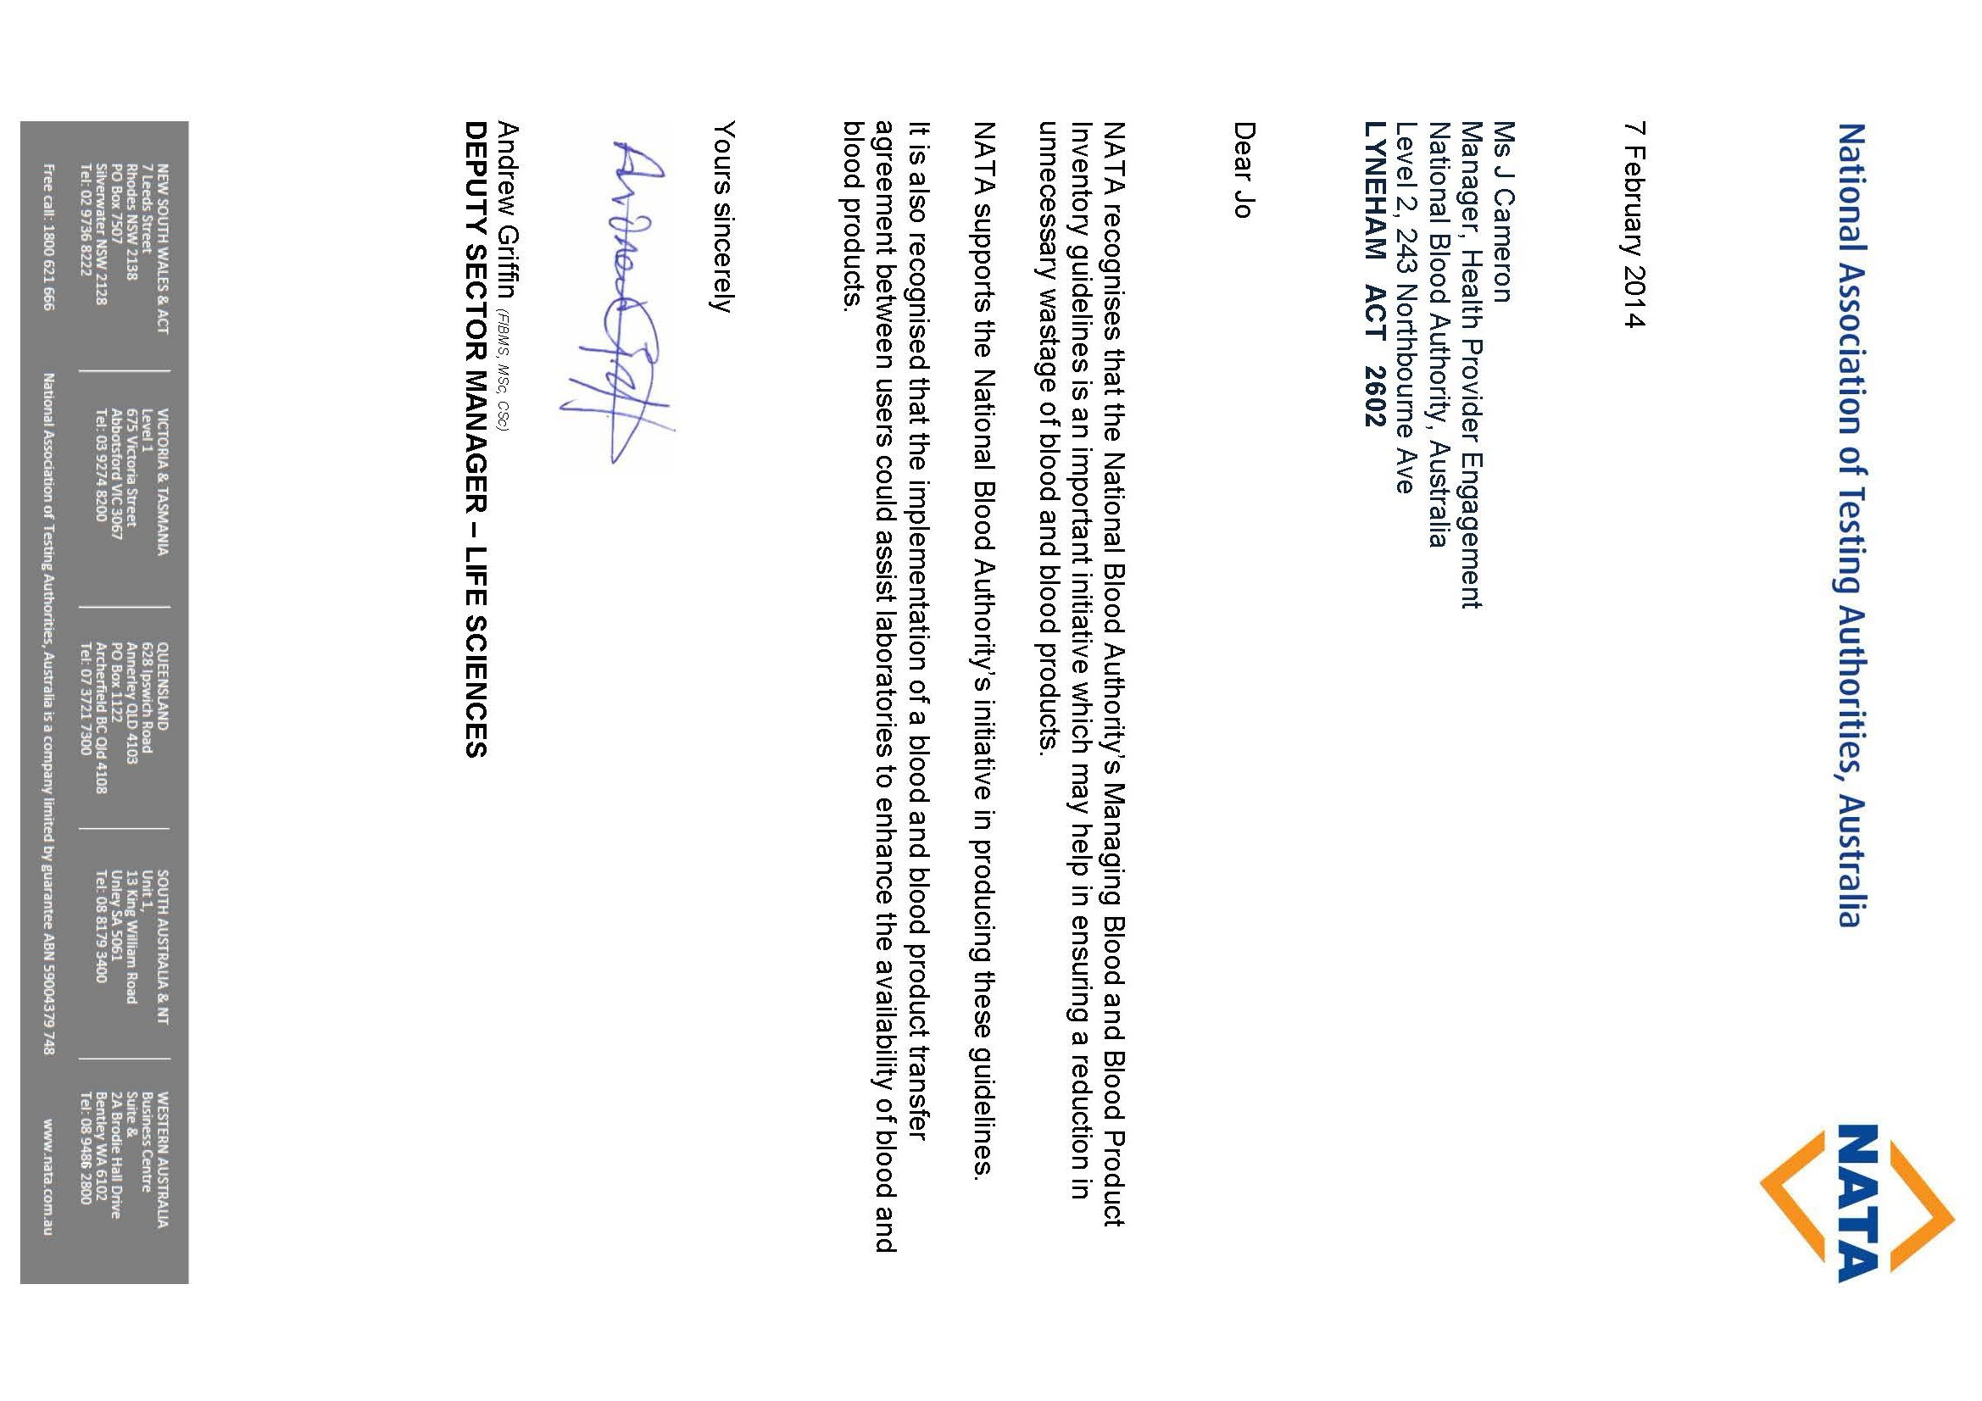
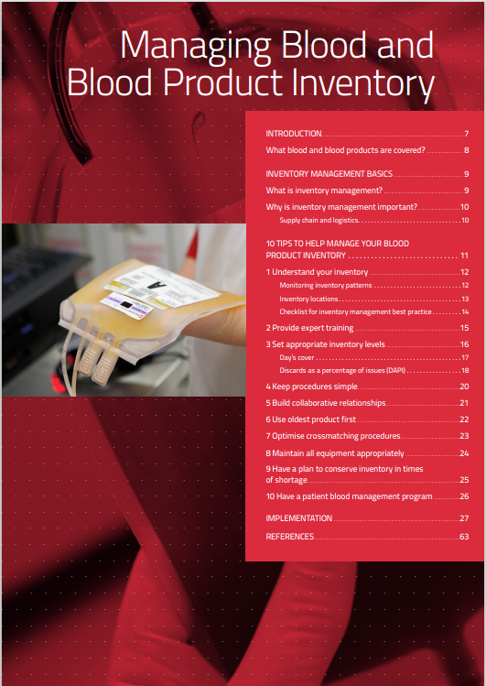

INTRODUCTION

The National Blood Authority Act 2003 states that the National Blood Authority (NBA) is "to carry out national blood arrangements to ensure that there is a sufficient supply of blood products and services in all the States and covered Territories; and to carry out national blood arrangements relating to safety measures, quality measures, contingency measures and risk mitigation measures for the supply of blood products and services."

The National Blood Agreement requires that all parties identify opportunities to develop and implement strategies for the Australian blood sector, to:
- promote optimal safety and quality in the supply, management and use of products, including through uniform national standards; and
- make best use of available resources to give financial and performance accountability, by all entities involved in the Australian blood sector.

Australian Health Ministers have issued the "Statement on National Stewardship Expectations for the Supply of Blood and Blood Products" which states that health providers should have processes, programs and facilities in place that minimise wastage of blood and blood products and that national planning, management and governance are supported by:
- health providers having an ordering and receipt verification process in place which provides adequate financial accountability as required by governments; and
- inventory data is provided on a regular and timely basis to assist in supply and demand planning requirements especially in times of national shortages.¹
The National Safety and Quality Health Service (NSQHS) Standard 7, Blood and Blood Products, requires health service organisations to have ‘systems to receive, store, transport and monitor wastage of blood and blood products safely and efficiently’.²
Many of the risks associated with receipt, storage, collection and transport of blood and blood products can be reduced. Systems and processes can be designed to address these risks. Systems for cold chain integrity, sample collection, cross-matching, product collection, and inventory management including storage, handling and transport should be monitored to identify and address weak spots.
These guidelines provide better practice processes that can be used by health providers to ensure these risks are mitigated and improvement opportunities are identified and implemented.

WHAT BLOOD AND BLOOD PRODUCTS ARE COVERED?
These guidelines are intended to cover the following products:
Fresh blood components and products
- Red blood cells
- Platelets
- Clinical fresh frozen plasma
- Cryoprecipitate
- Cryodepleted plasma
- Whole blood and other products such as autologous serum eye drops
Plasma & recombinant products
- Albumin
- Immunoglobulins, including immunoglobulin replacement therapy (e.g. IVIg)
- Hyperimmune globulins
- Clotting factors


INVENTORY MANAGEMENT BASICS

WHAT IS INVENTORY MANAGEMENT?
Good inventory management encompasses all the activities associated with ordering, storing, handling and issuing of blood and blood products to optimise efficiency.

Managing blood and blood product inventory is made up of two key factors:
- Product availability. Planning of inventory levels held, timing of deliveries and order volume; and
- Product integrity. Physical and process control of product in your facility, to ensure efficient and effective handling to maintain availability and minimise wastage.

Inventory management procedures, records and systems may vary significantly from one health provider to the next depending on the size and nature of the services provided. There is no single set of activities that will suit all health providers so you should examine which activities might work to improve inventory management for you. An effective inventory manager understands how to make use of the data available in order to determine how each part of the supply chain affects their facility and how it could be improved on.



WHY IS INVENTORY MANAGEMENT IMPORTANT?
Good inventory management is vital for health providers holding blood and blood products to ensure appropriate utilisation of a precious resource. Not holding enough inventory can potentially put patients at risk or disrupt routine services. However, having too much inventory can deplete products held by the supplier to insufficient levels, increase the age of product at transfusion and increase wastage through increased expiry. By managing inventory efficiently, health providers will be aware of their usage patterns and can order blood and blood products accordingly.

- The National Stewardship Statement of Expectations¹ states that health providers play an important part in minimising wastage. The statement also requires that health providers have an ordering and receipting verification process (such as BloodNet) in order to provide adequate financial accountability as required by governments. These processes are also required by healthcare organisations under NSQHS Standard 7 – Blood and Blood Products.²

SUPPLY CHAIN AND LOGISTICS
The term ‘supply chain and logistics’ describes the activities for supply and management of blood and blood products. Health providers can be involved in influencing many parts of the supply chain. This can be achieved through planning, implementing and controlling activities concerning:
- orders, deliveries and storage of products;
- stock movement and handling; and
- issue of blood and blood products to end users, including clinicians and patients.
Inventory management improvement activities can involve addressing the size, location, and number of deliveries, whether health providers supply to other health providers (hub and spoke type arrangements), as well as on-site storage arrangements and conditions for different products. It also involves addressing relationship issues among suppliers, distributors and end users (e.g. clinicians). This requires creating strong channels of communication with suppliers, distributors and end users so that important information gets through.

10 TIPS TO HELP MANAGE YOUR BLOOD PRODUCT INVENTORY
Blood products are a valuable perishable resource, sometimes scarce despite efforts to ensure a sustainable supply. Being able to use blood and blood products before they expire is desirable to maintain cost efficiency. Therefore, it makes sense to maintain an inventory of product that is at a level sufficient to meet requirements. Balancing this level with having sufficient product to meet clinical demand is often a challenge for health providers.

Blood and blood product inventory management is a trade-off between shortage and wastage. Practice has shown that there is a strong relationship between blood and blood product inventory levels and wastage.³ Reducing the level of inventory usually results in less wastage, so understanding how to appropriately and efficiently manage your inventory is important.

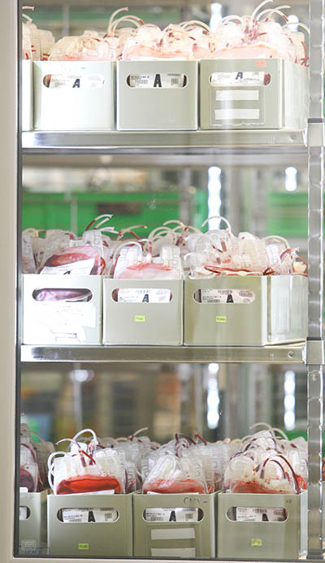

These guidelines aim to provide health providers with 10 simple tips for better practices in inventory management that can be applied to all blood and blood products. Some health providers will find that it is not possible to adopt all of these practices however you should use these guidelines to assess whether there is any room for improvement in your facility in any of the areas mentioned. More specific information around particular products, including advice on how to set inventory levels, is given in the modules relating to those products.

Tip 1: UNDERSTAND YOUR INVENTORY
Expert inventory managers understand and regularly monitor their inventory. This means they know and review patterns of inventory holdings, where inventory is held, trigger levels, delivery patterns, wastage rates, and usage rates. Understanding the patterns of all of these items will help plan requirements for improving the inventory management practices involved.

MONITORING INVENTORY PATTERNS
You should examine your current inventory practices to determine their efficiency. This involves looking at what your current inventory holdings are, as well as your usage and discard patterns, in conjunction with delivery and transport schedules. Ordering and delivery patterns should be examined to determine the best schedule to suit workflow requirements while maintaining cost effectiveness. The patterns may be reliant on the capacity to store products, the level of staffing, and the shelf life of product and demand patterns. For example, your facility may have a large haemophilia clinic once per week and this may determine when the bulk of the clotting factor products are ordered and delivered.
You may need to determine what you think is a safe level of stock for each type of product, i.e. inventory levels should be sufficient to ensure blood components are available to maintain expected daily patient needs, but not so high that results in high rates of discard due to expiry. You should also have an understanding of how these inventory levels will work in periods of short supply. Monitoring the number of blood products ordered, transfused, transferred and discarded can provide information regarding your inventory management, and can provide a basis for planning ahead. You can use a variety of resources available to perform this monitoring such as:
- reports available in BloodNet at www.blood.gov.au
- reports available from suppliers
- reports you generate yourself from your Laboratory Information System and associated databases.


INVENTORY LOCATIONS
Managing blood and blood product inventory is made up of two key factors:
- Product Availability: Planning of inventory levels held, timing of deliveries and order volume; and
- Product Integrity: Physical and process control of product in your facility, to ensure efficient and effective handling to maintain availability and minimise wastage.
Inventory management procedures, records and systems may vary significantly from one health provider to the next depending on the size and nature of the services provided. There is no single set of activities that will suit all health providers so you should examine which activities might work to improve inventory management for them. An effective inventory manager understands how to make use of the data available in order to determine how each part of the supply chain affects them and how it could be improved on.
BloodNet Reports
Some BloodNet reports that might help monitor your inventory include:
• Issues (INV002)
• Inventory (INV001, 006, 007 & 008)
• Discard (Fate 001, 002 &007)
• Transfers (Fate 003 & 004)
• Fresh Blood Orders & Issues (FUL010e)

CHECKLIST FOR INVENTORY MANAGEMENT BEST PRACTICE
Activity | Attended
Do you have a set time for placing orders? | □
Do you do an inventory count before placing orders? | □
Do you return unused reserved product to inventory before counting? | □
Do you receipt product into BloodNet / LIS within one hour of receipt? | □
Do you maintain and monitor blood product refrigerators according to guidelines? | □
Do you have Standard Operating Procedures that cover inventory management? | □
Do you have a training protocol that covers inventory management? | □
Do you have policies that cover movement of product between facilities? | □
Do you have policies that cover movement of product to ward areas? | □
Do you monitor and report on your discard rates to a governing body? | □
Do you monitor and report on your usage rates to a governing body? | □
Do you monitor and report on your transfer rates to a governing body? | □
Do you maintain up to date and accurate records? | □
Do you regularly review your inventory requirements? | □
Are your procedures simple enough for everyone involved to understand? | □
Do you regularly communicate with others outside your area who are involved in supply, handling and use of blood and blood products? | □
Are you able to inform others above of better practice processes? | □
Do you use Electronic Crossmatching where possible? | □
Do you utilise a Group and Screen or Maximum Blood Ordering Schedule where possible? | □
Do you have short reservation periods where possible? | □
Do you sort your inventory to allow oldest product to be used first? | □
Do you have contingency plans? | □
Are your contingency plans linked to your state or territory health emergency plan? | □
Do you have a patient blood management program? | □

Tip 2: PROVIDE EXPERT TRAINING
Research has shown that having staff that are well trained can have an overall positive effect on inventory management and reducing wastage.⁴ You should ensure that all staff involved in the handling of blood and blood products participate in a well-designed training program. Staff should learn the importance of inventory management and be instructed on how their decisions impact the supply chain.



Performing procedures in a consistent manner is important, along with having training protocols and procedures that ensure that only experienced personnel provide direction to new starters. Standard Operating Procedures (SOPs) should be easy to follow and clearly outline required tasks and processes, to minimise inconsistencies amongst staff.

Staff should be aware of the impact of inadequate storage and handling, as well as the implications of wasting blood. You can avoid putting patients at risk by assuring product integrity. Wasted product not only has financial implications, but can also mean less product is available where required, potentially resulting in an adverse clinical outcome.

Training should be provided, not only for laboratory staff, but for all staff in the organisation that order or use blood and blood products. The organisation’s Medical Officer induction program should include a session on blood use, including prescribing, ordering and use of blood and blood products. This has been shown to bring about a significant reduction in the stock required to be held on site.³

Tools
The National Blood Authority is developing some tools to assist in designing your training and will make them available on www.blood.gov.au

Tip 3: SET APPROPRIATE INVENTORY LEVELS
Each health provider is responsible for setting their own inventory levels and ensuring these are appropriate. There is a strong relationship between inventory levels and wastage. Hospitals and laboratories that hold more blood and blood products relative to their average daily use often have high wastage rates. The key to good inventory management is balancing sufficient inventory to meet clinical need while keeping wastage rates at a minimum.
Specific advice and guidance on how to set inventory levels for each different product, i.e. red cells, platelets, plasma and manufactured and recombinant products will be found in the specific modules relating to those products. The following are important factors that may influence decisions on inventory levels:
- Type of health provider. Hospitals and blood banks that have an emergency or obstetrics department can sometimes need a large volume of product available in a short time. If your hospital has this type of service you may like to set a higher minimum or trigger level of product, as restocking during an emergency may not always be possible.
- Daily usage rates. You can examine your average daily use by using the Fresh Blood Orders and Issues report found in the Inventory Report section in BloodNet. You should also examine your Days Cover relative to your usage (see below).
- Supply patterns (product received from suppliers or other health providers). You should consider all product entering your inventory. Product may be received either from the supplier or transferred from another health provider. The pattern of this may be consistent or may vary, and this can have an effect on your ordering patterns
Variability
It can be helpful to look at the degree of variability by blood type or product. If the variability is high, then you may consider holding more inventory. If the variability is relatively low, then you will not need to hold as much.

- Distance from supplier (leadtime). You may need to consider how far away your hospital or blood bank is from the Australian Red Cross Blood Service (Blood Service) or other supplier depot as this will have an effect on how quickly you will be able to re-stock once you reach your minimum level. If you are a long way from the Blood Service or other supplier depot you may like to set a higher minimum level. Refer to the BloodNet user manual for definitions of different order types and priorities. User manuals and tip sheets can be found at www.blood.gov.au/bloodnet
- Frequency of deliveries. Hospitals or laboratories that get few deliveries may need to set higher target levels than those that are restocked more frequently.
- Transfer patterns. Hospitals and laboratories that transfer product back and forth need to carefully examine the effects this has on inventory. For example, product may be able to be transferred to another health provider to enable it to be used before expiry, but should be transferred with sufficient expiry to ensure it is used. Arrangements should be in place with these laboratories to ensure this process is appropriate.
- Your discards as a percentage of issues (DAPI). If your discard rates are high, you may need to consider whether holding less stock is appropriate.

DAY’S COVER
Day’s Cover is the number of days of available stock that is held in inventory for a particular product. It can be calculated by dividing the number of available product units in inventory by the number of product units used (on average) per day over a given time period. It is generally recommended that you look at a time period that will be representative of current practice to determine this. For example, if your hospital has added a new surgical unit you may want to look at the time period since the unit was set up to determine the usage.
Balancing Costs
Each health provider should consider whether the level of inventory holdings will balance costs in relation to the level of discards and the number of deliveries

Day’s Cover = a ÷ b
Where
a = Number of available units in stock
b = Average daily use = number of units used over a one year period 365 (or you may like to use a different denominator if your facility doesn’t use blood and blood products every day of the week).⁴
This can be done for each type of product individually. For example:
11,000 units of red cells ordered over a 12 month period = 11000 ÷ 365 = 30 units per day
Number of available units in stock = 180
Days cover = 180 ÷ 30 = 6
This can be described as a health provider holding a stock of 180 units having about 6 day’s cover.

The ideal inventory level in terms of day’s cover may differ for each product type and type of health provider. However a good inventory manager will base the levels on experience and will allow for small changes over time to adapt to any practice changes at your facility.
Issuable Stock Index (ISI)
Day’s cover can also be referred to as the Issuable Stock Index or ISI, a term used internationally.

If you use BloodNet you can calculate your day’s cover for each fresh blood product using the Fresh Blood Orders and Issues Reports found in the Inventory Report section. You may like to set a minimum trigger level to alert you when product is getting low, and have well documented actions to take in these circumstances.

DISCARDS AS A PERCENTAGE OF ISSUES (DAPI)
Discard as a Percentage of Issues (DAPI) is a good way to make your discard data comparable with other health providers. You should use the FATE007 Fresh Component Health Provider Discards Report in BloodNet to compare your facility to those of a similar size nationally in the group category and against those in your state. This will allow you to benchmark your discards against others which is now occurring on a jurisdictional and national level.
A certain level of discards of blood and blood products, particularly fresh products with short expiry dates is both inevitable and appropriate to ensure that products are available where and when they are clinically necessary. However, there is a proportion of discards of blood and blood products that is neither inevitable nor appropriate and is this is termed wastage. Total discards are reported in BloodNet.
DAPI is calculated by taking the amount of blood and blood product units discarded in a given time period and dividing this by the total amount of blood and blood product units received by your facility in the same time period and multiplying this figure by 100 to give a percentage value.
DAPI = x ÷ y x 100%
Where
x = Number of units discarded
y = Number of units issued to you
For example:
50 Albumin units wasted over 12 months and 5,000 Albumin units issued to your facility over 12 months
DAPI = 50 ÷ 500 x 100% = 1%

Wastage as a Percentage of Issue (WAPI)
If you are comparing your results with international data, DAPI is frequently referred to as ‘Wastage as a Percentage of Issues’ (WAPI) internationally.

If you use BloodNet you can examine your discard patterns using BloodNet reports. Not all health providers will be able to limit discards to the same level. You should examine your own practice for each product and assess whether there is any room for improvement. Recording the reason for discard of a product is important for monitoring purposes. Monitoring trends of wastage will help identify those areas for improvement.
More information on discards, and strategies for reducing wastage can be found at www.blood.gov.au/wastage.

Tip 4: KEEP PROCEDURES SIMPLE
Making procedures too complicated can discourage people from performing them properly⁴. Hospital and laboratory staff are usually very busy, therefore simple procedures and/or checklists work best for maintaining effective inventory management.
Platelet Requests
Asking clinicians to plan ahead can be particularly helpful in planning platelet inventory where the shelf life is short.

One example of where a simple procedure might help is the laboratory stock count procedures. Sometimes performing a physical count of stock may give a more accurate picture of inventory levels if electronic records are organised in a complicated manner. Setting trigger ordering levels can prevent staff from placing unnecessary orders and therefore having excess inventory.
Simple planning may also help with inventory management. If possible, ask clinicians to provide you with details of product requirements in advance. Provide them with a simple procedure for informing the lab of requirements. You may like to order your product requirements in line with these requests plus only a small amount for unforeseen usage.


Tip 5: BUILD COLLABORATIVE RELATIONSHIPS
Having good relationships with all people involved in the supply, handling and use of blood and blood products can help with managing inventory. You should encourage clinicians to understand the inventory and ordering process to minimise the number of unnecessary orders that could lead to product unavailability. Explain to clinicians who are requesting blood and blood products the requirements and time frames needed when ordering product.
Collaborate
Good relationships with those outside your facility such as other health providers and suppliers can also help when transferring or ordering product. If you order for, or from, another health provider you should ensure they understand inventory management best practice.

Clinicians often turn to laboratory staff for advice when ordering blood and blood products. You should help raise awareness around patient blood management (refer to tip 10 below) and appropriate use by referring clinicians to local policies as well as national guidelines found at www.blood.gov.au/patient-blood-management.


Tip 6: USE OLDEST PRODUCT FIRST
Where appropriate, when products are received they should be sorted to allow them to be used on an oldest-product-first-out basis. This is particularly important for those products with a short shelf life such as platelets or thawed FFP, or when receiving products that may have been transferred to you from another health provider.

Special Circumstances
There are some special clinical circumstances where it may not be appropriate to use the oldest blood first (e.g Neonatal exchange transfusions). Hospitals should have a policy that describes the limited clinical situations where use of the oldest blood first may not be appropriate.

If you believe product may be stored for an extended period of time with a lower likelihood of being used, for example reserve emergency stock in a remote location within your facility, it may be better to choose fresher product but rotate it more regularly back into general inventory, to enable it to be used before expiry. Product should have adequate shelf life left before expiry when moved from reserved or remote locations back to general inventory. You should have documented arrangements for ensuring this occurs on a regular basis.

Options to consider if product is getting close to expiry might include transferring to another hospital or laboratory, rotating segregated inventories where possible and highlighting to others that product is soon to expire. One example may be to make up a sign for the fridge that clearly identifies stock with short expiry, enabling it to be the first selected for issue.

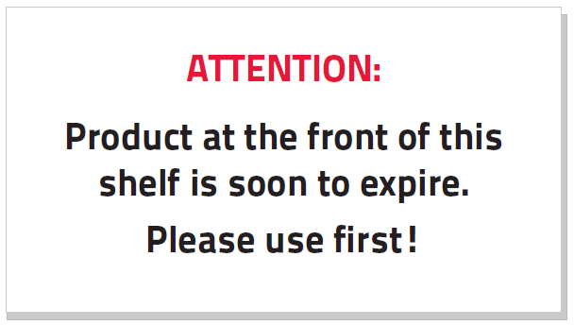

Tip 7: OPTIMISE CROSSMATCHING PROCEDURES
You should avoid reserving product, by crossmatch or otherwise, for a specific patient where the likelihood of use is uncertain. Each time blood and blood products are reserved for a patient, this product is effectively removed from ‘available’ inventory. This can create an artificial shortage and can cause unnecessary replacement orders.

Electronic Crossmatching
Where possible your laboratory should consider Electronic Crossmatching procedures. These procedures work well with Group and Screen policies, helping to maximise product in available inventory.

Laboratories should encourage using "Group and Screen" or "Maximum Blood Order Schedule (MBOS)" policies for red cell orders in patients without clinically significant red cell antibodies. Ideally a MBOS should be developed specifically for your hospital to give clinicians an idea of what the appropriate ordering patterns for blood and blood products are. One example of a "Maximum Surgical Blood Order Schedule (MSBOS)"can be found in Frank et al (2013).⁵

Where blood and blood products have been reserved for specific patients, consider short reservation periods to enable product to be moved back to general inventory if not used.



Tip 8: MAINTAIN ALL EQUIPMENT APPROPRIATELY
All equipment used for the storage, transportation and handling of blood and blood products, such as transport containers, refrigerators, freezers and plasma thawers should be maintained and monitored in accordance with relevant standards and guidelines.

These are:
- AS3864.2 2012 – Medical Refrigeration Equipment - For the storage of blood and blood products⁶
- NPAAC Requirements for Transfusion Laboratory Practice⁷
- ANZSBT guidelines for Pretransfusion Laboratory Practice⁸

Remote Refrigerators
AS 3864.2 2012⁶ states "the organisation which owns the medical refrigeration equipment used to store blood and blood products is responsible for ensuring that it is properly managed in accordance with the Standard and other regulatory requirements."

You should have a back-up plan for refrigerator failure, and be able to provide documented procedures to other hospital staff as to the correct storage and handling procedures for blood and blood products in these circumstances. Any remote refrigerators such as those at remote sites, emergency areas and other associated off-site facilities should also be maintained appropriately. Discarding product due to equipment failure can be avoided by following proper maintenance schedules and being prepared for unforeseen failures.

Tip 9: HAVE A PLAN TO CONSERVE INVENTORY IN TIMES OF SHORTAGE
Where inventory levels are running low, (either within your organisation or more widespread) you should have a plan for what to do to conserve product. You should develop local policies concerning the management of contingency events. These policies can cover shortages ranging from a small short-term shortage of a particular product to much more widespread shortages.

Communication
You should communicate shortages in supply to clinicians ordering the product. You may be able to ask them to consider the patient’s immediate requirements and whether the product could be ordered at a later date, when product becomes more available.

In times of more widespread shortage, your state or territory health department will have a contingency plan that you can adapt to fit your setting, and this should involve identifying key personnel to be responsible for communicating any shortages to those affected.

You should also be familiar with the National Blood Supply Contingency Plan⁹ found at www.blood.gov.au/nbscp.

Tip 10: HAVE A PATIENT BLOOD MANAGEMENT PROGRAM
One of the best ways to conserve blood and blood products is to avoid its use. Before the decision to transfuse is made, all of the alternatives, risks and benefits should be considered as there may be another, more appropriate product or treatment that can be used.
Finding the Guidelines
The NHMRC endorsed Patient Blood Management Guidelines¹⁰ can be found on the NBA website www.blood.gov.au/patient-blood-management

The iPad app is also available from the Apple App Store.

You should have an organisation-wide patient blood management program. This program should aim to manage and preserve the patient’s own blood to reduce or avoid the need for a blood transfusion. The program is a way to link clinical areas across a health provider such as medical officers, transfusion nurses and laboratory staff to ensure the most appropriate use of blood and blood products.


IMPLEMENTATION
Now that you have been provided with these 10 steps to improving inventory management practice, how do you start to make any changes to improve current practice?
- Read the modules on specific product types to get some further help with things you can do to improve inventory management and learn how to calculate recommended stock levels.
- Talk to other health providers that you know may be performing well, and have reduced their wastage rates, as they may be able to share some other better practice ideas with you.
- Establish champion networks to promote good inventory management practice.

Tools to help implement better practice inventory management are being developed by the National Blood Authority and will be found at www.blood.gov.au when available.

Contact the NBA for advice on support@blood.gov.au or call 13 000 BLOOD (13 000 25663).

Acknowledgements
The National Blood Authority would like to acknowledge the contributions of the following organisations to the development of these Guidelines:
- Hunter Area Pathology Service, New South Wales
- National Association of Testing Authorities (NATA)
- South Australian Department of Health, BloodMove Program
- Tasmanian Department of Health, Tasmanian Blood Product Network
- Therapeutic Goods Administration (TGA)

Endorsements
Managing Blood and Blood Product Inventory - Guidelines for Australian Health Providers has been endorsed by:
- Australian & New Zealand Society of Blood Transfusion Ltd (ANZSBT)
- The Royal College of Pathologists of Australia (RCPA)
The guideline is supported by:
- National Association of Testing Authorities (NATA)

References
- The Australian Health Ministers’ Conference Australian Health Ministers’ Conference Statement on National Stewardship Expectations for the Supply of Blood and Blood Products. (National Blood Authority: 2010).
- Australian Commission on Safety and Quality in Healthcare Safety and Quality Improvement Guide Standard 7: Blood and Blood Products. ACSQHC (2012).at <National Safety and Quality Health Service Standards>
- Perera, G., Hyam, C., Taylor, C. & Chapman, J. F. Hospital blood inventory practice: the factors affecting stock level and wastage. Transfusion medicine (Oxford, England) 19, 99–104 (2009).
- Stanger, S. H. W., Yates, N., Wilding, R. & Cotton, S. Blood inventory management: hospital best practice. Transfusion medicine reviews 26, 153–63 (2012).
- Frank, S., Rothschild, J., Masear, C., Rivers, R., Merritt, W., Savage, W. and Ness, P. Optimizing preoperative blood ordering with data acquired from an anesthesia information management system. Anesthesiology 118-6 (2013).
- Standards Australia Australian Standard. (2012). AS 3864.2-2012 Medical refrigeration equipment - For the storage of blood and blood products - User-related requirements for care, maintenance, performance verification and calibration. at <http://infostore.saiglobal.com/store/Details.aspx?productID=1600491>
- National Pathology Accreditation Advisory Council (NPAAC). (2008). Requirements for Transfusion Laboratory Practice (First Edition). Department of Health and Ageing, Commonwealth of Australia: Canberra, Australia.at <http://www.health.gov.au/internet/main/publishing.nsf/Content/health-npaac-docs-transfusion.htm>

- Australian & New Zealand Society of Blood Transfusion Guidelines for pretransfusion laboratory practice. (The Australian & New Zealand Society of Blood Transfusion Ltd: Sydney Australia, 2007). at <ANZSBT Publications>
- National Blood Authority. Australian Health Ministers Conference National Blood Supply Contingency Plan. 88 (2008).
- National Blood Authority. Patient Blood Management Guidelines Development. at <http://www.blood.gov.au/patient-blood-management>

