Creating a Special Order
Special orders are placed when a fresh product is required to have specific modifier(s), antigen requirements or if there is a need for it to be provided to you from a local Australian Red Cross Lifeblood Customer Service Delivery (CSD) site for a specific patient.
 | Please note: Patient information is not a mandatory requirement and should only be included if absolutely necessary for the order.

Perform the following procedure to Create a Special Order in BloodNet:
Create a Special Order
- Select the Orders tile located on the left of the home page.
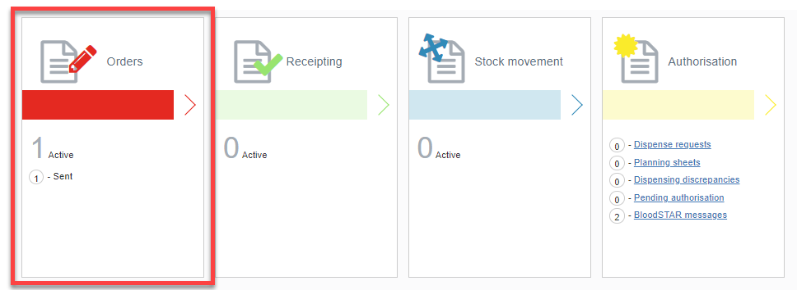

- Select the Create special order button.
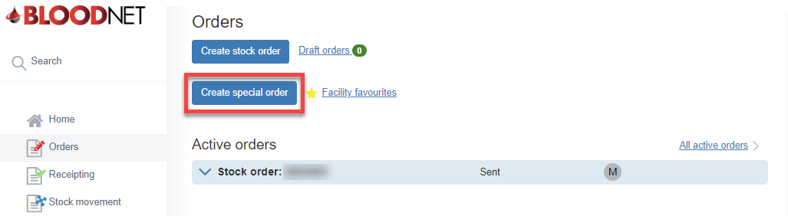

- Add the required items by selecting Add component or Add product.

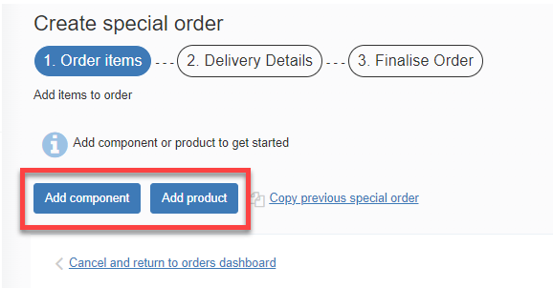

Please note: Fresh products are located in the components tab and manufactured products are located in the products tab.

- Once the component/product is selected, fill in all the required information and select either Save component/product or Save and add another component/product if more items are required.

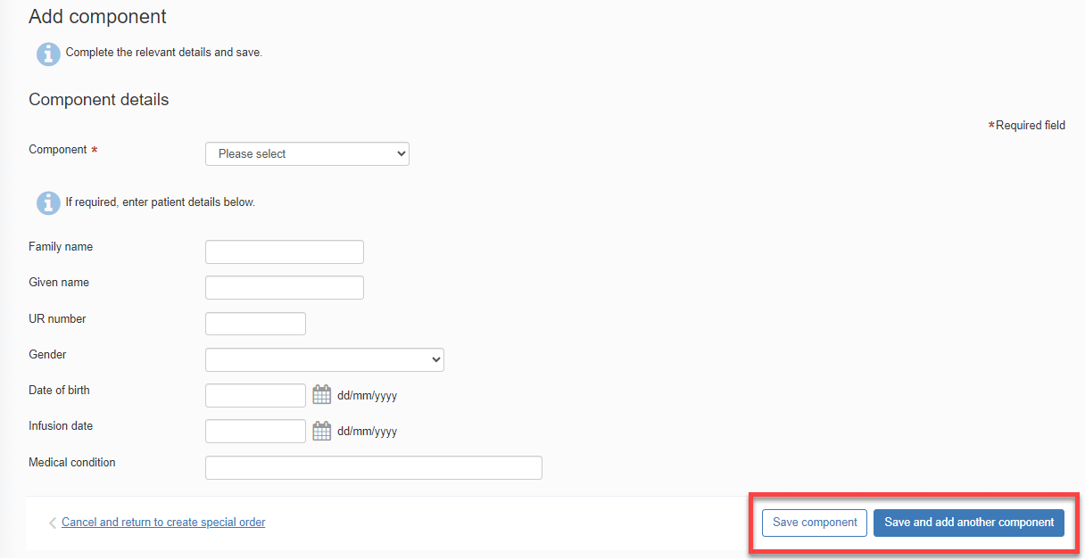

- Review 1. Order items and Edit or Delete as required and then select Next: delivery details.

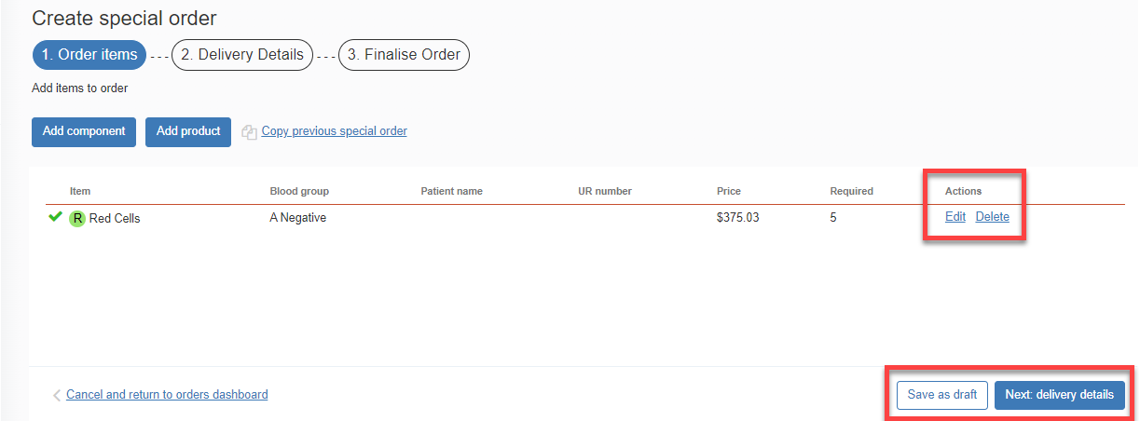

- Enter the order Priority, Delivery details, and add any relevant order/delivery comments by selecting the Add comment button.

When placing a Special Order with a Priority of:
- Routine the system will automatically select the next available date and time for dispatch based on Lifeblood’s distribution run schedule and the time that the order needs to be placed by.

Please note: You will have the option to select a later dispatch date and time in line with the distribution run schedule or you can Specify date and time required.
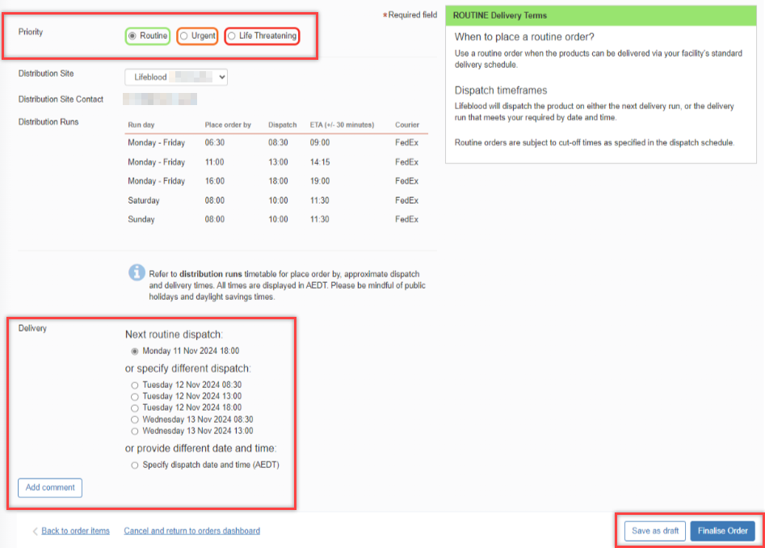

Please note: If you are in a rural/remote area, options for the next routine dispatch will not show and you will need to Specify required date and time.
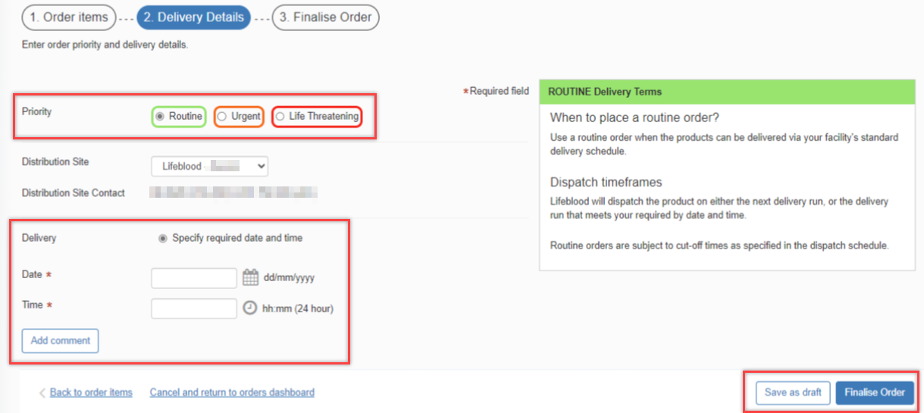

- Urgent the system will automatically select the Delivery option Ready for dispatch within 60 minutes of receipt.

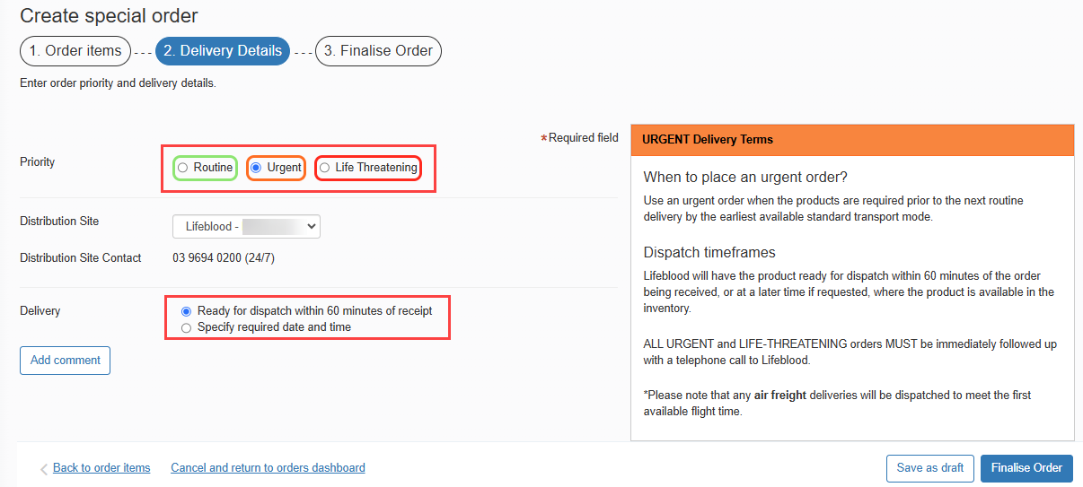

- Life Threatening the system will not provide any Delivery option and will require a phone call to your local Lifeblood CSD.

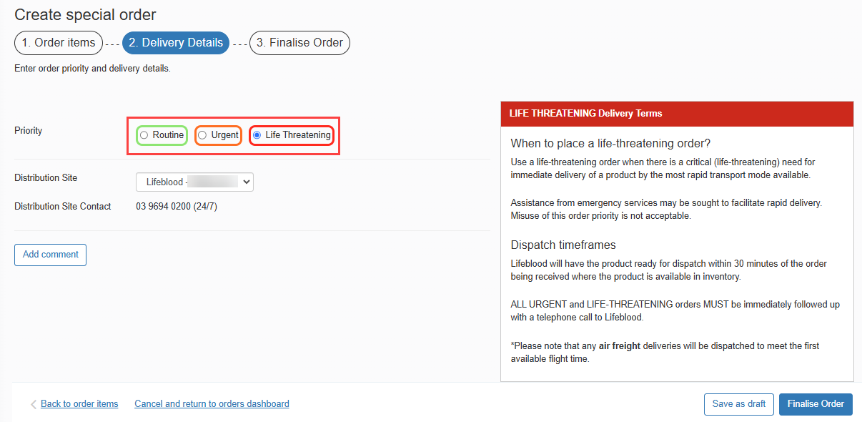

Once complete, select Finalise Order.

Please note: If you wish to edit the order, select the Back to order items hyperlink found in the bottom left corner of the tab and amend the order as necessary.
Please note: When placing an Urgent or Life-Threatening order, a pop up will appear. Select Yes to confirm you would like to change the priority to Urgent or Life Threatening.

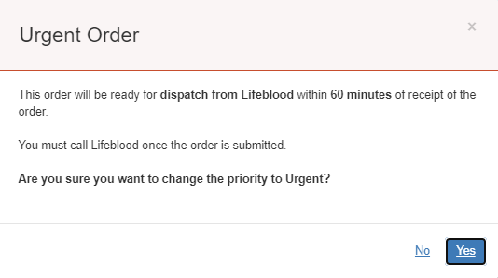
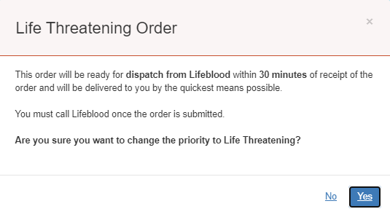

- Select the Send order button to send the order to the local Lifeblood CSD site.
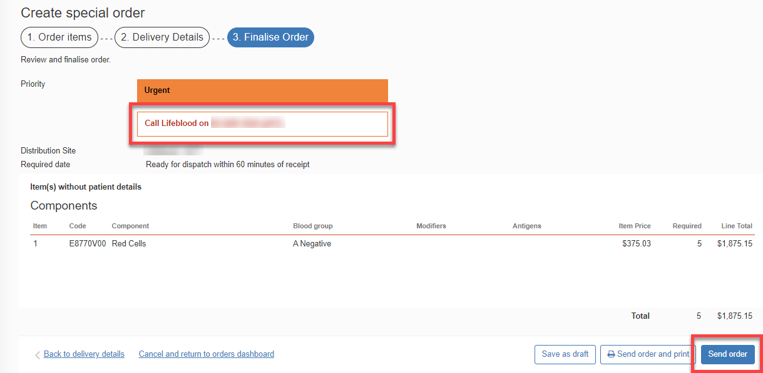

Please note: If your order is Urgent or Life Threatening, you MUST select the appropriate priority in Step 6. Do not write the priority in the comments box. All Urgent or Life Threatening orders MUST be followed up with a phone call to your local Lifeblood CSD site.
Please note: When the selected distribution run is no longer available due to missing the cut-off time, a red error message will be displayed at the top of the page. The error message is as follows

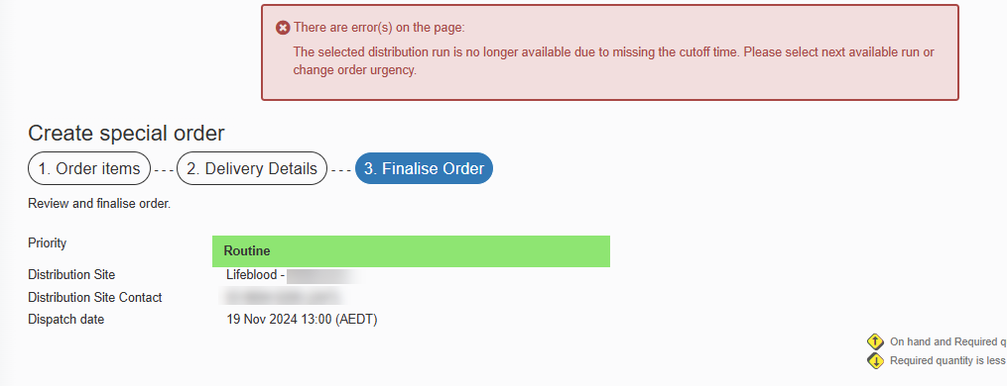

- Once the order has been sent to Lifeblood, it will remain under the Active orders section until all issue notes linked to the order are receipted. Once all components/products have been physically received, the order can be finalised in BloodNet.

