Creating a Stock Order
In BloodNet, a stock order must be submitted to receive components or products that are needed to be stocked at a facility. These orders are sent to a local Australian Red Cross Lifeblood Customer Service Delivery (CSD) site for dispatching.
Perform the following procedure to create a Stock order in BloodNet:
Create a Stock Order
- Select the Orders tile located at the top left of the home page screen.
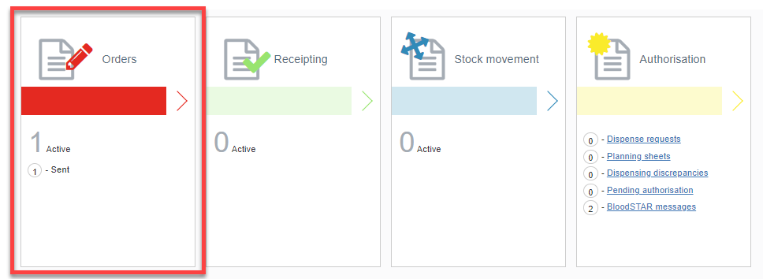

- Select the Create stock order button.
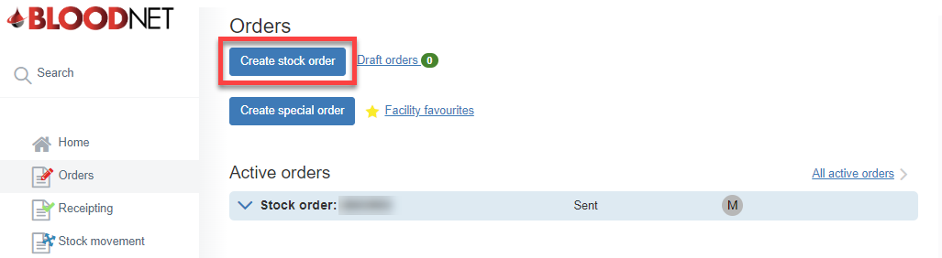

- Select the stock order template from the Current template drop-down.
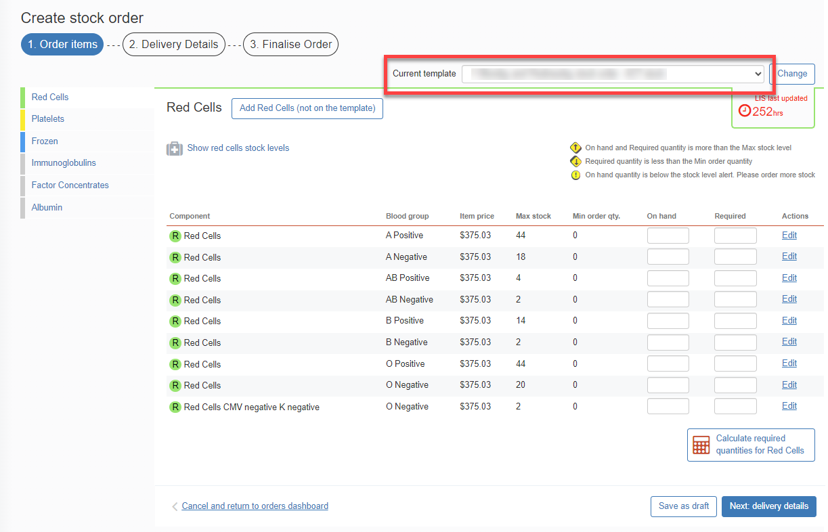
- Add the items by selecting the relevant Component or Product.
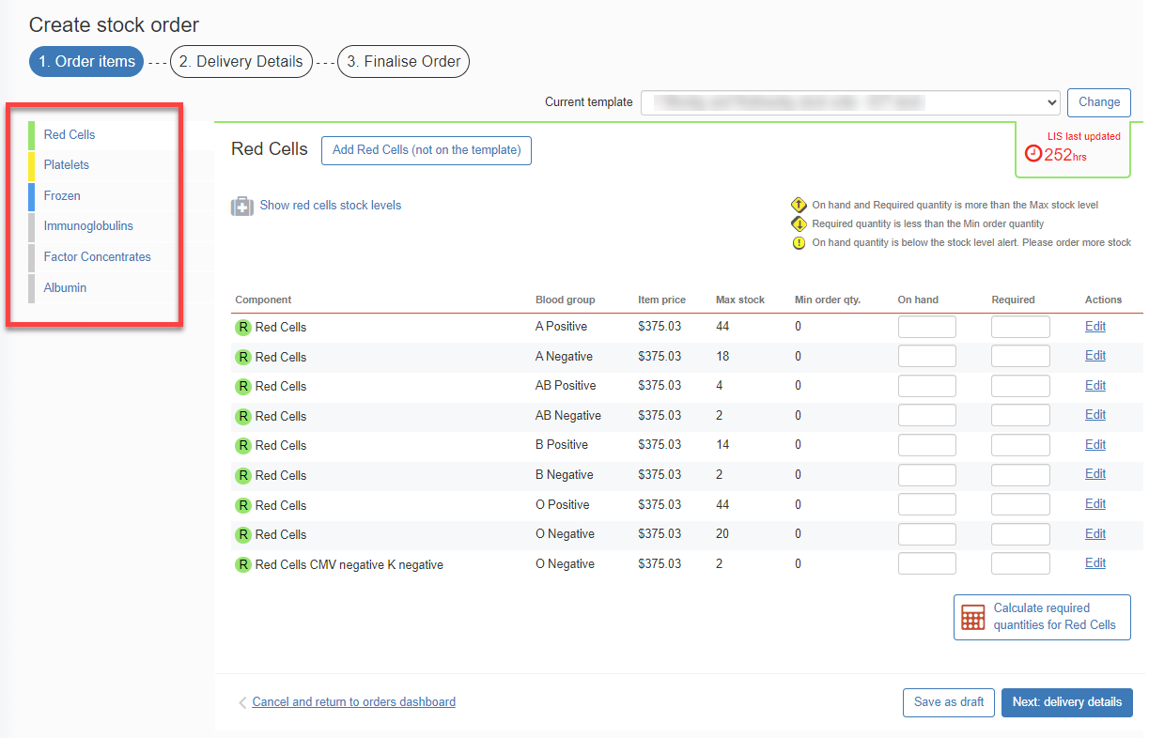

Please note: Components or Products that are not on the template can be added by selecting the Add Stock Type (not on the template) button.

- Enter the Required amount and then click Next: delivery details.

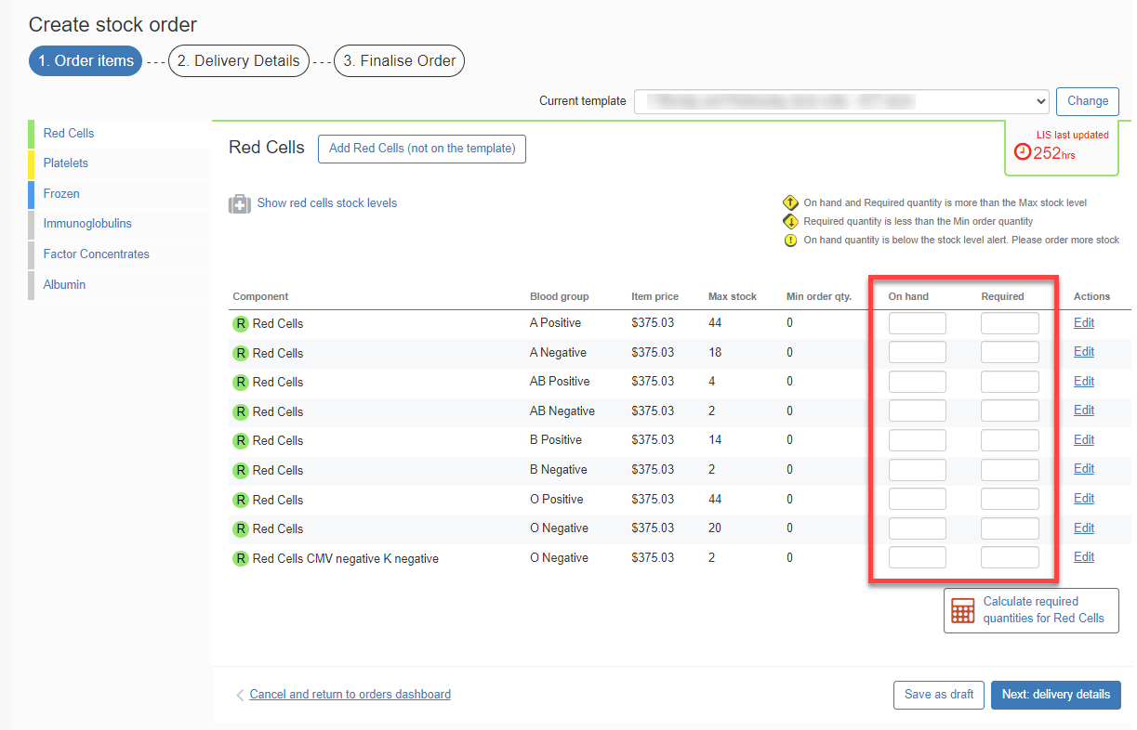

- Enter the order Priority, Delivery details and add any relevant order/delivery comments by selecting the Add comments button.

When placing a Stock Order with a Priority of:
- Routine the system will automatically select the next available date and time for dispatch based on Lifeblood’s distribution run schedule and the time that the order needs to be placed by.
Please note: You will have the option to select a later dispatch date and time in line with the distribution run schedule or you can Specify date and time required.
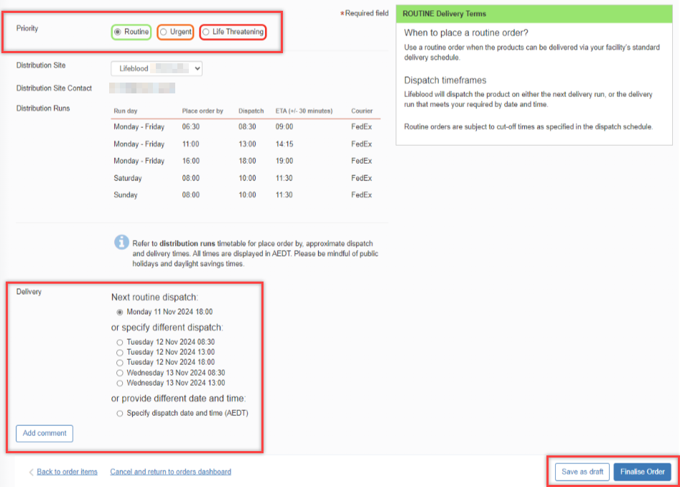
Please note: If you are in a rural/remote area, options for the next routine dispatch will not show and you will need to Specify required date and time.
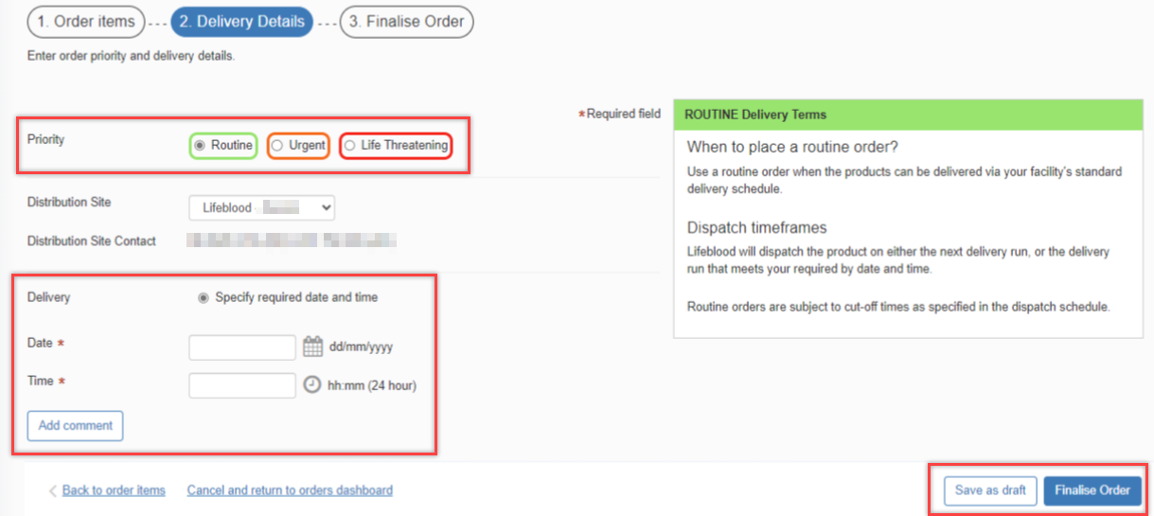
- Urgent the system will automatically select the Delivery option Ready for dispatch within 60 minutes of receipt.
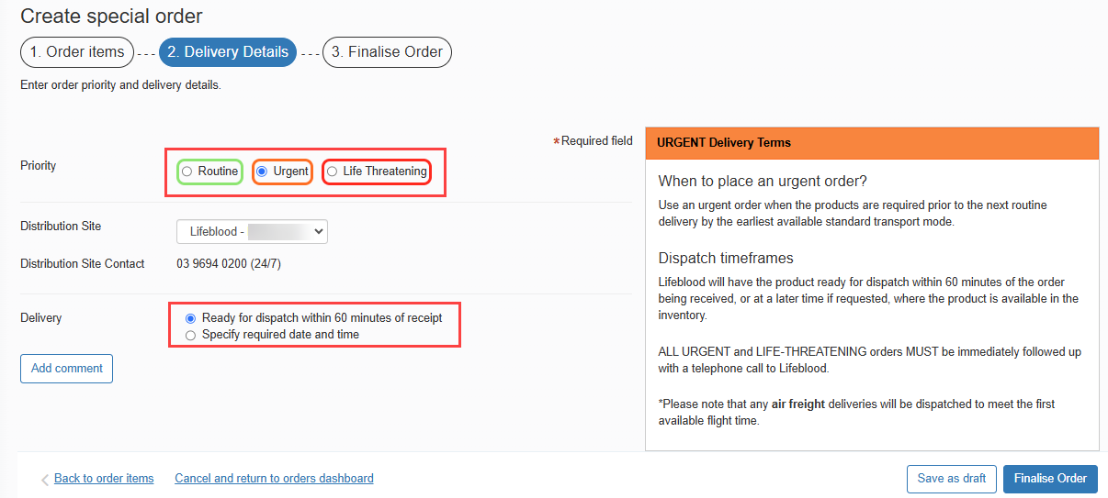
- Life Threatening the system will not provide any Delivery option and will require a phone call to your local Lifeblood CSD.
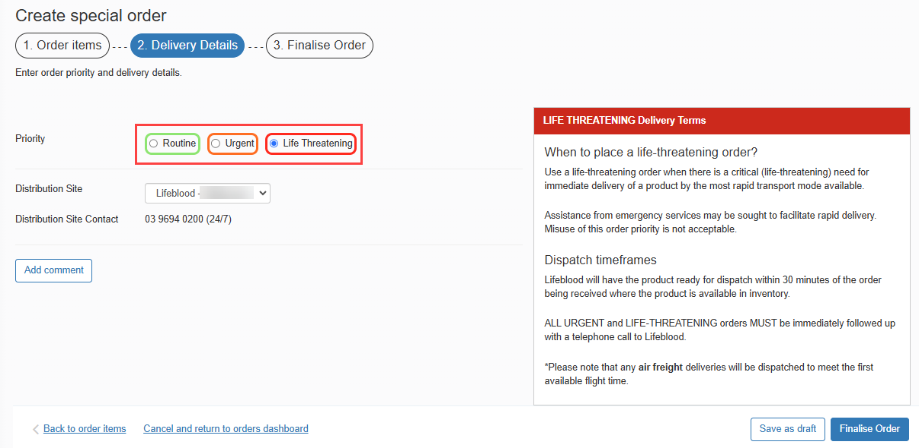

Once complete, select the Finalise Order button.

Please note: If you wish to edit the order, select the Back to order items hyperlink found in the bottom left corner of the tab and amend the order as necessary.
Please note: When placing an Urgent or Life-Threatening order, a pop up will appear. Select Yes to confirm you would like to change the priority to Urgent or Life Threatening.

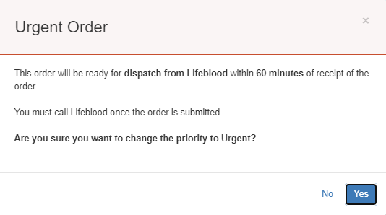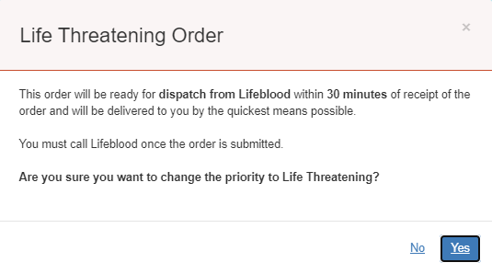

- Select the Send order button to finalise and send the order to the Lifeblood CSD site.
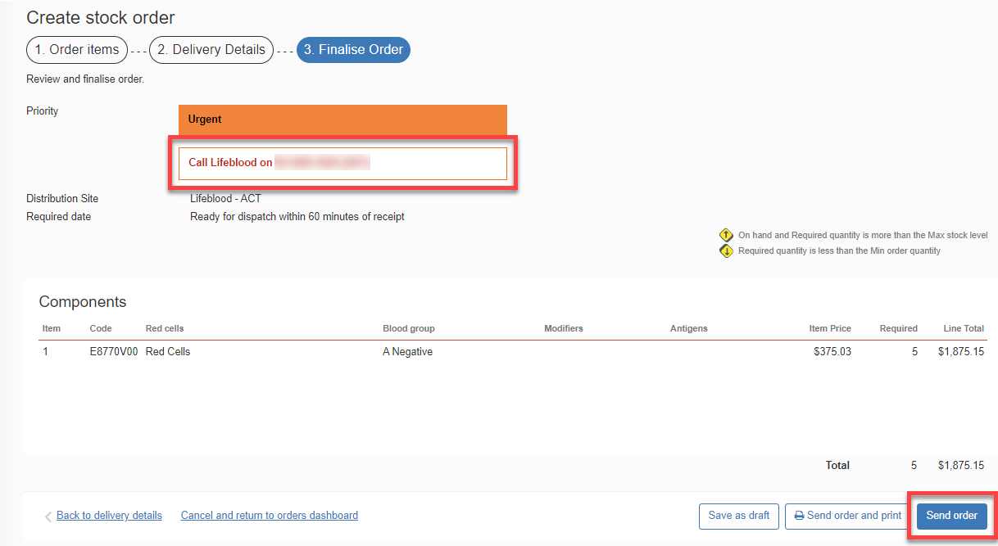
Please note: If your order is Urgent or Life Threatening, you MUST select the appropriate priority in Step 6. Do not write the priority in the comments box. All Urgent or Life Threatening orders MUST be followed up with a phone call to your local Lifeblood CSD site.
Please note: When the selected distribution run is no longer available due to missing the cut-off time, a red error message will be displayed at the top of the page. The error message is as follows

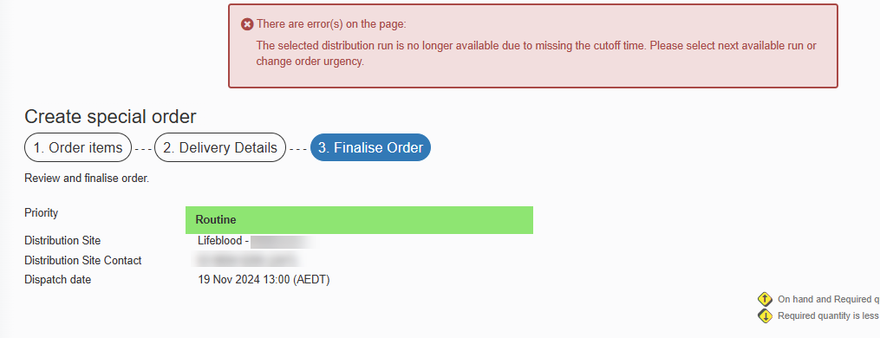

- Once the order has been sent to Lifeblood, it will remain under the Active orders section until all issue notes linked to the order are receipted. Once all components/products have been physically received, the order can be finalised in BloodNet.
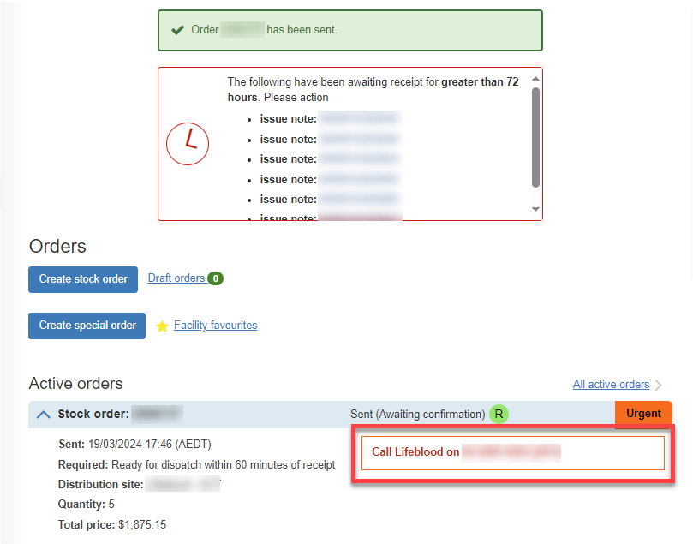

The Stock order has been sent to your local Lifeblood distribution site.

