Dispensing from a Dispense Request
This tip sheet outlines how to dispense a dose of immunoglobulin (Ig) in BloodNet directly from a dispense request. All Ig dispenses must be recorded in BloodNet.
Dispensing from a Dispense Request
- From the BloodNet homepage, click the ‘Dispense requests’ link in the ‘Authorisation’ tile.
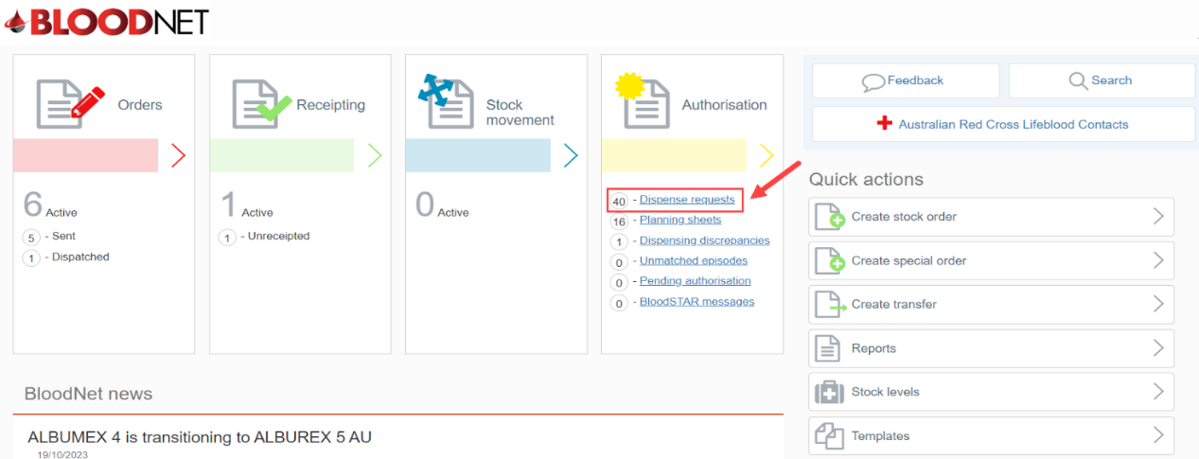

- A page will open with a list of ‘All dispense requests’ available for actioning by the dispensing facility.
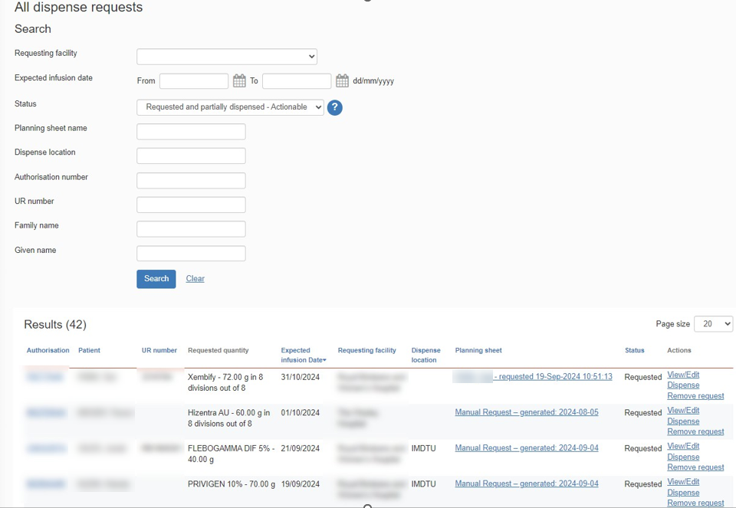

- Either:
  - Search for the dispense request by entering the patient details into the search fields and clicking the ‘Search’ button. Once the patient has been located, click the ‘Dispense’ link, or
  - Click the ‘Dispense’ link directly from the ‘All dispense requests’ page.

Please Note: There are also links to ‘View/Edit’ the request or ‘Remove request’.
Please Note: If there is no dispense request available, refer to the BloodNet tip sheet ‘Create a dispense from an authorisation record’.
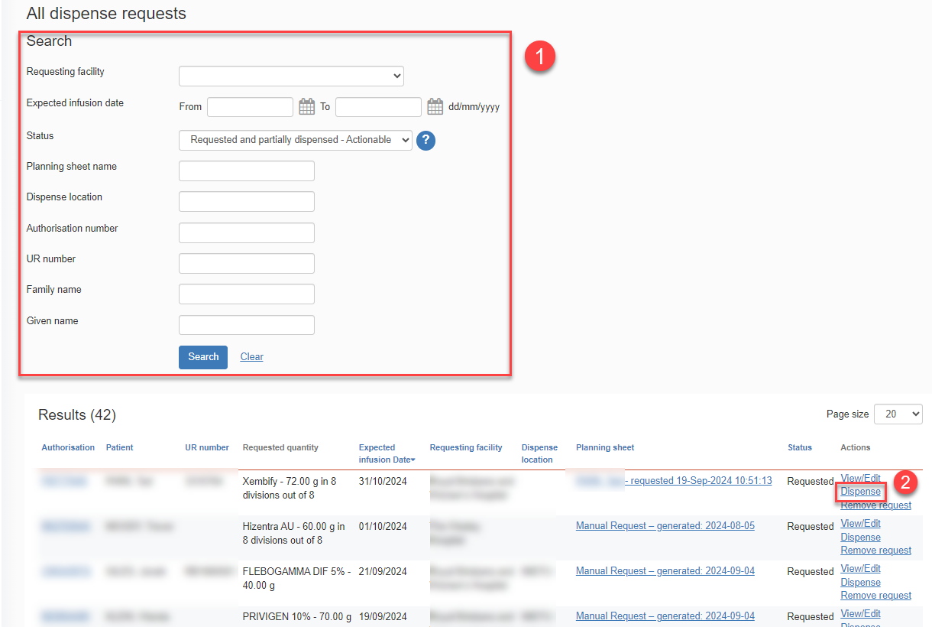

- On the ‘New dispense episode’ page, enter the ‘Dispense Date’ and ‘Dispense time’.

- Scan or enter the lot number/s and Quantity of product being dispensed in the blue box on the right side of the page and click the ‘Add item’ button.

- Enter the ‘Expected infusion date’. This is the date the patient is expected to receive the infusion.
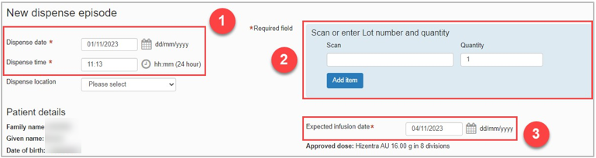

Please note: If you wish to edit the order, select the Back to order items hyperlink found in the bottom left corner of the tab and amend the order as necessary.

- Click the ‘Save Dispense episode’ button at the bottom right of the page to record the dispense.
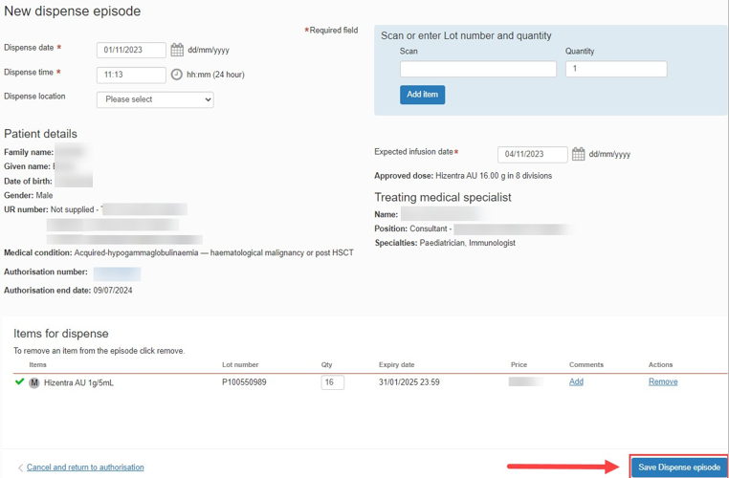

Please note: A warning message will appear if the ‘Dispensed product does not match authorised product.’ If the incorrect product is dispensed, this will cause a Dispense Discrepancy.
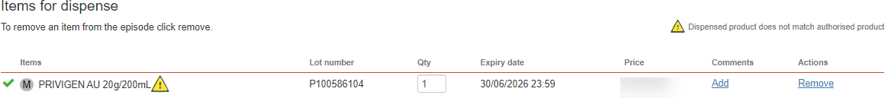

- The dispense episode has now been saved.
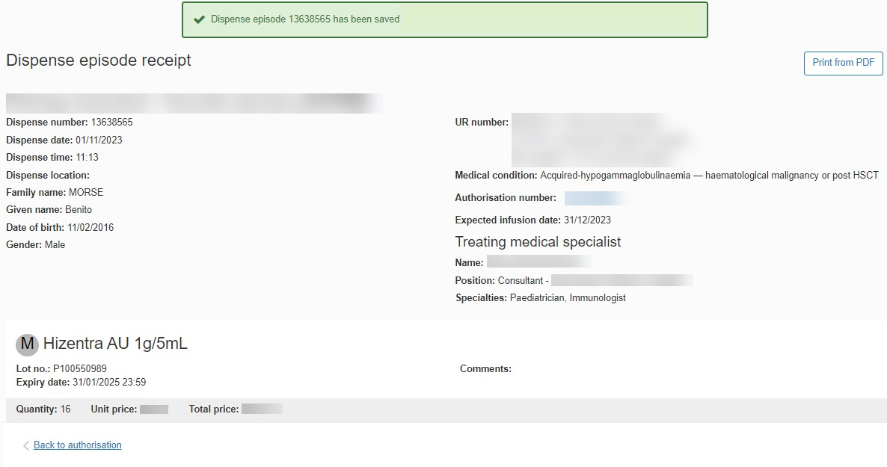

Please note: A receipt of the dispense episode can be printed by clicking the ‘Print from PDF’ button on the right of the page.

