Deactivating and Editing Access in BloodSTAR
As a user of BloodSTAR, you can deactivate your role if you no longer require access to a facility as well as edit your contact details for each facility you have access to.
Deactivating Access
- Log into BloodPortal with your BloodPortal Username and Password, then click into BloodSTAR.

- Select My Account located above the BloodSTAR ribbon.
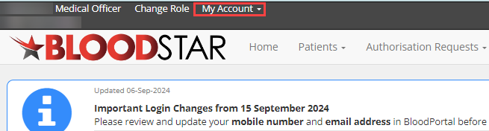

- Select My Contact Details to display all facilities you have access to.
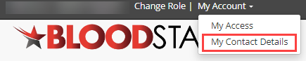

- Locate the position and facility you want to deactivate then select the Deactivate Role checkbox.
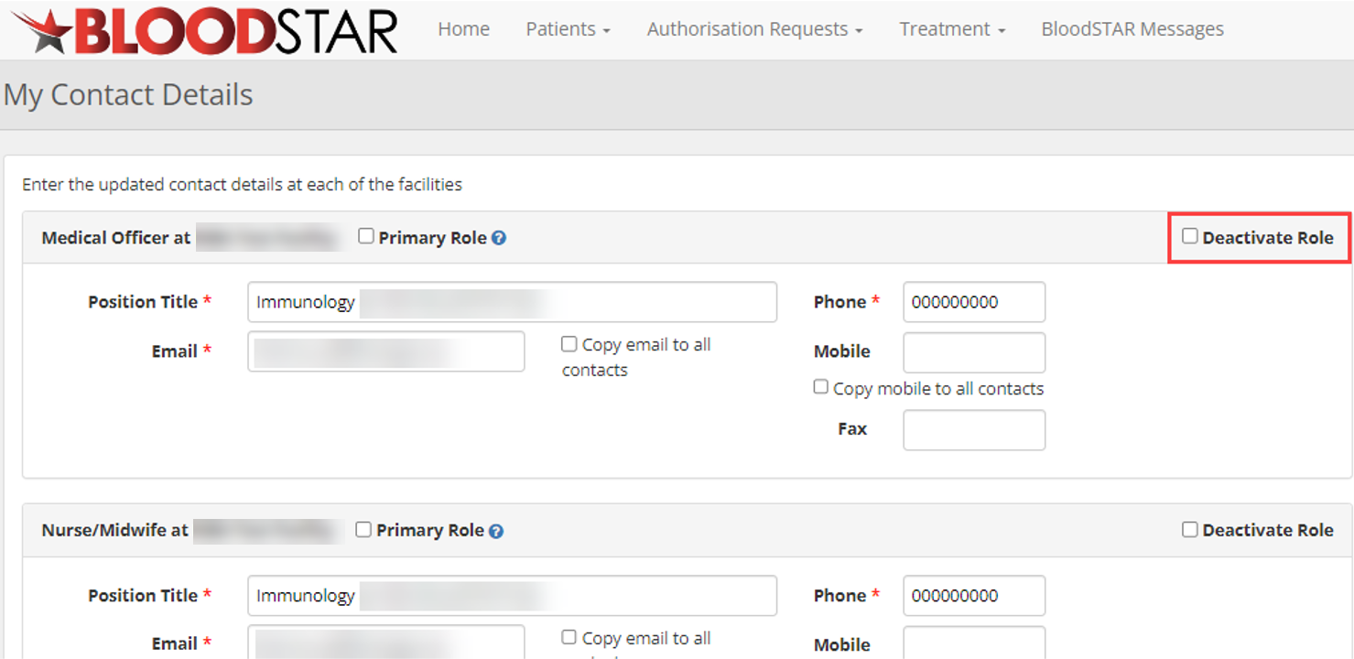

- In the Deactivation Reason, enter in the mandatory field a reason for deactivating role. Once complete, select Save.
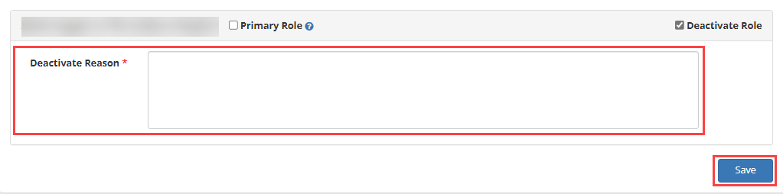

Please note: If Medical Officers have patients listed under their care, they will be displayed in a yellow alert notification.
Medical Officers must transition the care of these patients to another Medical Officer otherwise, they will continue to receive notifications relating to these patients.

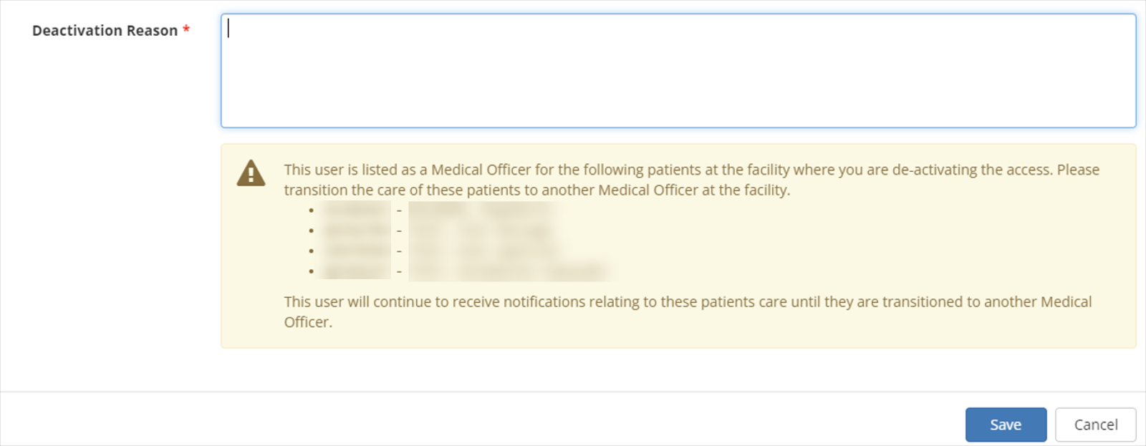

- The role will be deactivated, and a notification will display contacts have been updated.

Editing Access Details
- Log into BloodPortal with your BloodPortal Username and Password, then click into BloodSTAR.

- Select My Account located above the BloodSTAR ribbon.

- Select My Contact Details to display all facilities you have access to.

- Edit the relevant details and select Save to finalise.
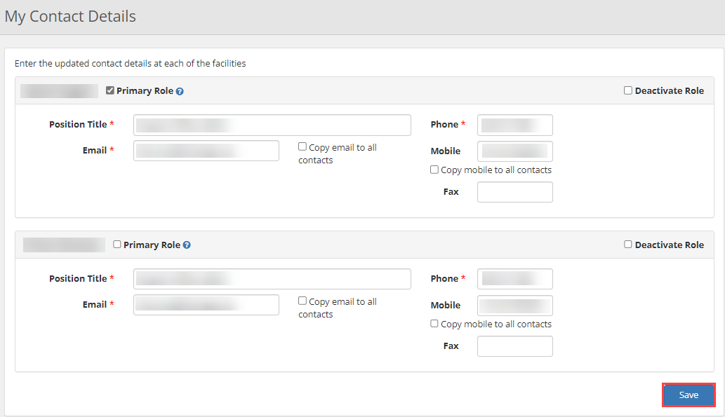

Deactivating and Editing a User’s Access in BloodSTAR – Facility Administrator Role
BloodSTAR Facility Administrators are nominated staff members within a hospital/facility with the authority to deactivate and edit a BloodSTAR user’s access.
Deactivating Access
- Log into BloodPortal with your BloodPortal Username and Password, then click into BloodSTAR.
- Select User Role Management.
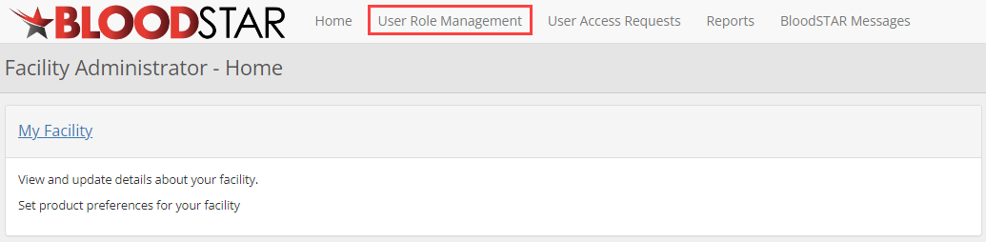

- Using filters, search for the user you would like to deactivate. Once you have located user, select View.
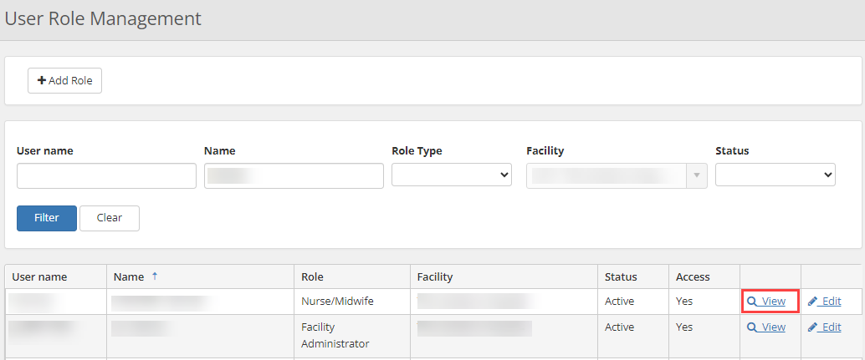

- Select Deactivate.
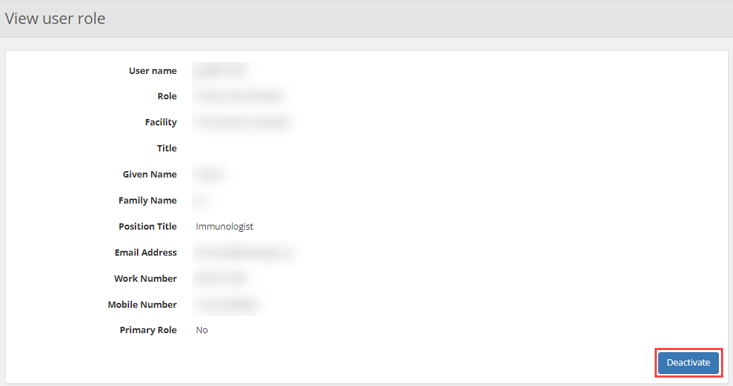
- Enter a reason for deactivating the user’s role. Once complete, select Save.
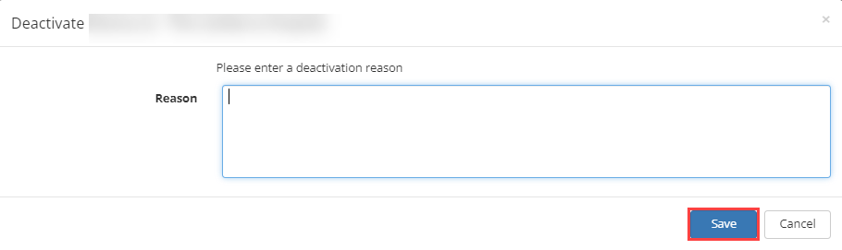

Please note: If Medical Officers have patients listed under their care, they will be displayed in a yellow alert notification.
Medical Officers must transition the care of these patients to another Medical Officer otherwise, they will continue to receive notifications relating to these patients.

Editing a User’s Access Details
- Log into BloodPortal with your BloodPortal Username and Password, then click into BloodSTAR.

- Select User Role Management.

- Using filters, search for the user you would like to deactivate. Once you have located user, select Edit. 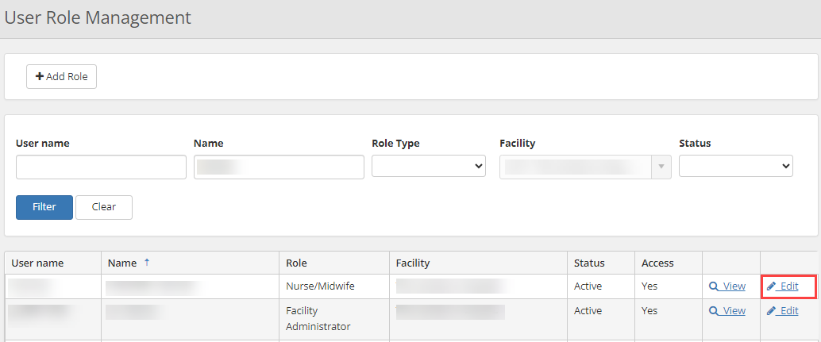

- Edit the user’s position title, email or phone number then Select Save.

- A notification will display contacts have been updated.

