Dose Change Requests

If a dose and/or product change is required, a request can be submitted through a patient’s Current Authorisation on the Patient Record page. BloodSTAR will prompt an Authoriser to review and action, as per the existing process.
In the scenario a different product than what has been allocated in BloodSTAR is requested, a clinically valid reason must be provided. A request for a different product is closely reviewed by Lifeblood Authorisers and may not be approved if clinical justification is not provided.

Requesting a Dose Change
- From either the home page, My Authorised Patients, or Authorisation Requests, select the patient that requires the change. Under the Patient column, select the patient’s name.

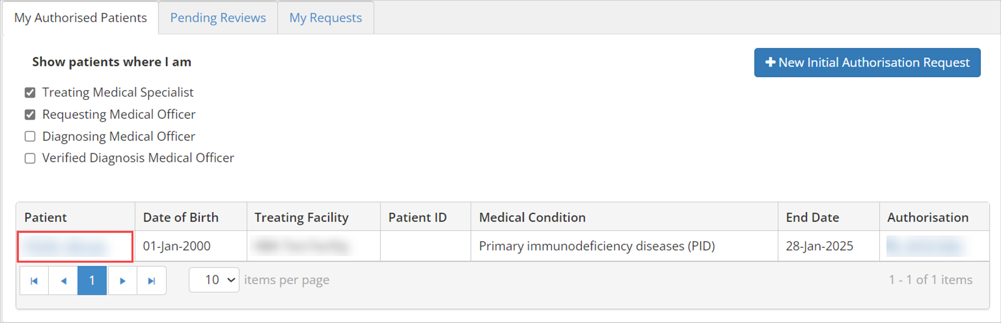
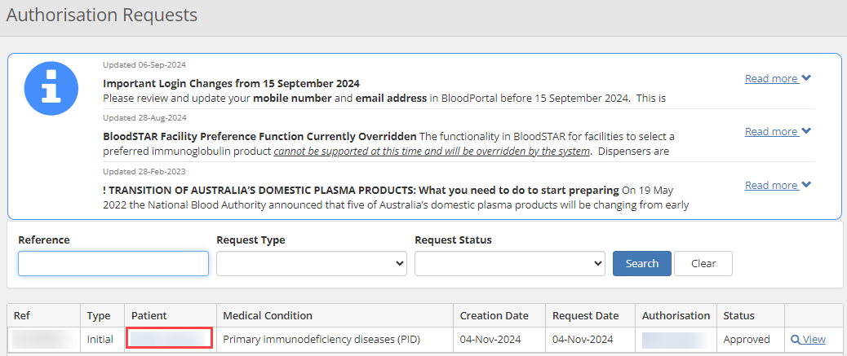

- Scroll down to view the details in Current Authorisation and under Regimen, locate dose to be changed. Under the Action column, select + Request Change.
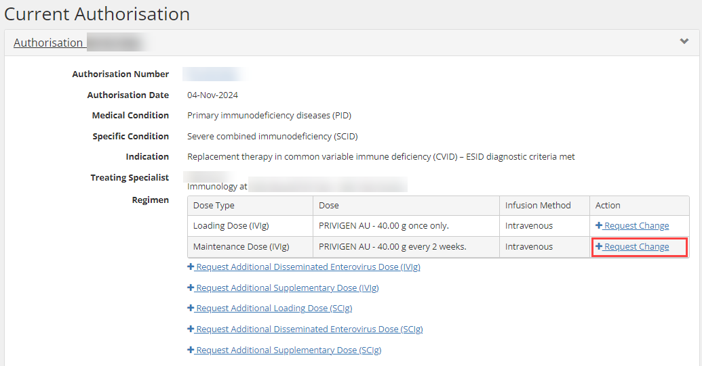
- On the Dose Change Request Form, select the Urgency in the drop-down box.

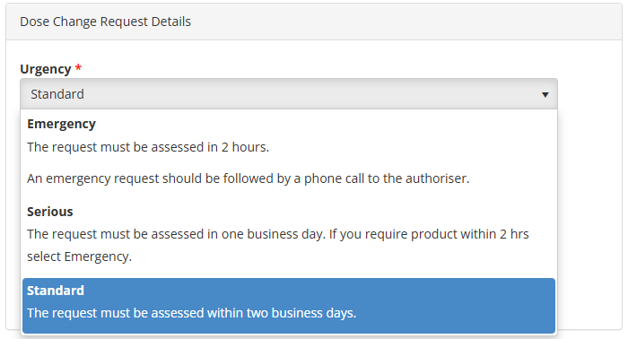

Please note: If the urgency is Emergency, it must be accompanied by a phone call to Lifeblood on the relevant phone number provided.

- In the Dose section, enter in all the mandatory fields with the new proposed changes.

Please note: the system will display the patients Last Recorded Weight if there was a previous authorisation request.

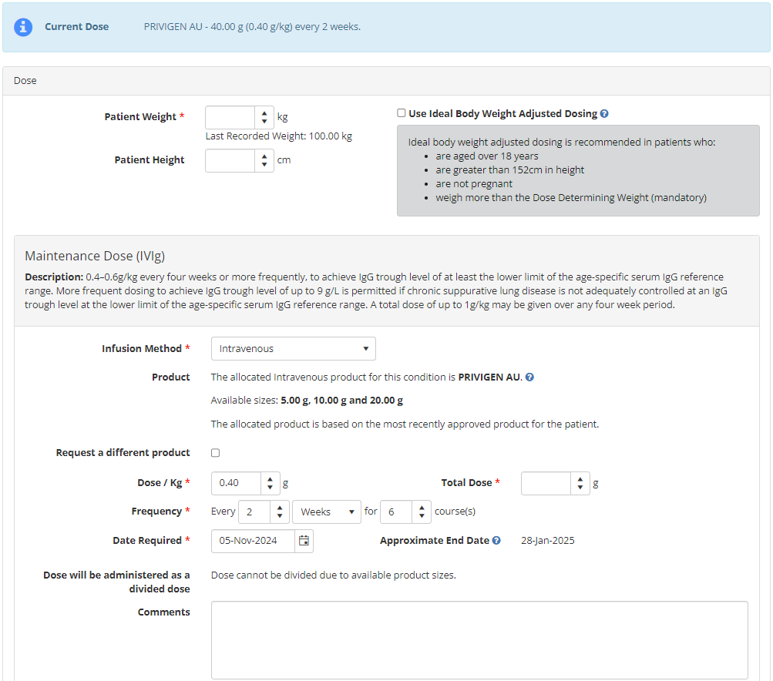

- Once complete, enter in mandatory fields in Submission including Reason for Dose Change, contact details and ticking the box to indicate all information submitted is accurate and true. Select Submit.
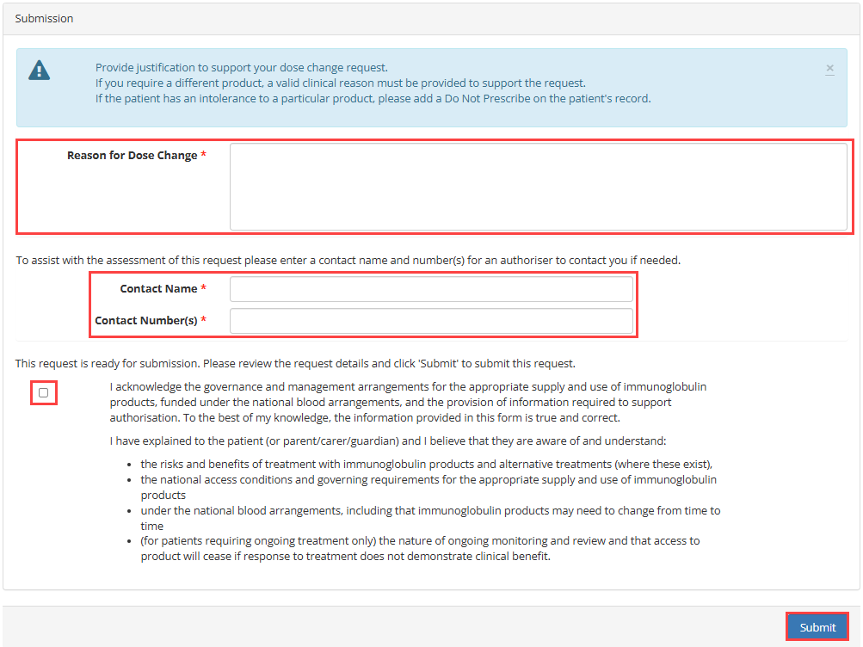

- The request will be sent to Lifeblood Authorisers for review.

Please note: For urgent approval, call Lifeblood Authorisers on 1300 707 755.

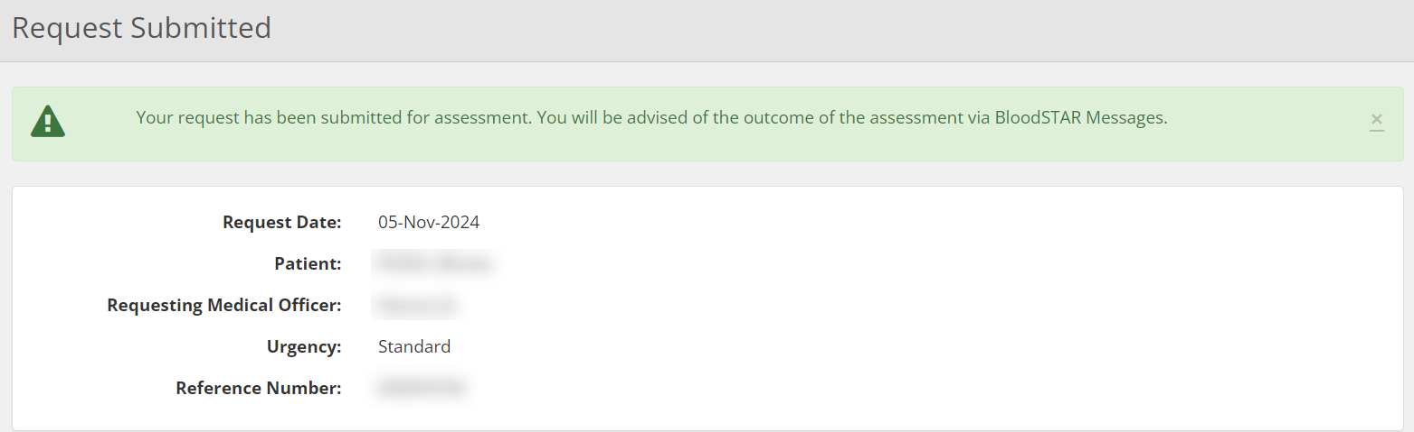

- Once assessed, the outcome will be displayed in BloodSTAR Messages.

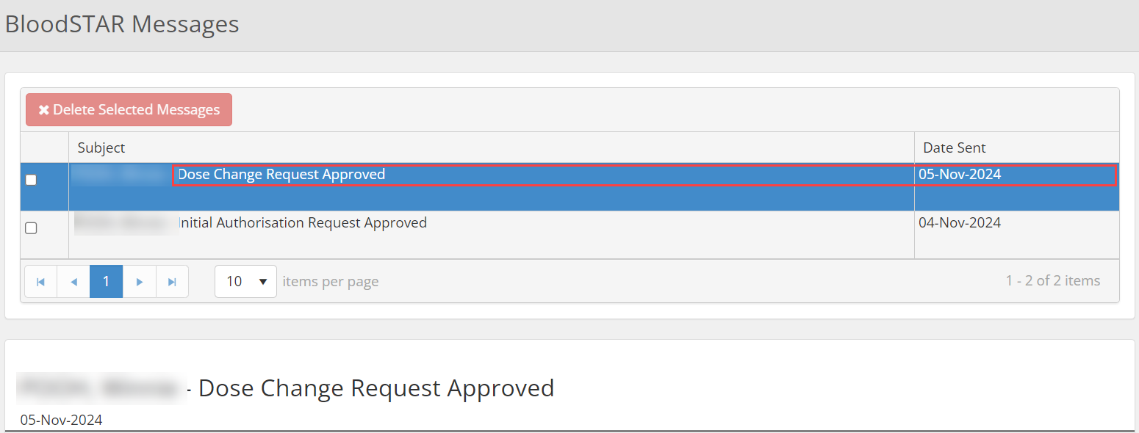

Type of Dose Changes

Change of Infusion Method
If the reason is to change the patient’s infusion method, i.e., IVIg to SCIg or SCIg to IVIg, tick the check box displayed below and proceed to the Dose section.

IVIg to SCIg:

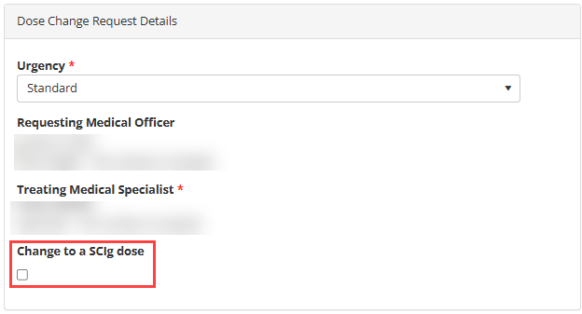

SCIg to IVIg:

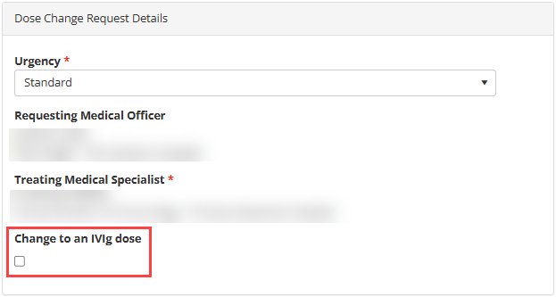

Change in Product Type
To change the allocated product, tick the box Request a different product.

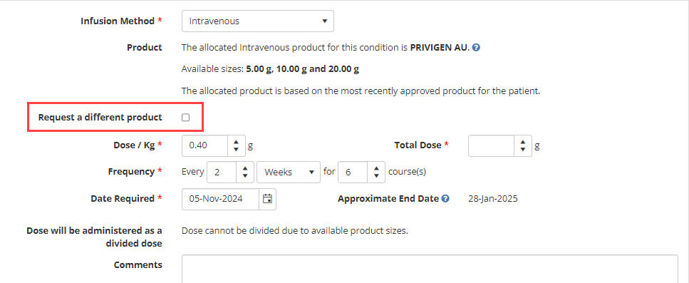

A yellow alert will pop-up allowing the option to select the Preferred Product in the drop-down box and a reason provided for the change.

Note: The reason must be clinically justified otherwise, the request may not be approved.

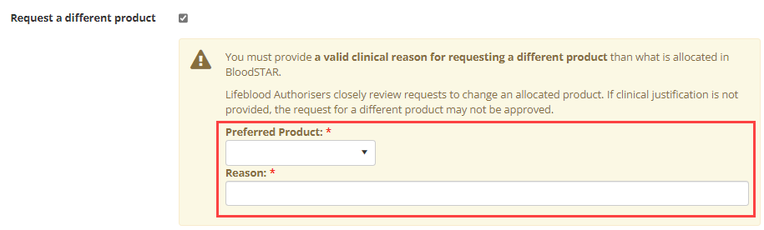

Change in Dose Amount
To change the dose amount, enter in the Dose / Kg section.

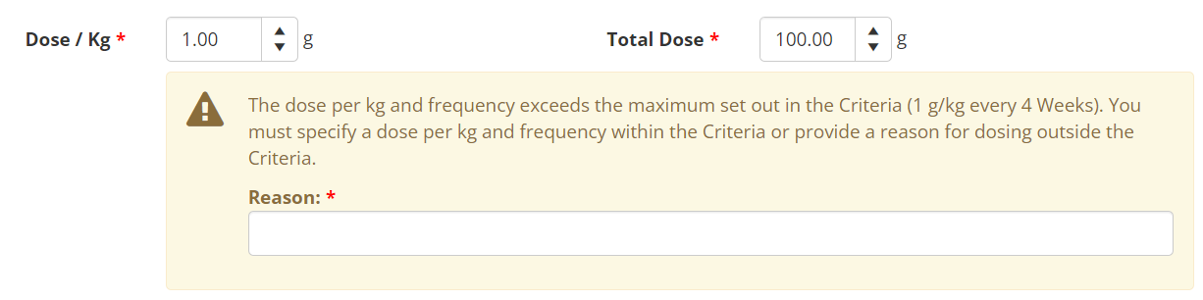

Please Note: If the dose exceeds the amount set out in the criteria, a yellow alert will pop-up and a clinical reason is required.

Change in Frequency and Number of Courses
To change the frequency and/or number of courses, enter in the Frequency section.

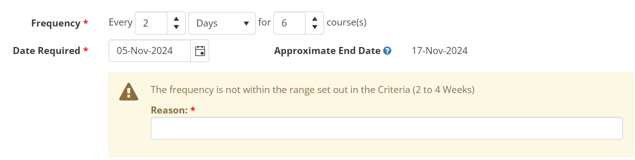
Please note: If the dose frequency is not within the range set out in the criteria, a yellow alert will pop-up and a clinical reason is required.

