Facility Administrator role
Reviewing BloodSTAR User Access Requests

BloodSTAR Facility Administrators are designated staff members within a hospital/facility with the authority to approve BloodSTAR access requests for the hospital’s Medical Officers and Nurses.
What is the Facility Administrators role?
- Verify that Medical Officers and Nurses are employed or practice within their facility.
- Confirm that the user holds a suitable position for the role that has been requested.

- Go to https://portal.blood.gov.au/ and Login with your BloodPortal Username and Password. Alternatively go to www. blood.gov.au and click on ‘Blood Portal’.

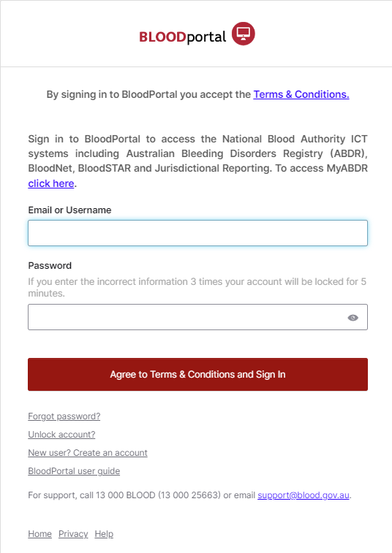

- If you have access to multiple roles in BloodSTAR ensure you are logged in with your Facility Administrator role. Your role will be displayed at the top of the screen next to your name. If you need to change roles click on Change Role at the top of your screen.

- From the Facility Administrator home page click on User Access Requests.
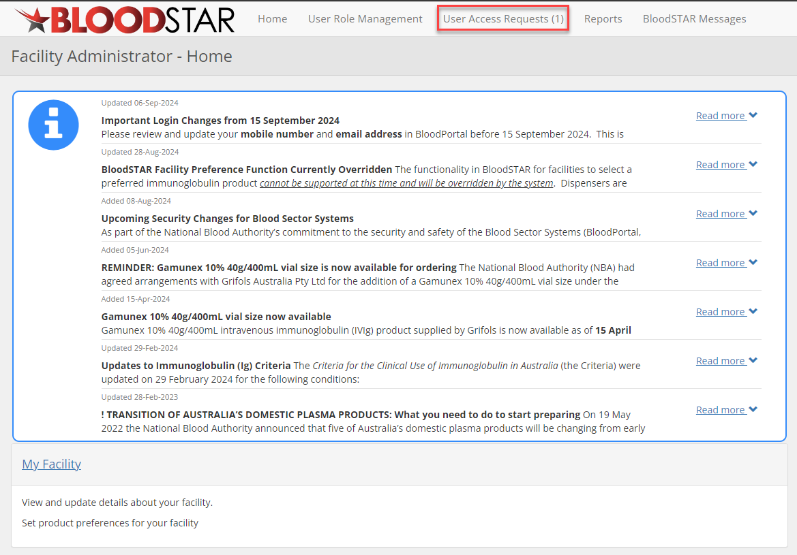

- You will see a list of pending access requests at your facility. Click on Approve/Reject to review the User Access Request.
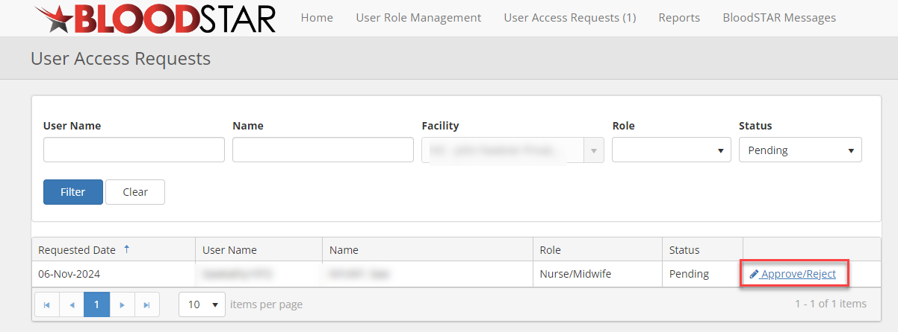

- Verify that the user is employed or practices within the facility.

- Confirm that the user holds a suitable position and registration for the requested role.

 | Nurses that have a AHPRA endorsement as an advanced practitioner can request access for the Medical Officer role.

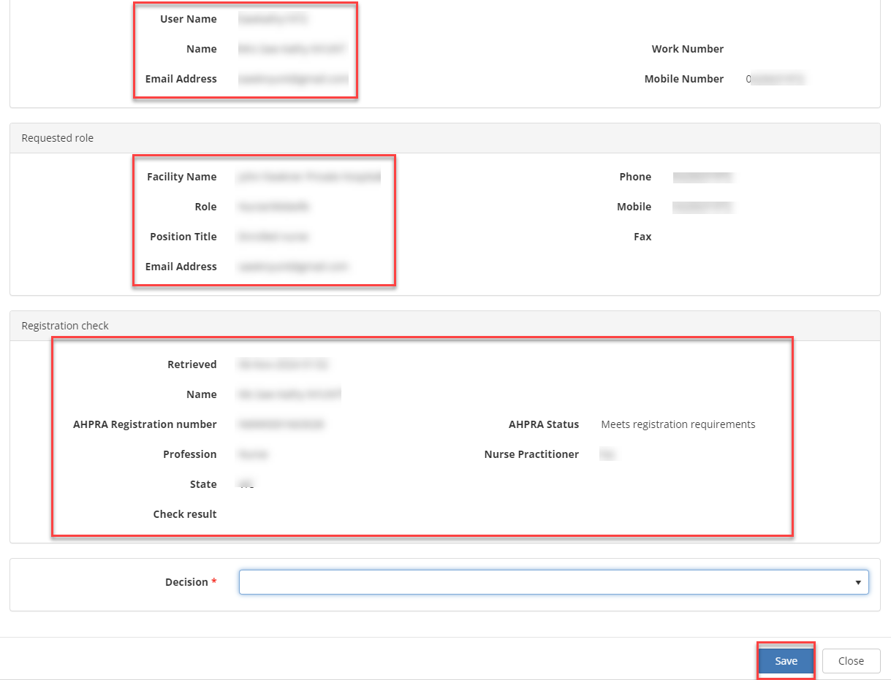

- Complete the Approval Declaration to Approve or Reject as appropriate and then click the Save
button at the bottom right of your screen.

