Submitting Review Outcomes and Creating a Continuing Authorisation Request
If a patient requires a Continuing Treatment, a Review or to Cease Treatment for Immunoglobulin (Ig), a Review Outcomes Form will need to be submitted through a Record Review.

The form can be found through the following methods:
- Home page under Pending Reviews tab
- Patient Record page under Current Authorisation
- View Authorisation page under Record Review tab
- BloodSTAR Messages page under Review Reminder

How to Navigate to the Review Outcome Form – Record Review
Option 1:
From the Home page, select the Pending Review tab. Select Record Review on the patient that requires the review.

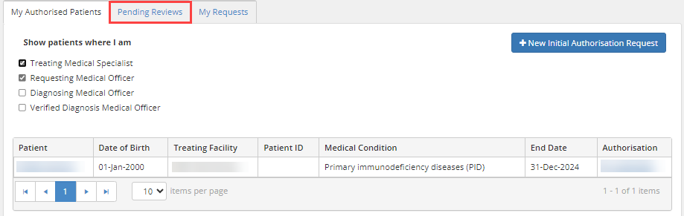
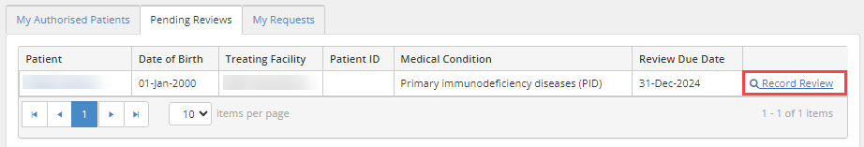

Option 2:
From the Patient Record page, scroll down to Current Authorisation and select Record Review on the bottom right-hand corner.

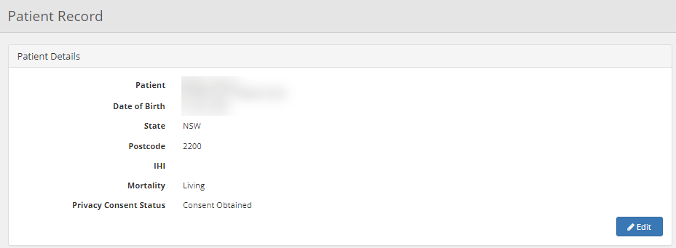
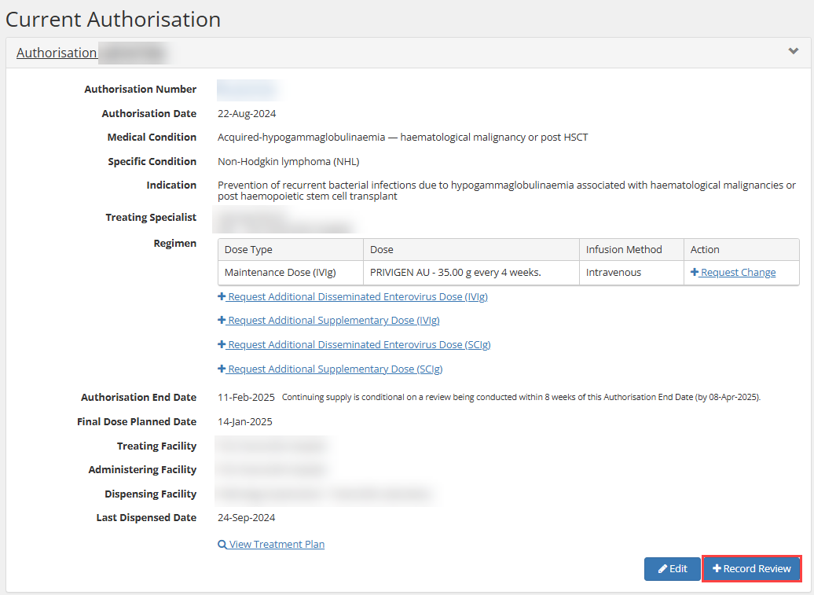

Option 3:
From the View Authorisation page, select the Record Review tab. Select + Record Review button.

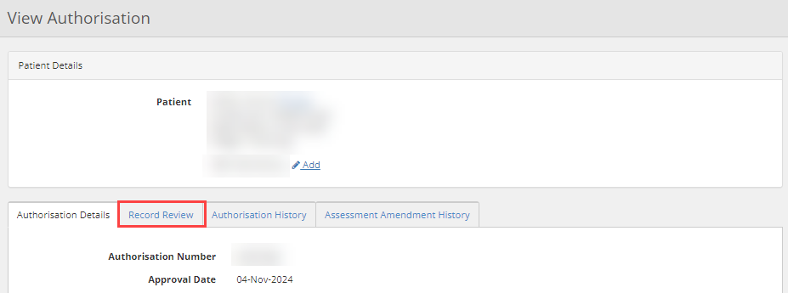
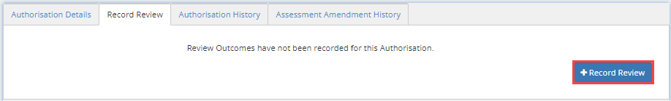

Option 4:
Once an approved Immunoglobulin (Ig) Authorisation is nearing or has just exceeded its expiry date, BloodSTAR will notify Medical Officers involved with the authorisation and prompt them to submit review outcomes and will provide the option to submit a Record Review Outcomes.

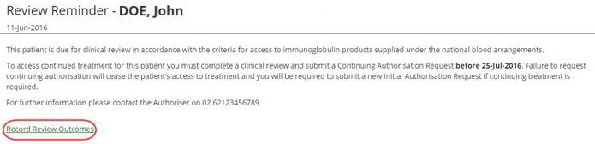

Before requesting for a continuing authorisation request, check there are no more remaining doses on the current treatment plan. If there are planned doses remaining, they will be deleted after a new continuing authorisation request is submitted.

 | Note: A request for continuing supply is conditional on a review being conducted within 8 weeks of the Authorisation End Date with specified date displayed in brackets.

Remaining doses can be checked through the following 3 options:

Check remaining doses for a patient’s authorisation
Option 1:
From the Patient Record page, scroll down to Current Authorisation under Final Dose Planned Date. This will also be displayed on the View Authorisation page.

This section will display either:
- A date which is based on the planned date or partially dispensed, or
- No remaining dose text will display if there are no remaining planned doses.

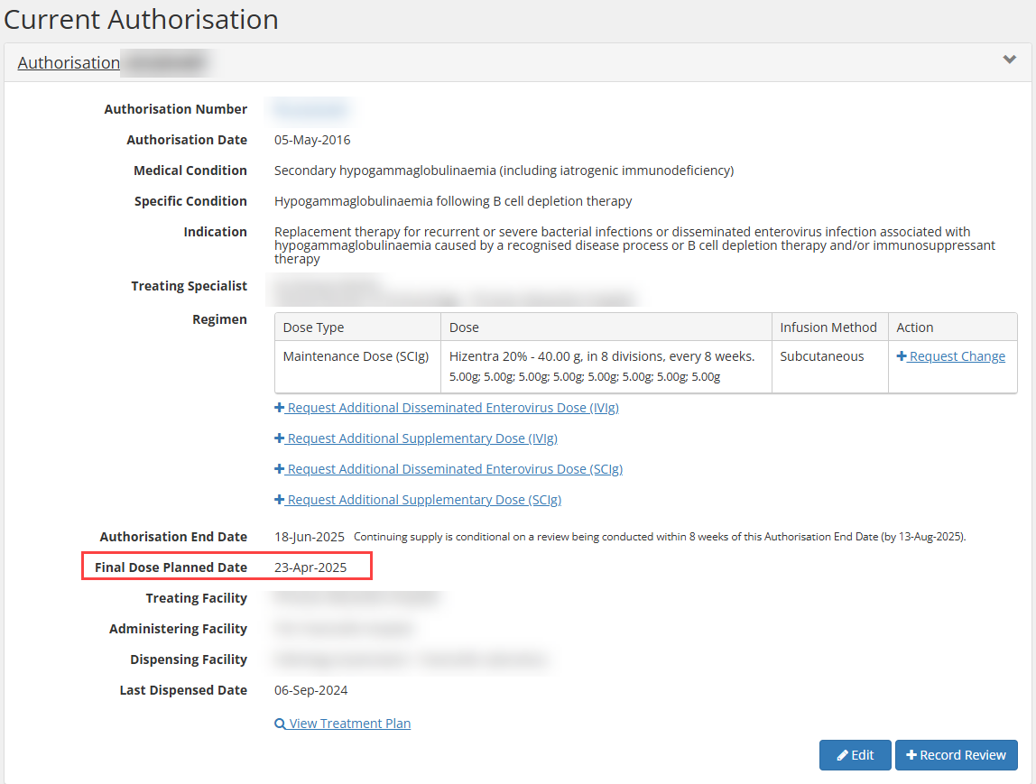

Option 2:
From the Patient Record page, scroll down to Current Authorisation select Treatment Plan hyperlink. The Treatment Plan will pop-up. Scroll down to the bottom where the final planned date will be displayed.

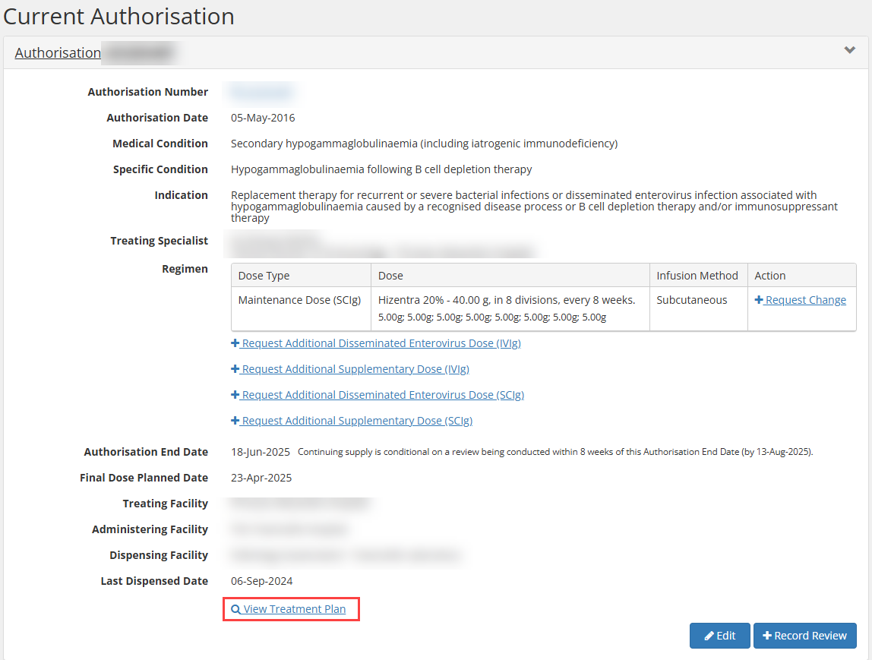

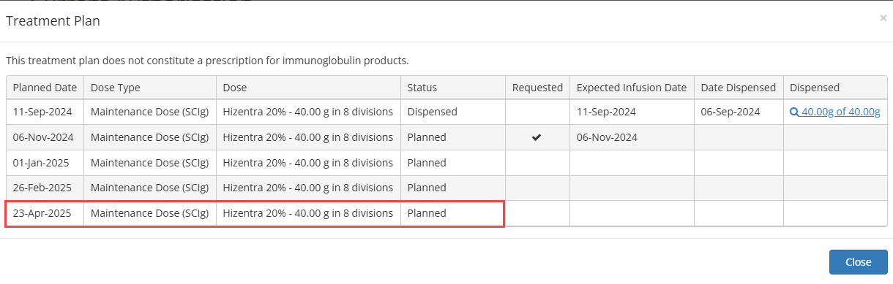

Option 3:
From the View Authorisation page, scroll down to the bottom of the Treatment Plan where the final planned date will be displayed.

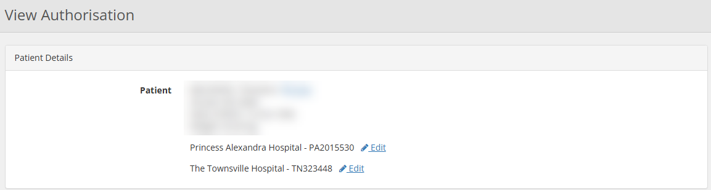

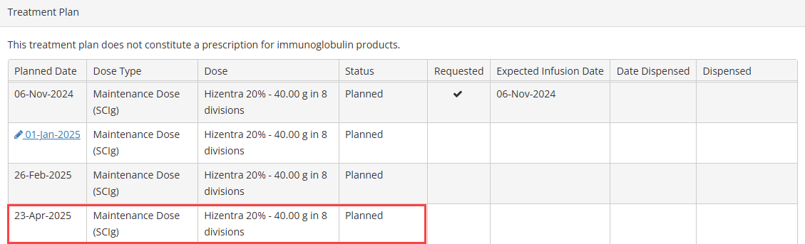

Submitting a Review Outcome Form – Requesting Continuing Treatment
- On the Review Outcome Form, fill in the Review Details, Review Criteria and select Request Continuing Treatment in the Review Outcome.

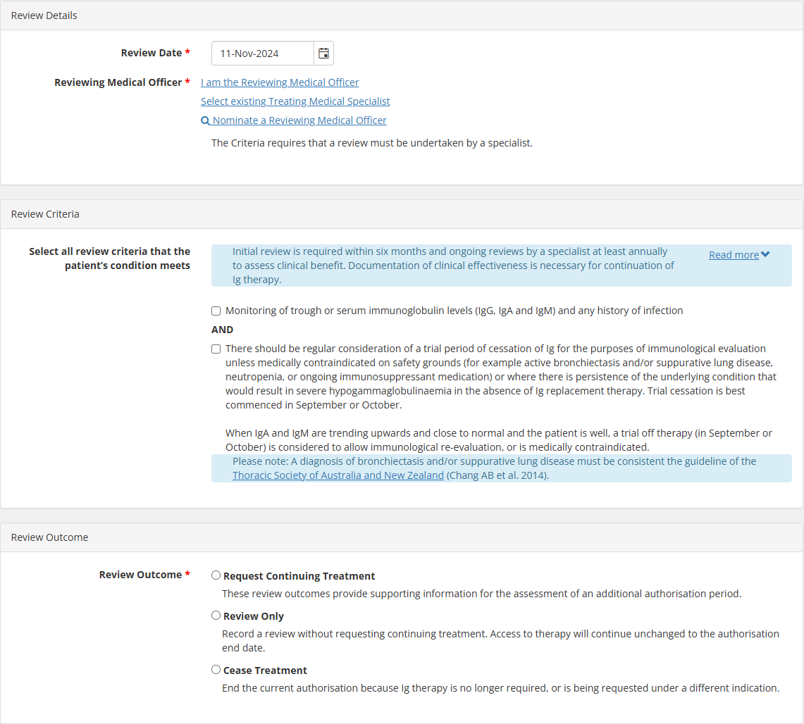

Note: When requesting continuing treatment, if no doses have been dispensed on the patient’s current authorisation, a blue notification will be displayed, and the option can’t be selected. The message is as follows.

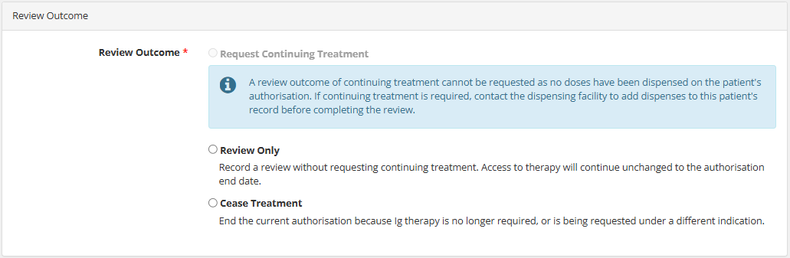

- The page will update, displaying the Continuing Authorisation Request.

Note: If there are planned doses remaining in the current treatment plan, it will be deleted and the Date Required can’t be selected before this date. A warning message will be displayed, and the message is as follows

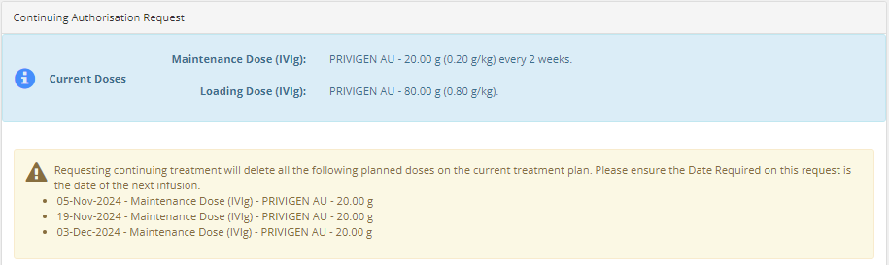
- Fill in all the relevant fields below.

Note: BloodSTAR will display the patients Last Recorded Weight if there was a previous authorisation request

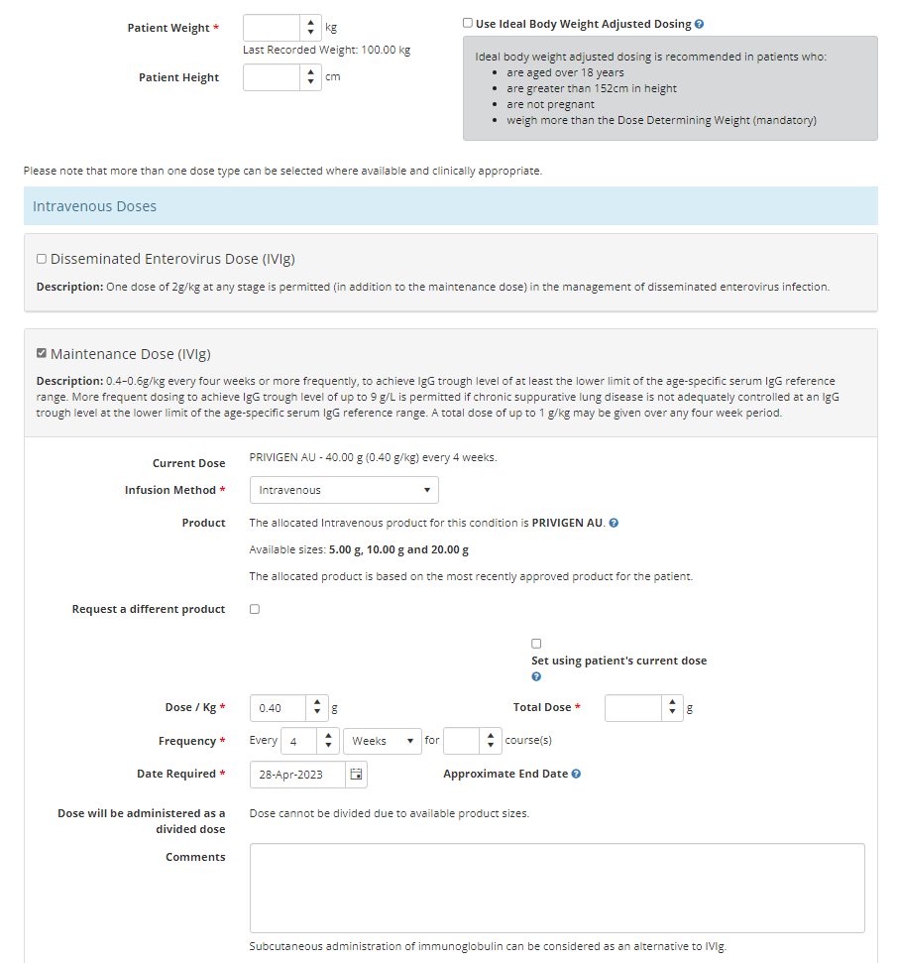

Note: The system will prepopulate the Date Required to be the same as the next planned date and display a message saying Date required matches the next planned date. There is no treatment gap.

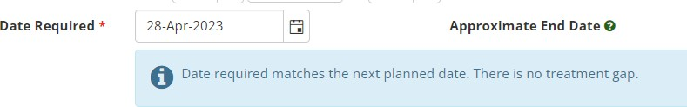
Note: If the date required is changed, creating a treatment gap, the system will display a pop-up message advising the date entered creates a treatment gap and will suggest an alternative treatment date to avoid a gap in treatment. The suggested date is based on the frequency selected in the new request.

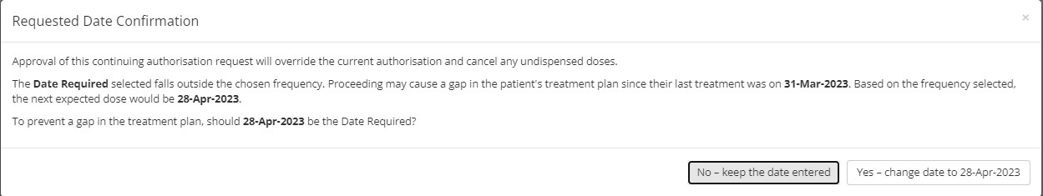

There are two ways of recording patient review outcomes.
Option A: If you select No – keep the date entered, the date you entered (e.g. 20 May 2023) will become the date of the first approved dose for this Continuing Authorisation Request. This may cause a gap in the treatment as specified in the pop-up.

Option B: If you select Yes – change date to [Insert date], the date suggested by the system (e.g. 28 April 2023, in the example above) will be the date of the first dose for this Continuing Authorisation Request. This function is designed to reduce the number of unintentional gaps in a patient’s treatment plan.

- Once complete, confirm contact details and tick the box to indicate all information submitted is accurate and true. Select Submit.

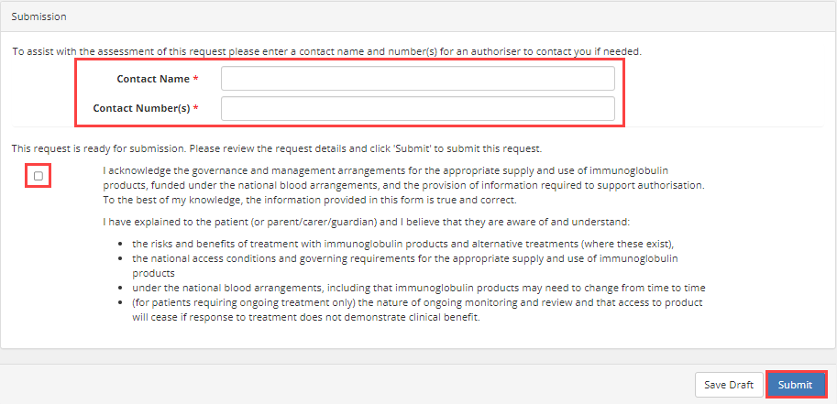

- A notification will acknowledge the request has been submitted for Lifeblood Authorisers to review, and the outcome will be displayed in BloodSTAR Messages.
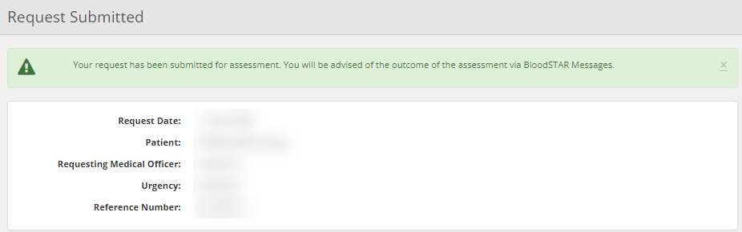

Medical Officers can review a patient’s authorisation without requesting for continuing treatment.

Review Outcome Form – Review Only
- On the Review Outcome Form, fill in the Review Details, Review Criteria and select Review Only in the Review Outcome.

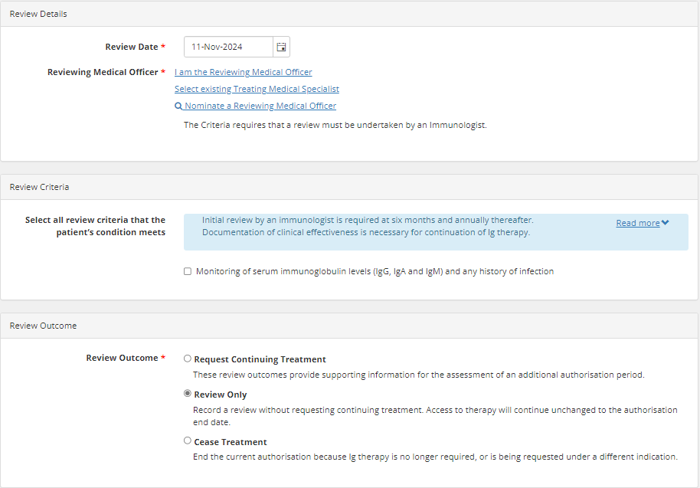

- Once complete, select Submit.

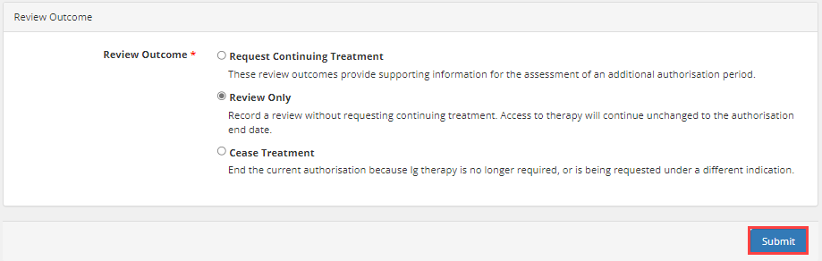

- A notification will acknowledge the request has been submitted and navigate back to the Patient Record page.

Medical Officers can cease a patient’s current authorisation if it is no longer required or is being requested under a different indication. You have the option to cease treatment immediately or to choose a later date.

Review Outcome Form – Cease Treatment
- On the Review Outcome Form, fill in the Review Details, Review Criteria and select Cease Treatment in the Review Outcome.
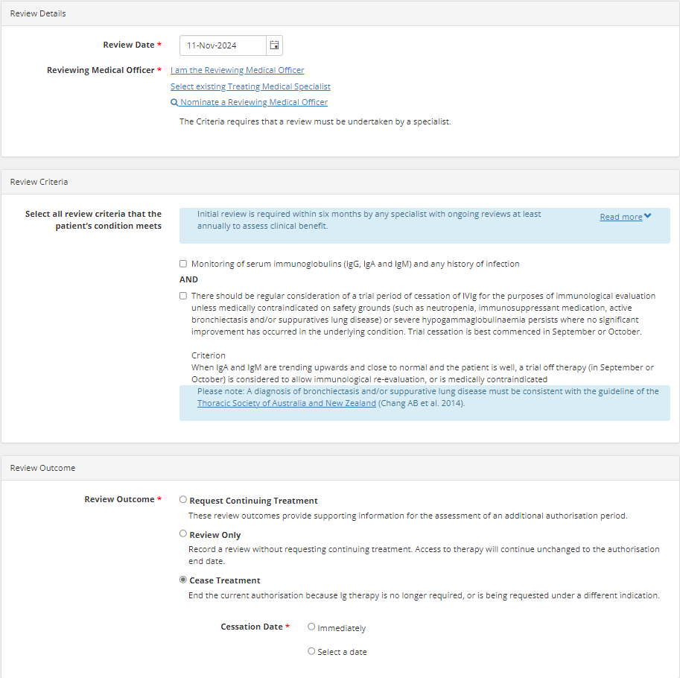

- Select an option in the Cessation Date.

Note: If there are planned doses remaining in the patient’s authorisation, ceasing treatment will cancel all the planned doses after the selected cessation date. A warning message will be displayed, and the message is as follows.

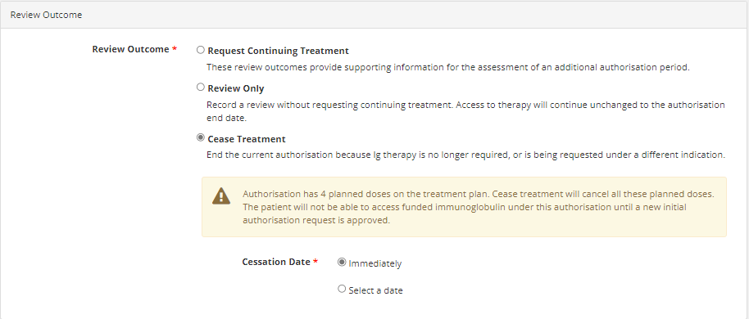

- A notification will acknowledge the request has been submitted and navigate back to the Patient Record page

- To view the ceased Authorisation, select Record Review under View Authorisation.
