User Registration and Role Request

BloodSTAR User Registration is a two-part process comprised of:

1. **BloodPortal User Registration** – Creating a single username and password for all NBA systems
2. **BloodSTAR Role Request** – Requesting a role and location for access to your facility including the status of access requests.
   1. Go to [www.blood.gov.au](http://www.blood.gov.au/) and click on Blood Portal login in the top right corner.



* 1. Login with your BloodPortal username and password. If you do not have an account already, please select the **New User? Create an account** link next to the login button.

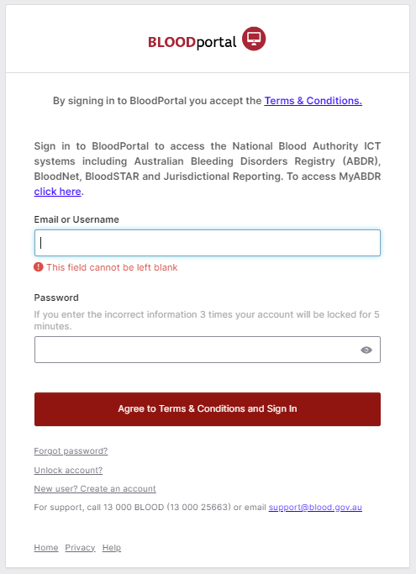

If you are creating a new account, please remember:

* + - You only need ***one*** BloodPortal account (covering all NBA systems) – if you practice in multiple locations, you can apply for access to specific applications at multiple locations using the one BloodPortal account.
    - Your mobile phone number and email address are used for automated password resets and must be unique.
    - If you are unable to register using your preferred email or mobile number it may be because you have an existing BloodPortal account. Please call the Support team.
  1. Click on the **BloodSTAR** tile.

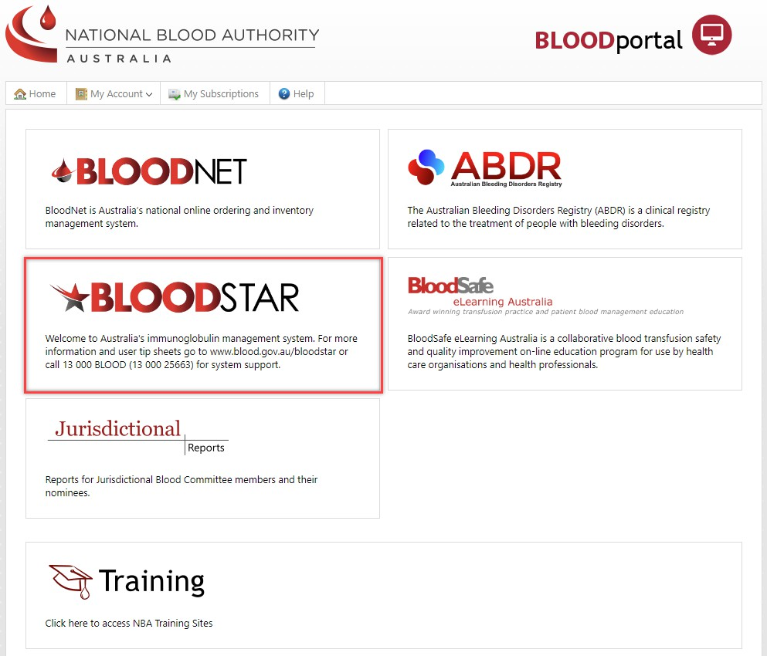

* 1. Select the **My Account** drop down menu and select **My Access** to request additional access.

* 1. Select **Add role to Access Request** which will prompt a pop-up window.

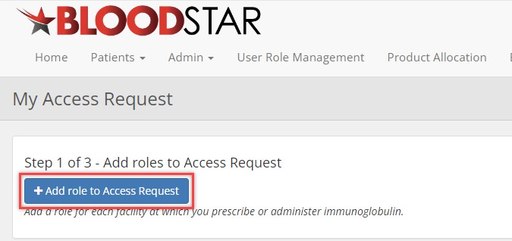

|  |  |
| --- | --- |
|  | If you are a Nurse Practitioner, you can submit an access request as a Medical Officer. |

* 1. All mandatory fields will need to be completed then select **Save**.

**Please note**: Once you’ve added your AHPRA number, BloodSTAR will confirm the details related to the number with you. If they are correct, select the checkbox confirming the AHPRA details are correct and belong to you.

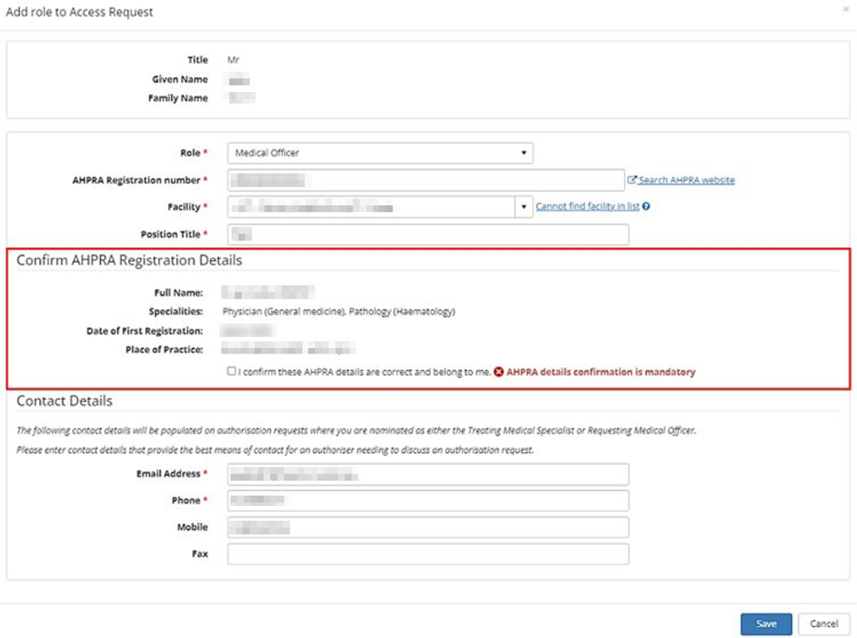



* 1. If you work at multiple locations, select the **Add role to Access Request** to submit another access request prior to submission. If you do not work at multiple locations, proceed to the next step.

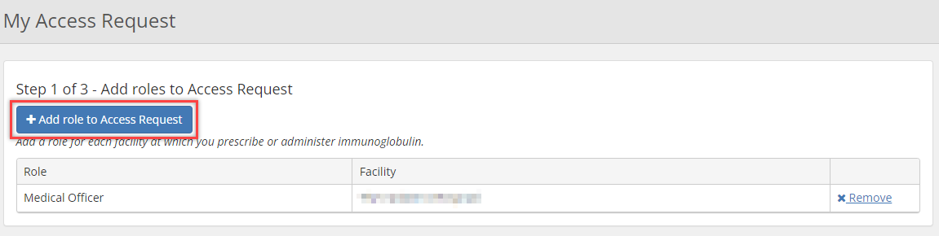

* 1. You *must read and accept* the BloodSTAR terms and conditions before the access request can be submitted. Once read and accepted, select **Submit**.

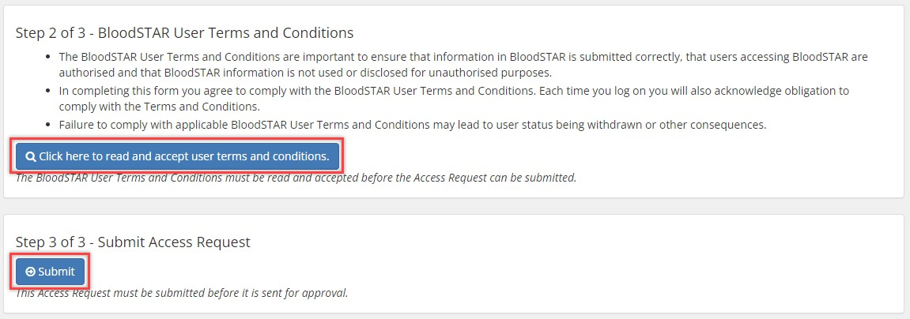

* 1. A green notification will show at the top of the Access Request History page to advise the access request/s has been submitted and pending the approval of your Facility Administrator (staff at your facility). You will receive an email when your request has been approved.

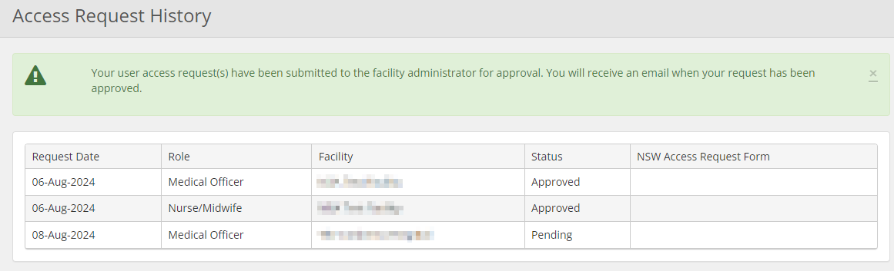

* 1. The Access Request History page will have a table of your access request history and the status for each request with notes.

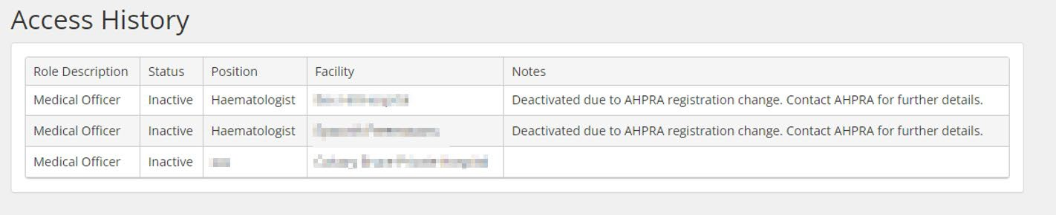

**Please note**: When a user’s AHPRA registration status changes to **unregistered**, the system will automatically deactivate the user’s roles.

For any AHPRA queries, please contact AHPRA on 1300 419 495.



If you are unable to follow up your request with your Facility Administrator, please call Support on 13 000 BLOOD (13 000 25663) for assistance with this process.