Blood Sector Systems

Release Notes

8 December 2024

# BloodSTAR Release 3.14

BloodSTAR version 3.14 has been released on **8 December 2024.** The following is a list of the updates to BloodSTAR.

4024 – Dose change requests outside the criteria require Authoriser approval

The following change has been made to the existing automatic approval rules for dose change requests.

When a dose change request is submitted, and the requested dose is outside of the criteria it will not be automatically approved and instead will be submitted to an Authoriser for approval.

A dose change request is outside the criteria when any of the following apply:

* The requested dose per kilo is higher than the maximum dose
* The requested dose is higher than the maximum dose per period per kilogram
* The frequency is more than allowed.

5971 – Dose change requests with no change to dose details

The following change has been made to the existing automatic approval rules for dose change requests.

When a dose change request is submitted, and the medical officer has not made any changes to the requested dose, frequency or number of courses the request will not be automatically approved and instead it will be submitted to an Authoriser for approval.

5024 – Nurse Practitioner request for Medical Officer role

Nurses that have AHPRA endorsement as an advanced practitioner can request access for the Medical Officer role. The system will now undertake an automated check against AHPRA credentials and will allow the request if the credentials are valid.

4229 – Last recorded weight to display on Initial Authorisation

When an Initial Authorisation is created, the patient’s last recorded weight (if available) will be displayed under the Patient Weight field for the information of the Medical Officer.

4008 – Patient Search – New instructions message

A new message has been added to the Patient Search screen to provide instructions on the minimum search terms required to return search results. The new message is as follows:

*Please enter at least two search terms below (FAMILY NAME and Given Name together are deemed as one search term)*

5742 – Authorisation Review Date Message

An updated message has been included on Active Authorisations to give clearer advice on the date that a review must be conducted by for continuing supply. The message now includes a specific date for the review to be completed which is 8 weeks after the Authorisation End Date.

4857 – Display divided doses

As part of the Regimen in the Authorisation Details, the divided doses for a patient are now displayed. The first 10 doses are visible and if there are more than 10 doses the user can hover over the three dots at the end of the list to see the full details.

Example of 8 divisions

Example of 28 divisions with hover over

1146 – Authorisation Notes for Lifeblood Authorisers and NBA System Support

A new Authorisation note feature for Lifeblood Authorisers and NBA System Support Officers has been provided.

When viewing the patient details there is a new section which displays the full authorisation history for the patient. It includes the details of the authorisation and assessment notes for Initial, Dose Change, Additional Dose and Continuing Authorisation Requests in all statuses (Approved, Closed, Completed, In Assessment, Requested).

4967 – Stop re-calculation of a superseded regimen

When a product is Returned to Stock on a superseded regimen the system will not recalculate the treatment plan on the superseded regimen. This will prevent additional Planned lines being added to the treatment plan that won’t be used.

5743 – Medical conditions not supported by the criteria

When creating an initial authorisation, if the selected medical condition is not supported by the criteria, an error message will be displayed, and the request will not be able to be continued. The error message is as follows:

*Ig treatment is not supported for the selected medical condition. Please refer to the Criteria for the clinical use of immunoglobulin in Australia for further information or contact Lifeblood on 1300 707 755. For conditions not supported within the Criteria patients may obtain Ig via Direct Order arrangements or directly from relevant suppliers.*

The Medical Officer can choose one of the following actions:

* Select a different Medical Condition that is supported by the criteria
* Cancel the request using the Cancel Request button
* Navigate back to the home screen and the request will be saved as a draft available from the My Request tab.

659 – Lifeblood Authoriser - Access to edit Planned Treatment Dates

Lifeblood Authorisers will have access to edit the Planned Date on a Treatment Plan when required. The rules for the edit functionality are the same as those applied for medical officers and NBA support officers.

5656 – Message to transfer patient care on deactivation of Medical Officer role

When a medical officer’s role is deactivated, a new message will be displayed to show the patients where the medical officer is still listed. Care of these patients should be transferred to another medical officer at the facility.

5745 – Updated report for Facility Administrators

The following two new columns have been added to the FM01 – Facility User Report to provide the last login date and the number of active patients for each user at the facility. These new columns will assist Facility Administrators to better manage user access and transition of patient care at their facility.

5744 – Automated approval of some Emergency authorisations

When an emergency initial authorisation is submitted for one of the following medical conditions and indications it will be automatically approved if the request meets the criteria.

* Immune thrombocytopenic purpura (ITP) – adult (Indication 3 - ITP with life-threatening haemorrhage or the potential for life-threatening haemorrhage)
* Immune thrombocytopenic purpura (ITP) – children (Indication 1 - treatment of life-threatening bleeding in a child with ITP)
* Guillain–Barré Syndrome
* Toxic Shock Syndrome
* Kawasaki disease
* Myasthenia Gravis (Indication 1 – Myasthenia Crisis)

A new message has also been added to the Urgency field under Serious to provide more guidance on selecting the appropriate urgency level.

“*Serious – The request must be assessed in one business day. If you require product within 2 hrs select Emergency”*

When the request is automatically approved, the following approval screen will be displayed.

4335 – Continuing treatment not available if no doses are dispensed

When a record review is undertaken and there have been no doses dispensed on the patient’s authorisation the medical officer will not be able to Request Continuing Treatment.

The following new information message has been added to direct the medical officers on the correct action:

*A review outcome of continuing treatment cannot be requested as no doses have been dispensed on the patient’s authorisation. If continuing treatment is required, contact the dispensing facility to add dispenses to this patient’s record before completing the review.*

The medical officer can still complete a Review Only or Cease Treatment.

5112 – Lifeblood Authoriser – Add Authoriser Note to a patients record

Lifeblood Authorisers will be able to add Authoriser Notes to a patient’s record. Authorisers will be able to update or delete the notes as required.

# BloodNet Release 5.14

BloodNet version 5.14 has been released on **8 December 2024**. The following is a list of the updates to BloodNet.

4676 – All dispense requests screen – new dispense location column

On the “All dispense requests” screen a new column has been added to the search results to show the Dispense Location.

4349 – Transfer episode screen – new blood group column

When viewing a Transfer episode, a new column has been added to display the blood group for the item. If the item is not fresh blood there will be no data displayed in the column.

5545 – BloodNet order form – Barcode for order number and AHP

The order form for Stock Orders, Special Orders and Cancellations has been updated to include a barcode for the Order Number and the facility code.

4749 – Unmatched Episodes Screen

A change has been made to the unmatched episodes screen so that the default search results exclude items that are labelled as ‘Domestic product – No Authorisation’. A checkbox is available to select if these items need to be viewed.

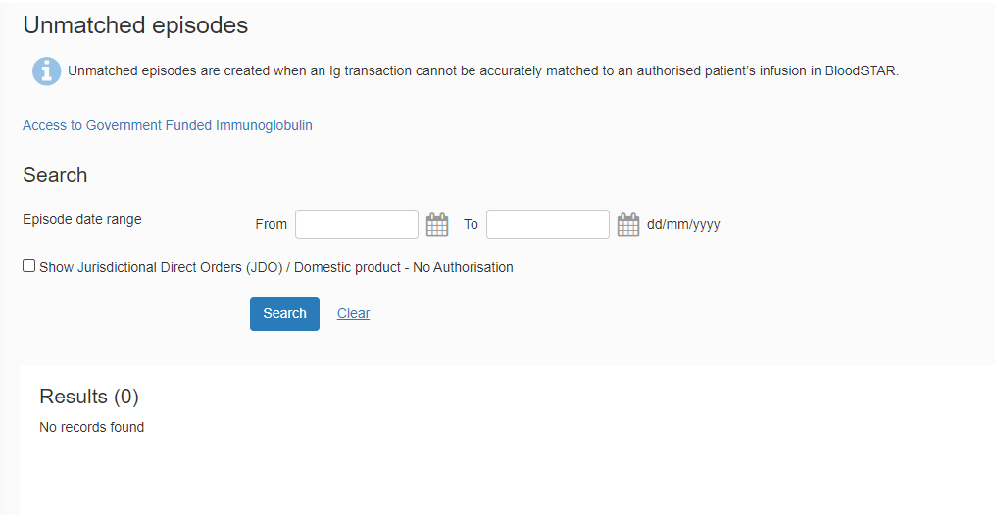

4366 – Display divided doses

When viewing the authorisation, the divided doses are now displayed as part of the Regimen and the dose details. The first 10 doses are visible and if there are more than 10 doses the user can hover over the three dots at the end of the list to see the full details.

Example of 8 divisions

Example of 28 divisions with hover over

4858 – Home Page – Feedback Form

A new message has been added to the Feedback form to help explain how to submit feedback to the NBA and to Lifeblood. The new message is as follows:

*Use this form to submit general feedback and systems issues to the Blood Operations Centre at the National Blood Authority.  Feedback for Lifeblood on quality issues must be submitted against the individual item when receipting the product.*

The Contact reasons available on the form have been reduced to two options, Change Request and General Feedback.

5812 – Lifeblood Delivery Schedules

When a facility is placing a **Stock or Special Order** with a **Priority of Routine** the system will automatically select the next available date and time for dispatch based on Lifeblood’s distribution run schedule and the time that the order needs to be placed by.

If the default selection is not suitable, the facility will have options to select a later dispatch date and time in line with the distribution run schedule or the option to specify a dispatch date and time.

The following new information message provides advice on the time zone and a reminder to consider public holidays and weekends.

*Message words: “Refer to****distribution runs****timetable for place order by, approximate dispatch and delivery times (please note distribution runs will vary on public holidays). All times are displayed in AEDT (please be mindful of daylight savings times).”*

Where the Lifeblood Distribution Site does not have a distribution run schedule available the facility will be required to enter a dispatch date and time.

When the facility selects to finalise the order, the system will check that the time is before the ‘Place order by’ time in the Distribution Run. Where the time is later, the order will not finalise, and the facility will need to select from the future available distribution runs or specify the date and time for dispatch.

The order form will display the dispatch date and time when the order is viewed or printed to PDF.

When a facility is placing a **Stock or Special Order** with a **Priority of Urgent** the system will automatically select the Delivery option ‘Ready for dispatch within 60 minutes of receipt’. The facility will also have the option to specify a required date and time.

5869 – Access for NBA Support Officers to remove Planned infusion lines

Additional access is available for Blood Operations Centre (BOC) Support Officers to remove infusion lines from a superseded regimen that are in Planned status. The lines will be processed consistent with the following existing system rules:

* Where there is **no** related dispense request the system will **delete** the infusion line
* Where there **is** a related dispense request the system will **cancel** the infusion line.

This change will allow BOC Support Officers to remove infusion lines when requested to prevent unintended LIS matches.

4510 – Access for NBA Support Officers to remove discard episodes

Additional access is available for Blood Centre Operations (BOC) Support Officers to remove discard episodes after a product has expired. If a request is made to BOC to remove a discard episode, details of the circumstances will be required before the action can be taken.

4509 – Change to Return to Stock rules

Additional access is available for Blood Centre Operations (BOC) Support Officers, Facility User and Facility Administrators to return to stock on an infusion line under the treatment plan, where Authorisation is expired more than 7 days and cancelled Authorisation.

4358 – Update BloodNet feedback email

Update to direct all BloodNet feedback emails to [support@blood.gov.au](mailto:support@blood.gov.au).