Stock Movement Dashboard
The Stock Movement module in BloodNet allows users to transfer and discard Blood and Blood Products. Transfer episodes should be created when a product is moved to or from your facility and Discard episodes should be created when a product is discarded for any reason.
To access the Stock movement dashboard click on the Stock movement tile from the home page. You will not that the tile contains details of any active transfer episodes at your site.
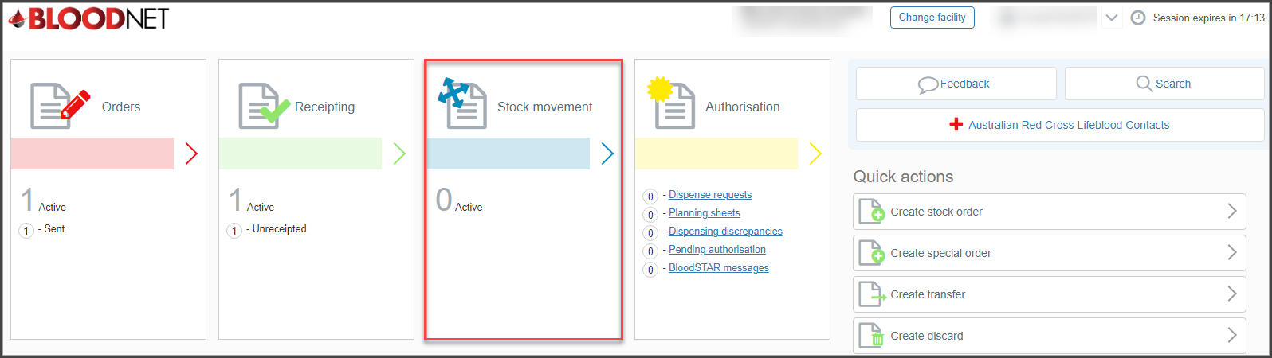
The Stock movement dashboard displays an overview of your site’s most recent Transfer and Discard episodes and also allows users to create transfer and discard episodes. There is also a Check item status/movement history search box at the top right of the dashboard which allows users to search for products and view the history of the product and/or discard or transfer the product depending on the product type and status.
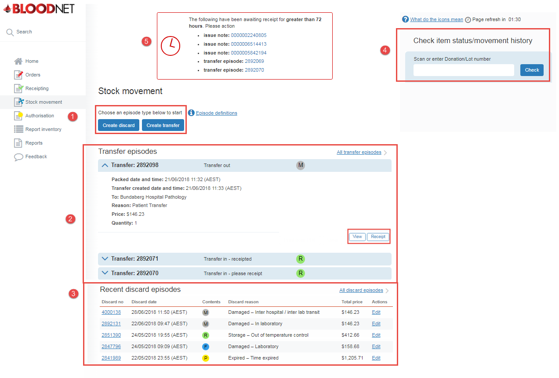

- Stock movement
This section provides links to create discard or transfer episodes.

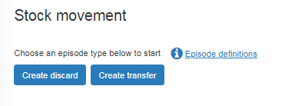
- Transfer episodes
This section displays recent transfer episodes. It will display all the transfer details such as the packed date and time, transfer created and time and reason. You can click either View or Receipt if you wish the action the episode. Click the blue arrow to expand the episode details.

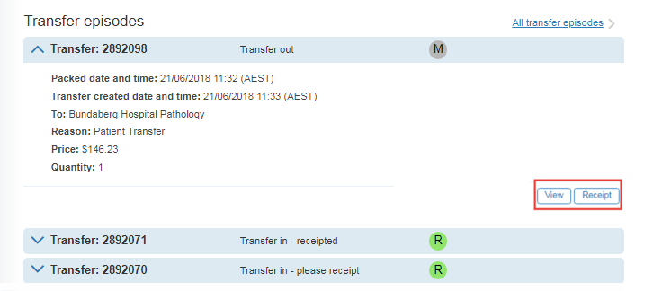

- Recent discard episodes
Recent discard epsides will appear. You can click the discard number hyperlink to view further details. Please note: only Facility Administrators can edit recent discard episodes.

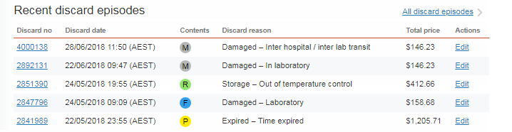

- Search function
Scan or manually enter the Donation or Lot number to check the item status or movement. Click Check when the details have been entered.

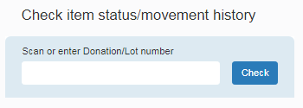
- Unreciepted issue notes
Issue notes which have been awaiting reciepting for greater than 72 hours will display on the top of the stock movement dashboard until they have been actioned. Click on the blue issue not hyperlink to action these requests.
You can hover over ‘what do the icons mean’ for a breakdown of the product/components icons.

