Requesting Multiple Subcutaneous Immunoglobulin (SCIg) Dispense Requests

Requesting multiple SCIg doses in BloodSTAR:
- Once a patient has been approved to receive SCIg, requesting a dispense from the Dispenser will often require requesting multiple doses at once. The planned doses can be viewed from the patient’s treatment plan by clicking on their authorisation number.
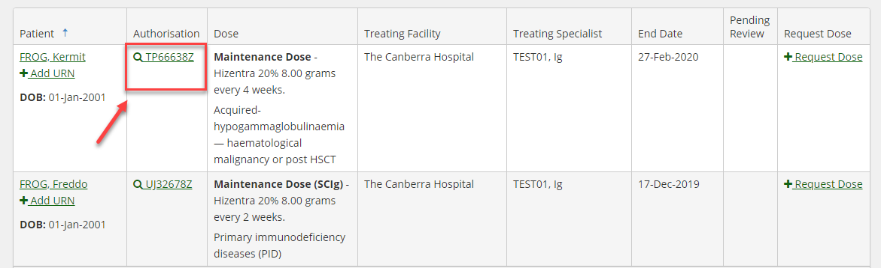
- The planned doses for the authorisation period will be listed under the ‘Treatment Plan’ heading.
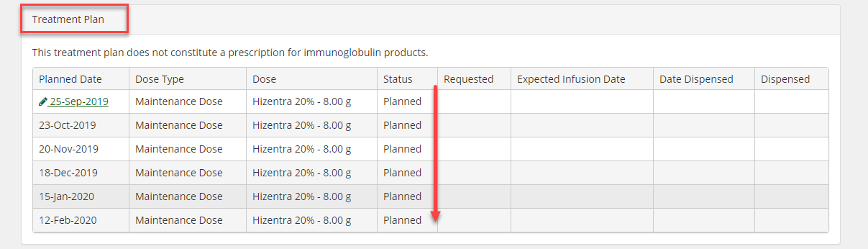
- The most effective way to request dispensing of multiple doses for SCIg patients is to submit a planning sheet that has all of the required doses for each patient for the selected period.

- Select ‘Planning Sheets’ from the ‘Treatment’ menu.
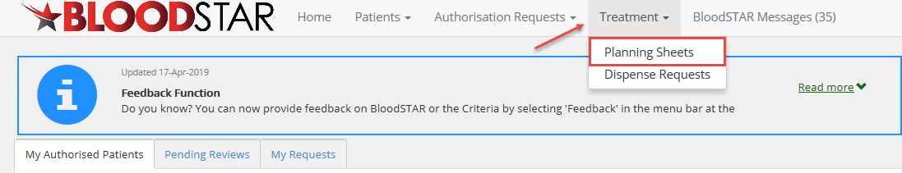

- Click on ‘+New Planning Sheet’ to create a new planning sheet.
- Fill in all mandatory fields marked with a * and click ‘Save’.
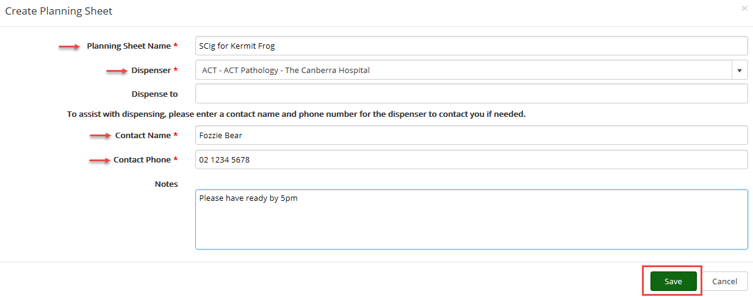

- Click on ‘+ Add Patient’. This will bring up a list of all patients at your facility. You can either perform a search for the patient or scroll down the list to locate them. Once you have found the patient click ‘Select’.

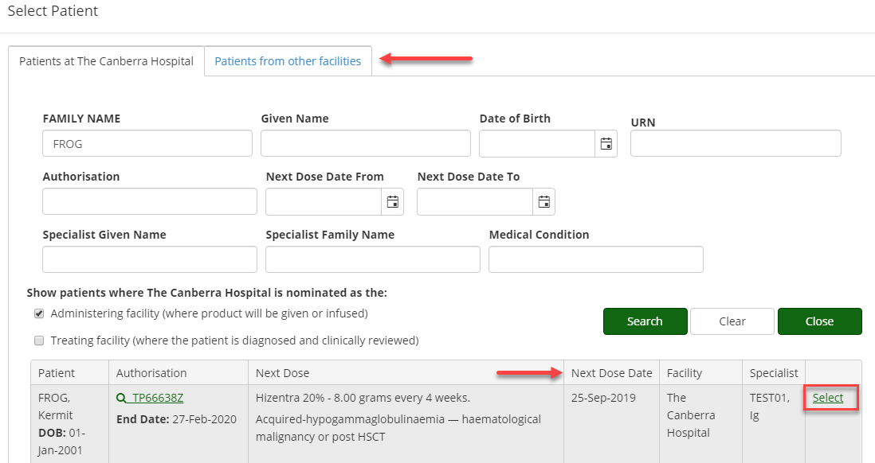

- The next scheduled dose will appear for you to add. You can edit the date and quantity if required by clicking on the ‘Edit’ button.
- Click ‘Add next dose’ to request more than one dose for the patient.
Please note: whilst you can add multiple doses onto a planning sheet, the nominated dispensing facility can only dispense up to two months’ worth of product as per the requirements in the National Policy: Access to Government Funded Immunoglobulin Products in Australia.
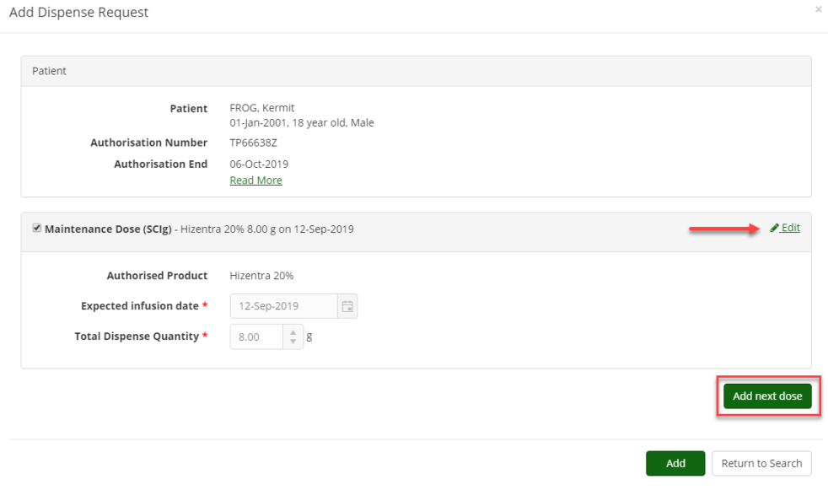

- Once all the required doses have been selected, click ‘Add’ to finalise the planning sheet.

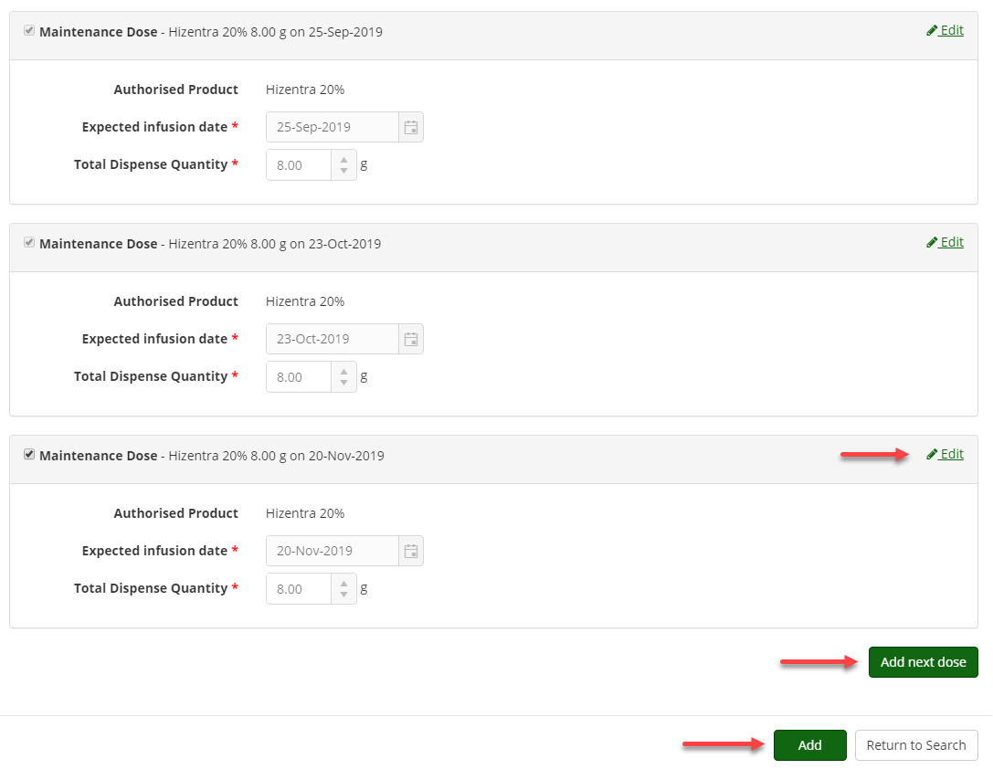

- Once the planning sheet is complete, click ‘Submit’. The planning sheet will be sent to the nominated dispensing facility for actioning. You can edit the doses on the planning sheet, provided it has not been dispensed (see step 12).

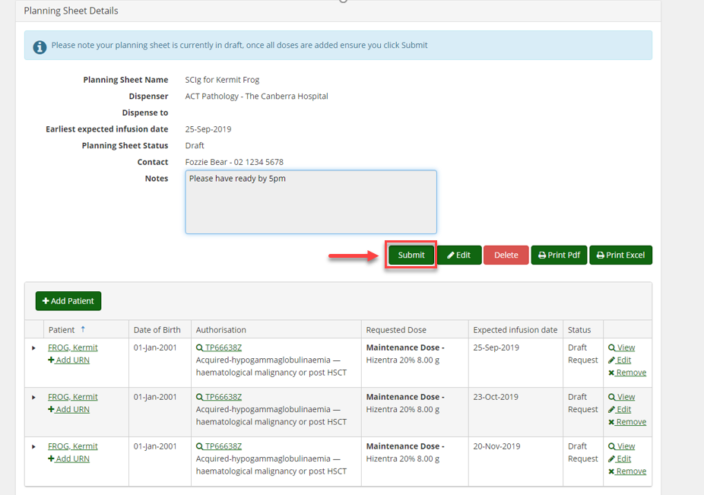
- How to edit a planning sheet

- Click on the ‘Treatment’ tab and select ‘Planning Sheets’ from the drop down menu
- Locate the planning sheet or individual dispense request and click on the ‘View’ hyperlink
- From the request select the ‘Edit’ hyperlink next to each dispense request. Amend the dispense request and save.

