Changing Between BloodSTAR User Roles
BloodSTAR allows users to change between their approved roles because they may work at multiple facilities. Examples include:
- You may be a Medical Officer and the Facility Administrator within the one facility, or
- You may have access as a Medical Officer or Registered Nurse at more than one facility.
Please note: You can follow this tip sheet to change between your roles irrespective of what they are e.g. Medical Officer, Registered Nurse, Administrator or Authoriser.

How do I change roles in BloodSTAR from my home page?
- To change your role from your home page click on “Change Role” situated in the black bar at the top of the screen. This will take you to your Role/Facility or login screen.
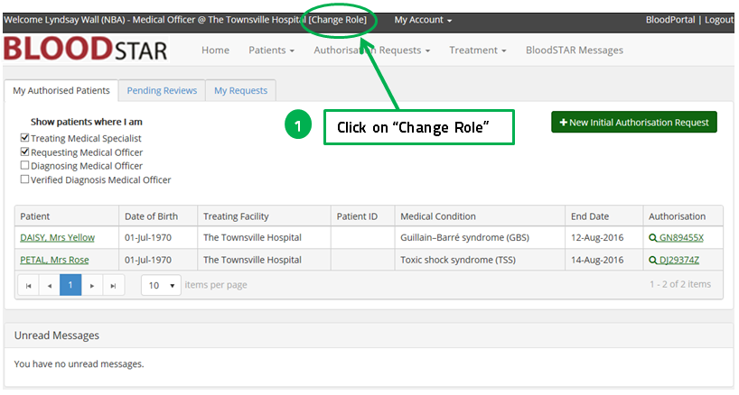

How do I change roles in BloodSTAR from the Select a Role/Facility or login screen?
- If the role you wish to choose is available to you on this screen, simply click on “Select” next to the role you want.
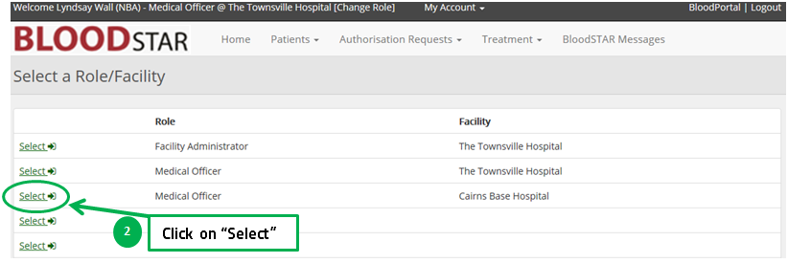

- If the role you wish to access is not in the list you will need to submit an access request or follow up on the access request you have submitted but has not yet been approved.
