**Requesting an Authorisation Under a new a New Condition**

When the diagnosis of a patient with an existing Ig authorisation changes, a Medical Officer / Prescriber must cease the patient’s current authorisation by recording a review and then submitting a new Initial Authorisation Request for the new condition.

**How do I locate the current authorisation?**

There are two ways to locate the patient:

1. Select the patient from the list on your home page:

**Click on the patient’s name**



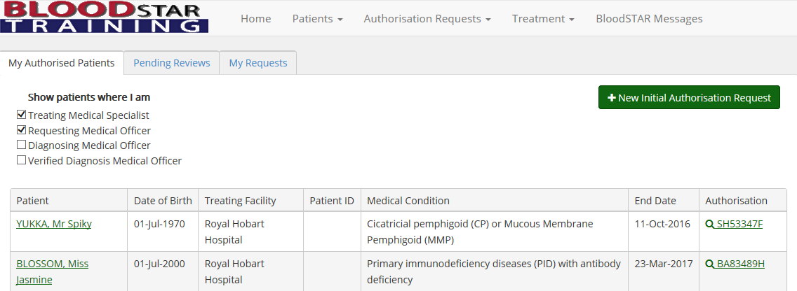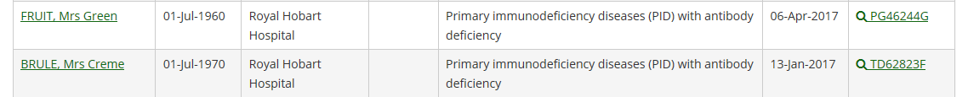

**OR**

1. Search for the patient; click on the **Patients** menu at the top of your home screen, then select **Search**.

**Click on “Patients” then “Search”**



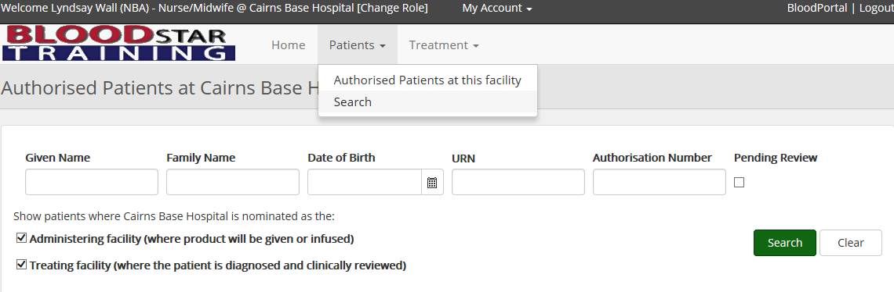

1. Complete the patient details with at least three (3) of the following identifiers; given name, family name, MRN/URN of the patient’s usual facility, date of birth or individual health identifier (IHI). If required you can change the search scope from within your facility to state wide or national.

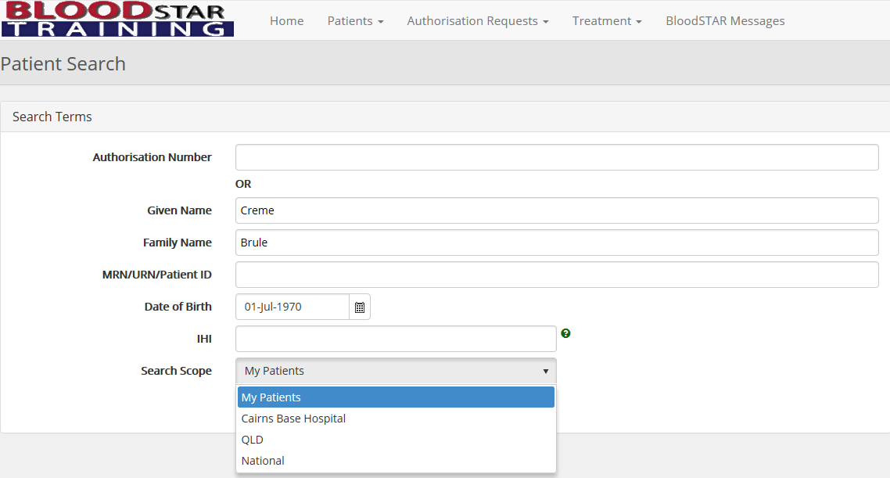

**Select search scope**

1. Click on **View** to view the patient’s record.

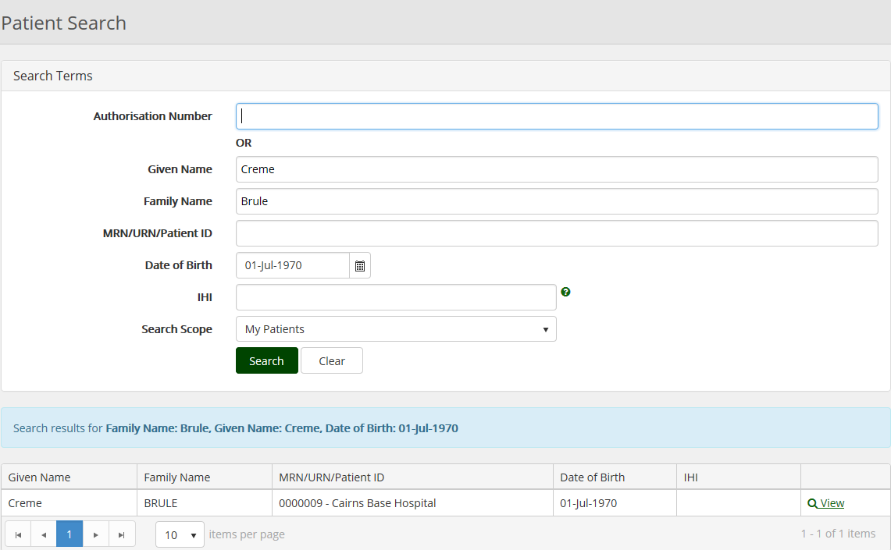

**Click “view” to see the patient’s authorisation details**

**How do I cease the current authorisation and change to a different condition?**

1. Once you select the patient scroll down to their **Current Authorisation**. From here select **Record Review**.

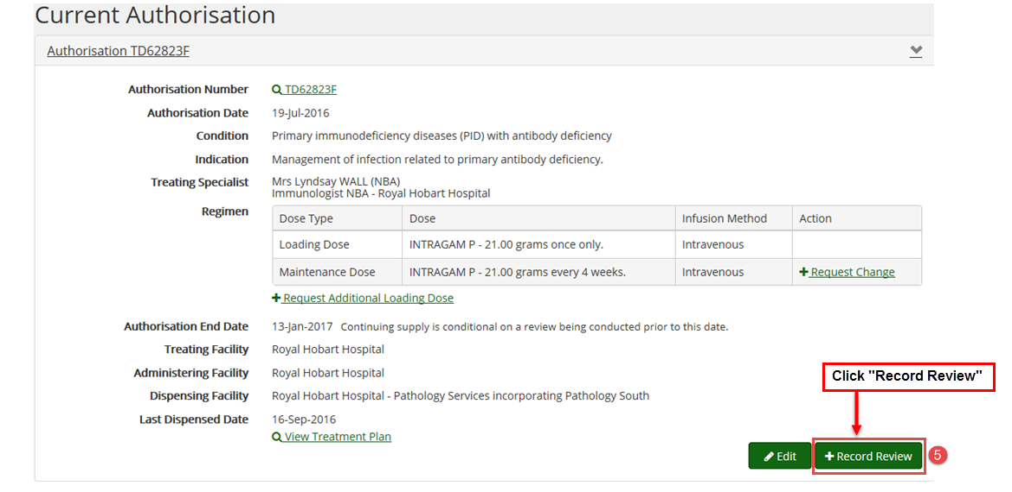

1. On the Review Outcomes page under the **Review Criteria** section select the criteria that the patient’s condition meets. Under the Review Outcome section select the **Cease Treatment** option.

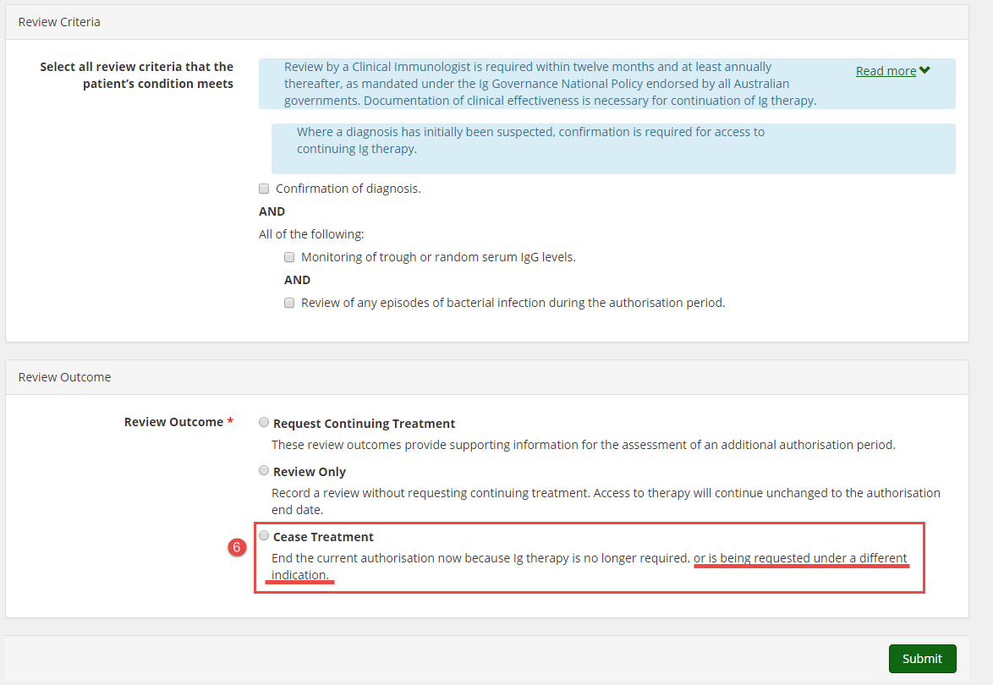

You will receive the following warning: “*Authorisation has X planned doses on the treatment plan. Cease treatment will cancel all these planned doses. The patient will not be able to access funded immunoglobulin under this authorisation until a new initial authorisation request is approved*.”

Select the Cessation Date and click the **Submit** button.

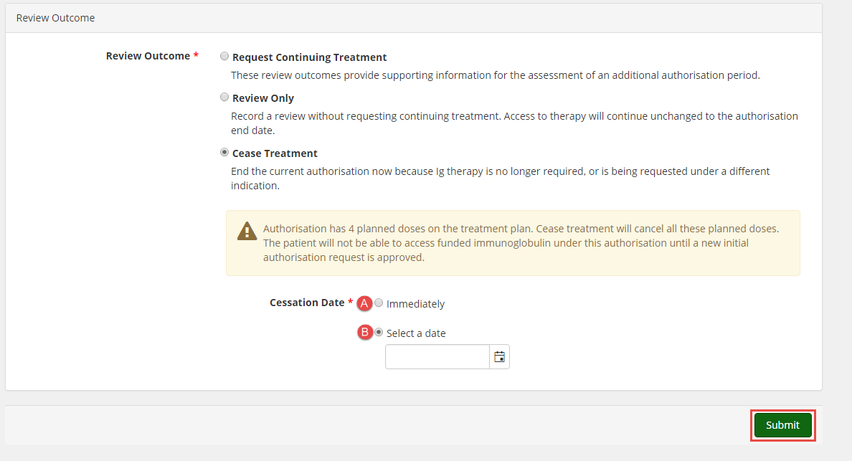  
  
  
7. From here you will automatically see the patient’s record. Scroll down to Authorisation Requests and click on + New Initial Authorisation.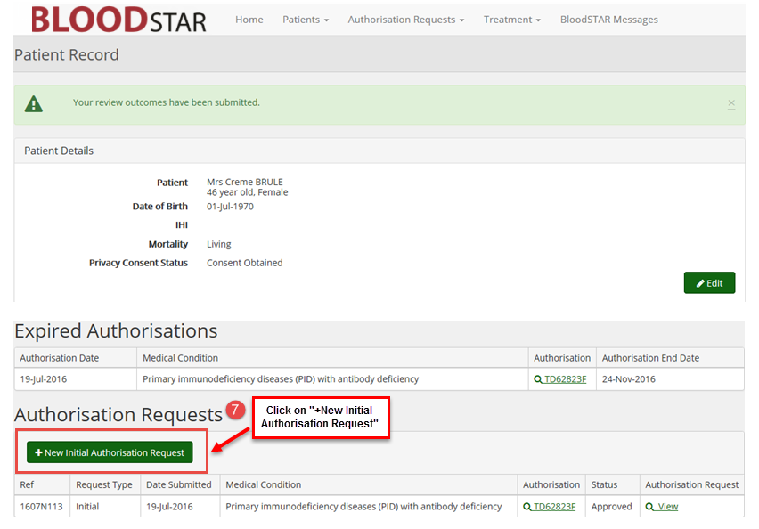

1. The New Initial Authorisation Request will automatically populate with the patient’s details. Continue with the request as usual, ensuring you enter the new condition on step 2 of the form.

