Dispense Requesting for Subcutaneous Immunoglobulin (SCIg) Product
In the current version of BloodSTAR (version 2.1 – Aug 2016), all dosing is set up using an intravenous immunoglobulin (IVIg) model. To request SCIg in version 2.1, some additional action is required to ensure correct dosing is accurately represented.

The next BloodSTAR update (version 2.2), will introduce subcutaneous immunoglobulin (SCIg) dose modelling to simplify the process for managing SCIg patients.
To request multiple doses to be dispensed at the same time
- Once a patient has been approved to receive SCIg, requesting a dispense from the laboratory will often require requesting multiple doses at once. You can see the planned doses from the treatment plan by viewing the patient’s authorisation from your home page by clicking on the authorisation link.
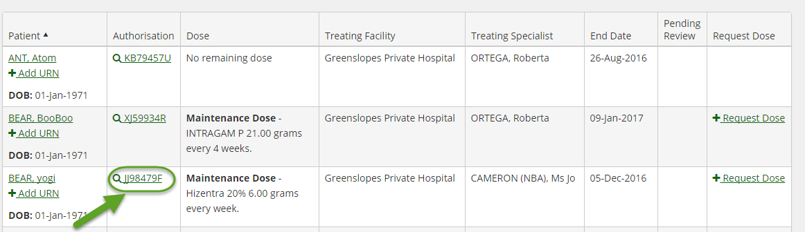

- You can see the planned doses for the authorisation period listed under the Treatment Plan area.
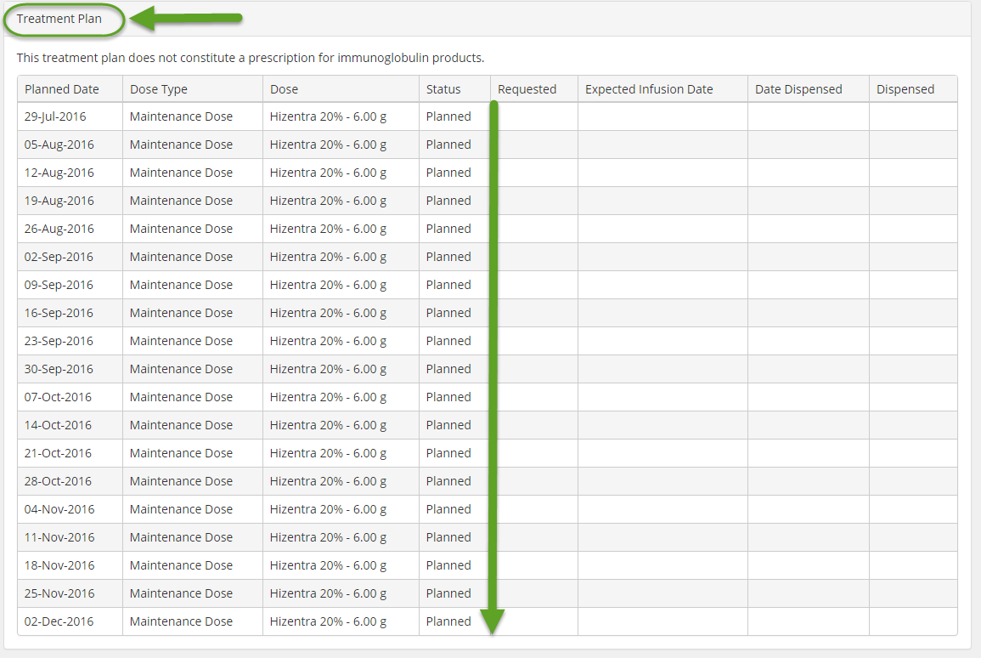

- The most efficient way to request dispensing of multiple doses for your SCIg patients is by submitting a planning sheet that has all of the required doses for each patient for the selected period.
- Select the Planning Sheets option from the Treatment menu.
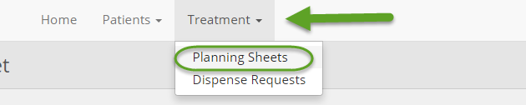
- Click Create New Planning Sheet to create your new planning sheet.
- Give the planning sheet a name, fill in any additional details and notes that your dispenser may require, and save.
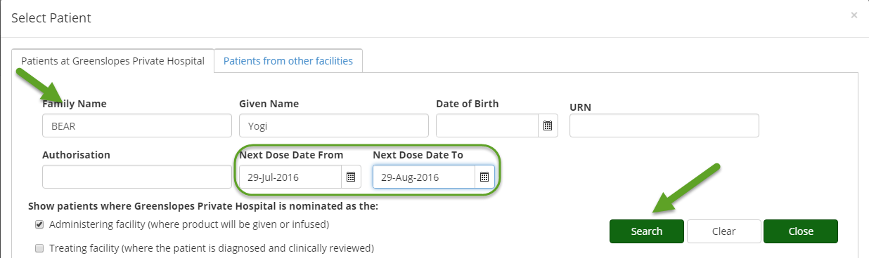
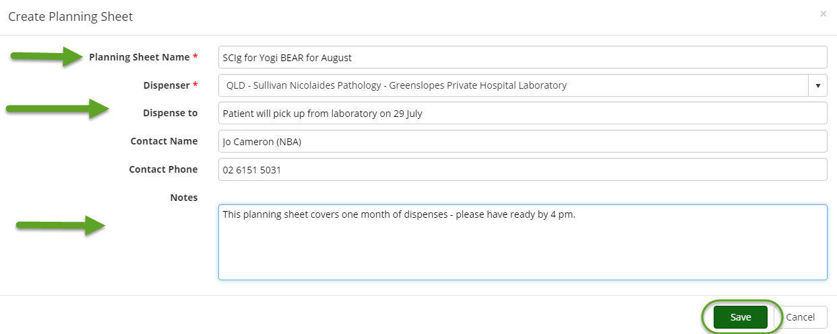
- Click on Add Patient, which will bring up the Select Patient form where you can search for your patient and the period that you require the doses to be dispensed for.

- This will bring up the first dose within this period. Click Select to review and then add this dose to the planning sheet.
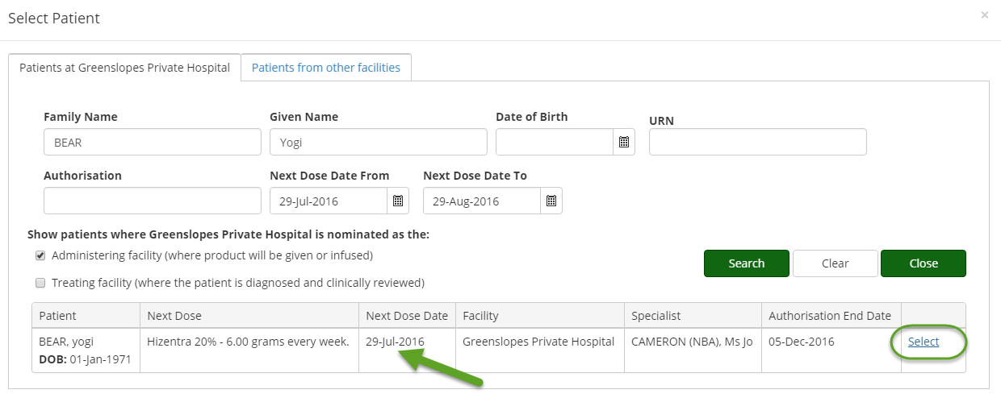

- You will be returned to the Select Patient form where the next dose within the selected period will be shown.
- Repeat steps 8 and 9 until all required doses have been selected and then click Close.
- Click Submit to send the plan to the dispenser. You can also choose to Edit, Delete, or Print from this page.
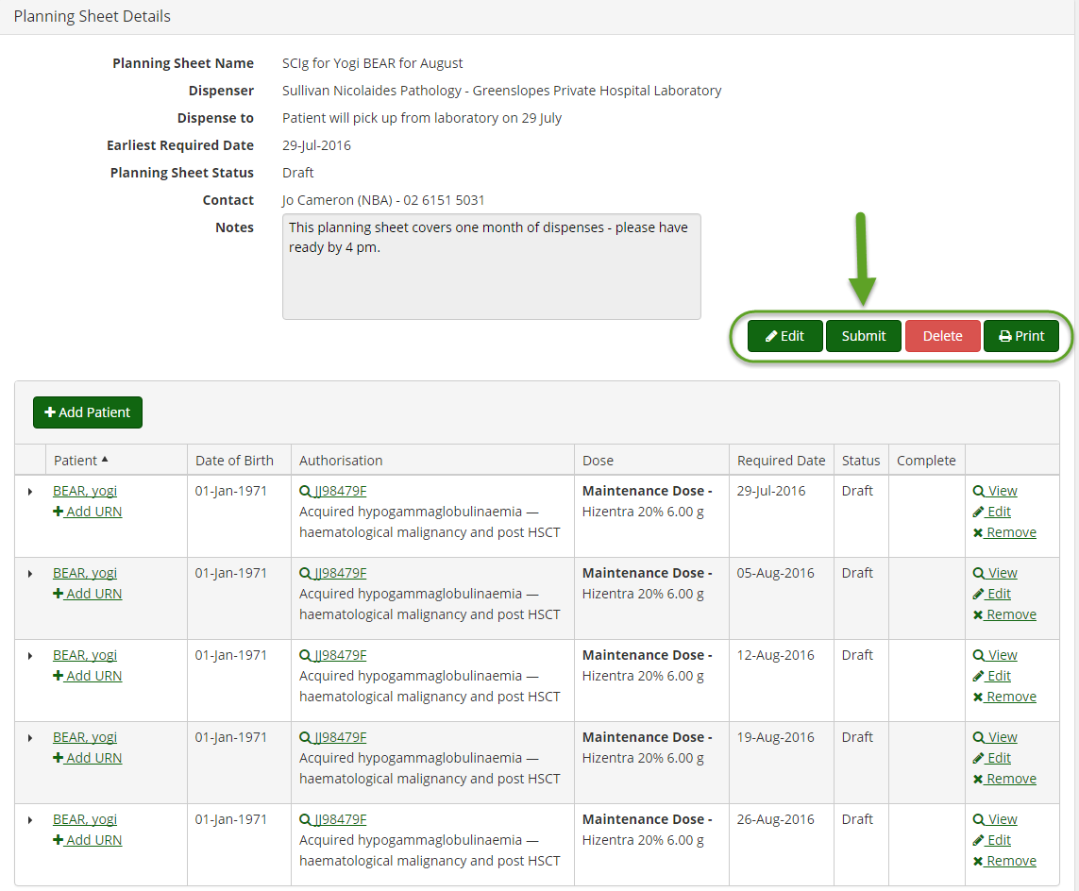

- Alternatively you can add individual dispense requests by searching for the patient from the home page, however this is not efficient for the dispenser.

