Transfer of Care in BloodSTAR
BloodSTAR allows both Medical Officers and Nurses to transfer a patient’s care from one Treating Medical Specialist to another or to transfer the patient’s care to another facility. This can be due to a number of reasons including a patient relocating to another area or transferring to another Medical Officer with a different specialty.
How do I transfer the care of my patient to another Medical Officer?
- Select the patient you wish to transfer from your patient list on the home page by clicking on either their name or authorisation number.
Medical Officer view:
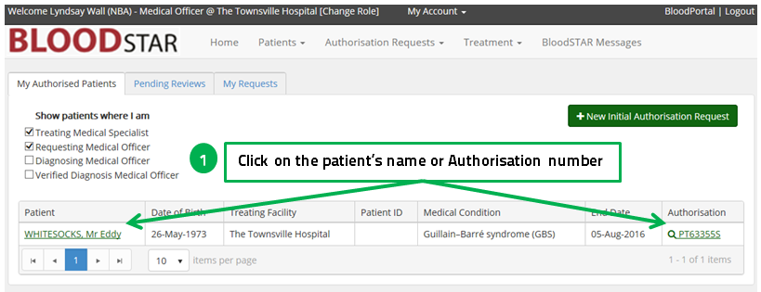
Nursing view:
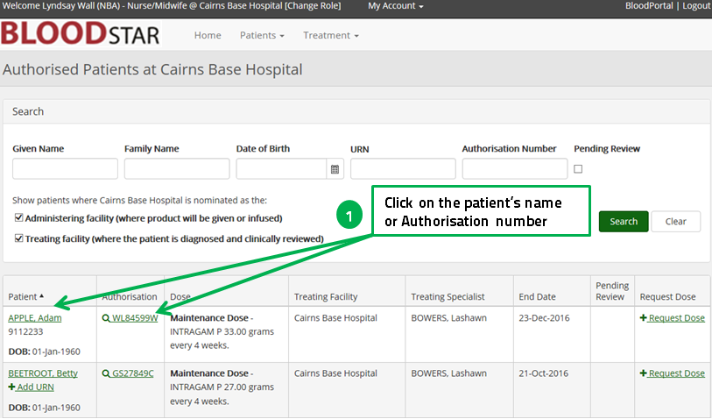

If you click on the patient’s name:
- This will open up the details of their current authorisation. Click on “Edit” in the “Current Authorisation” box
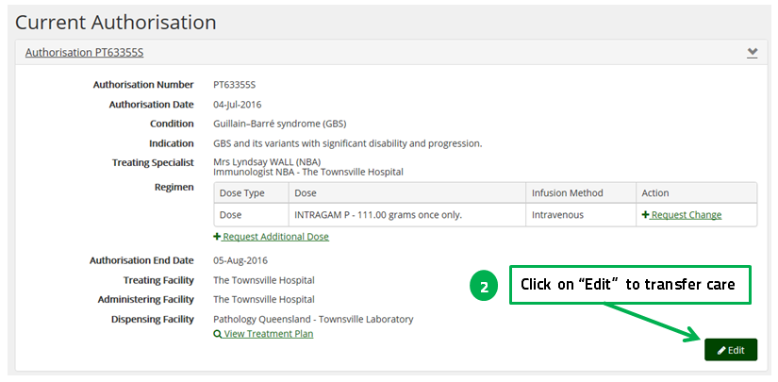
If you click on the Authorisation number:
- This will open up the screen below with the patient’s and authorisation details. Click on “Edit” in the “Authorisation details” tab
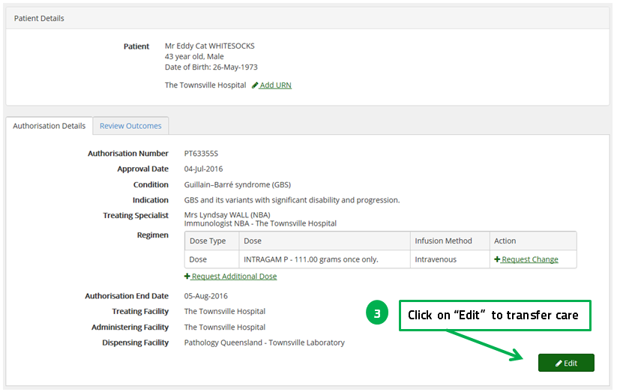

- In the new screen select “Change Treating Medical Specialist”
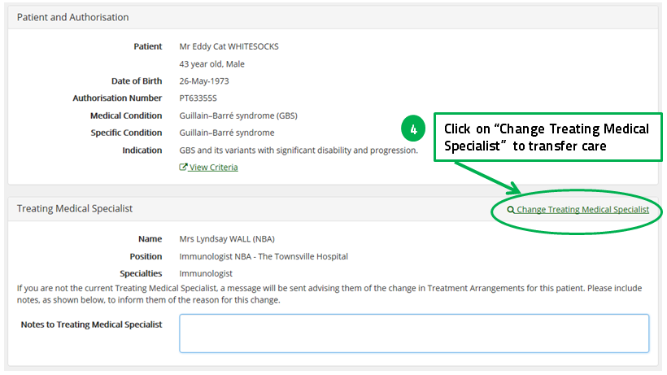
- Start typing the name of the Medical Officer to whom you are transferring care.
- Select from the drop down list.
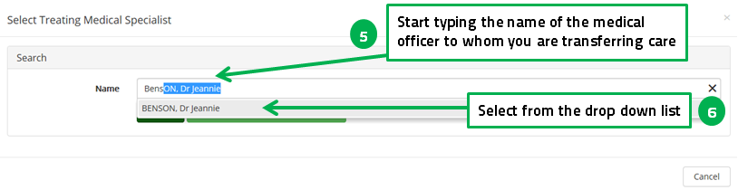

- Click select against the Medical Officer’s name.
Please note they may have a number of roles if working at different treating facilities.
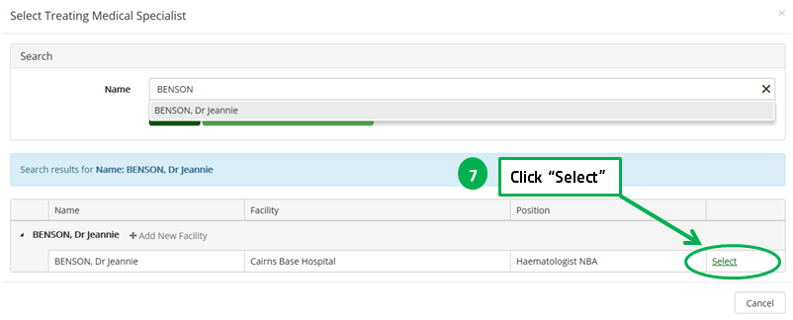
- Write relevant treatment of communication notes to the Medical Specialist about the patient you are transferring, as appropriate.
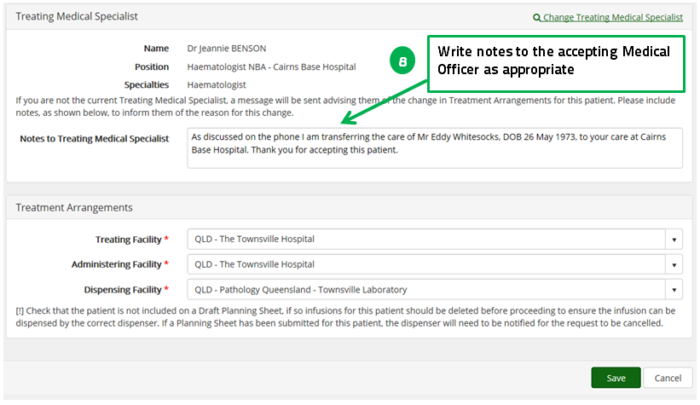

- Change the treating, administering and dispensing facilities from a drop down list or start typing, as appropriate.
Please note: It may be that you need to change the facilities the patient has a relationship with in BloodSTAR but not the Treating Medical Specialist so change the fields required on this page before you click Save.
- Click Save to save your changes.
