**Submitting an Ig Dispense Request for a Patient from another facility/state or the travelling patient**

BloodSTAR allows nurses to submit a product dispense request for patients who present for treatment from other facilities and/or states. This tip sheet outlines how a nurse can search for a patient, view their authorisation details, create and submit an Immunoglobulin (Ig) dose request to the dispenser.

**How do I search for and view the authorisation details of a patient from another facility/state?**

1. To search for a patient who presents for treatment from another facility, click on the “*Patients*” in the tab at the top of your home screen, then select “*Search*”.

**Click on “Patients” then “Search”**



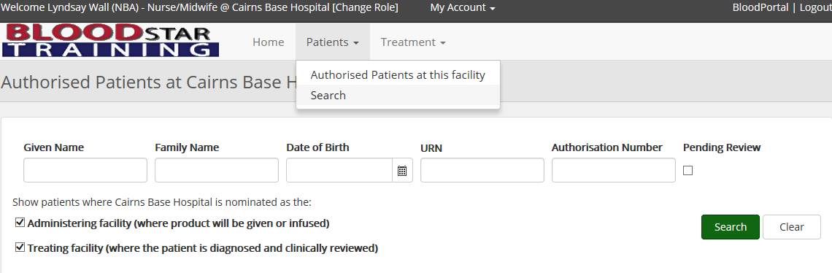

1. Complete the patient details with at least three (3) of the following identifiers; given name, family name, MRN/URN of the patient’s usual facility, date of birth or individual health identifier (IHI). Change search scope from within your facility to either your state or nationally.

**Select search scope**



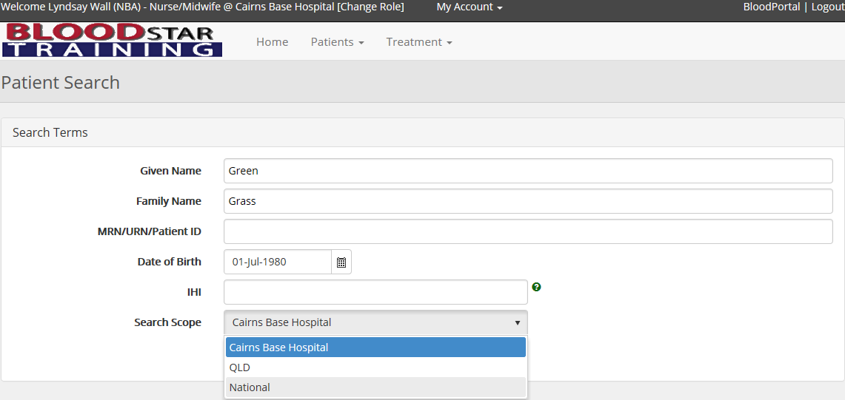

1. You will be asked to select a reason for viewing the patient’s authorisation as you would not normally have access to the information. After selecting the reason, click the green “*Search*” button located under the drop-down box.



**Select the reason for your search then click the green “Search” button**

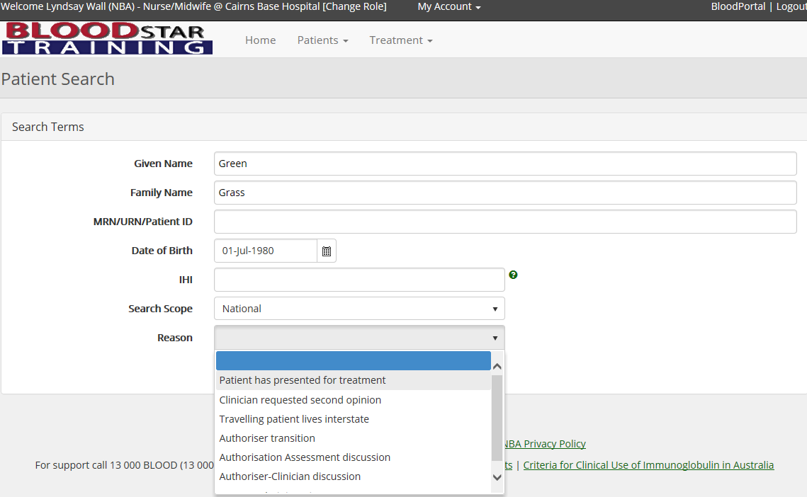

1. Click on “*View*” to review the patient’s details and authorisation



**Click “view” to see the patient’s authorisation details**

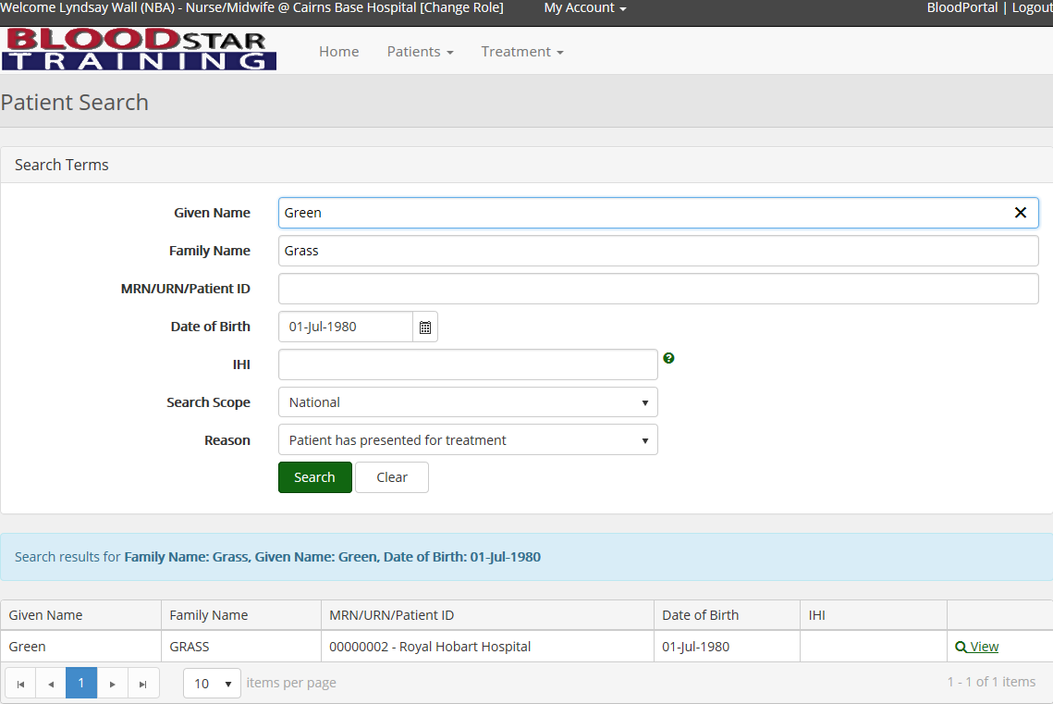

1. A pop-up window will ask you for a second time to select a reason for viewing the patient’s details and authorisation. Click “*OK*” after selecting your reason.
2. To view the patient’s Treatment Plan, scroll down to the “*Current Authorisation*” heading and click on “*View Treatment Plan*”. This will open the Treatment Plan in a pop-up window showing doses already dispensed and the due date of the next dose.

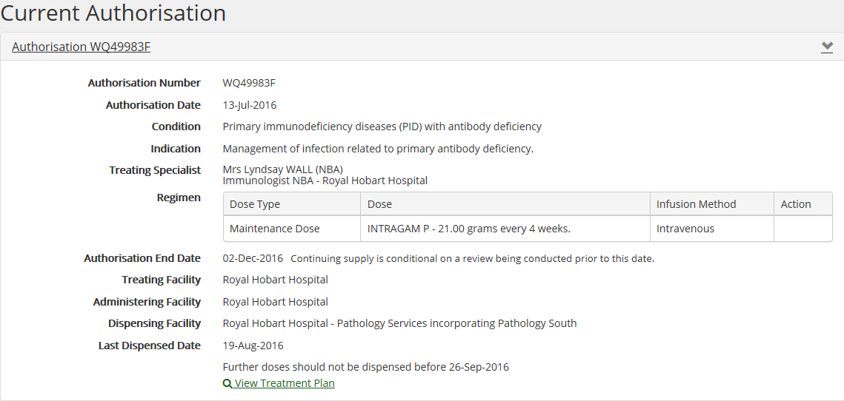

**Click “View Treatment Plan” to see when the next Ig dose is due**

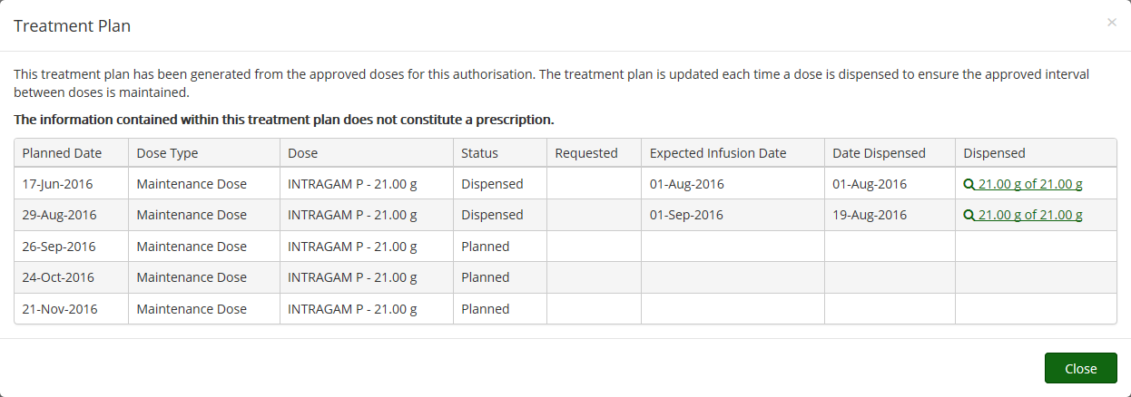

**How do I submit a dispense request for a travelling patient, or a patient from another facility?**

1. Ig dispense request for a patient from another facility/state can only be requested through a planning sheet. Click on the “*Treatment*” tab at the top of your screen then select “*Planning Sheets*”.



**Click “Treatment” then “Planning Sheets”**

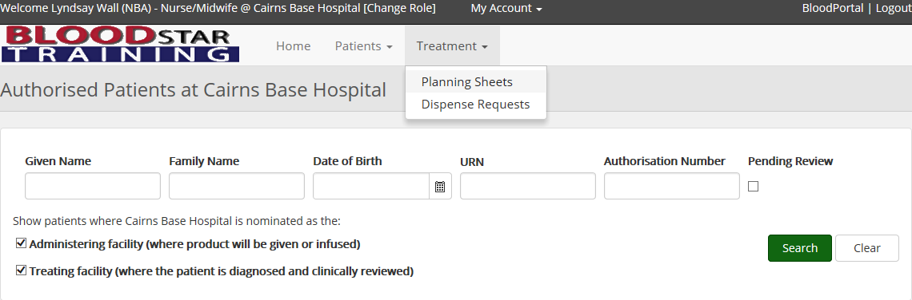

1. From here you can either create a new planning sheet by clicking on *“+ New Planning Sheet*” for the travelling patient/s only or add the patient to an upcoming planning sheet. See [BloodSTAR Tip Sheet - Creating and submitting a planning sheet in BloodSTAR](https://www.blood.gov.au/system/files/documents/BloodSTAR-Tip-Sheet-Creating-and-submitting-a-planning-sheet-in-BloodSTAR.pdf) for information on creating Planning Sheets.

**Add to an existing planning sheet that has not yet been submitted**

**Create a new planning sheet**



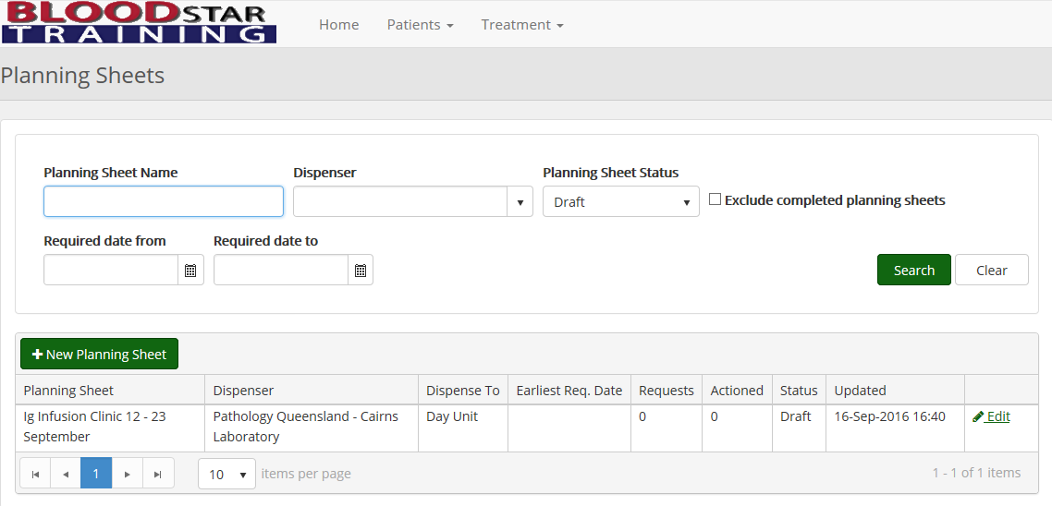

1. Once you have either created a new planning sheet or opened an existing one you can add the travelling patient/s by clicking on *“+ Add Patient*”

**Add patients to the planning sheet by clicking “+ Add Patient”**



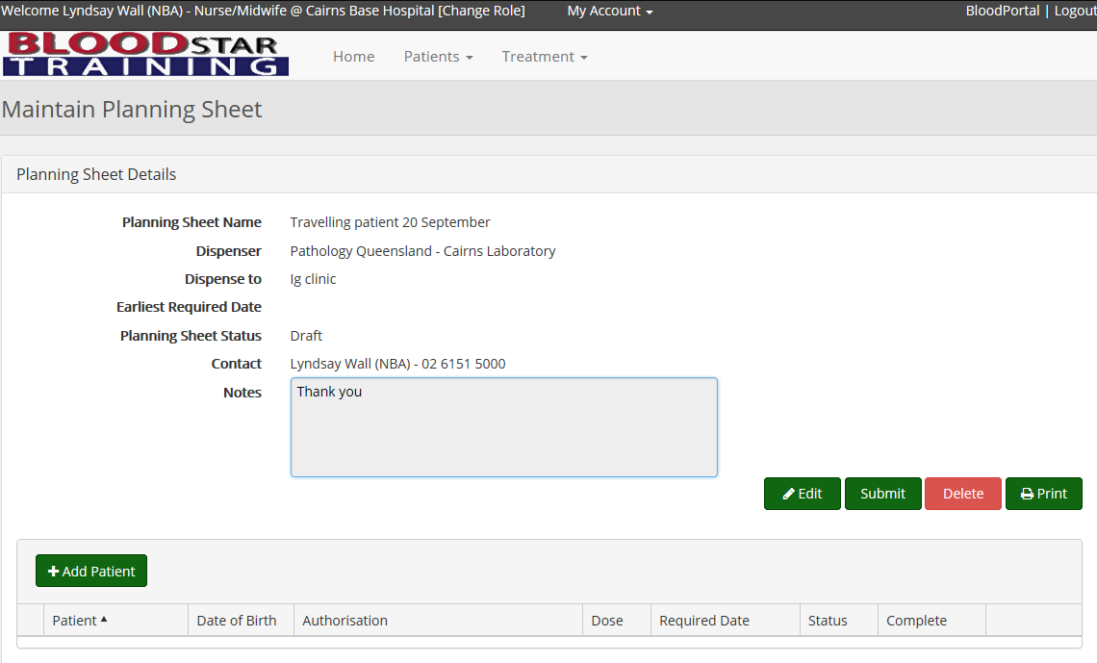

1. Click on the “*Patients from other facilities*” tab to search for your travelling patient.
2. Complete the patient search details as per above and add the patient to the planning sheet by clicking on “*Select*”.

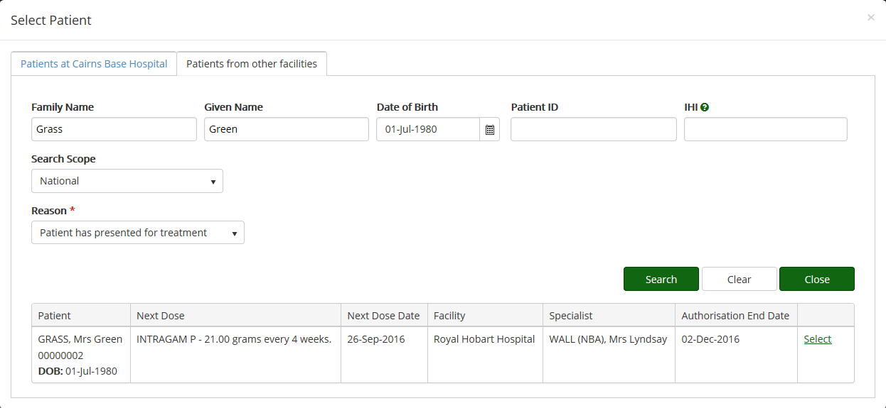

**Click “Patients from other facilities”**

**Click “Select” to add the patient to the planning sheet**

1. Review and edit the Ig dose or date if required, then click “*Add*” to add the dose to the planning sheet. See [BloodSTAR Tip Sheet - Creating and submitting a planning sheet in BloodSTAR](https://www.blood.gov.au/system/files/documents/BloodSTAR-Tip-Sheet-Creating-and-submitting-a-planning-sheet-in-BloodSTAR.pdf) for information on editing date and dose details.
2. BloodSTAR will confirm you have added the dose to your planning sheet. Click *“Close”* to return to your planning sheet template. You can continue to add more patients to this planning sheet if needed. Click on “*Submit*” when all the patients have been added.
3. You will receive notification that the planning sheet has been submitted.

**Please note**: It is advised that you notify your dispenser if you edit any details on a submitted planning sheet in case they have already begun dispensing Ig from it.