User Tip Sheet –Facility Administrator role

Reviewing BloodSTAR User Access Requests
BloodSTAR Facility Administrators are designated staff members within a hospital/facility with the authority to approve BloodSTAR access requests for the hospital’s Medical Officers and Nurses.
What is the Facility Administrators role?
- Verify that Medical Officers and Nurses are employed or practice within their facility;
- Confirm that the user holds a suitable position for the role that has been requested.
1. Go to https://www.bloodstar.blood.gov.au/ and Login with your BloodPortal Username and Password. Alternatively go to www. blood.gov.au and click on ‘Blood Portal’.
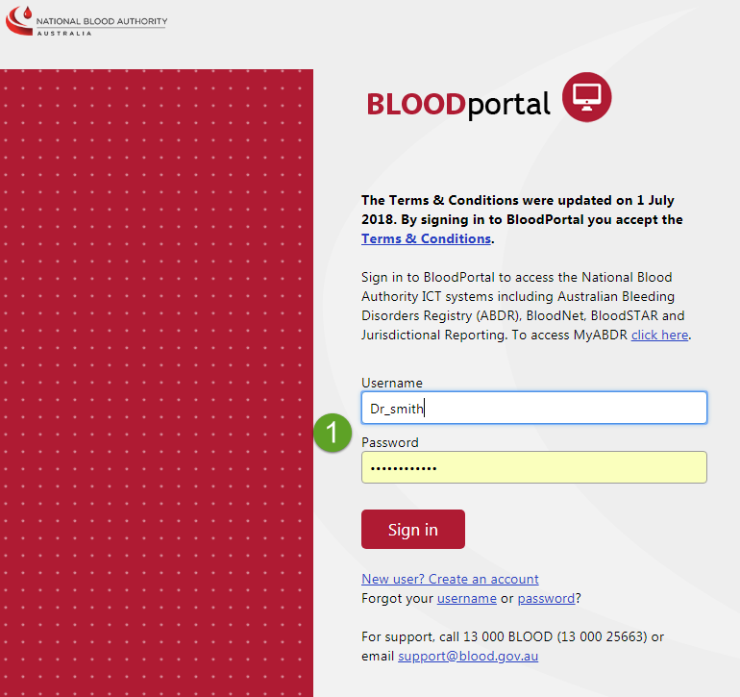

2. If you have access to multiple roles in BloodSTAR ensure you are logged in with your Facility Administrator role. Your role will be displayed at the top of the screen next to your name. If you need to change roles click on Change Role at the top of your screen.
3. From the Facility Administrator home page click on User Access Requests.

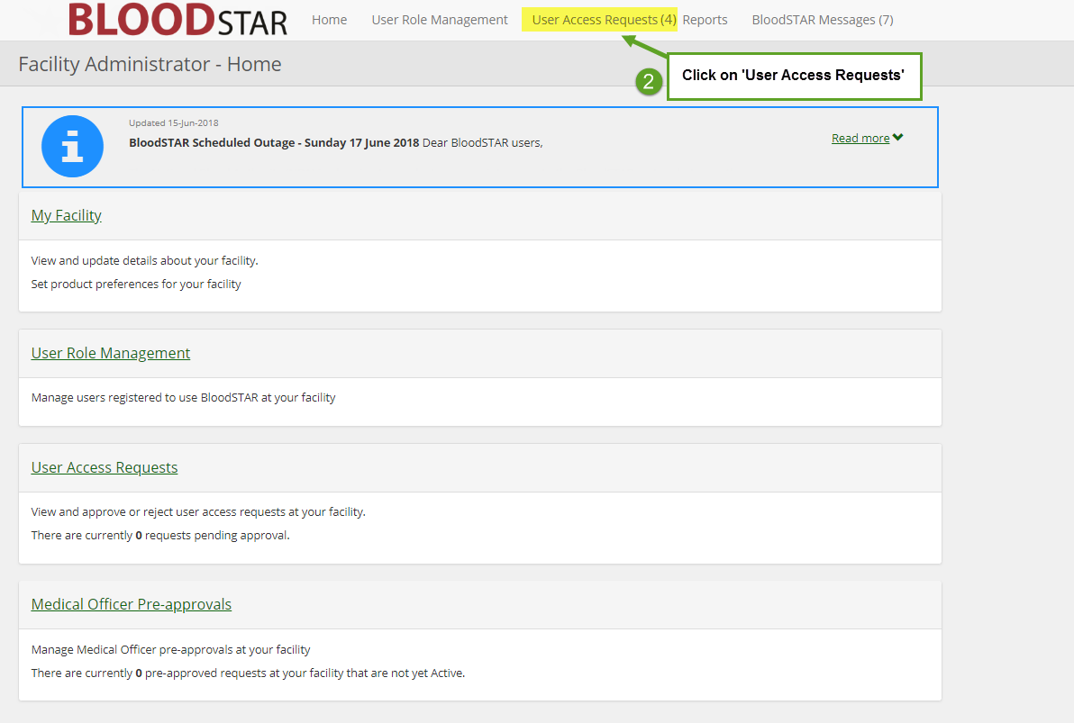

3. You will see a list of pending access requests at your facility. Click on Approve/Reject to review the User Access Request.
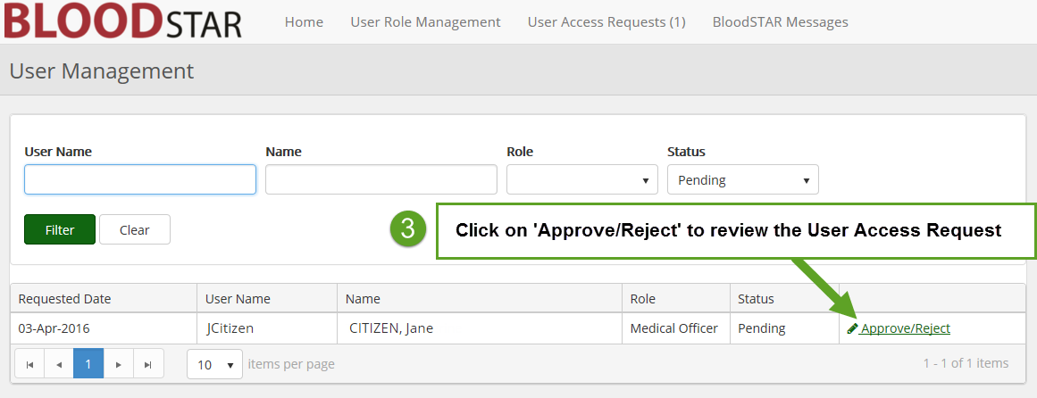
4. Verify that the user is employed or practices within the facility.

5. Confirm that the user holds a suitable position and registration for the requested role.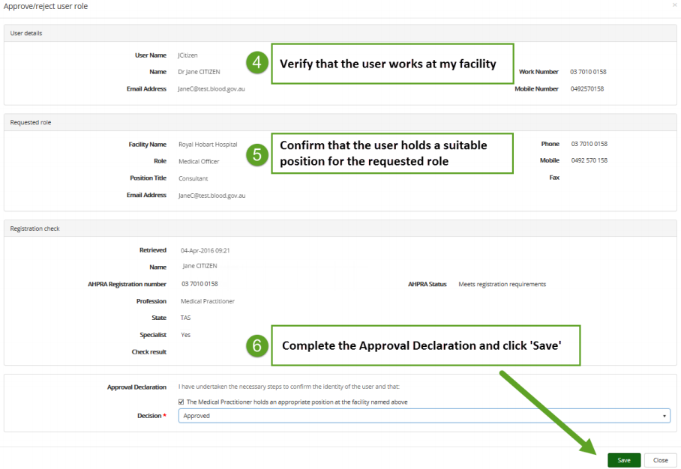
6. Complete the Approval Declaration to Approve or Reject as appropriate and then click the Save button at the bottom right of your screen.
Example Case
Dr Smith is beginning work in the immunology department of Tidy Town Hospital. It is expected that within the course of his work at the hospital he will need to prescribe immunoglobulin treatment. As part of the department’s registration/orientation process, Dr Smith is advised that he needs to access BloodSTAR. Dr Smith opens the BloodSTAR homepage and completes a Medical Officer user access request for Tidy Town Hospital.
Once the request is submitted, the facility administrator Fiona Jones is notified by email of a pending User Access Request. Fiona logs into BloodSTAR and reviews Dr Smith’s request. Fiona needs to confirm that Dr Smith is a legitimate employee of the hospital. She might do this by:
- Looking up Dr Smith’s record in the staff directory;
- Calling the doctor (using the contact details in the staff directory) to confirm that he is the person who submitted the request; or
- Contacting the head of Immunology to confirm Dr Smith’s engagement.
Once Fiona is satisfied that the request is a legitimate request and that Dr Smith is working at the hospital, she approves the access request.
An email is sent to Dr Smith to tell him that access has been granted. The next time Dr Smith accesses BloodSTAR he will be able to access Tidy Town Hospital’s patient records.
Note – Due to patient privacy constraints if Dr Smith works at more than one hospital, he will need to complete a separate Access Request for each separate hospital.

