User Tip Sheet –Facility Administrator Role

Providing Access to Facility Administrators in BloodSTAR
Important Point: Before being able to grant any access, a facility administrator must first collect the following details from the user;
  - the user’s BloodPortal username
  - the user’s position title, and
  - the user’s best phone number

How to provide Facility Administrator access to a user
1. Go to https://www.bloodstar.blood.gov.au/ and Login with your BloodPortal Username and Password.
2. Go to change role at the top of the page and select ‘Facility Administrator – Relevant facility name’ to enter the system as that role.
Please note: the facility you choose must be the facility you are providing access to for the user.

3. Click on ‘User Role Management’.
4. From the Role Management page select ‘Facility Administrator’ from the drop down list and click ‘Add Role’.
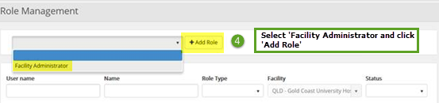
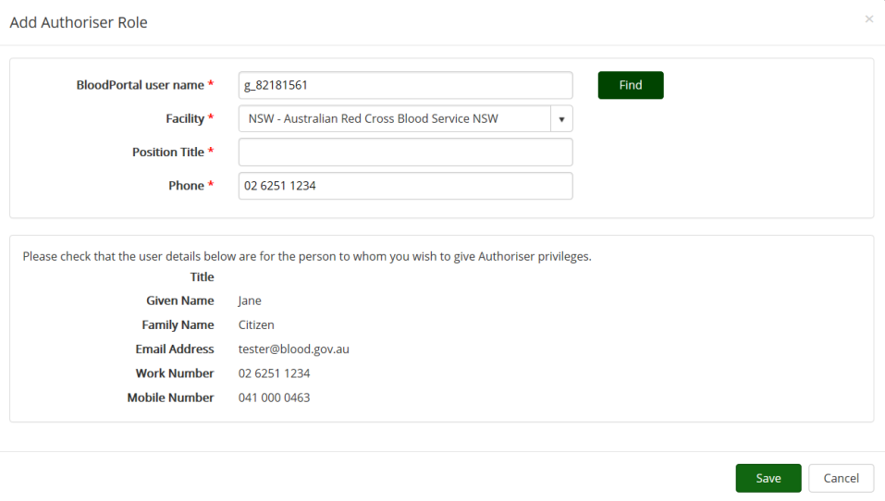
5. Enter in the user’s BloodPortal user name and click ‘Find’. This will return the information against that user’s registration.

6. Verify the users details are correct and click ‘Save’ to finalise.

