User Tip Sheet –Facility Administrator role

Deactivating or Editing a User’s Access Details in BloodSTAR
How to deactivate a user’s access to your facility
1. Go to https://www.bloodstar.blood.gov.au/ and Login with your BloodPortal Username and Password.
2. Click on ‘User Role Management.
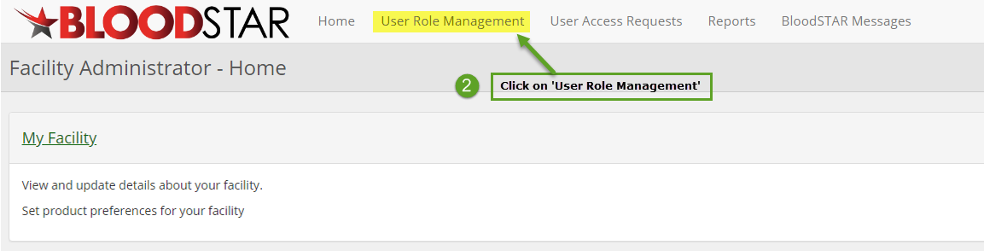
3. Under the ‘User Role Management’ page filter to find the person you would like to deactivate and click ‘View’ next to the user’s access.
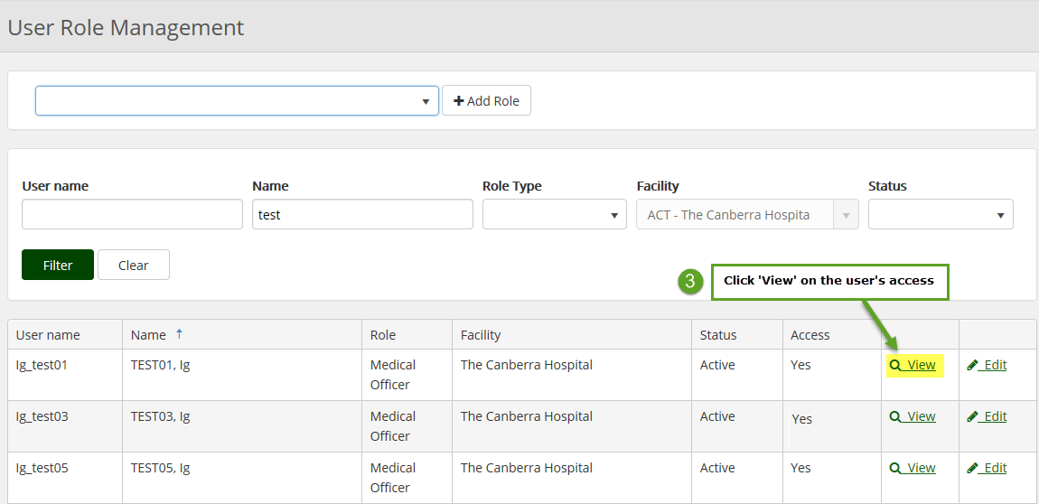
4. Click ‘Deactivate’
5. Enter in a deactivation reason and click ‘’Save’ 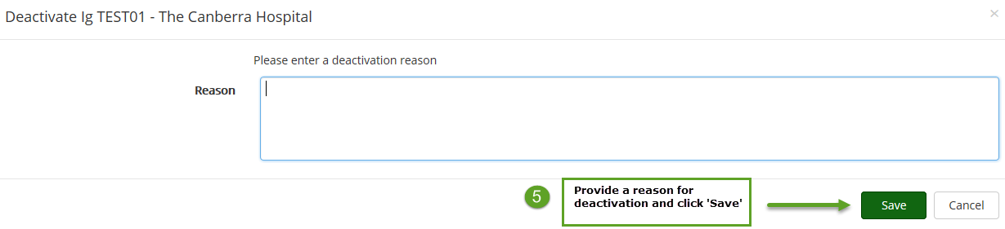

How to edit a user’s access details
1. Under the ‘User Role Management’ page filter to find the person you would like to view.
2. To edit the user’s position title, email or phone number click on ‘Edit’ next to the user’s access.
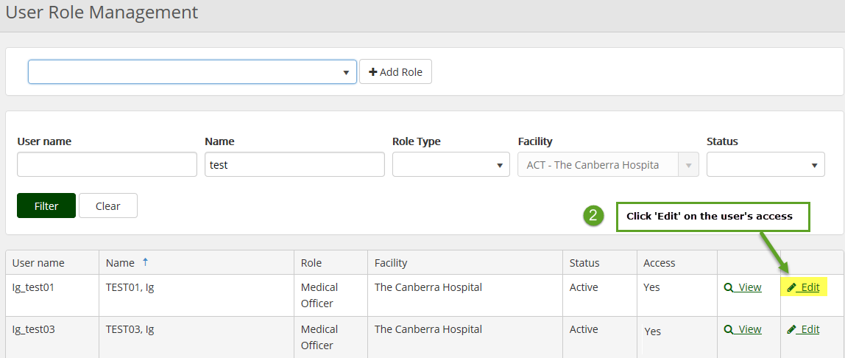
3. Edit the relevant details and click ‘Save’ to finalise.
