Creating and Using Facility Favourites – Tip sheet
Special orders that are likely to be ordered more than once can be added to the ‘Facility favourites’ list. Facility favourites can only be created from special orders that have been sent or dispatched and are not cancelled. The order should also not have already been added to the facility favourites. Adding an order to facility favourites can be done via the ‘Add to facility favourites’ link available on:
- Orders dashboard – within the accordion of a Special order in the Active orders list
- The ‘Special order details’ screen.
Creating a facility favourite from the Orders dashboard
- Locate the special order in the ‘Active orders’ list on the ‘Orders’ dashboard and click the drop down arrow to expand the view.

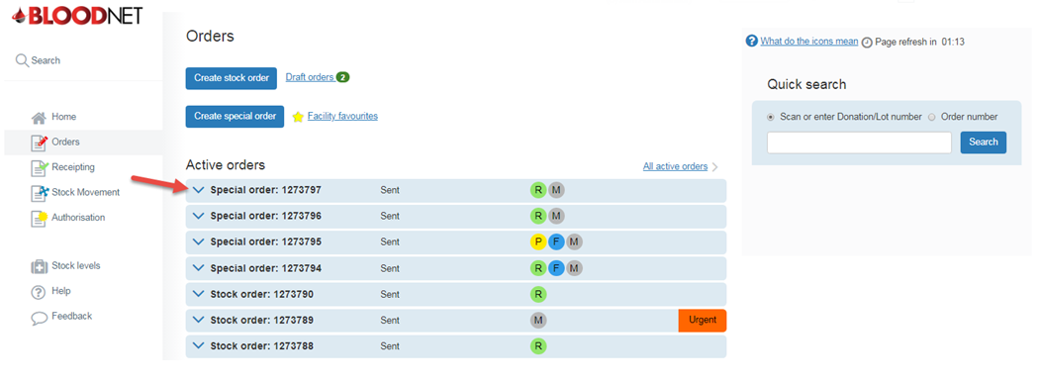
- Click on the ‘Add to facility favourites hyperlink.

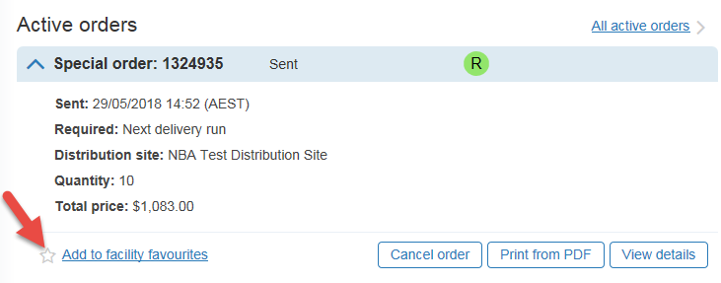’

Please note: If an order has already been added to facility favourites and cannot be added again, a yellow star is displayed.

- Name and provide a description of the facility favourite in the pop up dialogue box and click the ‘Add’ button. The order will be saved as a facility favourite.
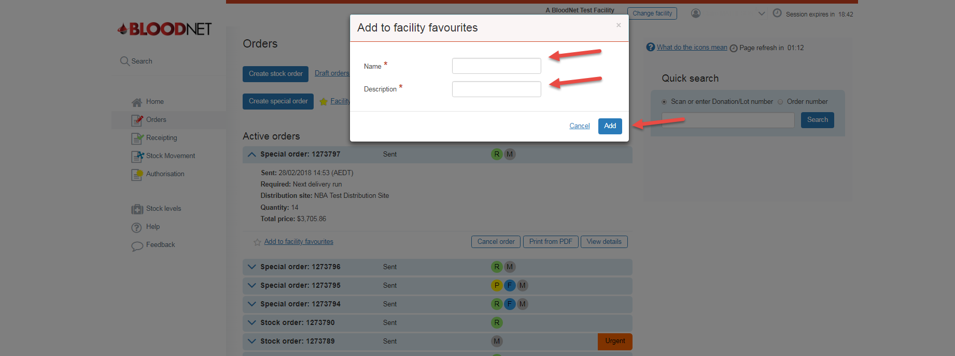

Creating a facility favourite from the ‘Special Order details’ screen
- Search for your order from the ‘quick search’ menu or ‘All Active orders’ and click on ‘view’ or the order number hyperlink.
- Click on located on the top right corner of the ‘Special order details’ screen.
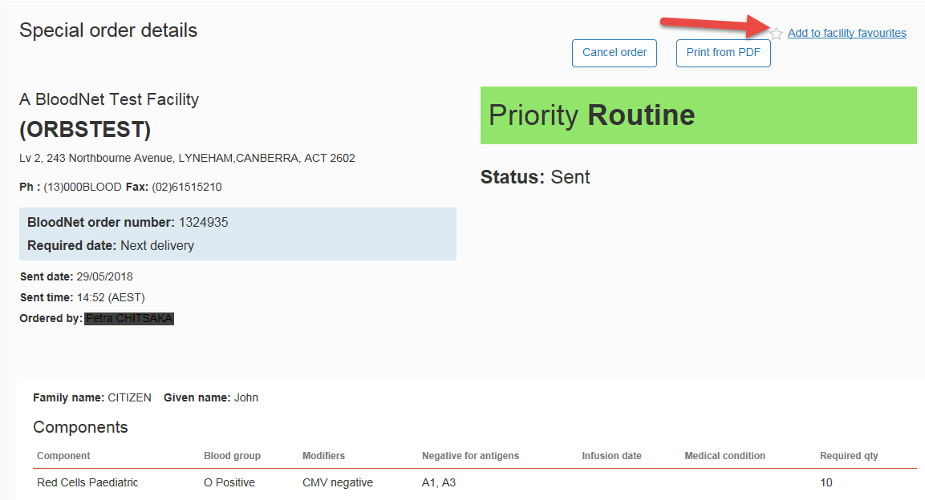

Please note: If an order has already been added to facility favourites and cannot be added again, a yellow star is displayed.
- Name and provide a description of the facility favourite in the pop up dialogue box and click the ‘Add’ button. The order will be saved as a facility favourite.

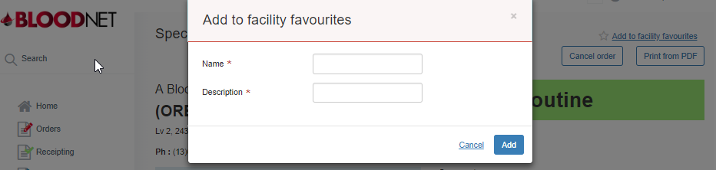

Using a facility favourite
Saved facility favourite orders provide easy access and a fast way of submitting special orders.

- To utilise a facility favourite click on the ‘Orders’ tile from the BloodNet home page.
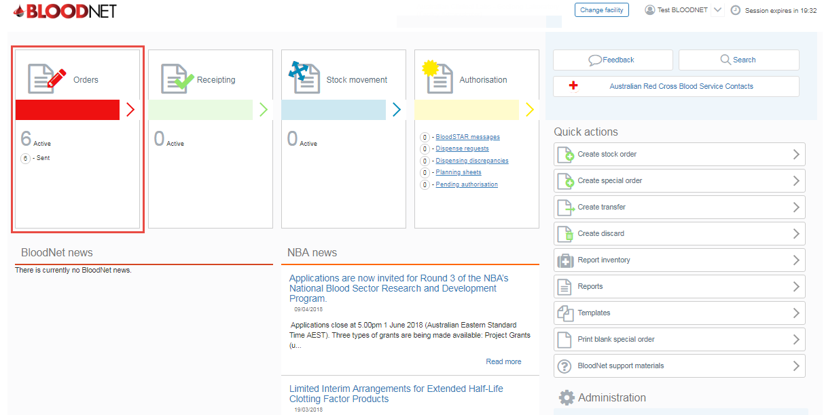

- From the orders dashboard, click on the ‘Facility Favourite’ hyperlink to access all saved facility Favourites.

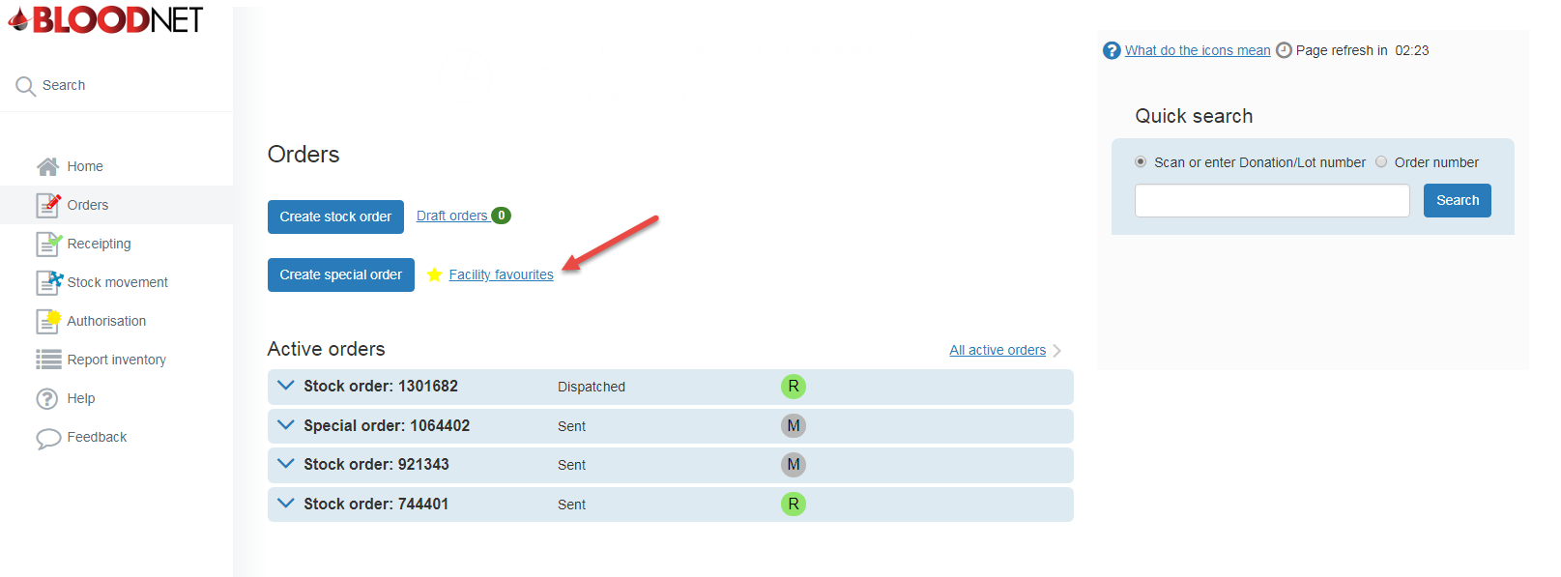

- Click on the ‘Use’ hyperlink to select the facility favourite order you wish to use. This will open a ‘Create special order’ screen which is pre-populated with the details of the order that was used to create the favourite.
Please note: You can search for saved favourites by typing the name of the facility favourite in the search box and clicking the ‘Search’ button.
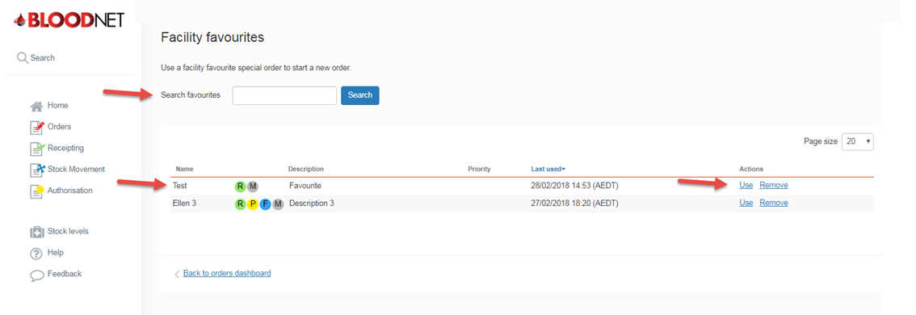

- Edit the order accordingly before clicking on the ‘Next: confirm delivery details’ button at the bottom right of your screen.
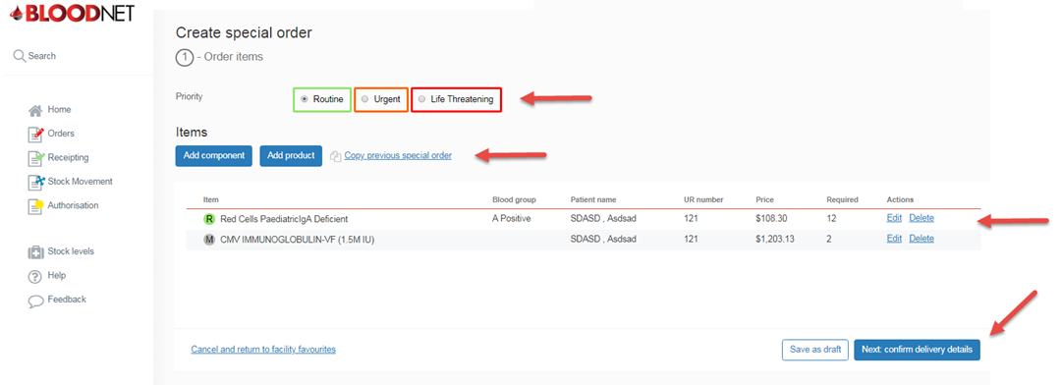

- Confirm the order details are correct and then click the ‘Send order’ button to place the order.
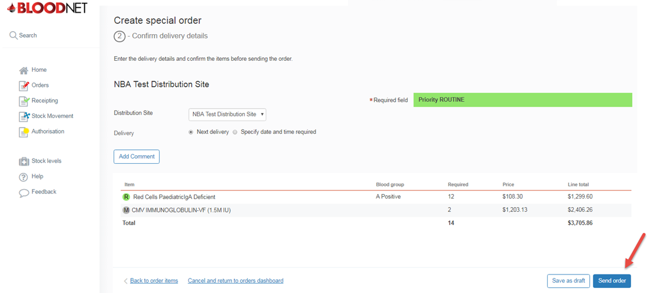
Important: If your order is Urgent or Life Threatening, you MUST select the appropriate priority. Do not write the priority in the comments box. All Urgent or Life Threatening orders MUST be followed up with a phone call to your local Blood Service Customer Delivery. Contact details are located on the top right of the BloodNet homepage.

