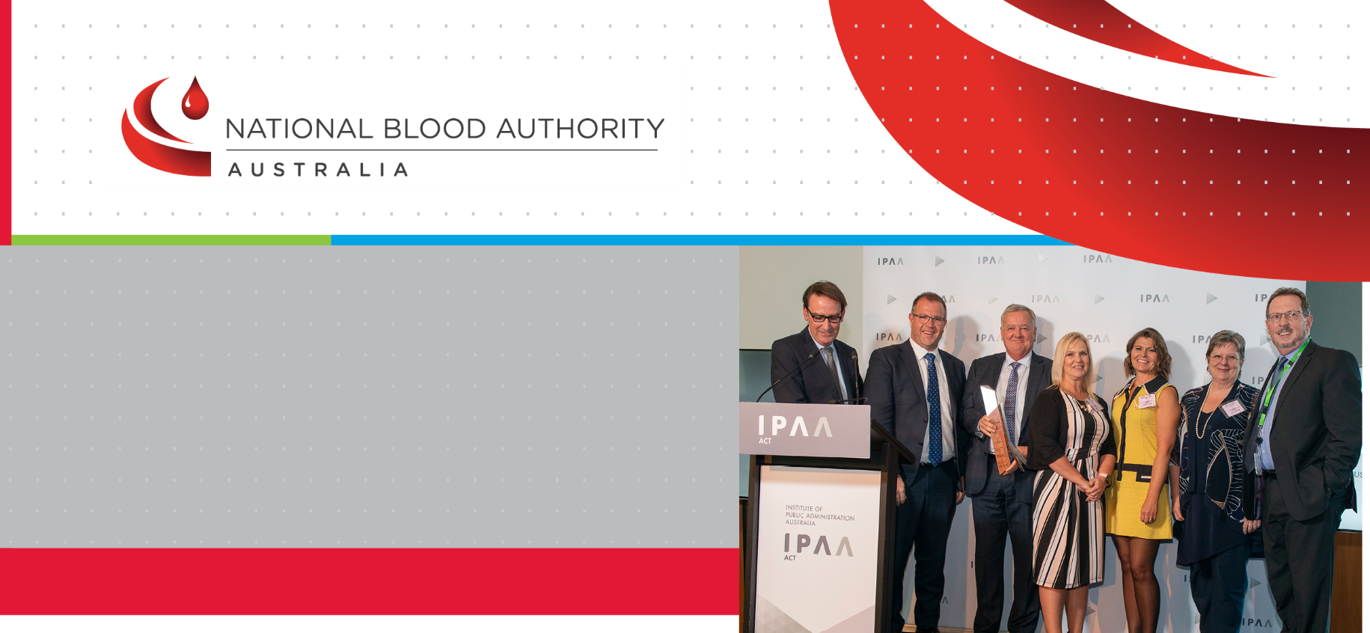
Australia’s National Blood Authority has been presented with the 2019 Prime Minister’s Silver Award for Excellence in Public Sector Management for its work in developing and implementing Australia’s National Immunoglobulin Governance Program.

MEDIA STATEMENT : 18 November 2019

National Blood Authority wins the Prime Minister’s Silver Award for Excellence in Public Sector Management for 2019
The Award is given by the Institute of Public Administration Australia (IPAA), and was presented by The Hon Ben Morton MP, Assistant Minister to the Prime Minister and Cabinet, and Dr Steven Kennedy PSM, Secretary of the Treasury and IPAA ACT President, at a ceremony at Parliament House in Canberra on 13 November 2019.
The National Blood Authority was amongst 46 entrants from Commonwealth, State, Territory and local government departments and agencies across Australia, and one of 22 shortlisted entrants. Six awards were presented at the ceremony. More information on all entrants and the other awards presented can be found at https://www.act.ipaa.org.au/pmaward-winners-19 .
The National Blood Authority has ensured uninterrupted supply of immunoglobulin products in Australia since 2004. The continuous and increasing demand for immunoglobulin has presented challenges for security of supply and affordability.
These challenges have been met through the National Immunoglobulin Governance Program, supported by a national online management reporting system, BloodSTAR. Together, the Program and BloodSTAR deliver an integrated, dynamic, rules-based system that is based on revised criteria for the clinical use of immunoglobulin in Australia. The initiative was implemented nationally in late 2018.
The Award judges were impressed by the strong commitment of the NBA to working collaboratively with a complex set of stakeholders to take a user-centric development approach to the Program.
The innovative approach in developing this governance program delivers a world-first national arrangement to support clinical treatment for patients using precious, high cost immunoglobulin products made from donated blood plasma.
This project has been delivered successfully within the resourcing provided through the national blood budget. It has already delivered a moderation in the annual increase of demand for immunoglobulin products from a long term average of 11% per year to 7.2% in 2018-19, while maintaining access to immunoglobulin therapy for patients within a wide range of chronic and acute immunological, neurological, haematological, transplantation and other clinical contexts.
www.blood.gov.au

Visit www.blood.gov.au to download NBA publications or
to access more information about NBA activities.

In accepting the Award, the Chief Executive of the National Blood Authority, Mr John Cahill, highlighted both the fundamental importance of blood products derived from individual acts of blood donation for numerous critically and chronically ill patients throughout Australia each year, and also the significant challenges of ensuring a secure, cost effective and sustainable supply of blood products—the cost of immunoglobulin products alone representing more than half of the $1.3 billion national budget for blood products in Australia each year.
Mr Cahill emphasised the invaluable contribution of the many specialist clinicians, nurses, transfusion scientists, patient representatives, patients and other experts and stakeholders, along with collaborators from the Australian Red Cross LifeBlood and all Commonwealth, State and Territory health departments, for the successful development and implementation of the Program.
Mr Cahill also paid tribute to the work of all NBA personnel who have worked with great commitment on the Program over a significant period of development and implementation, and highlighted the passion, dedication and enthusiasm of staff generally for their work at the NBA. Mr Cahill underlined the Program as an excellent example of what a small, agile agency is able to achieve through maintaining a clear focus on objectives and outcomes, and working very effectively in an open and collaborative way with a wide range of partners.
The National Blood Authority was a previous winner of a Silver Award in the 2006 Prime Minister’s Award for Excellence in Public Sector Management and has also been a recipient of a United Nations Public Service Award in 2010. It has received numerous other awards for important projects and programs and the National Immunoglobulin Governance Program was also recognised earlier in 2019 with Australian Business Awards for Business Innovation and Supply Chain Management.
Extensive information on the National Immunoglobulin Governance Program, and Australia’s arrangements for the supply of blood products generally, can be found on the NBA website at www.blood.gov.au . For further information please contact Mr Michael Stone, NBA Deputy Chief Executive, telephone 02 6151 5003.

Visit www.blood.gov.au to download NBA publications or
to access more information about NBA activities.

www.blood.gov.au

