MODULE 2:
MANAGING INTRAVENOUS AND SUBCUTANEOUS IMMUNOGLOBULIN INVENTORY

MODULE 2:
MANAGING INTRAVENOUS AND SUBCUTANEOUS IMMUNOGLOBULIN INVENTORY CONTENTS

Version 2 : September 2018

Introduction 3
Role of the dispenser 3
Keeping appropriate inventory levels 4
Ordering 5
Dispensing 8
References 10

Introduction
Immunoglobulin (Ig) product is a precious and high cost resource requiring careful management. Ig may only be supplied to eligible patients authorised under the Criteria for the clinical use of immunoglobulin in Australia¹ (Criteria).
The purpose of this Module is to assist health providers in meeting the requirements of the Ig Governance National Policy² (National Policy) by:
- describing how to establish and manage stock levels
- outlining the Ig product ordering models
- identifying different methods to determine ordering requirements/trigger
- providing recommendations for good practice
This guidance should be read in conjunction with the basic overarching inventory management principles provided in Managing Blood and Blood Product Inventory: Guidelines for Australian Health Providers.³
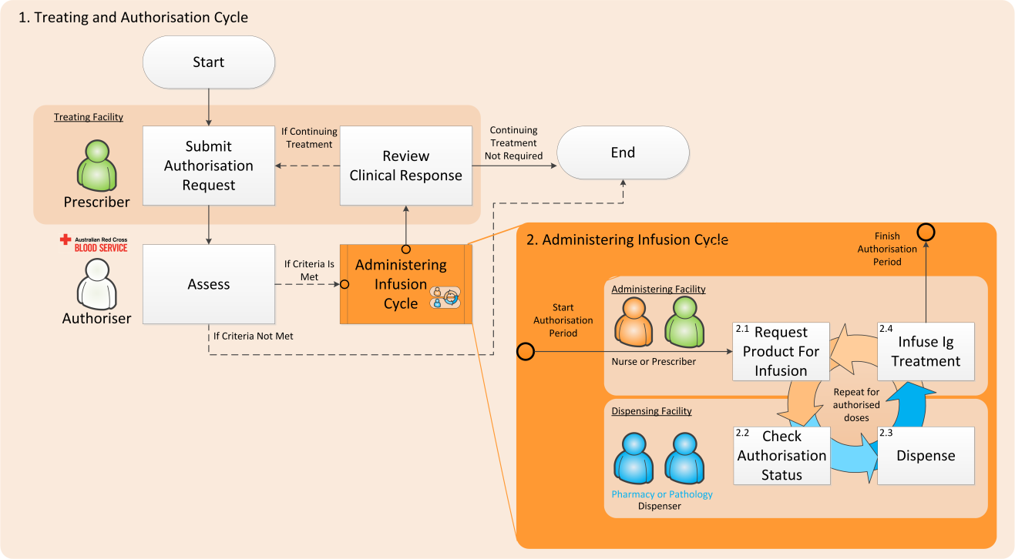

Role of the dispenser
The terms dispenser and dispensing facility are used to describe the area (pathology, pharmacy etc.) that has the primary responsibility for product ordering according to clinical demand, ensuring cold chain integrity, inventory management and dispensing of Ig products to authorised patients only. The activities of the dispenser may be assisted by a coordinating nurse or ward role but the responsibility should be centralised at the dispensing facility.

The dispenser is responsible for:
Why is good Ig Inventory Management important?
- Promotes safe, high quality management and use of immunoglobulin products
- Ensures that the right immunoglobulin products are available for your patients at the right time
- Good inventory management is required as outlined by the expectations set out in the Australian Health Ministers’ Statement on National Stewardship Expectations on the Supply of Blood and Blood Products (the Stewardship Statement), issued on 12 November 2010⁴
- product ordering from the distributor (the Australian Red Cross Blood Service [Blood Service]), in BloodNet
- inventory management within the dispensing facility and;
- dispensing product to the treating facility for use by authorised patients only, in accordance with the Ig access arrangements.
The dispenser is responsible for ensuring every vial of Ig product ordered, held and dispensed goes to a patient with a current authorisation, unless otherwise arranged in accordance with the National Policy.
!

Keeping appropriate inventory levels
Holding more products relative to your use can often contribute to higher wastage rates. The key to good inventory management is balancing sufficient inventory to meet clinical need while keeping wastage rates, and therefore costs, at a minimum. Stock levels should be set based on what you are going to require over a certain period of time for your authorised patients. You can use your Ig Stock Requirements Forecast Report* in BloodNet to understand the amount of product you have planned to dispense or requested, or the Issues Report (INV002) to review how much product has previously been issued to you over a given period of time, to help you decide how much stock to hold for the period of time that you define. You should also take into account your storage space, supplier delivery schedule and staff rosters for those that process and manage the inventory. Consideration can also be given to holding small quantity of additional stock for contingency use (for any new or existing patients who require urgent product), for example in smaller remote sites where deliveries may be infrequent.
Dispensers should not hold in excess of one month supply of IVIg or two months’ supply of SCIg.
!
As stewards of this expensive and precious resource, dispensers need to regularly review and minimise their inventory holdings to prevent expiry related waste and stock hoarding. If you are a dispenser who only manages authorisations infrequently you should consider not ordering a stock and only ordering on demand.
*Note: As at September 2018, the Ig Stock Requirements Forecast Report is under redevelopment.

Ordering
Product ordering by the dispenser must be done through BloodNet to track and close the information loop for Ig product management and should be based on clinical demand for authorised patients. Orders should be coordinated with information from planned patients or dispense requests for authorised patients. Before placing an order for more Ig product, the dispenser should always consider their current stock on hand and only order enough product to cover authorised clinical demand up until their next order.
Dispensers, Prescribers and Nurses may need to establish protocols to communicate with one another about when product is required, in order to establish ordering patterns to ensure adequate stock to meet clinical demand.
Things to consider when ordering
- Product authorisation – what is the amount of product required and when is it required (planned or requested dispenses))
- Ig product usage rates (history)
- Geographic location (distance from supplier and time to deliver)
- Frequency of deliveries
- On-site storage arrangements
- Supply to other health providers (e.g. hub and spoke arrangements)
- Local protocols on how dispense requests are triggered
The Ig Stock Requirements Forecast Report in BloodNet allows users to enter a date in the future to calculate the required quantities of product to cover the dispenser for authorised clinical demand up until the entered date.
To ensure compliance with the Privacy Act (Cwlth), all orders for Ig products placed in BloodNet must be placed as Stock Orders (i.e. no patient details supplied).
Reconciliation of dispensed product against patient authorisations is undertaken periodically at the health service level by the dispenser, not by the Authoriser (Australian Red Cross Blood Service).
There are two different models the dispenser can use when placing product orders.
a) Stock replenishment
This model uses a set target for inventory level and is best suited for dispensers that use a large amount of product, place orders at regular intervals and the forecast stock requirement is steady from one ordering cycle to the next. The stock replenishment model is based on a regular pattern of planned infusions, and allows the dispenser to hold a consistent level of inventory between cycles. The dispenser should have a good understanding of their regular average use for the order cycle frequency, and set an appropriate inventory maximum target level in BloodNet. It is important for dispensers using this model to regularly review their inventory targets against actual infusion plans and dispense requests to account for any changes to requirements, including any changes to domestic/imported product allocation.
Method:
Stock required = Inventory target level minus current stock on hand
b) Scheduled infusions
This model is best suited for dispensers that use a small irregular amount of product. There is no standard target level of inventory maintained by the dispensers using this model.
Before ordering, the dispenser should review the BloodNet authorisations tab for planned or requested dispense requirements for authorised patients for that ordering period. The Ig Stock Requirements Forecast Report* may also be used. The dispenser assesses the stock required for that period against how much stock they have on hand and subtracts this from the required stock to get the quantity to enter into the Stock Order template in BloodNet.
Method:
Stock required = Forecasted stock requirements for desired period minus current stock on hand
Regardless of model used, the dispenser is responsible for ensuring that every vial of product ordered and dispensed only goes to an authorised patient, unless otherwise arranged in accordance with the National Policy.
!
If a dispenser anticipates that there may be a significant increase in demand they are advised to contact and inform the Blood Service so that the monthly stock ordering the Blood Service manage with the NBA can be closely monitored.

Examples
Dispenser A (Stock Replenishment)
Dispenser A gets their Ig replenished every second day during the week. They examine their weekly dispense requests from the nurses via BloodSTAR which are usually submitted a week in advance of scheduled infusions. The average requirement remains fairly consistent from week to week meaning that they are happy to have a regular set target for stock holdings. This target has been set as a maximum stock level in BloodNet.
Every second day the dispenser would place an order based on their required target minus their current stock on hand.

Dispenser B (Scheduled Infusions)
Dispenser B places their orders once a week and they receive dispense requests from the nurses via BloodSTAR a week in advance of scheduled infusions. The amount of product required based on these dispense requests can vary significantly from week to week. Before ordering, the dispenser would check the dispense requests in BloodNet to determine the quantity of Ig required for that week. If the required product quantity is already available in inventory, there is no need for an order. However if inventory stock is less than the required quantity, the dispenser would then calculate the difference and place a BloodNet stock order.
Note: Instead of using dispense requests, the dispenser can choose to use the planned authorised patient list for the facility for a certain period to place an order.

Dispensing
To ensure accurate dispense reconciliation in BloodSTAR, product should be allocated to patients at the time of dispense, and not upon receipt into inventory.
!
Ig must only be dispensed against planned infusions or dispense requests for authorised patients, except in exceptional circumstances as outlined in the national policy. The dispenser should review the dispense request for accuracy and take into account any past or current variations noted in the planning sheet/infusion plan. Product should only be dispensed where:
- it is for a patient with a current authorisation
- the requested product type is the authorised product type
- the quantity matches or is less than the authorised quantity
- the interval since the last infusion matches the authorised interval
OR
- there is a justifiable reason to which a dispense request is outside of the infusion plan. i.e. the patient fails to turn up on time (Note: this will require action in BloodNet as it will result in a dispense discrepancy).
When dispensing Ig product, Dispensers should issue product in accordance with the Immunoglobulin Governance National Policy.
It is important to record dispensing information in BloodNet via the Authorisation tab to ensure the patients’ treatment plan in BloodSTAR is updated and there is traceability of product dispensed to patients in case of product recall and to reconcile dispense records with authorisations to identify, investigate and correct anomalies. Dispensers will need to perform reconciliation of dispense records where that dispense episode does not match details of an authorisation in BloodSTAR, because the timing, dose or product is not as expected. This will involve the dispenser regularly checking both the Dispense Discrepancies and Unmatched Fate Episodes (for LIS facilities only) on a regular basis and ensuring that any pending items under both menu items are actioned.
Reconciliation of dispense records should be done as frequently as possible to ensure appropriate follow-up of dispense episodes that cannot be matched to authorised dispense requests.
!
Any Ig product that has been dispensed but not used should be returned to the Dispenser, deallocated and returned to stock against that patient via the BloodNet Authorisation module. Clinical areas, other than the Dispenser, should not hold an inventory of Ig product. Dispensers should consider regular audits of clinical areas to ensure all unused Ig product has been returned.

Dispensing product where patient authorisation has not been obtained
Refer to the Ig Governance National Policy
Where Ig product is dispensed and patient authorisation has not been obtained for the approved supply of funded immunoglobulin product under the national blood arrangements:
- where the dispenser holds imported product, imported product only should be dispensed.
- an authorisation request must be submitted within seven business days through BloodSTAR and supply approved under the national blood arrangements otherwise the hospital/ health facility may be invoiced directly for the full cost of the product in accordance with the jurisdictional direct order (JDO).
For more information about JDO and other supply arrangements, please refer to the NBA website at http://www.blood.gov.au/Intravenous-Ig. Please ensure you refer to local state/territory policies, where these exist.

References
- Criteria for the clinical use of immunoglobulin in Australia at https://www.criteria.blood.gov.au
- Ig Governance National Policy: Access to Government Funded Immunoglobulin Products in Australia at http://www.blood.gov.au/Ig-program
- Managing Blood and Blood Product Inventory: Guidelines for Australian Health Providers at http://www.blood.gov.au/inv-mgt-guideline
- Australian Health Ministers’ Statement on National Stewardship Expectations on the Supply of Blood and Blood Products (the Stewardship Statement), issued on 12 November 2010 at https://www.blood.gov.au/stewardship
12092018

