Searching for Dispense Episodes
- To search for a dispense episode click on the ‘Authorisation’ tile on the BloodNet homepage.
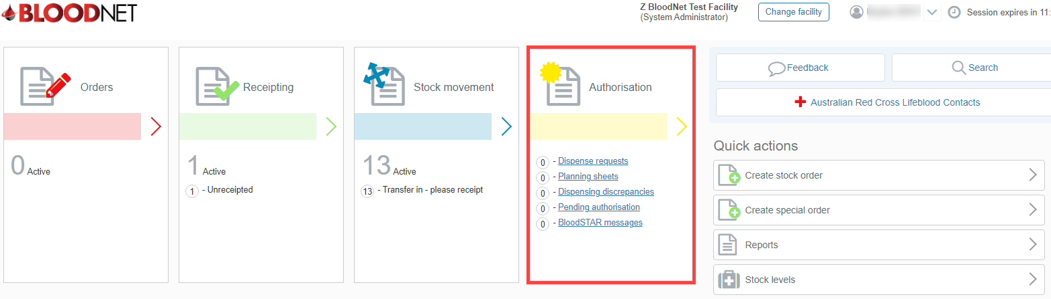

- From the Authorisation Dashboard click on the ‘Dispense Episodes’ hyperlink.

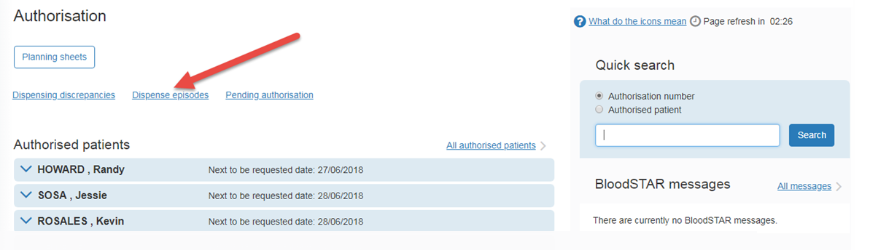

- The ‘All authorisation dispense episodes’ page displays your facility’s dispense episode history. To search for a specific dispense episode, enter the patient’s details into the Authorisation number and/or Family and/or Given name search fields and click on the Search button. You can also enter a Date range to search for dispense episodes created during a specific time.

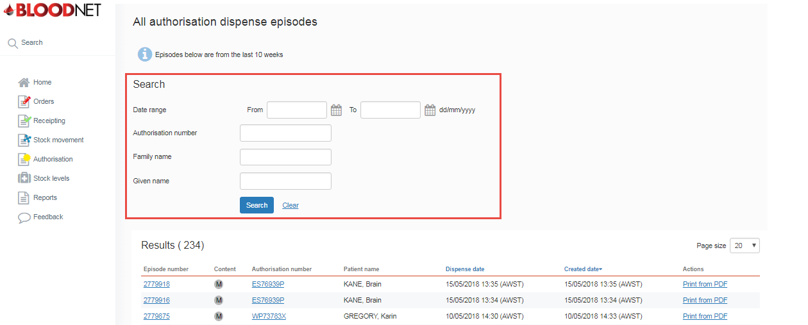

- From the Results list click on the Episode number to view the information about the dispense episode which includes the type of episode (Dispense or Return to stock) and details of the component / product(s) involved. You can also click on the Authorisation number to view the details of the authorisation.
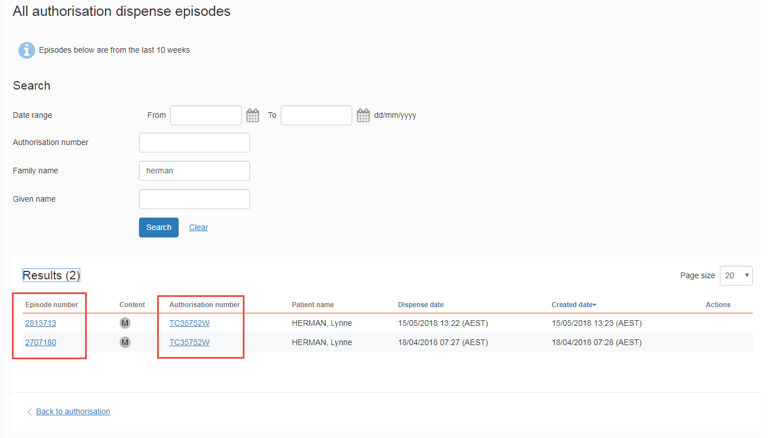

- The view Dispense/Return to stock episode page.
