5

Registering and Requesting Access to BloodNet

Purpose

This Tip Sheet is designed for people who access BloodNet at their facility and therefore need to create an individual login to the BloodPortal to enable them to access BloodNet. Individual logins are essential for BloodNet to enable an appropriate audit trail to be developed to identify which officers undertook which actions.

Step 1

Navigate in a web browser to https://portal.blood.gov.au and click on New User? Create An Account as highlighted by the red arrow below.

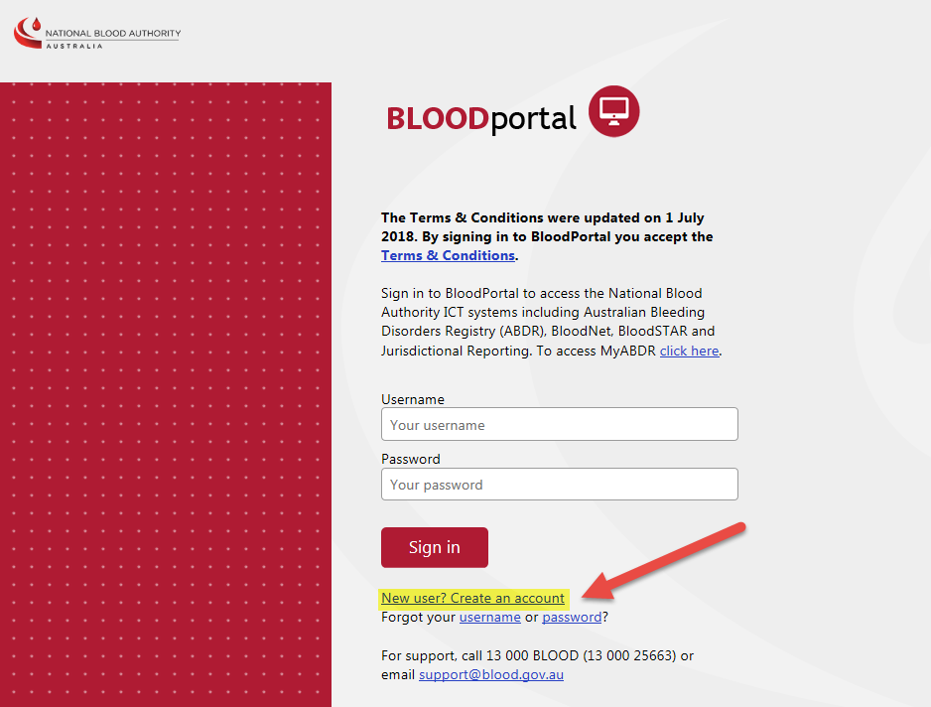

This will take you to the BloodPortal registration page shown below.

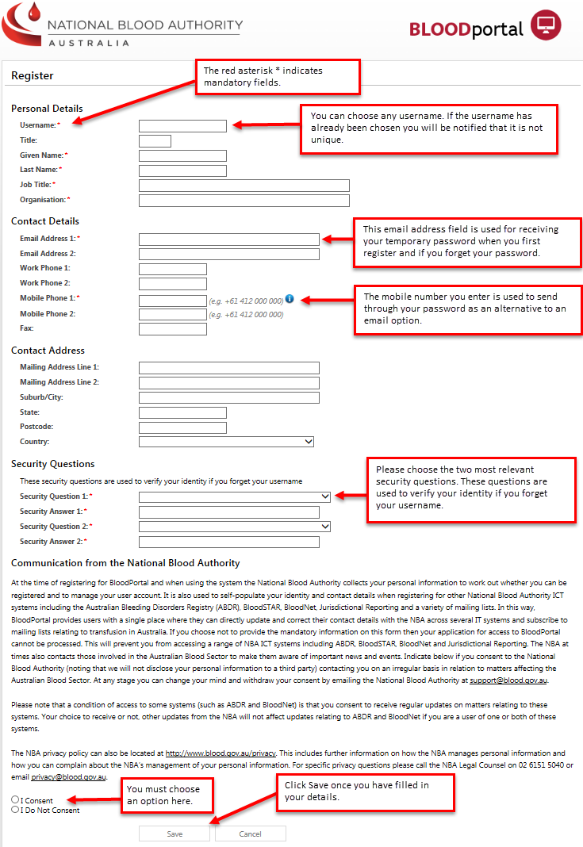

Step 2
After completing the form click the Save button. You will be presented with the screen below indicating that your account has been registered.

A temporary password will be sent through to your nominated email address and mobile phone number.
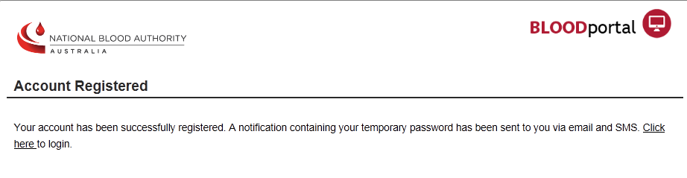
Step 3

You have now finished registering your BloodPortal account.

The next step is to login and request access to BloodNet. Navigate in a web browser to https://portal.blood.gov.au . You will need to enter the username you created for BloodPortal above and the temporary password you received via email or SMS. As this is the first time you are accessing the site you will be asked to change your password.
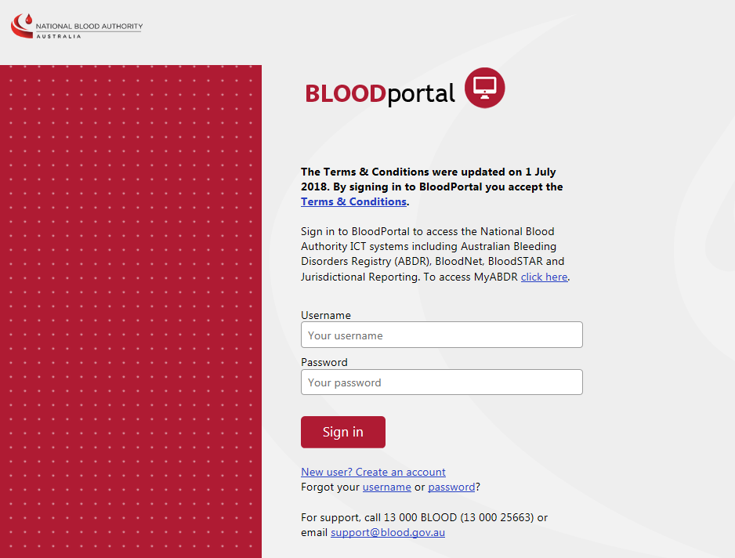

Important: Once you have created a BloodPortal account you can supply the facility administrator at your site with your username and they can grant you access using the Add user access function. Alternatively you may continue with the steps below to submit an access request.

Step 4

After logging in you will see the BloodPortal home page as shown below. From here you can access the BloodNet application page, Jurisdictional Reports and My Subscriptions for NBA Subscriptions. Please click on the BloodNet tile to request access to your BloodNet Facility as shown below. You will be directed to the BloodNet Request access page

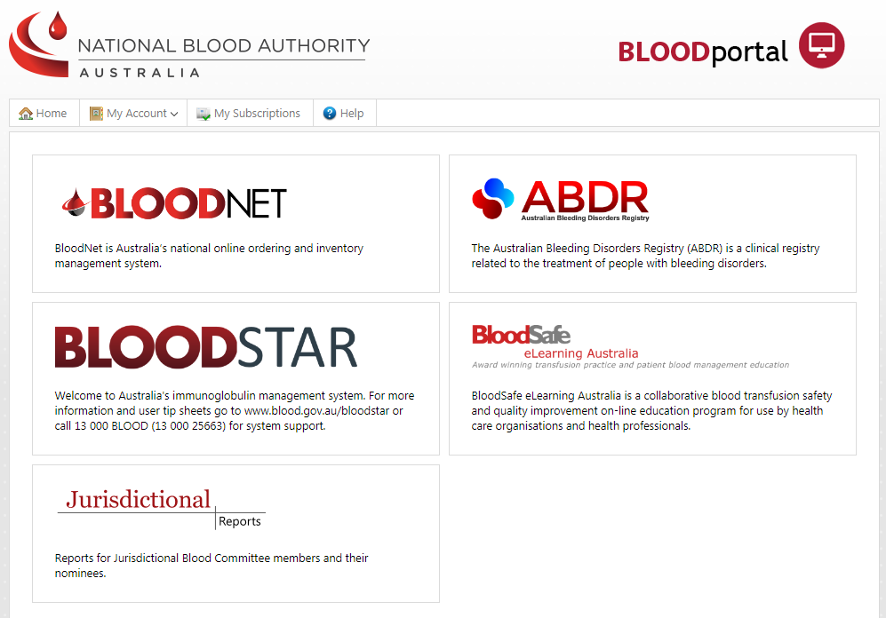
On the Access Request page click the Add facility access button and select your state/territory, facility and most suitable role from the drop down menus. Click the Add facility button to add the role and facility to your access request.
Please note, you can only have access to one role at each facility.

Available Roles to choose from include:

Facility read only
This role has limited access to only view information within BloodNet.
Facility user
This role has access to manage blood and blood products.
Facility administrator
This role has the same access as the Facility user role with additional administration rights.

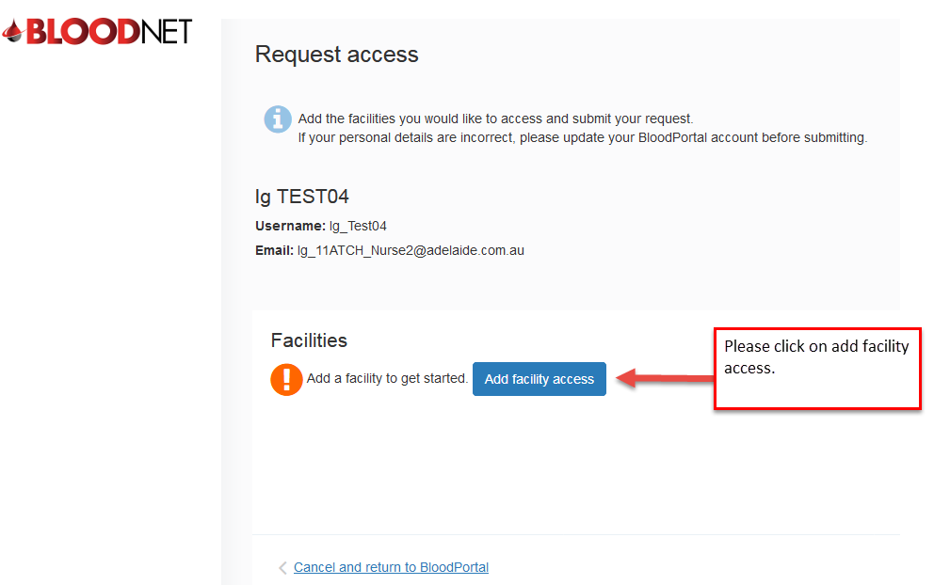

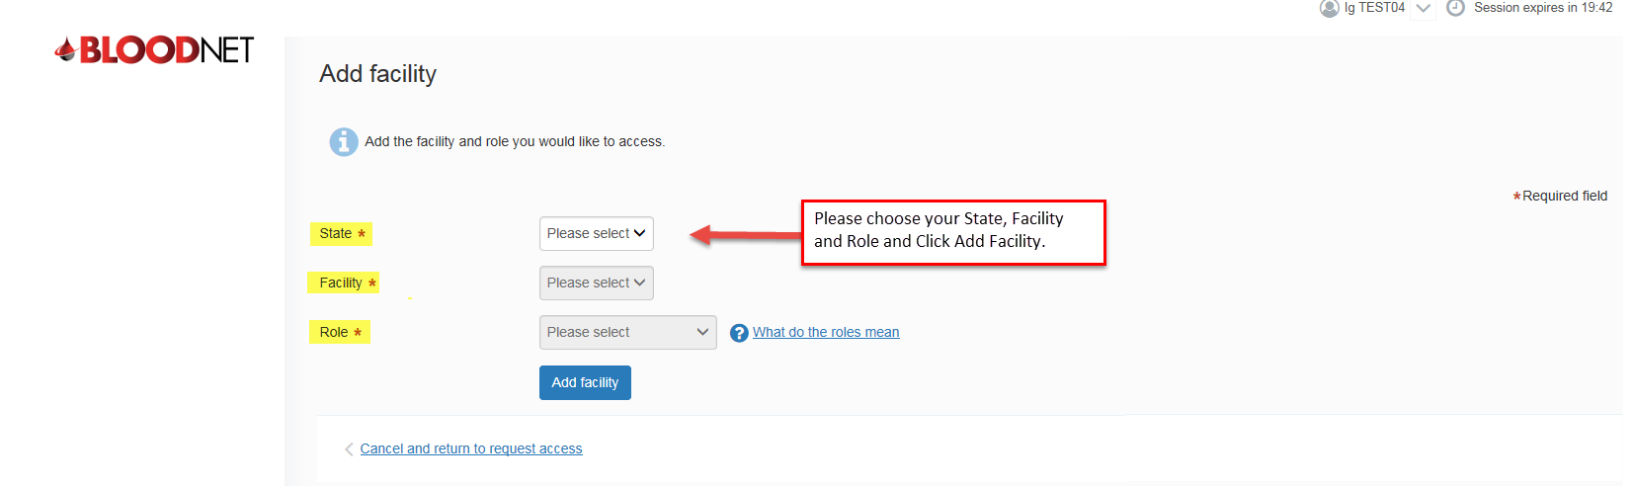

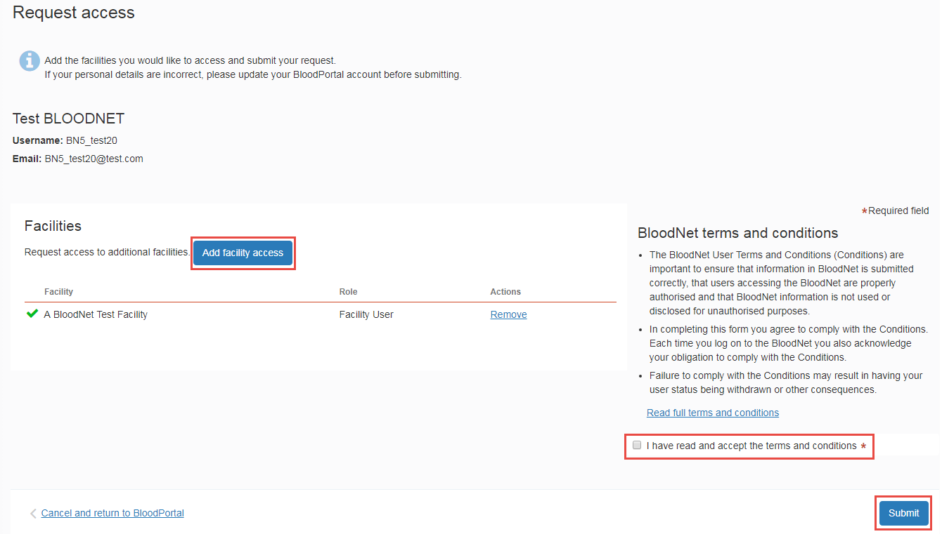

If you require access to multiple facilities you can click the Add facility access button and add as many facilities to your access request as required.

Next click on the Read full terms and conditions link to open the terms and conditions. Click the checkbox to confirm that you agree to the terms and conditions and then click the Submit button to submit your access request.

The facility administrators as your site will be notified of your request via email.

Step 5

Please wait for your facility administrator to approve your request. You will receive an email notification once your request has been assessed.

When a new BloodNet site is implemented, the initial facility administrator role is approved by the NBA. Outside of this situation the NBA will only approve access to facilities or LIS BloodNet sites in extenuating circumstances.

Your access request can be viewed by logging into your BloodPortal account and clicking on the BloodNet tile. Alternatively, if you already have access to BloodNet and are requesting additional access, log into BloodNet with you existing access, click on your username at the top right of your screen and then select My access details.

For Further Assistance

If you need further assistance please contact us on 13 000 BLOOD (13 000 25663) or email support@blood.gov.au

