
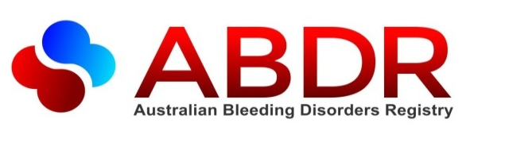

Consent to Privacy

What’s new?
On 26 January 2015 a new version of
MyABDR will be released. It will include
a new ABDR privacy consent form.
MyABDR app: After that date, when you use the app,
you will be prompted to update it and login.
MyABDR app and web site: when you login, you will be
asked to complete the new ABDR privacy consent form
before you can continue.
At your Haemophilia Treatment Centre (HTC):
Alternatively, your HTC may ask you to complete a printed
consent form.

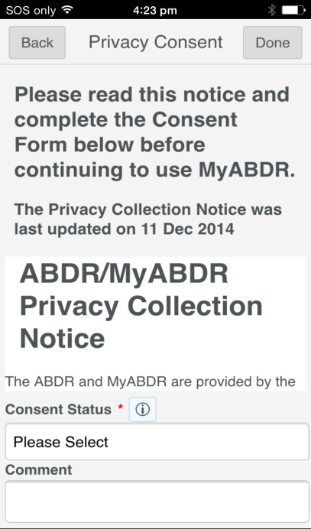

What is this all about?
The Australian national laws to protect your privacy have been made stronger.
As a result, you are now being asked formally if you consent or agree to have your personal information in the ABDR.
You may also be asked to consent on behalf of your child if they are the patient at the HTC and are under 18.
This is called an opt-in system
- It will make it clear whether you have agreed to have your personal information in the ABDR.
- You also have the opportunity to find out more about the ABDR and how your personal information is used and protected
In the past it was an opt-out system – your personal information was kept in the ABDR unless you asked for it not to be entered in the system. You may recall your Haemophilia Treatment Centre talking to you about the ABDR and giving you a pamphlet.
What is the ABDR?
The Australian Bleeding Disorders Registry (ABDR) is a computer database of health care information about people with bleeding disorders.
The ABDR is the system used by Haemophilia Treatment Centres around Australia for the clinical care of their patients.



What is the ABDR used for?
The ABDR helps your doctor and other health professionals in your treating team at the HTC to understand your care and treatment needs, and is used to check which treatments work best for you to improve your health and wellbeing.

People with bleeding disorders can contribute information to the ABDR through MyABDR. This helps in managing their health and treatment with their HTC.

Statistics from the ABDR can help specialist clinicians, researchers and advocates like Haemophilia Foundation Australia to study trends and patterns and work to improve treatment and care.

Statistics from the ABDR about the amount of treatment product being used can help the government to stocktake and plan for purchase of future supplies.
How is the ABDR kept secure?
The ABDR is protected with the highest level of security and there are strict controls to protect your privacy. See the ABDR/MyABDR Privacy Collection Notice in this leaflet for more information.

What do I need to do?
- If you already know about the ABDR and are comfortable with your data being included, you can complete the consent form
- You may wish to learn more about the ABDR and privacy first. Some sources of information are in the box below

- When you are satisfied you understand, complete the consent form.
MORE INFO
Finding out more about the ABDR and privacy
In this leaflet, read

ABDR/MyABDR Patient Information and Informed Consent
and the ABDR/MyABDR Privacy Collection Notice

Talk to your doctor or nurse at your Haemophilia Treatment Centre
Talk to the ABDR support team at the National Blood Authority (NBA)

Visit www.blood.gov.au/abdr
or call 13 000 BLOOD (13 000 25663)
or email abdr@blood.gov.au

What are my options?
If you are the patient at the HTC, you complete the consent form for yourself.
If you are a parent or legal guardian, you complete the consent form on behalf of your under-age child or the person who is the patient.

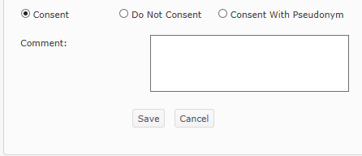

Consent
This means you understand and agree to have your (or your child’s) personal data in the ABDR.
Do Not Consent
This means you understand and do not want your (or your child’s) personal data in the ABDR.
Choosing this option will mean that the HTC cannot enter data about you (or your child) in the ABDR. You will not be able to use MyABDR. If you already use MyABDR, your access will stop.
A decision not to consent will not impact on treatment but your doctors and haemophilia treatment team will need to make different arrangements to access your (or your child’s) latest medical records. It would be valuable to discuss this with your HTC first before choosing this option.
Consent With Pseudonym
This means you understand and agree to have your (or your child’s) personal data in the ABDR, but under a different made-up name.
Choosing this option will send a message to the HTC requesting this option. You will need to contact the HTC to see whether they are able to set up a pseudonym and still properly manage your patient records. You will also need to discuss how this would work in situations such as care in other hospitals or health care settings or in emergencies.
Comment
There is also an option on the Privacy Consent Form to include comments for your HTC.

What if I change my mind?
The ABDR and MyABDR are voluntary and you can choose to opt in or out at any time. To change your ABDR and MyABDR consent status:
- If you completed a consent form at your HTC, or did not consent or consented with a pseudonym, contact your HTC directly.
- If you completed your consent on MyABDR, you can change your privacy consent status after you log into MyABDR.

NEED HELP?
Step-by-Step guides are available on the MyABDR web site – www.blood.gov.au/myabdr
SUPPORT
T: 13 000 BLOOD (13 000 25663)
E: myabdr@blood.gov.au
You can talk to your doctor or nurse at your Haemophilia Treatment Centre
For more information on MyABDR and ABDR, you can also contact
Haemophilia Foundation Australia
T: 1800 807 173 E: hfaust@haaemophilia.org.au
www.haemophilia.org.au/myabdr

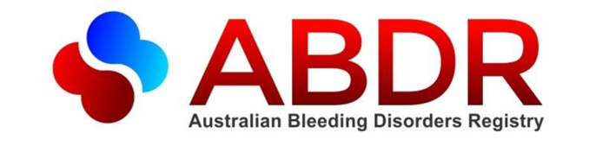

Information for patients
We request that you/your child register in the Australian Bleeding Disorders Registry (ABDR). If you/your child have been getting treatment and care for your/their bleeding disorder, you/they may already be registered, and we ask that you/your child continue being a part of the ABDR. Before you do, it is important that you understand what is involved and what will be done with the information you provide. This form contains answers to some of the questions you might have. At the end of this form is a section for you to sign to confirm you agree to participate. If you have any questions after reading this form, please contact the relevant person before signing this form. You will find a list of contact details on the next page.
Excerpt from the ABDR/MyABDR Privacy Consent Form
Patient Information and Informed Consent

What is the ABDR?
The Australian Bleeding Disorders Registry (ABDR) is a computer database of healthcare information about people with bleeding disorders. This information recorded includes your name and contact details, information about your health and treatments (such as your height and weight, diagnoses, treatment plan and use of treatment products), what health services you have used (such as doctors’ appointments and hospital admissions), and whether you faced any complications through your treatment.
The ABDR is not your hospital medical record. The ABDR is a special medical record about you and your bleeding disorder condition that is separate to other hospital and/or health care service medical records.

How will the ABDR help me?
ABDR helps your doctor and other health professionals in your treating team at your Haemophilia Treatment Centre (HTC) to understand your care and treatment needs, and is used to check which treatments work best for you to improve your health and wellbeing. If you travel, or move interstate, you can say if you want this medical record to be available to specified staff in HTCs around Australia. The ABDR also helps Government to plan so that there are enough treatment products in Australia to meet the needs of all patients with bleeding disorders.

I have heard of MyABDR. What is it?
MyABDR is a secure app for smartphones and a computer website for people with bleeding disorders or parents/caregivers. The MyABDR app and website link directly to the ABDR. You can use MyABDR to record home treatments and bleeds and manage treatment product stock. If you don’t want to use the app or website, you can use the MyABDR paper-based treatment diary. No other apps, websites or treatment diaries will link directly to the ABDR.
If you agree to use MyABDR, you will enter the information about your bleeds, treatment and product stock using the app or website. The information you enter into the MyABDR app or website will be available in the ABDR system used by your treatment team at your HTC as soon as you transmit it. You will be able to check all the information you enter later on the app or website.
You can get more information about MyABDR from your doctor at your HTC or by visiting http://www.haemophilia.org.au/foundationsandservices/myabdr.

Which patients can join the ABDR?
Australians diagnosed with a bleeding disorder are eligible to join. These bleeding disorders include:
Haemophilia A, B, and C | von Willebrand disease (1, 2, 2A, 2B, 2M, and 3)
Other factor deficiencies (e.g. Factor II, V, X, XII, XIII) | Fibrinogen disorders
(A)Symptomatic carriers (Haemophilia A and B) | Platelet disorders
Acquired bleeding disorders | Vascular disorders

What do other patients think of the ABDR?
The ABDR is not new – it has been around since 1988 when it was first funded by the Haemophilia Foundation Australia (HFA). There are now more than 5000 patients in the ABDR, which includes most HTC patients in Australia. They think it is important for their information to be in the ABDR so that they get the treatment and care they need. The ABDR is now provided by the National Blood Authority, an Australian Government Agency.

How do I register for the ABDR or MyABDR?
If you consent to being included in the ABDR, then your treating doctor and treatment team at your HTC will register you and give you a copy of this form to keep if you want to look at it again later. If you would like to register for MyABDR at a time convenient to you, then go to http://www.blood.gov.au/myabdr.

What if I don’t want to be in the ABDR, will it affect my treatment?
The ABDR is completely voluntary. You can opt out of the ABDR at any time. If you choose not to be in the ABDR then this will not impact your treatment. However, your doctor and haemophilia treatment team at HTCs around Australia will not be able to readily access your latest medical records as easily as they can if you are a part of ABDR. It will also be harder for the National Blood Authority to accurately forecast what products are required to treat people with bleeding disorders in Australia.

What about my privacy?
Any personal information about you that is collected and held in the ABDR is protected by law, including the Privacy Act 1988 (Cth). The attached privacy collection notice explains how your privacy and personal information is protected.

Who can I contact if I would like more information?
You can get further information and assistance about ABDR or MyABDR from:
- The ABDR support team at the NBA - visit www.blood.gov.au or call 13 000 BLOOD (13 000 25663) or email abdr@blood.gov.au
- The Australian Haemophilia Centre Directors’ Organisation (AHCDO) - visit www.ahcdo.org.au or call (03) 9885 1777 or email info@ahcdo.org.au

Endorsements
Endorsement from Haemophilia Foundation Australia (HFA)
Haemophilia Foundation Australia supports the ABDR. It helps doctors and other treating health professionals to understand more about the care and treatment needs of people affected by bleeding disorders. The ABDR will assist and guide planning to ensure treatment product is available when it is needed. We are confident the steps in place will mean accurate, reliable and confidential data is available and that your personal information is protected.
www.haemophilia.org.au
www.haemophilia.org.au

Endorsement from Australian Haemophilia Centre Directors’ Organisation (AHCDO)
The ABDR is a valuable tool that provides a summary of those affected with haemophilia and other bleeding disorders in Australia. Data from the ABDR is the best information available for clinicians to advise governments making policy decisions regarding treatment needs and product availability.
National statistics available through the ABDR will give AHCDO an overview of practice and allow opportunities for improvement. This data can be pooled to compare Australian treatment standards with international benchmarks. The ABDR will continue to provide the ability to assess quality of life and other important clinical questions arising across Australia.
AHCDO’s partnership on this initiative with the National Blood Authority, Haemophilia Foundation Australia and other specialist health professional groups is vital to the pursuit of excellence in clinical treatment practices.
www.ahcdo.org.au
ABDR/MyABDR Privacy Collection Notice
The ABDR and MyABDR are provided by the National Blood Authority (NBA) which is an Australian Government agency responsible for the supply of blood and blood products in Australia. The NBA provides the system in cooperation with individual Haemophilia Treatment Centres (HTCs) around Australia, the Australian Haemophilia Treatment Centre Directors’ Organisation (AHCDO) and Haemophilia Foundation Australia (HFA).
This notice explains how your personal information in the ABDR and MyABDR will be managed and protected. A copy of the NBA’s privacy policy can be found at http://www.blood.gov.au/privacy. This policy gives more details on how the NBA manages personal information and how you can make a privacy complaint to the NBA.

Why is my personal information collected?
The personal information about you that is collected in the ABDR and MyABDR includes your name and contact details, your diagnoses and treatment plan as well as your height and weight, what other health services you may use in your treatment of your bleeding disorder (such as physiotherapy, pathology and your doctor’s appointments), the treatment products you receive, and whether you had any complications from your treatment.
This information is not your complete medical record. Rather, it is a special record of you and your bleeding disorder that your treatment team at your HTC can use to give you the best care and treatment for you. This information is also important for the NBA to make sure enough blood products are available to you when you need it. If you choose not to be in the ABDR then this will not impact your treatment. However, your doctor and haemophilia treatment team at HTCs around Australia will not be able to readily access your latest medical records as easily as they can if you are a part of ABDR. It will also be harder for the National Blood Authority to accurately forecast what products are required to treat people with bleeding disorders in Australia.
Sometimes, your treating HTC, other health professionals who treat you, the NBA and/or research staff from HFA and Australian Haemophilia Centre Directors’ Organisation (AHCDO) may require reports using your information from the ABDR. These reports are used to help improve healthcare practice and to forecast and plan Australia’s clotting factor supply. Reports that are published from ABDR will only give statistics and/or summaries that do not identify individuals. Therefore, you will never be identified from these reports.

What happens when I give my consent for the ABDR?
You can consent to being included in the ABDR either directly with your HTC by signing this consent form or by registering for MyABDR online. When you do so, from that point, staff at your HTC will enter your health and personal information that identifies you in the ABDR. This will include any information you enter into the MyABDR app or website. Once your information has been entered into the ABDR, it becomes an up-to-date record about your bleeding disorder condition that is used by your treatment team for your health care and the administrative support staff at your HTC to maintain an accurate record.

Who will access my personal information?
The ABDR Steering Committee manages the security and access to the ABDR so that only authorised users have access to the ABDR. This committee is made up of representatives of AHCDO, NBA, a State or Territory Government representative and HFA. The Steering Committee grants access to authorised staff of the NBA, AHCDO and HFA. This access is limited, controlled and managed to make sure the data is reliable, that the ABDR is used correctly, and/or provide reports for quality assurance and for research.
- Authorised NBA staff provide technical and user support for the ABDR and MyABDR, assist in managing the integrity of the data entered into the ABDR, and extract information for approved reports and research
- Authorised AHCDO staff help co-ordinate data entry at HTCs, and support good healthcare practice to improve the health and wellbeing of patients

Research is currently limited to developing clinical guidelines and undertaking benchmarking to improve treatment and care for people with bleeding disorders. Any additional research using information in the ABDR will only be undertaken in accordance with the requirements of the Privacy Act 1988 (Cth).
How can I be confident that my personal information is protected?
Maintaining your privacy and appropriate confidentiality is a top priority to us and strict security rules, managed by the ABDR Steering Committee, are in place to guarantee patient privacy is maintained at all times. Only authorised staff from your HTC, the NBA and AHCDO can directly access your data to perform specified roles. Your information is kept on the ABDR database which is physically located in a secure data centre in Australia. These procedures protect your information from misuse, unauthorised access, interference, alteration, loss and/or disclosure.

Do I have to use my name to be included in the ABDR?
If you would prefer to be known by a name that is not your actual name (i.e. a pseudonym) for the purposes of your record in the ABDR and your registration in MyABDR, then you can do so if your HTC is able to implement this option without impacting on their ability to properly manage your records. Your HTC will still need to identify who you are to make sure the right information from your HTC medical record is entered into your ABDR record. If you choose to use a pseudonym in the ABDR then you will need to talk to your HTC about the availability of this option. Any MyABDR registration will then need to link to this ABDR record, by using the same pseudonym.

Can I access my personal information?
You have the right to access and seek correction of your personal information on the ABDR, in accordance with privacy laws. Your HTC is generally the best place to go first to access and seek changes to your personal information. If you are unhappy with the response from the HTC, you can contact the privacy commissioner in your State or Territory. You may also contact the NBA at privacy@blood.gov.au.

If I have changed my mind, how do I opt out of the ABDR?
The ABDR and MyABDR are voluntary and you have the choice to opt out at any time. If you gave consent to be included in the ABDR directly to your HTC then you will need to opt out by contacting that HTC directly. If you only consented to be included in the ABDR through registering for MyABDR, then you can opt out of both ABDR and MyABDR by changing your privacy consent status when you log onto MyABDR. Once you change your status on MyABDR then you can no longer enter your information into the app or website.

January 2015

