Actioning Dispensing Discrepancies

Dispensing discrepancies are created when an Immunoglobulin product is dispensed for a patient outside of the authorisation constraints. If the dispense discrepancy reason is valid, you can resolve the discrepancy and provide justification. If the product was dispensed incorrectly, it can be returned to stock via the patient’s authorisation. This tip sheet will explain how to action dispensing discrepancies in BloodNet.

- Click on Dispense discrepancies hyperlink from your BloodNet home page.
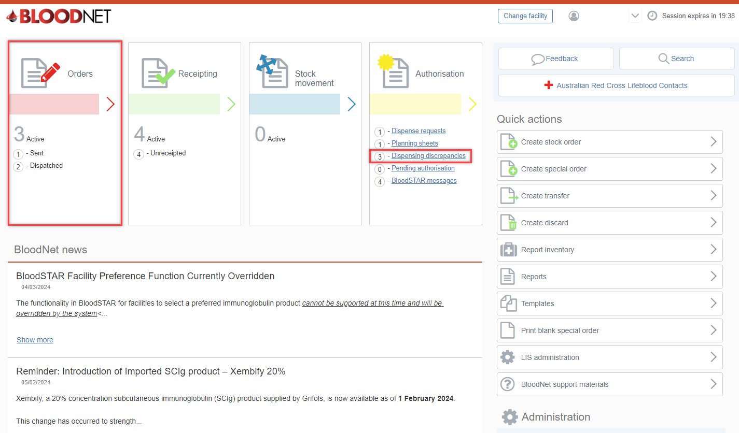

- The Dispensing discrepancies page will display a list of pending discrepancies. The blue hyperlinks give you the option to click into a patient’s authorisation, view treatment episode and resolve a discrepancy.
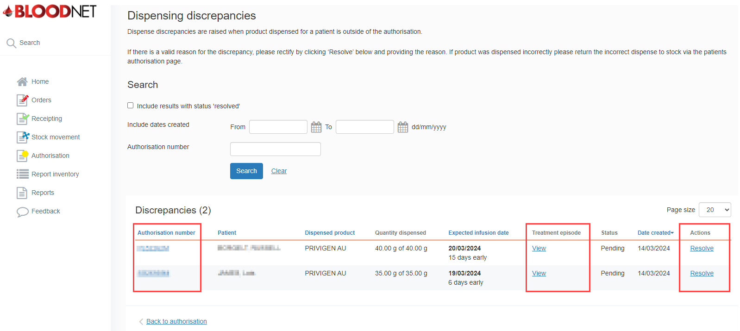

- To resolve a discrepancy, click the Resolve hyperlink beneath Actions. A window will open on the screen that will give you the option to record a Justification for the discrepancy. Enter the reasoning in the text box and click the OK button.

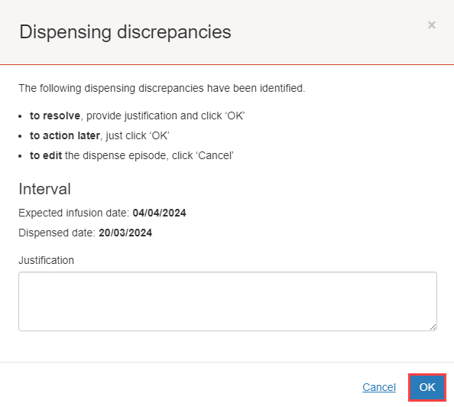

- If the discrepancy occurred due to an incorrect dispense then you can click on Authorisation on the left of the screen to view the patient’s authorisation. This will allow you to view the patient’s treatment plan and complete a Return to Stock episode. This will remove the discrepancy.
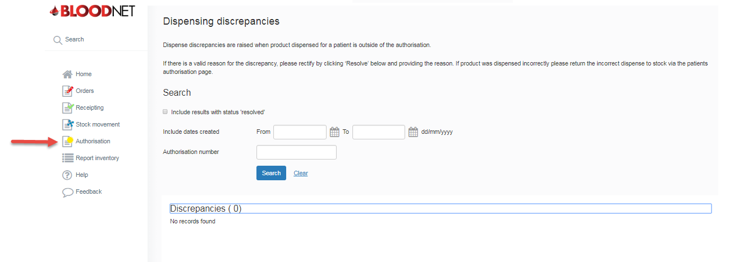

Note: Email reminders for dispense discrepancies older than 48 hours will be sent to all active facility administrators on a weekly basis. Facility Administrators should use this email to remind staff to resolve any dispense discrepancies in a timely manner. Example email shown below.
It is recommended for Facilities to have two facility administrators at all times.

