Creating a Special Order
Special orders are placed when a fresh product is required to have specific modifier(s), antigen requirements or if there is a need for it to be provided to you from a state-local Australian Red Cross Lifeblood Customer Service Delivery site for a specific patient.
Please note: Patient information is not a mandatory requirement and should only be included if absolutely necessary for the order.

Perform the following procedure to Create a Special Order in BloodNet:
Create a Special Order
- Select the Orders tile located on the left of the home page.
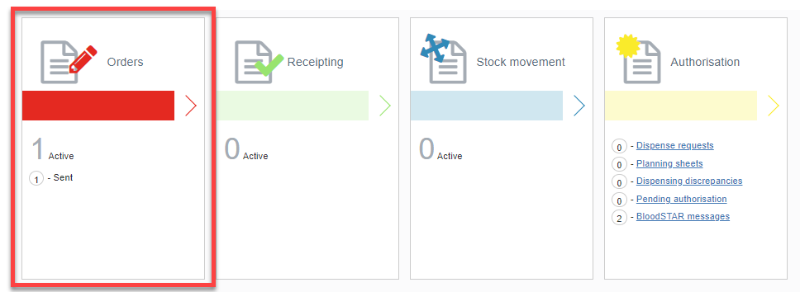

- Select the Create special order button.
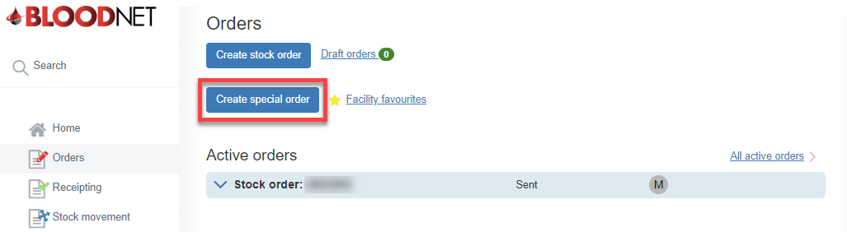

- Add the required items by selecting Add component or Add product.
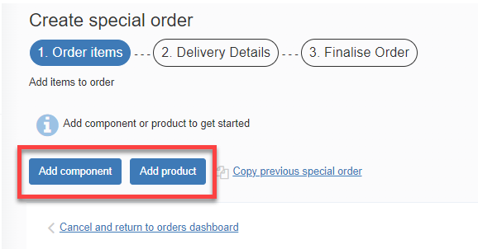

Please note: Fresh products are located in the components tab and manufactured products are located in the products tab.

- Once the component/product is selected, fill in all the required information and select either Save component/product or Save and add another component/product if more items are required.
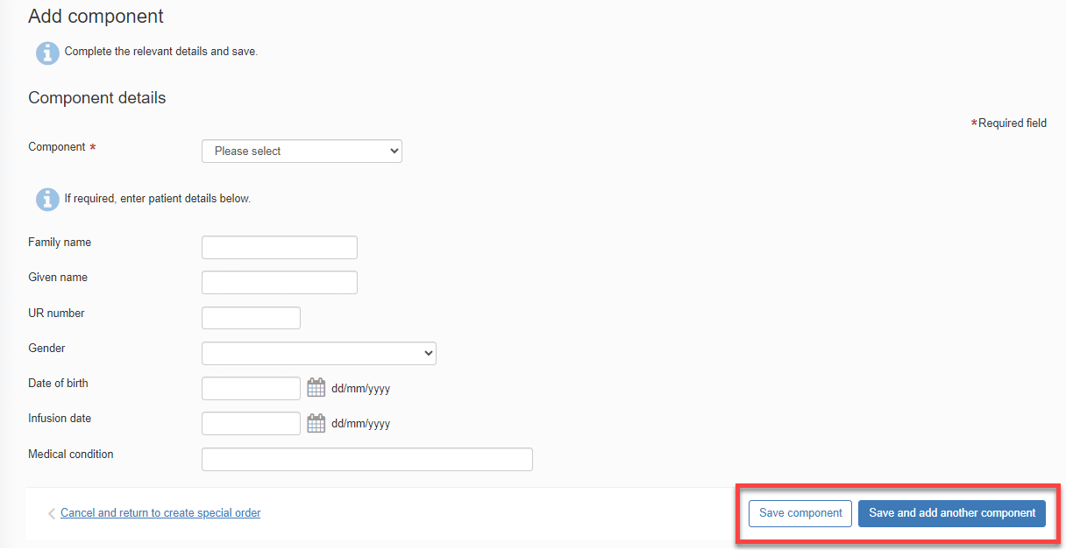

- Review 1. Order items and Edit or Delete as required and then select Next: delivery detail.
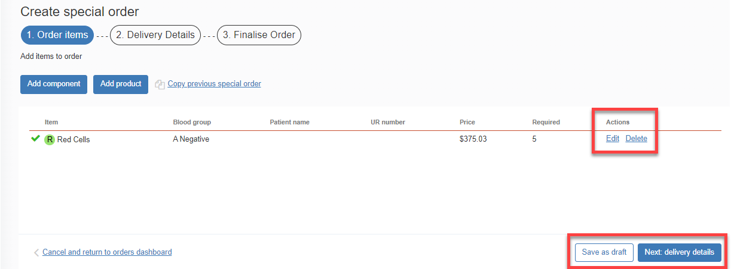
- Enter the order Priority, Delivery details and add any relevant order/delivery comments by selecting the Add comment button. Once complete, select the Finalise Order button.
Please note: When confirming the Delivery details for the order, you can Specify date and time required.

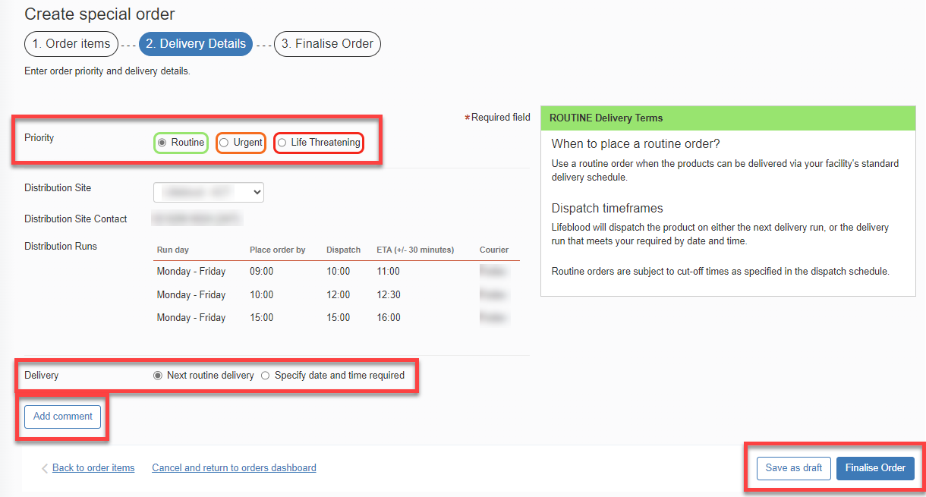

Please note: If you wish to edit the order, select the Back to order items hyperlink found in the bottom left corner of the tab and amend the order as necessary.

- When placing an Urgent or Life Threatening order, a pop up will appear. Select Yes to confirm you would like to change the priority to Urgent/Life Threatening.
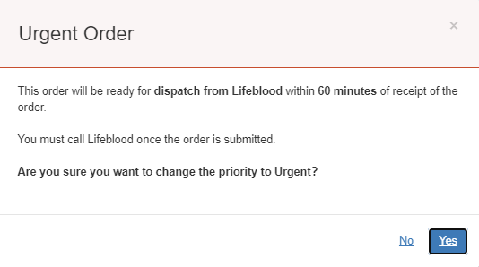

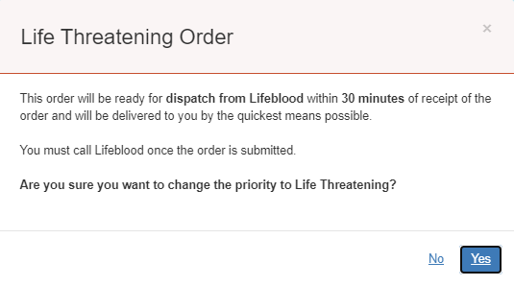

- Select the Send order button to send the order to the local Lifeblood distribution site.
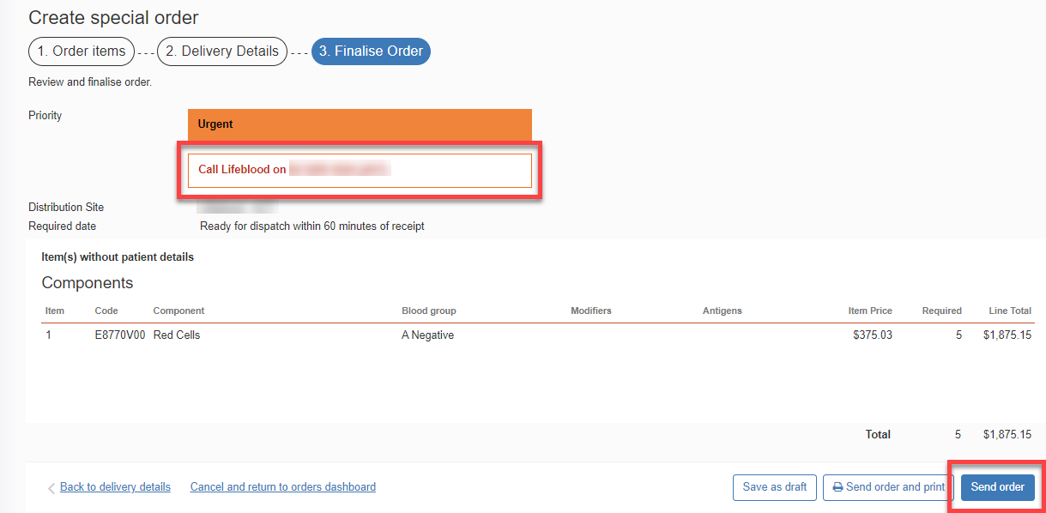

Please note: If your order is Urgent or Life Threatening, you MUST select the appropriate priority in Step 6. Do not write the priority in the comments box. All Urgent or Life Threatening orders MUST be followed up with a phone call to your local Lifeblood Customer Service Delivery site.

- Once the order has been sent to Lifeblood, it will remain under the Active orders section until all issue notes linked to the order are receipted. Once all components/products have been physically received, the order can be finalised in BloodNet.
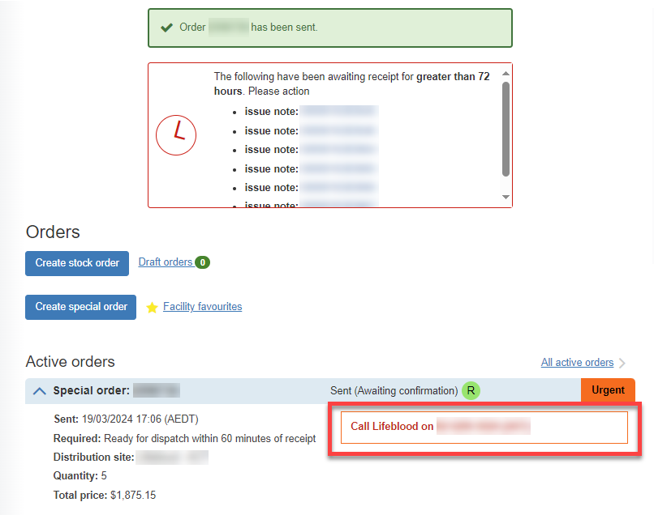

The Special order has been sent to your local Lifeblood distribution site.

