Creating a Stock Order
In BloodNet, a stock order must be submitted to receive components or products that are needed to be stocked at a facility. These orders are sent to a state-local Australian Red Cross Lifeblood Customer Service Delivery site for dispatching.
Perform the following procedure to create a Stock order in BloodNet:
Create a Stock Order
- Select the Orders tile located at the top left of the home page screen.
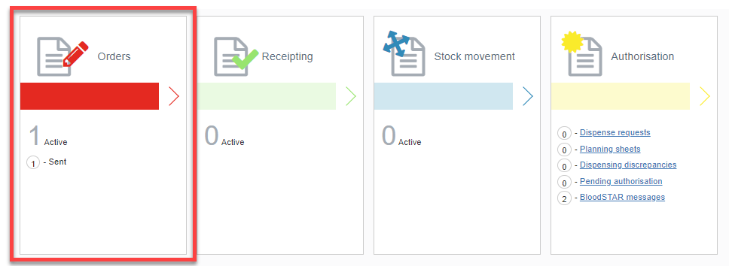

- Select the Create stock order button.
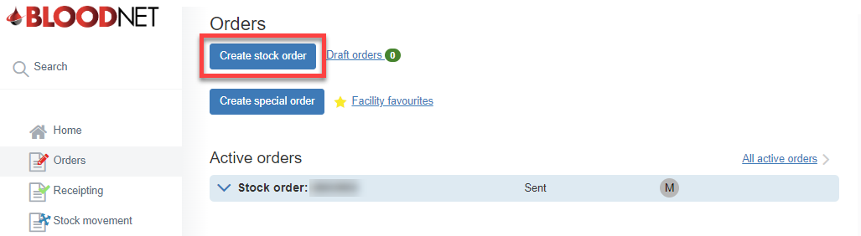

- Select the stock order template from the Current template drop-down.
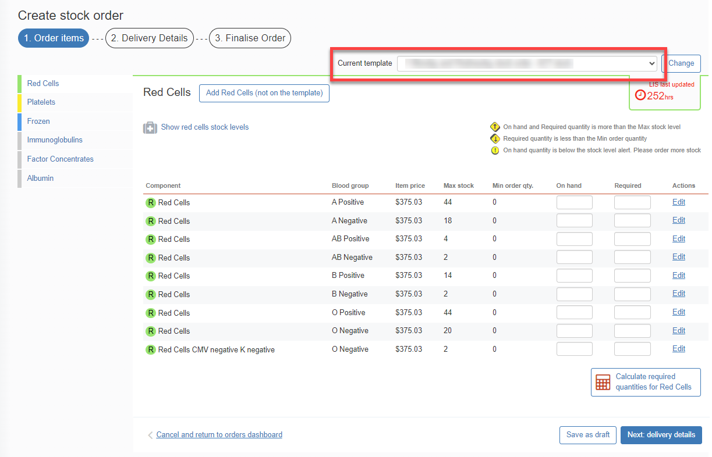
- Add the items by selecting the relevant Component or Product.
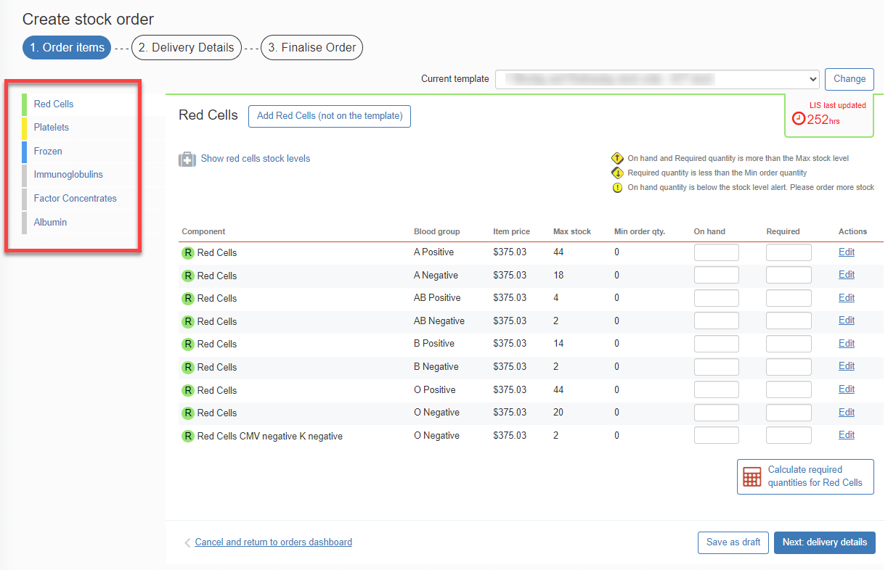

Please note: Components or Products that are not on the template can be added by selecting the Add Stock Type (not on the template) button.

- Enter the Required amount and then click Next: delivery details.
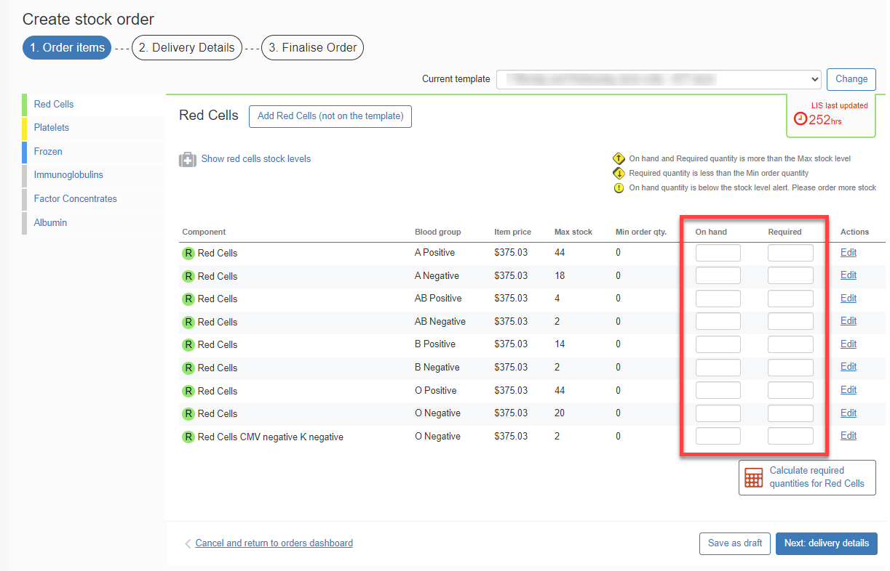

- Enter the order Priority, Delivery details and add any relevant order/delivery comments by selecting the Add comments button. Once complete, select the Finalise Order button.

Please note: When confirming the Delivery details for the order, you can Specify date and time required.

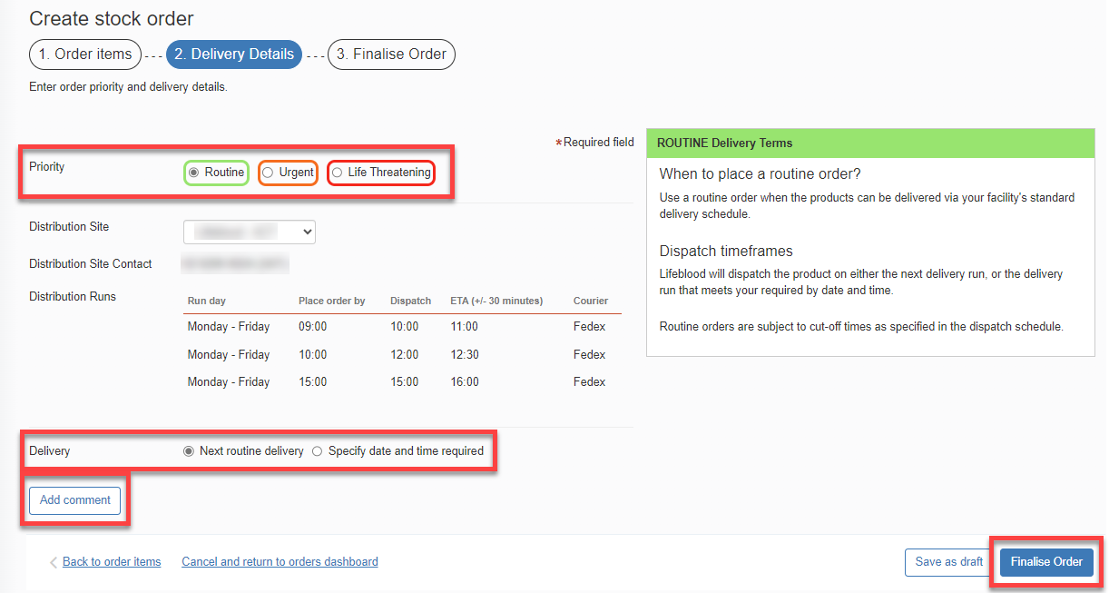

Please note: If you wish to edit the order, click on Back to order items hyperlink found in the bottom left corner of the tab and amend the order as necessary.

- When placing an Urgent or Life Threatening order, a pop up will appear. Select the Yes button to confirm you would like to change the priority to Urgent/Life Threatening.
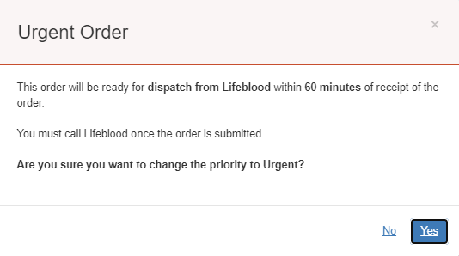

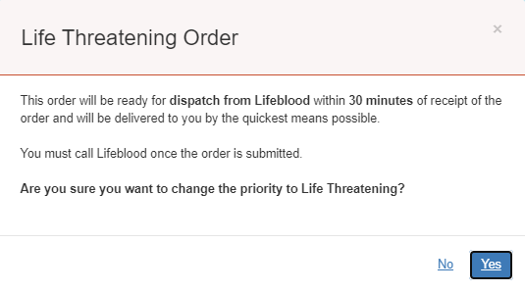

- Select the Send order button to finalise and send the order to the Lifeblood distribution site.
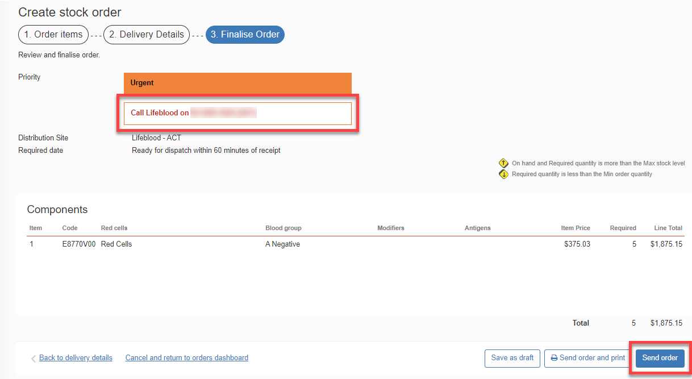

Please note: If your order is Urgent or Life Threatening, you MUST select the appropriate priority in Step 6. Do not write the priority in the comments box. All Urgent or Life Threatening orders MUST be followed up with a phone call to your local Lifeblood Customer Service Delivery site.

- Once the order has been sent to Lifeblood, it will remain under the Active orders section until all issue notes linked to the order are receipted. Once all components/products have been physically received, the order can be finalised in BloodNet.
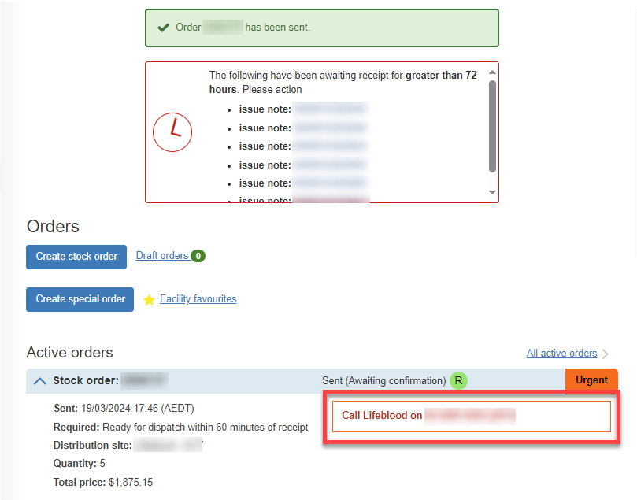

The Stock order has been sent to your local Lifeblood distribution site.

