Dose Change Requests

If a dose and/or product change is required, a request can be submitted through a patient’s Current Authorisation on the Patient Record page.
Reductions in Immunoglobulin doses do not require review and approval by Authorisers if the requested dose falls within the original authorised dose. A patient’s BloodSTAR authorisation will be updated immediately after a Dose Change Request is submitted.
If the requested dose exceeds the authorised amount, BloodSTAR will prompt an Authoriser to review and approve, as per the existing process.
In the scenario a different product than what has been allocated in BloodSTAR is requested, a clinically valid reason must be provided. A request for a different product is closely reviewed by Lifeblood Authorisers and may not be approved if clinical justification is not provided.

Change Infusion Method
If the requested infusion type is equal to the approved infusion type in the original authorisation (IVIg to IVIg or SCIg to SCIg) and is the same product it will be updated immediately as the request falls within the original authorised dose.

If the requested infusion type is a different infusion type to the approved infusion type in the original authorisation (IVIg to SCIg or SCIg to IVIg), BloodSTAR will prompt an Authoriser to assess the request.

IVIg to SCIg

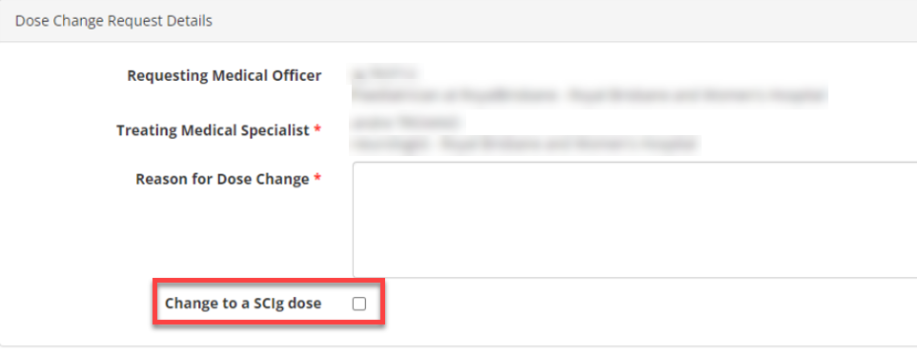

Or
SCIg to IVIg
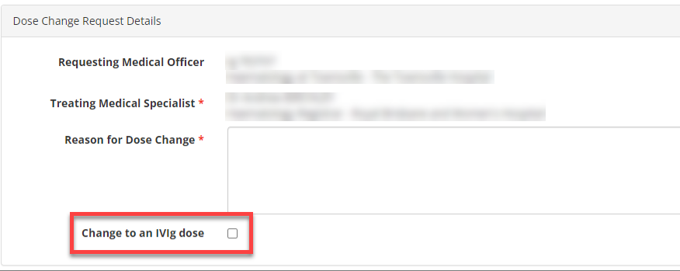

Change in Dose Amount
If the requested dose is less than or equal to the approved dose in the original authorisation, it will be updated immediately as the request falls within the original authorised dose parameters. The product will need to remain the same as the approved product in the original authorisation. Please refer to Action – Change in Product.

If the requested dose is greater than the approved dose in the original authorisation, BloodSTAR will prompt an Authoriser to assess the request.

Change in Product
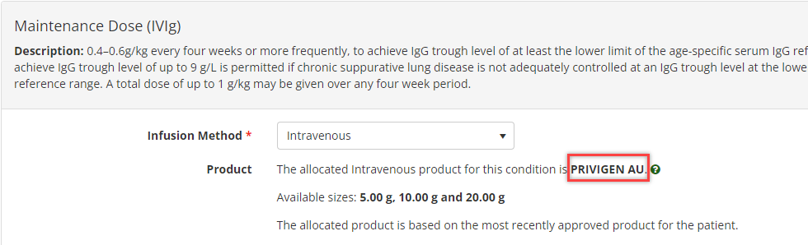
If the requested product is the same as the approved product in the original authorisation (e.g. Product A = Product A), it will be updated immediately and will not require an approval as the request falls within the original authorised dose parameters. The dose amount will need to be less than or equal to the original authorisation. Please refer to Change in Dose Amount.

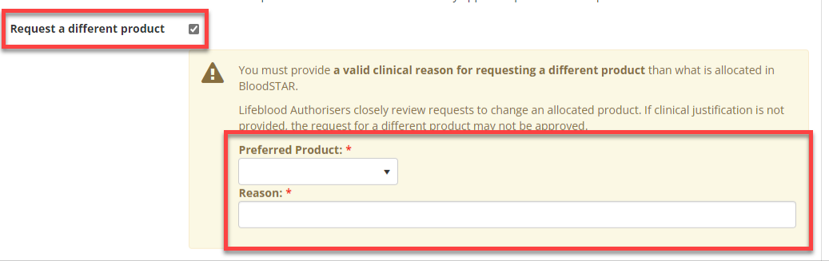
If the requested product is a different product to the approved product in the original authorisation (e.g. Product A Product B), BloodSTAR will prompt an Authoriser to assess the request as the request does not fall within the original authorised dose. In the scenario a different product than what has been allocated in BloodSTAR is requested, a clinically valid reason must be provided.

Change in Frequency
If the requested frequency is equal to the approved frequency in the original authorisation, the dose change request will be updated immediately as the request falls within the original authorised dose.

If the requested frequency is less than the approved frequency in the original authorisation, the dose change request will be updated immediately as the treatment becomes less frequent, hence the total dose decreases.

If the requested frequency is greater than the original approved frequency, BloodSTAR will prompt an Authoriser to assess the request as the treatment becomes more frequent, hence the total dose increases.
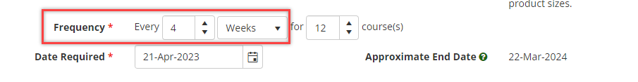

Change in Number of Courses
If the number of requested courses is less than or equal to the remaining approved courses, it will be updated immediately as the request falls within the original authorised dose.

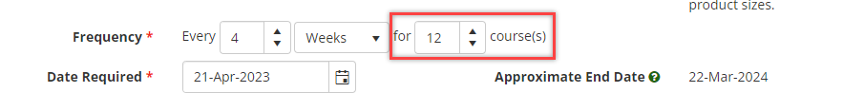
If the number of requested courses is greater than the remaining approved courses, BloodSTAR will prompt an Authoriser to assess the request as the number of courses does not fall within the original authorised dose.

Outcome
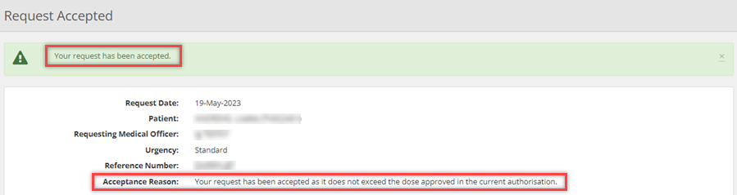
When the dose change request falls within the approved dose in the original authorisation:

When the dose change request does not fall within the approved dose parameters in the original authorisation:
