Requesting a Dose/Product Change or an Additional Dose

Requesting a Dose/Product Change
If a dose and/or product change is required, a request can be submitted through a patient’s Current Authorisation on the Patient Record page.
Reductions in Immunoglobulin doses do not require review and approval by Authorisers if the requested dose falls within the original authorised dose. BloodSTAR authorisations will be updated immediately after a Dose Change Request is submitted.
If the requested dose exceeds the authorised amount, BloodSTAR will prompt an Authoriser to review and approve, as per the existing process.
In the scenario a different product than what has been allocated in BloodSTAR is requested, a clinically valid reason must be provided. A request for a different product is closely reviewed by Lifeblood Authorisers and may not be approved if clinical justification is not provided.

Changing the Product Type or Dose Size in an Existing Authorisation
- From either your home page, My Authorised Patients, or from My Requests, locate the patient that requires the change. Under the Patient column, click on the Patient name.

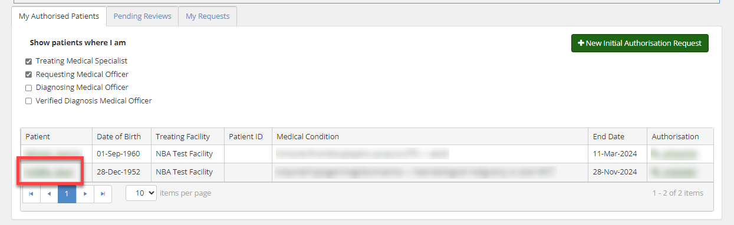
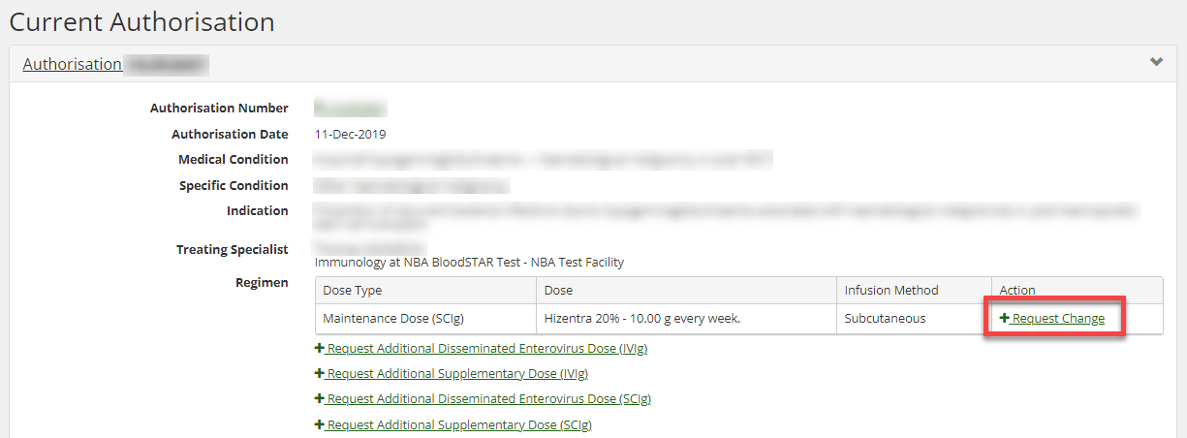
- Scroll down to view the details under Current Authorisation. Under Regimen, locate the dose you want to change. Under the Action column, click + Request change.

- On the Dose Change Request form, select the urgency of the change request. Please remember that if the review request is at Emergency status, it must be accompanied by a phone call to Lifeblood on the relevant phone number provided.

- Enter all relevant details in the free text Reason for Dose Change section under Dose Change Request Details.

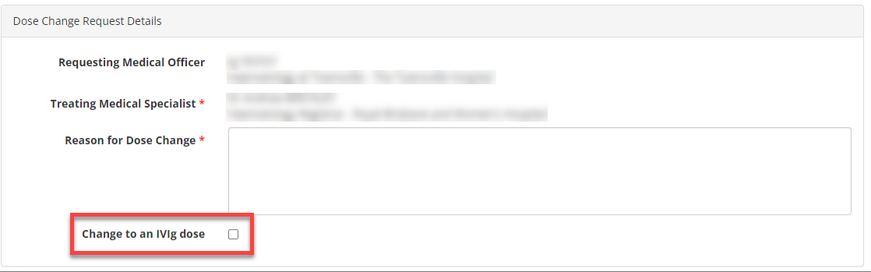

- Proceed to the Dose section and enter the patient’s weight.

- If you wish to change the allocated product, tick the box labelled Request a different product, and then select the product you would like to nominate instead, as well as the Reason why, keeping in mind that a clinically valid reason must be provided.

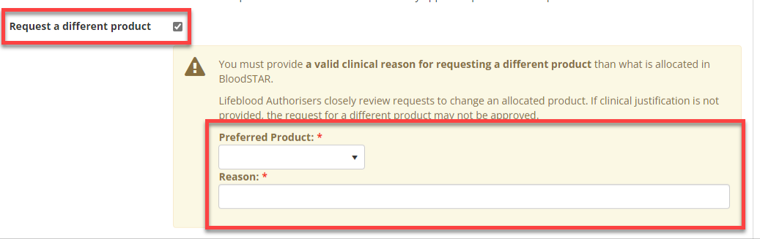

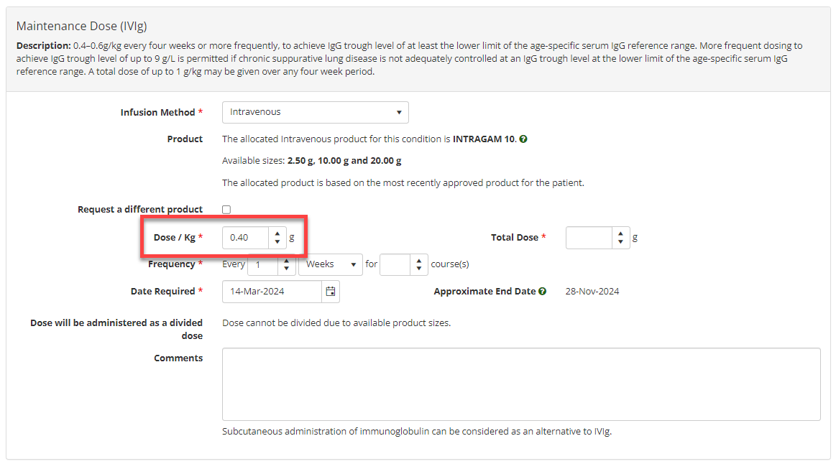
- To change the strength of the dose, enter a different value under Dose/Kg
- If the dose exceeds the recommended dosage per kilogram, you will be asked to provide a reason.

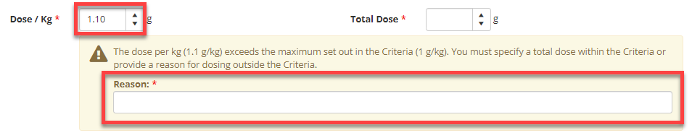

- Once all required changes have been entered, confirm your contact details, and tick the box to indicate all information submitted is true and accurate to the best of your knowledge and then click Submit.

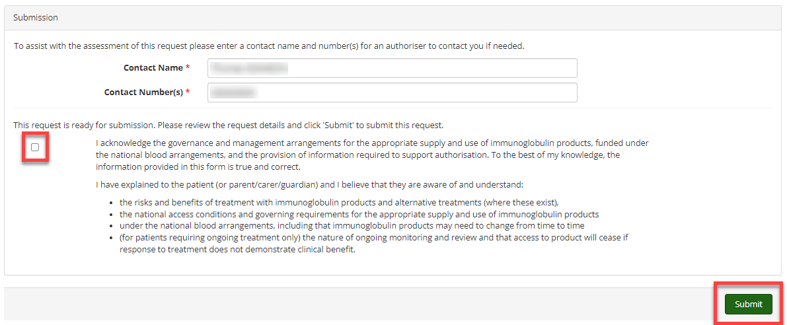

Requesting an Additional Dose
Under some Medical Conditions, there is the ability to request an additional dose if your patient requires it. If an additional dose is available for your patient’s diagnosis you will have the option under the Regimen section of the patient’s Current Authorisation.

Requesting an Additional Dose in an Existing Authorisation
- Once you have located the patient record scroll down to view the details under Current Authorisation. Under Regimen, click + Request Additional *Dose (method)*.

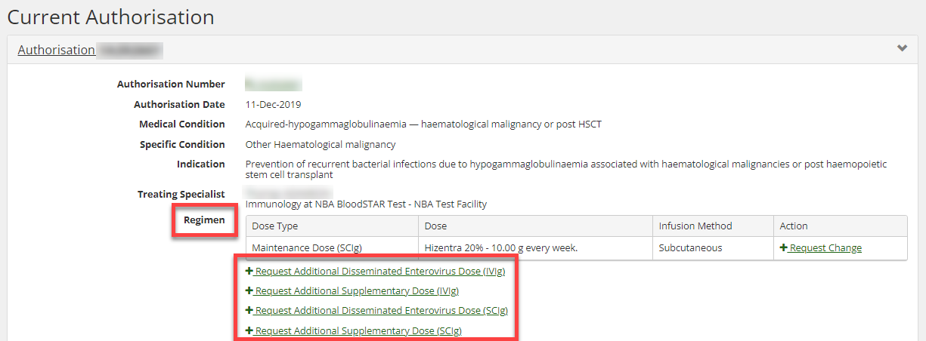

- On the Request Additional Dose page, select the Urgency of the request.

- Enter all relevant details under Reason for additional dose in the Additional Dose Request Details section.

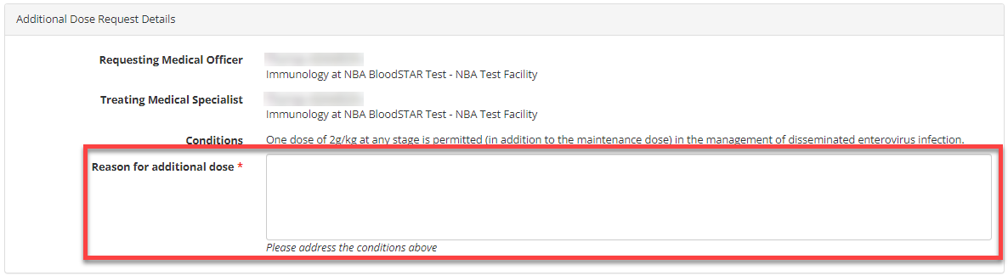

- Go to the Dose section and enter the patient’s weight, as well as all applicable details of the additional dose. Once all details are correct, tick the box to indicate all information submitted is true and accurate to the best of your knowledge and then click Submit.
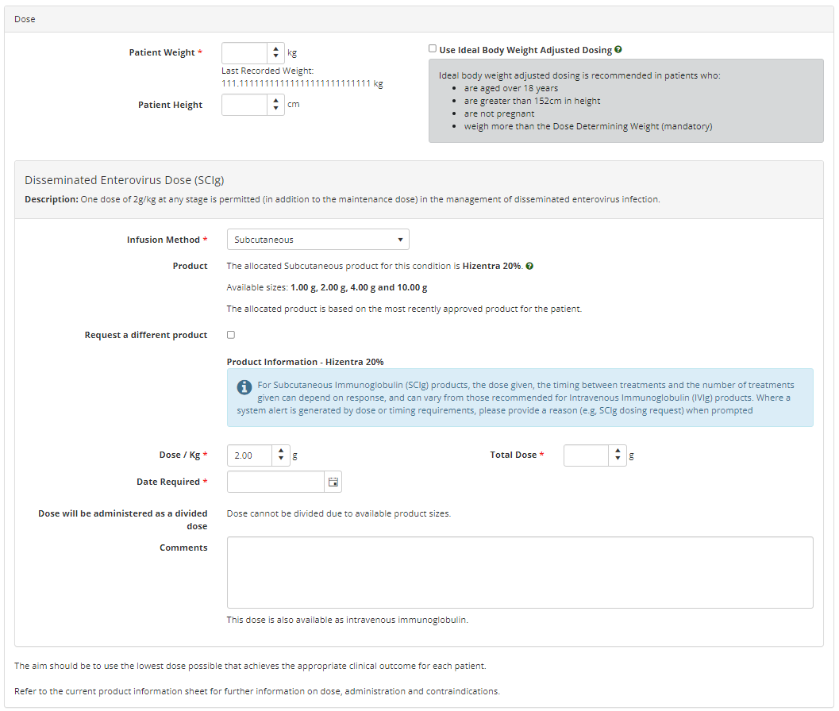

- You will receive an email and an in-system notification when the request has been actioned.

