Viewing Authorisation Details in BloodSTAR
BloodSTAR allows nurses to view a patient’s Authorisation Details and Treatment Plan. Information available to users includes, authorisation number, authorisation start and end dates, medical condition, current regimen, treating arrangements, planned treatment dates, as well as other important details. Below shows the steps for viewing a patient’s Authorisation in BloodSTAR.
Confirm a Patient is Authorised to Receive Ig
- You can see a list of all patients registered to your facility from your home page.

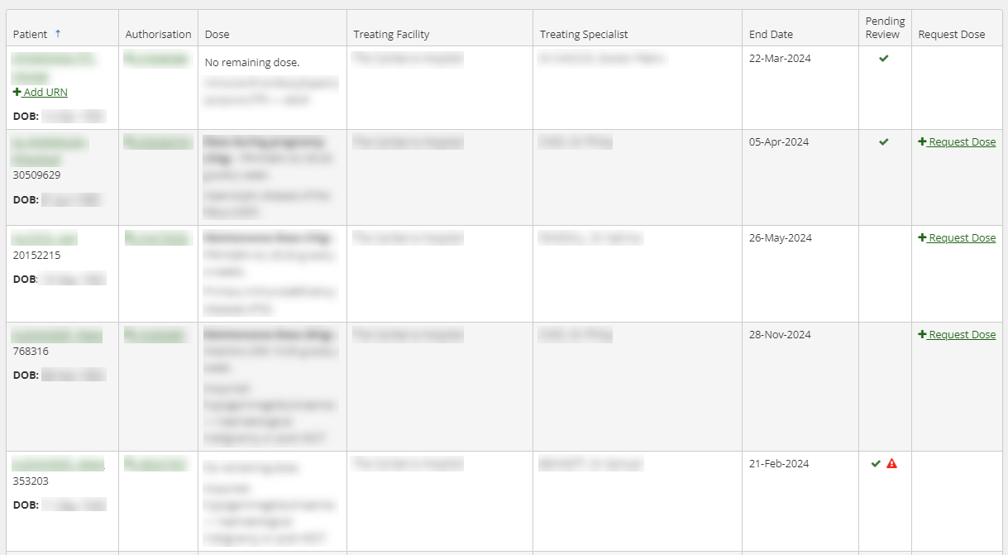

- Alternatively, you can use the search function to look up individual patients. You need three identifiers, e.g. FAMILY NAME, Given Name, Date of Birth, URN and/or Authorisation Number.

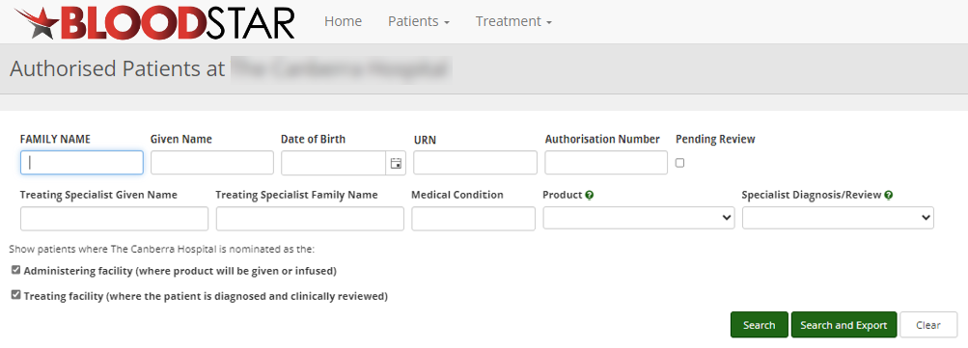

- Click on the number in the Authorisation column to view the patient’s Current Authorisation details.

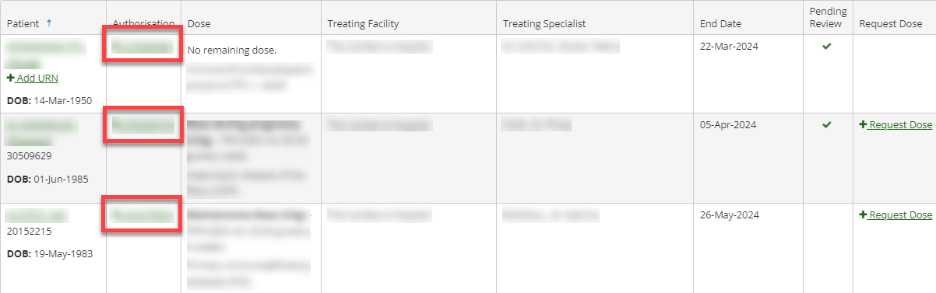

- This will open the details of the patient’s Current Authorisation and their Treatment Plan.

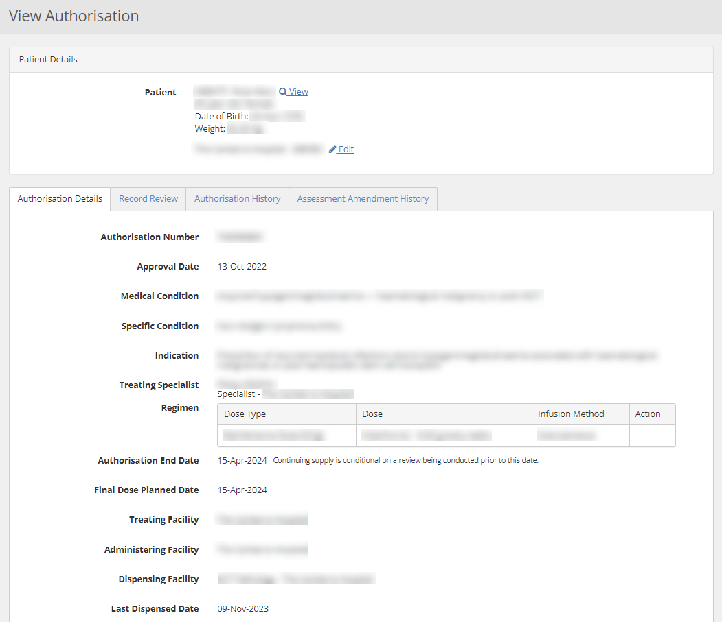

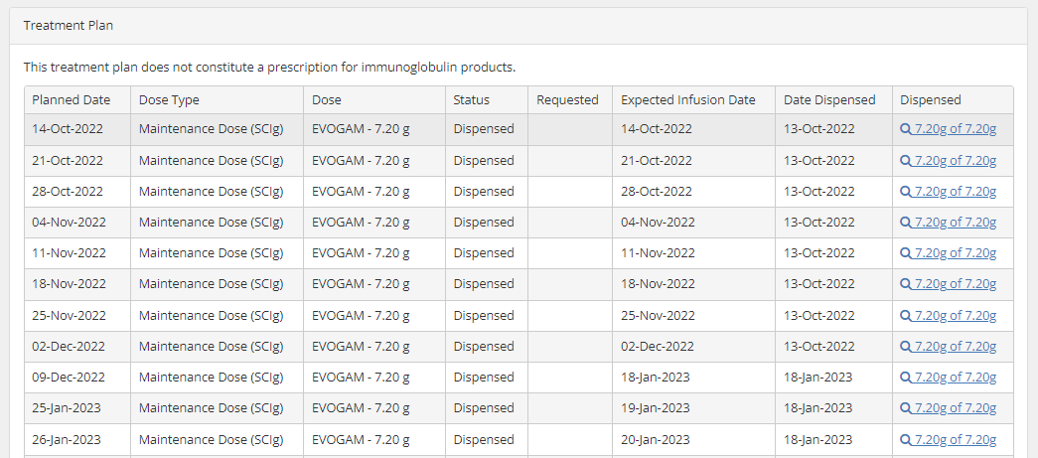

- You can also search for patients from another facility using the Search option in the Patients tab at the top of the page. Ensure the Search Scope is changed from your facility to National for a wider search parameter.

