Nurse/Midwife Home Page

The Nurse home page in BloodSTAR displays the list of authorised patients who are associated with the user’s facility. From this screen users can perform the following actions:
- Search for authorised patients
- View authorisation requests
- View patients who have pending reviews
- Navigate to the Patient Search, Planning Sheets and Dispense Request pages
- Create and submit a product dispense request for an individual patient

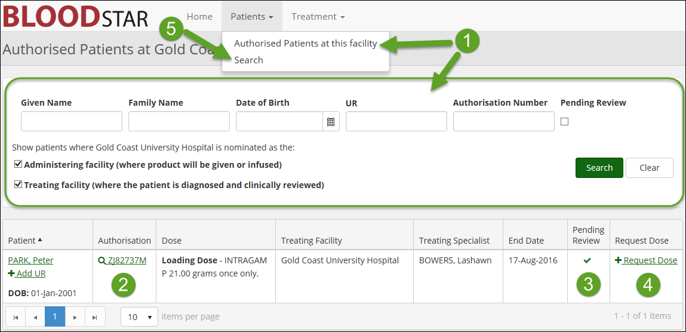
- Patient Search from the home screen
Nurses can search for patients from the home screen using the available fields. You can refine your search to include only patients who are administered or prescribed Immunoglobulin (Ig) product at your facility by clicking on the relevant tick boxes, both of these search options are selected by default. There is also the option to search for patients who have a pending review in the system by clicking on the tick box under ‘Pending Review’.
- View Authorisation Request
A patient’s authorisation reference number is listed in the Authorisation column. To view a patient’s authorisation details click on the authorisation reference number. You will be taken to the View Authorisation page which displays a patient’s current authorisation details, treatment plan and review outcomes.

- Pending Reviews
If a patient has an upcoming review of their Ig authorisation, a tick will appear in the Pending Review column 8 weeks prior to their authorisation end date. The authorisation end date can be viewed in the End Date column.
- Create and submit a product dispense request
To create and submit a dispense request for a patient click on the Request Dose link in the Request Dose column. The Add Dispense Request pop up window will appear where you can select the dispensing facility and select and customise the required loading and/or maintenance dose.

- Navigate to the Patient Search page
You can navigate to the Patient Search page by clicking on the Patients drop down menu at the top of the screen and then clicking on Search. From the patient search page users can search for patients across their state or nationally.
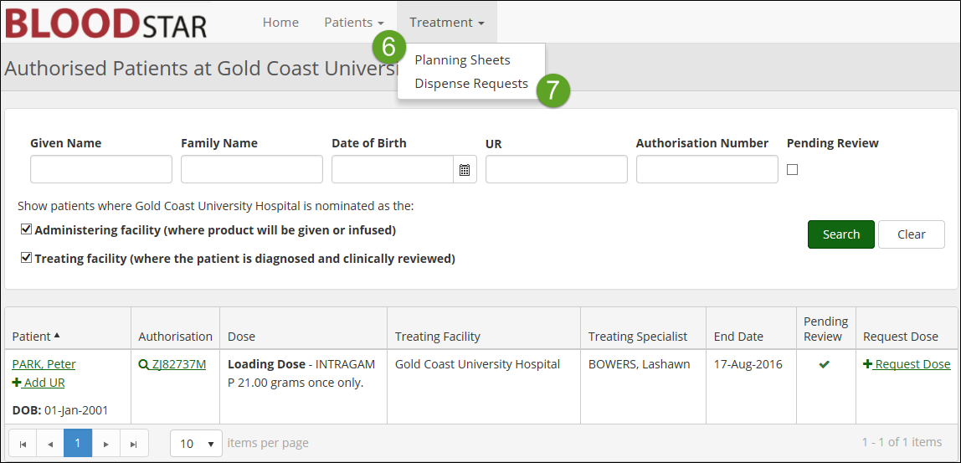
- Navigate to the Planning Sheets page
To navigate to the Planning Sheets page click on the Treatment drop down menu at the top of the screen and then click on Planning Sheets. From the Planning Sheets page you can create, submit and search electronic planning sheets.

- Navigate to Dispense Requests page
To navigate to the Dispense Requests page click on the Treatment dropdown menu at the top of the screen and then click on Dispense Requests. From the Dispense Requests page you can search for submitted dispense requests.

