Creating Multiple Patient Dispense Requests – Planning Sheets
- To request Ig doses for multiple patients, for example all patients booked into a clinic, click on the “treatment” tab at the top of the screen. From here you can select “Planning Sheets”.
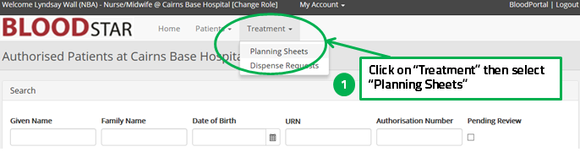
From the planning sheets screen you can:
- Review existing listed planning sheets by clicking on “View” to see the details,
- Search for existing planning sheets using the search function. These may be in draft, already submitted, in progress or completed, or
- Create a new planning sheet by clicking on “+ New Planning Sheet”.
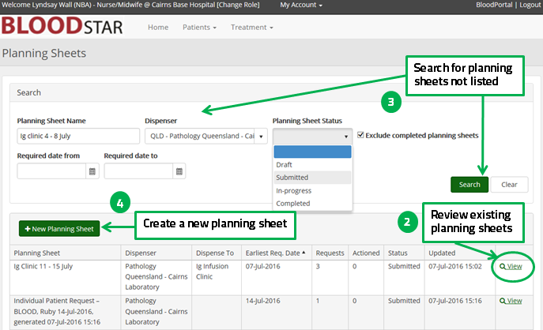

Creating New Planning Sheets:
- Click on “+ New Planning Sheet”. The Create Planning Sheet screen will appear with your name, contact number and default Dispenser pre populated. You can change any of these details, if required. From here you will enter in your free text to mane the planning sheet, dispense location here you want the dispenser to send the product and any relevant notes to the dispenser.
- Click “Save” when done.
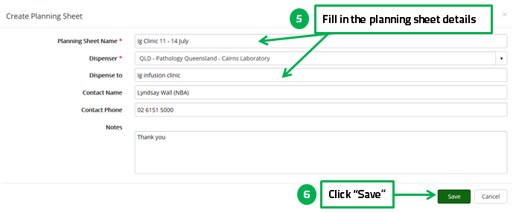
- From here you can start adding patients, edit the details or delete new draft planning sheet.
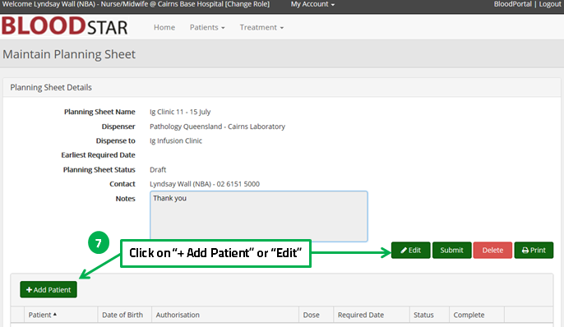

- The Select Patient screen allows you to either add the patient from the list by clicking on “Select” or use the search function. The search function can be useful if there are many patients registered at your facility. If you are searching for patients in your facility you can search using any identifier.
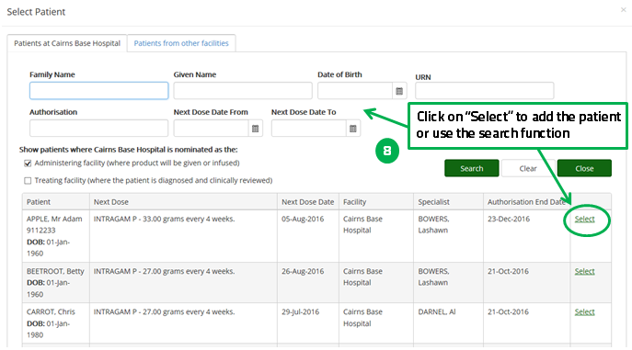
- The details of the patient and dose are now available for review. If you click edit you will be able to alter the Ig administration date, dose or product.
Please note you may be required to provide a reason for altering these details.
- Click on “Add” to add the patient to the planning list. Repeat the process for all patients you need to add.
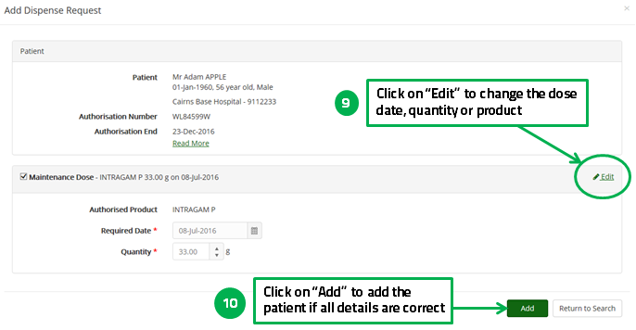

- You can also search for patients from other facilities. This function may be required for travelling patients or those transferred from another facility. Click on the “Patients from other facilities” tab at the top; enter at least 3 identifiers, select the search scope (state or national) and a reason then click on “Search”.
- You can add the patient as outlined above by clicking on “Select”.
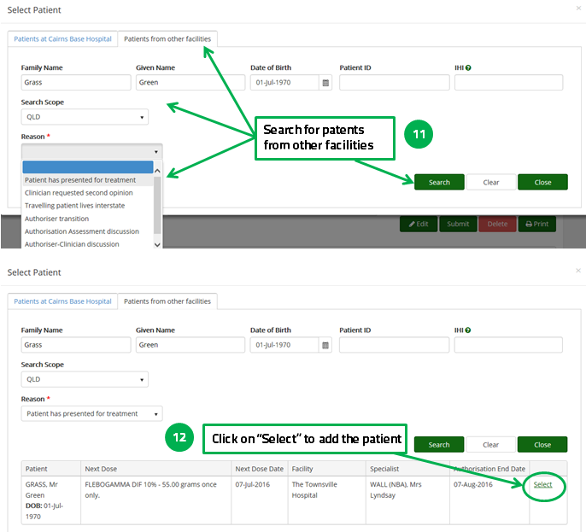

- Review your planning sheet. Click on “Submit” when all the patients have been added to your planning sheet. You can also view, edit or remove patients from the list
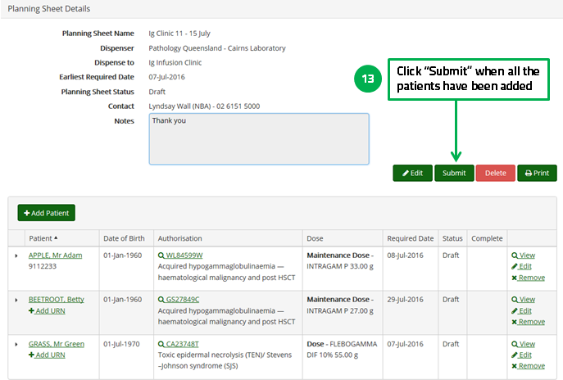
- You will receive notification that the planning sheet has been submitted.
- You can also print your planning sheet, if required.
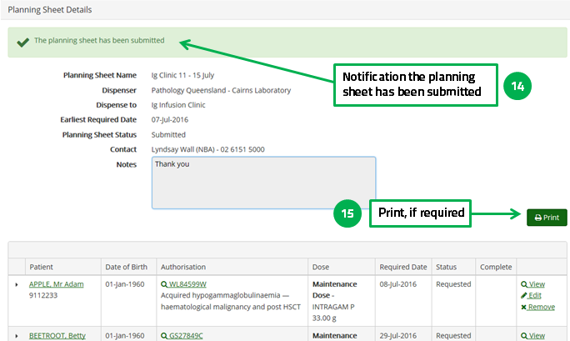

- Now you can see your Planning Sheet and any others listed. You can view or edit the sheets until they are dispensed by clicking on “View”.
