Submitting an Ig dispense request for individual patients in BloodSTAR
BloodSTAR allows nurses to view patient’s authorisation details, create and submit a product dispense request for individual patients or a planning sheet for multiple patients. This tip sheet outlines how a nurse can request Immunoglobulin (Ig) doses to be dispensed for individual patients.
How do I request Ig for my patients?
- To request an Ig dose for an individual patient, click on the “Request Dose” link against the patient for whom you want to obtain the dose.
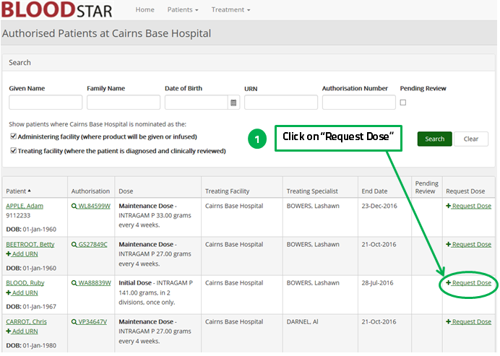
- Review the patient and dose details. If they are correct click on “Submit” to request the dose. Or,
- Click on “edit” to edit details of the Ig date, dose or product.

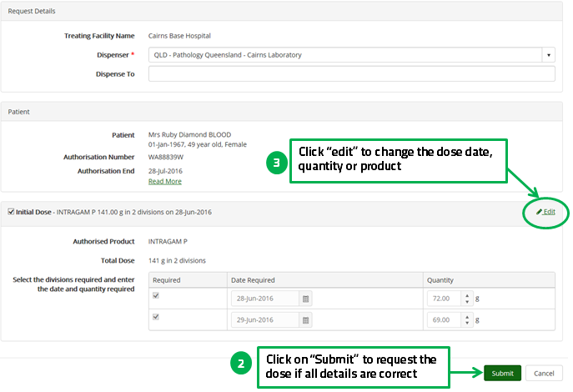

- If you click edit you will be able to alter the Ig administration date, dose or product.
Please note you may be required to provide a reason for altering these details.
