Making an Initial Authorisation Request
An Initial Authorisation Request will need to be submitted if the patient is required to have Immunoglobulin (Ig) but is not an authorised patient in BloodSTAR or their authorisation has expired.

Submitting a New Initial Authorisation Request
- There are two ways to start a New Initial Authorisation Request.

Option A: From your home page as a Medical Officer, click the Authorisation Requests tab at the top of the page and click New Initial Authorisation Request.

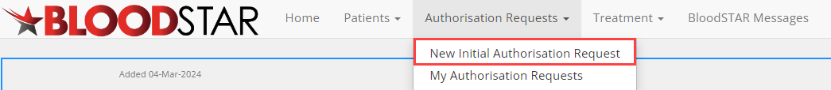

Option B: Click the + New Initial Authorisation Request large green button on the homepage.

- A Find Patient for Initial Authorisation Request window will appear, as shown below.
Enter the full name and date of birth of the patient and click Find Patient. If there is an exact match, the patient will appear for you to select and continue with a patient already in BloodSTAR; a partial match will not return results. If there is no match, select Continue to create patient and progress with the authorisation request.
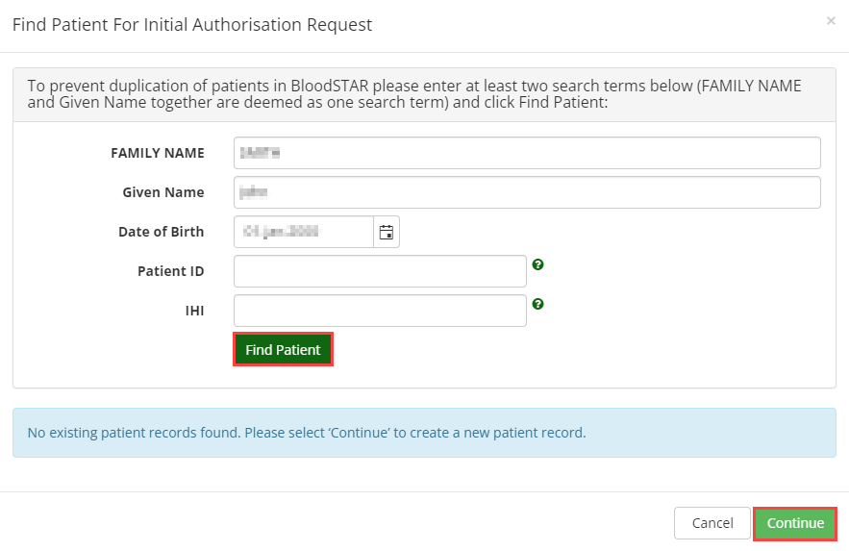

- Enter in your patient’s consent status, select whether the consent granted was verbal or written, who granted the consent and the date it was obtained. You can nominate if the consent status is recorded in the medical record and (optionally) upload a scanned copy of any consent you have received in writing.

Note: Patients must consent to having their details stored in BloodSTAR.
Patients can find copies of the consent form and information on what details are required on the More Information – Privacy Statement and Notice link.

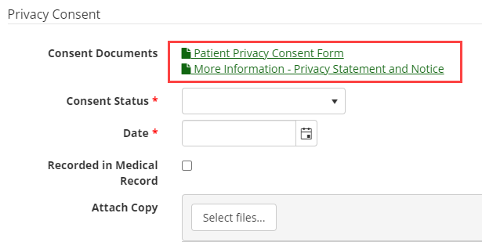

- Once your patient’s basic details have been entered and consent obtained, you will be taken to Step 1 of the Initial Authorisation Request. There are three functions you can perform on this page:
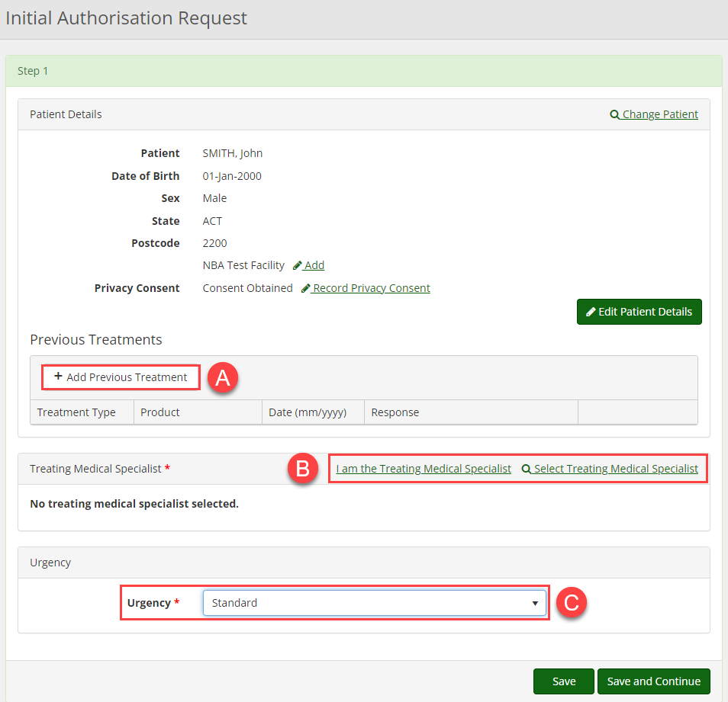

- If relevant, enter any previous treatments for the patient by clicking + Add Previous Treatment.

- Add the Treating Medical Specialist details to the form. If you are the Treating Medical Specialist, click on, I am the Treating Medical Specialist. If you are the Requesting Medical Officer select Change Treating Medical Specialist to nominate a prescribing specialist.

- Set the urgency of the authorisation to one of the following:
- Standard: Request will be assessed within 2 business days.
- Serious: Request will be assessed within 1 business day.
- Emergency: Request will be assessed in 2 hours and a follow up call will be required.

Note: Authorisations that have a status of Emergency must be accompanied by a call to Lifeblood Authorisers on 1300 70 77 55 after the authorisation has been submitted. Once all necessary details have been entered, click Save and Continue.

- In Step 2, the Treating and Administering Facility will be auto populated as the facility where the nominated Treating Medical Specialist is registered. If your patient will physically receive treatment at another facility, select that site from the Administering Facility drop-down menu and, if not auto populated, select a Dispensing Facility.

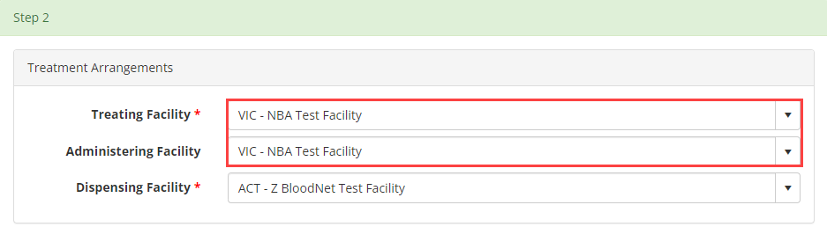

The facility types are as follows:
- Treating Facility: the facility at which a specific patient's treatment will be managed (diagnosed, prescribed and reviewed). This may be the same location as the Ig infusion is administered.

- Administering Facility: the facility where the patient goes regularly to have their Ig infusions administered. This may be the same location that the patient sees their Treating Medical Specialist.

- Dispensing Facility: the facility from which it is anticipated that product will be normally dispensed for a specific authorised patient.

- Begin typing the diagnosis into the Find Condition field. All the possible diagnosis options will populate to be selected. Once a medical condition has been selected, the page will continue to populate further required details under Qualifying Criteria and Supporting Evidence. To assist in the assessment of your authorisation request, please ensure you enter as much information as you have available. When completed, click Save and Continue.

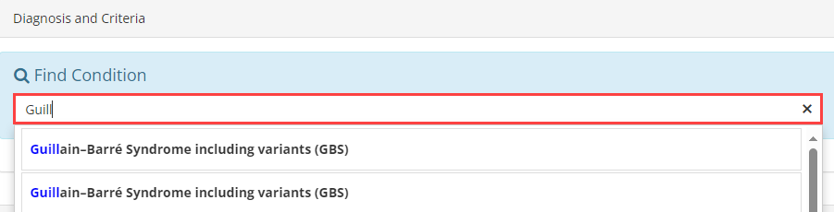

- In Step 3, enter the Patient Weight. If you are calculating dosage by Ideal Body Weight, tick the corresponding box User Ideal Body Weight Adjusted Dosing and a Height field will appear. This will then alter the weight value according to Ideal Weight values and change the requested dosage accordingly. Otherwise, just enter the patient’s weight.
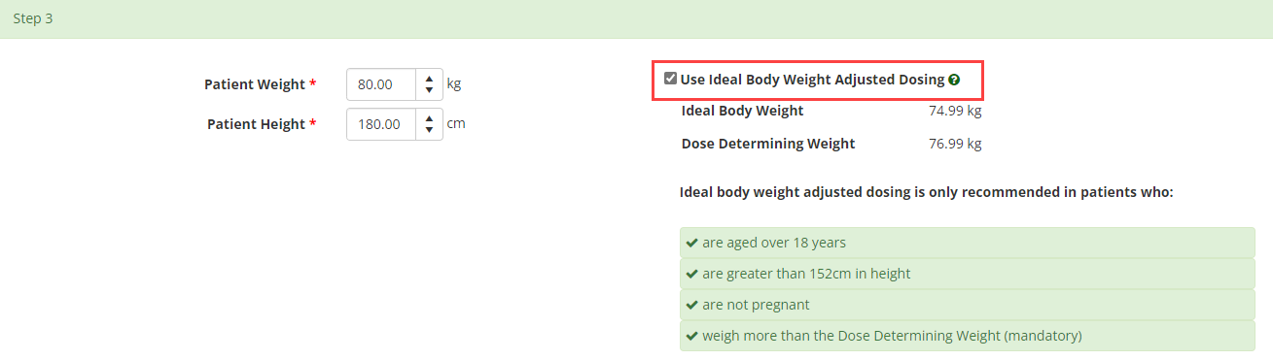

- Select one or more doses that are required where clinically appropriate such as maintenance or loading dose, from the available options. The options available are determined by the diagnosis selected.

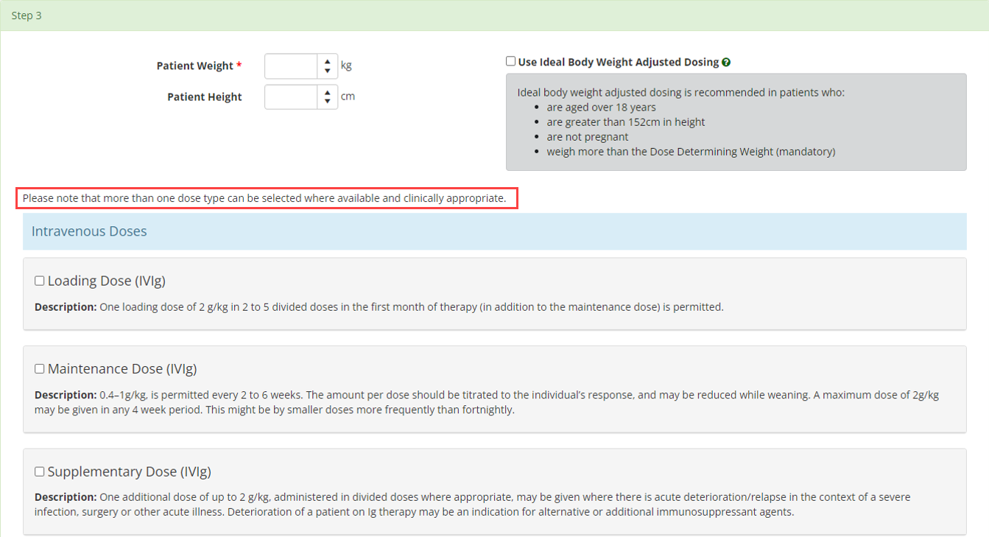

- The Product and Dose/Kg will be prepopulated and is determined by the entered diagnosis and your state. Enter the details of the treatment, including Frequency, Date Required and any comments.

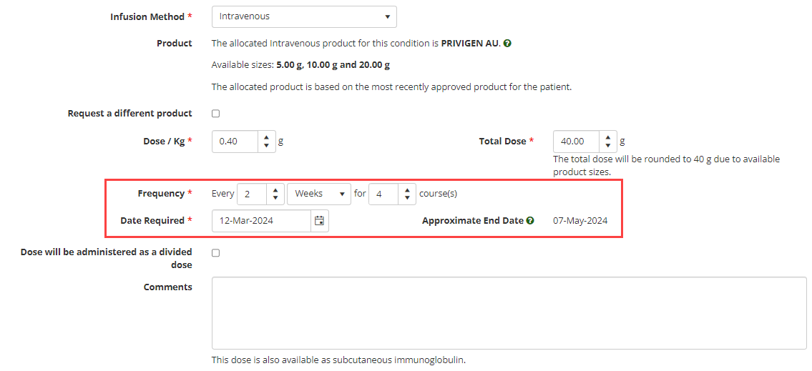

- If you need to select a different product, proceed with this step. Otherwise, skip to step 11.
Tick the box marked Request a different product. A mandatory field will appear for you to select an alternate product from the drop-down list and a valid clinical reason must be provided.

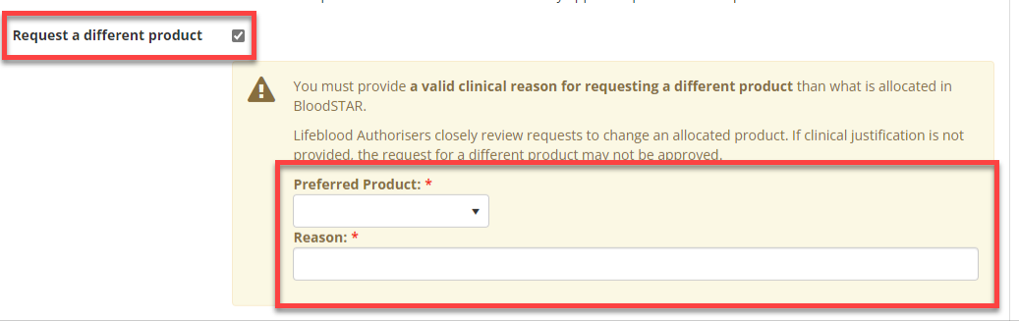

- If the dose is to be administered as a divided dose, click on the Dose will be administered as a divided dose checkbox. The option to specify the Number of divisions will appear as well as the option to Specify your own divisions. If you do not select the Specify my own divisions option, BloodSTAR will automatically divide the dose as equally as is possible with the available vial sizes of the specified product. If you select Specify my own divisions option, you will be able to customize the divisions of the total dose.

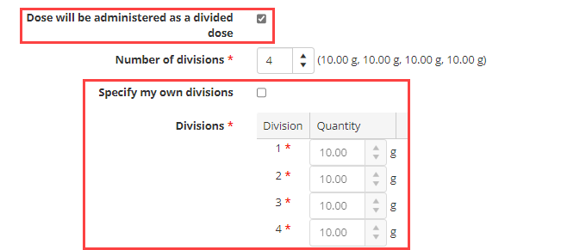
Note: Treatment duration and amount per kilogram is calculated automatically off the weight entered for the patient. If you need to prescribe more than the recommended maximum of product per kilogram, enter this under Dose/Kg. If the Dose/Kg is higher than the recommended amount under the criteria you must enter a reason. When all details are completed, click Save and Continue.

- Confirm all details and check the box Accepting Terms and Conditions. Click Submit to complete the request.

