Submitting Review Outcomes and Creating a Continuing Authorisation Request

Step | Action - Checking the remaining doses for a patient’s authorisation
1. | There are 3 ways of checking the patients remaining doses.  Option A: In the Patient Record, under Current Authorisation details, next to Final Dose Planned Date will either:  - Display a date which is based on the planned date or partially dispensed.  - No remaining dose text will display if there are no remaining planned doses.  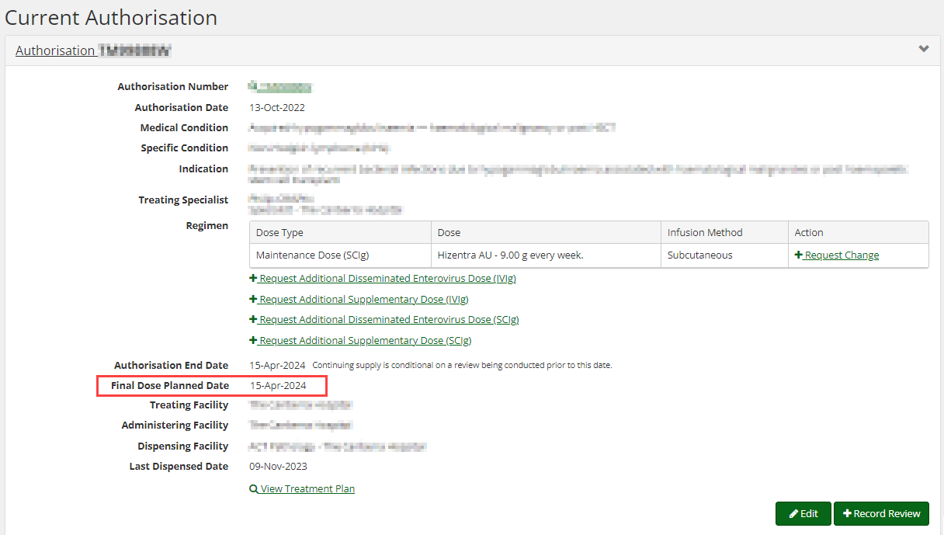  Option B: By clicking on the green hyperlink beside authorisation number to access the View Authorisation page.  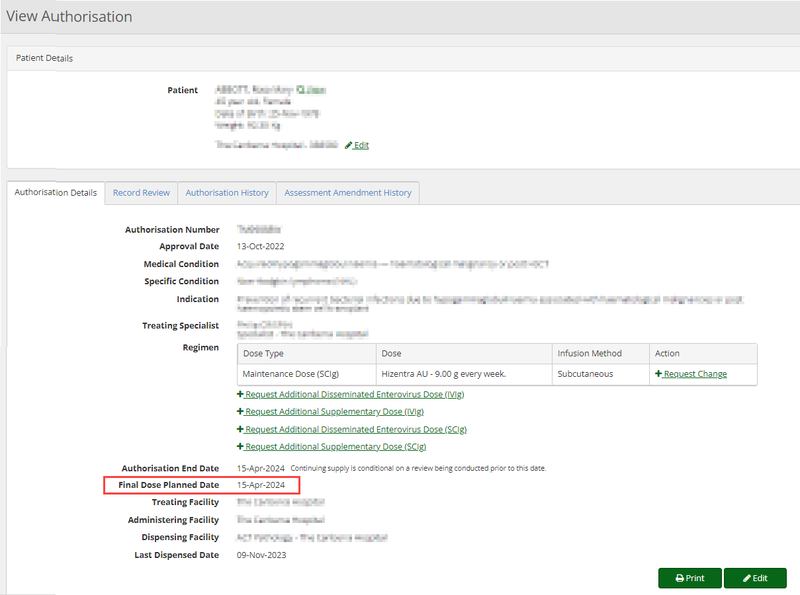  Option C: In the Patient Record, you can view the patient’s treatment plan by selecting View Treatment Plan or select the authorisation number and scroll to the bottom of the screen.  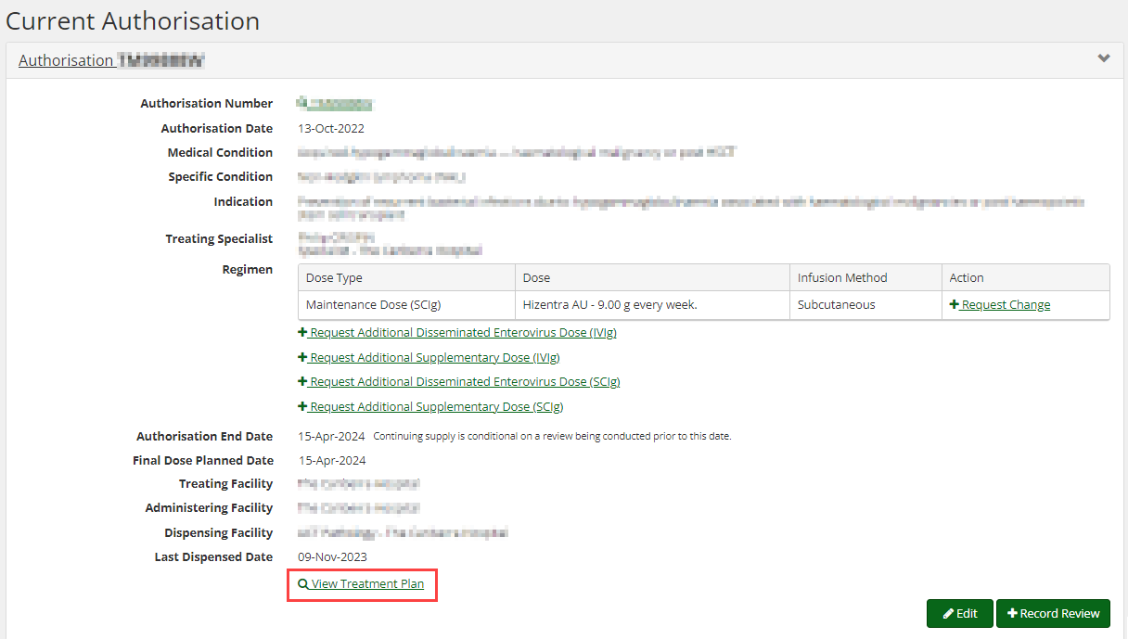  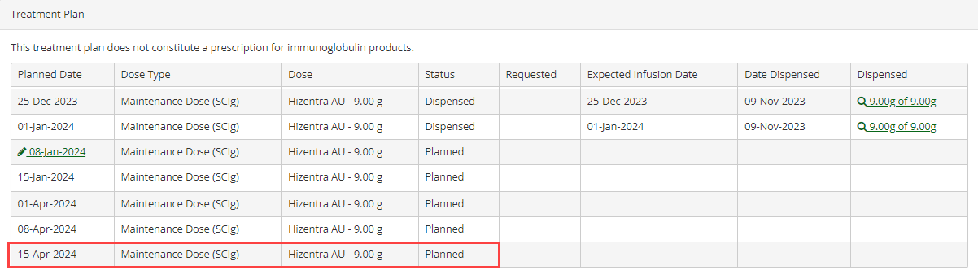

Once an approved Immunoglobulin (Ig) Authorisation is nearing or has just exceeded its expiry date, BloodSTAR will notify Medical Officers involved with the authorisation and prompt them to submit review outcomes and will provide the option to submit a Continuing Authorisation Request.

Step | Action - Checking the remaining doses for a patient’s authorisation
1. | There are two ways of recording patient review outcomes.  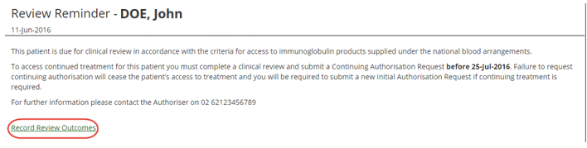  Option A: Click on the link in your emailed notification and you will be automatically directed to the relevant BloodSTAR message in the BloodSTAR Messages tab. Within that relevant message, click the link Record Review Outcomes at the bottom.  Option B: Once you are logged in as a Medical Officer, select the Pending Reviews tab on the Home page. This will display all authorisations that require review in the next 8 weeks or those that have expired in the last 8 weeks. Locate the patient you want to record a review for and click Record Review.  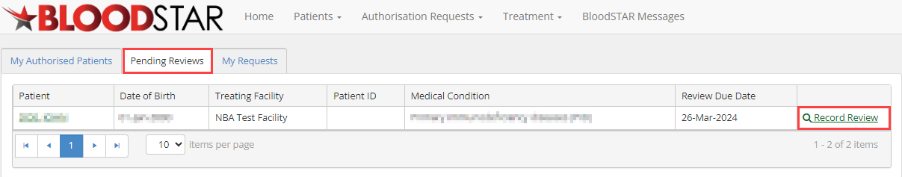
2. | 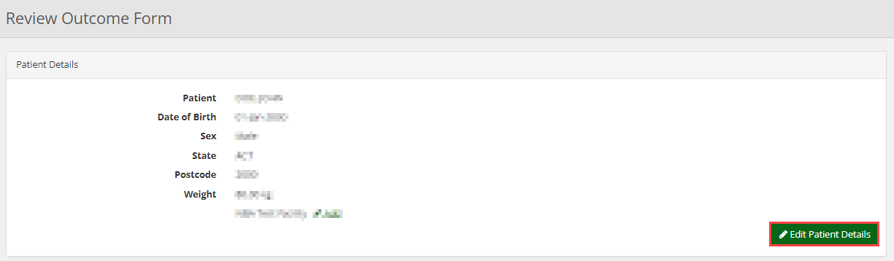  On the Review Outcome Form, confirm that all patient details are correct and if necessary, change or update them by selecting Edit Patient Details.
3. | Scroll down, enter the Review Date, and nominate the Reviewing Medical Officer.  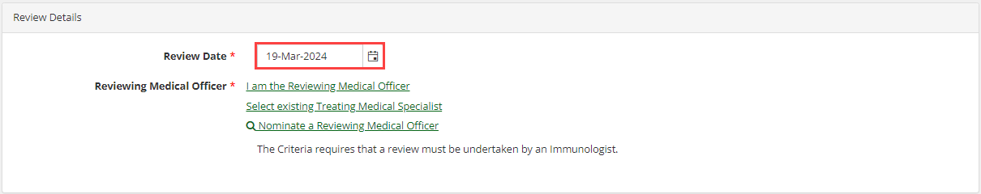
4. | Under Review Criteria, select all applicable options for the Qualifying Criteria according to your patient’s condition and fill in all relevant Supporting Evidence details. These options are dependent on the original diagnosis and, if selected, will create fields for you to enter more information about the patient.
5. | In Review Outcome, select the overall review outcome from the available options:  - Option to request continuing treatment for the current Ig Authorisation.  - Record a review/change on the authorisation without requesting continuing treatment.  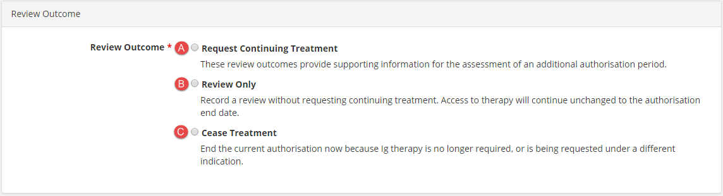  - Cease the current authorisation as Ig therapy is no longer required or is being requested under a different indication. You have the option to cease treatment immediately or to choose a later date.

Step | Action – Submitting a Continuing Authorisation Request when there is one or more planned doses remaining in the previous authorisation
1. | 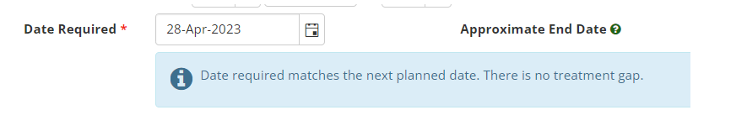  The system will prepopulate the Date Required to be the same as the next planned date and display a message saying Date required matches the next planned date. There is no treatment gap.
Step | Action – Submitting a Continuing Authorisation Request for the same dose type (IVIg to IVIg or SCIg to SCIg) and the date required is changed, creating a treatment gap.
1. | 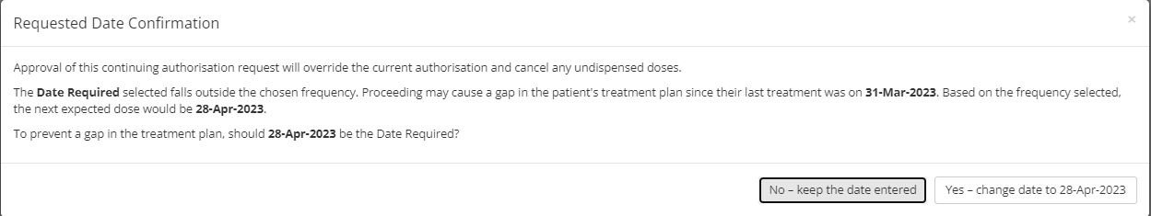  The system will display a pop-up message advising the date entered creates a treatment gap the system will suggest an alternative treatment date to avoid a gap in treatment. The suggested date is based on the frequency selected in the new request.  There are two ways of recording patient review outcomes.  Option A: If you select No – keep the date entered, the date you entered (e.g. 20 May 2023) will become the date of the first approved dose for this Continuing Authorisation Request. This may cause a gap in the treatment as specified in the pop-up.  Option B: If you select Yes – change date to [Insert date], the date suggested by the system (e.g. 28 April 2023, in the example above) will be the date of the first dose for this Continuing Authorisation Request. This function is designed to reduce the number of unintentional gaps in a patient’s treatment plan.

