ABDR/MyABDR privacy consent form – MyABDR web site

Completing the form on the web site

- Go to the web site - https://www.myabdr.blood.gov.au

- Enter your email address and password to login as usual

- Select a patient

  - MyABDR account for one patient:
If this MyABDR account is only for one patient (eg, you or your child), the ABDR/MyABDR Privacy Collection Notice will be displayed at this point.

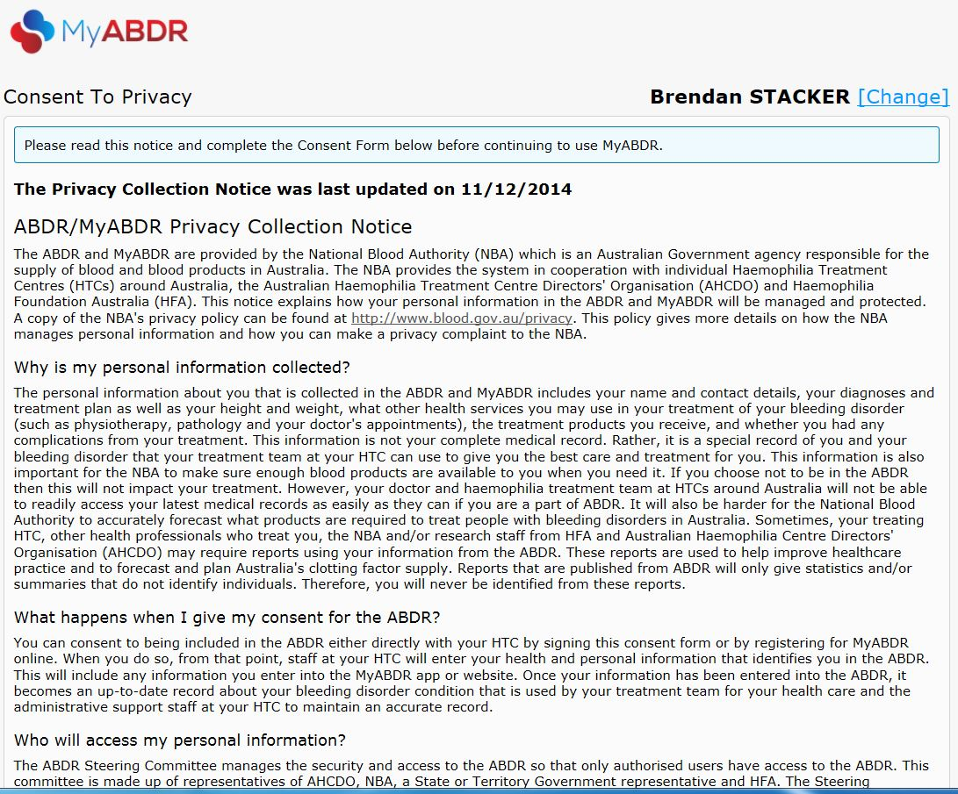

Go to step 4 for instructions on completing the consent form.

  - MyABDR account for two or more patients (eg, where you switch between two or more children)

If you have a MyABDR account for two or more patients (eg, where you switch between two or more children, or a parent and a child), your first screen will be SELECT A PATIENT.

Choose one of the patients/children.

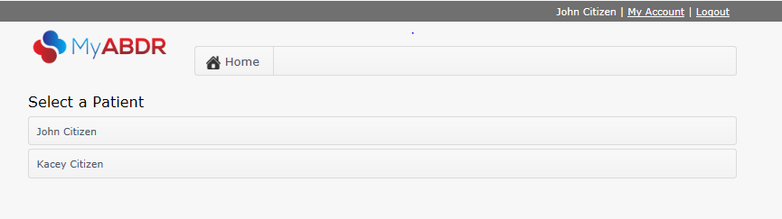

After selecting the patient/child, the ABDR/MyABDR Privacy Collection Notice will be displayed.

Follow the instructions from step 4 to complete the consent form for this patient/child.

If you select CONSENT for the first patient/child, you will be returned to the SELECT A PATIENT screen.

You can now:

- Select the second patient/child to complete the consent form for them as well
- Or select the first patient/child and go on to record a treatment for them or product for their inventory as usual.

You will need to complete a consent form for each patient/child. The consent form will be displayed when you first select each patient/child.

- Read the entire Privacy Collection Notice.
Make sure you continue to the bottom of the page.

This is an updated version of the Privacy Collection Notice you read when you first registered for MyABDR.

The Australian national laws to protect your privacy have been made stronger.

As a result, at the end of this Notice you are now being asked formally if you consent or agree to have your personal information in the ABDR.

You may also be asked to consent on behalf of your child if they are the patient at the HTC and are under 18.

This is called an opt-in system.

- It will make it clear whether you have agreed to have your personal information in the ABDR.

- You also have an opportunity to find out more about the ABDR and how your personal information is used and protected

In the past it was an opt-out system – your personal information was kept in the ABDR unless you asked for it not to be entered in the system. You may recall your Haemophilia Treatment Centre talking to you about the ABDR and giving you a pamphlet.

- Consenting

At the end of the Notice, you will see three (3) options for consent.

Option 1 – CONSENT

If you choose this option, it means you understand the Privacy Collection Notice and agree to have your (or your child’s) personal data in the ABDR.

To select this option, click in the circle next to Consent and click on SAVE.

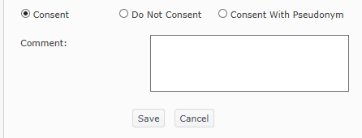

This message will appear:

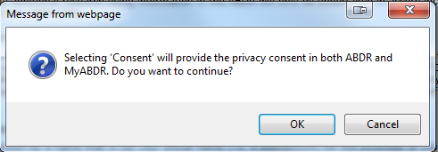

If you click on OK, you will be taken to the MyABDR home screen where you can use MyABDR as normal.

If you click on Cancel, you will be taken back to the Consent to Privacy screen

Option 2 - Do Not Consent

This means you understand the Privacy Collection Notice and do not want your (or your child’s) personal data in the ABDR.

Choosing this option will mean that the Haemophilia Treatment Centre (HTC) cannot enter data about you (or your child, if they are the patient) in the ABDR. You will no longer be able to use MyABDR.

A decision not to consent will not impact on treatment but your doctors and haemophilia treatment team will need to make different arrangements to access your (or your child’s) latest medical records. It would be valuable to discuss this with your HTC first before choosing this option.

To select this option, click in the circle next to Do Not Consent and click on SAVE.

A message confirming your choice will appear, eg:

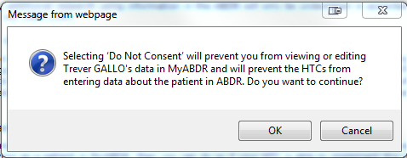

If you click on Cancel, you will be taken back to the Consent to Privacy screen
If you click on OK, you will be taken to the MyABDR login screen. You will no longer be able to use MyABDR for this patient (eg, you or your child).

Option 3 - Consent With Pseudonym

This means you understand the Privacy Collection Notice and agree to have your (or your child’s) personal data in the ABDR, but under a different made-up name.

Choosing this option will send a message to the HTC requesting this option. You will need to contact the HTC to see whether they are able to set up a pseudonym and still properly manage your patient records. You will also need to discuss how this would work in situations such as care in other hospitals or health care settings or in emergencies.

To select this option, click in the circle next to Consent With Pseudonym and click on SAVE.

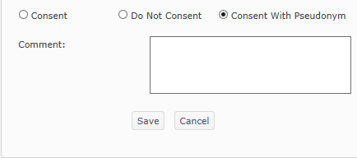

A message confirming your choice will appear, eg:

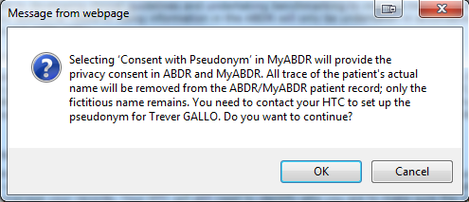
If you click on Cancel, you will be taken back to the Consent to Privacy screen
If you click on OK, you will be taken to the MyABDR home screen where you can use MyABDR as usual

Troubleshooting

What if I have already completed a printed ABDR/MyABDR Privacy Consent Form at my HTC?

If you have already completed a printed Consent Form at your HTC, your HTC will register your decision about consent in the ABDR at the HTC.

When your decision is registered in the ABDR, it will turn off the updated ABDR/MyABDR Collection Notice page at login.

- If you chose Consent or Consent with Pseudonym on the printed form, you will be able to use MyABDR as usual.

- If you chose Consent with Pseudonym on the printed form with the agreement of your HTC, your HTC will organise for the patient name that appears on the MyABDR home page after you login to be the same as your pseudonym.

- If you chose Do Not Consent on the printed form, your login to MyABDR will no longer work. You will not be able to enter data about the patient (you or your child) in MyABDR and the HTC will not be able to enter data about you or your child, if they are the patient, in the ABDR.

I have already completed a printed ABDR/MyABDR Privacy Consent Form at my HTC, but the Privacy Collection Notice has still appeared when I login.

If there has been a delay between you completing the form and the HTC entering your decision about consent in the ABDR, the Privacy Collection Notice will still appear when you login to MyABDR.

In this case, you can complete the online consent form with the same decision as on your printed form, and make a note that you have already completed a printed form in the COMMENT box.

I have already completed a ABDR/MyABDR Privacy Consent Form. What do I do if I change my mind later?

The ABDR and MyABDR are voluntary and you can choose to opt in or out at any time.

To change your ABDR and MyABDR consent status:

- If you completed a consent form at your HTC, contact your HTC directly.

- If you did not consent or consented with a pseudonym, contact your HTC directly.

- If you completed your consent on MyABDR, you can change your privacy consent status after you log into MyABDR on the web site version.

Go to DETAILS in the top menu

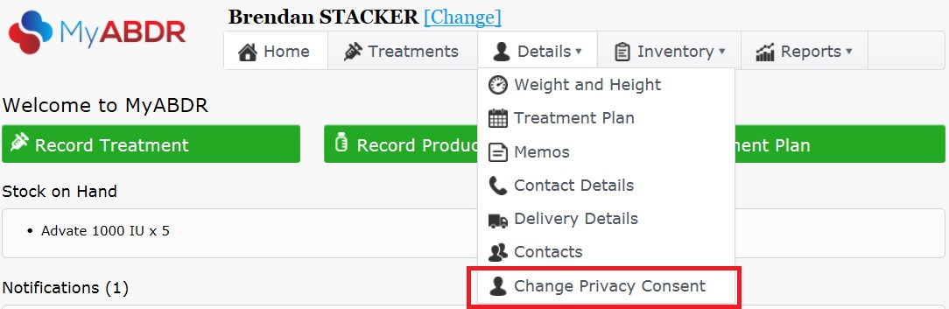

Select CHANGE PRIVACY CONSENT

When you select CHANGE PRIVACY CONSENT, you will be presented with the PRIVACY COLLECTION NOTICE.

Go to step 4 for instructions on completing the consent form. (page 4)

