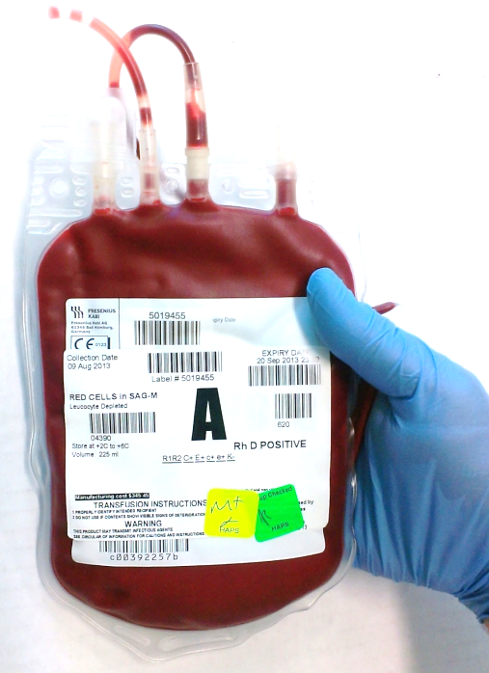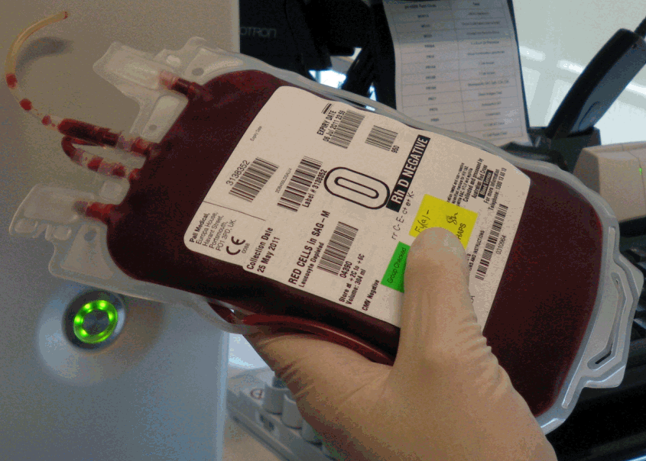 |  | Single  Unit  Transfusion
 |  | Patient Blood Management GuidelineS

The single unit transfusion guide is intended for use by all clinicians responsible for prescribing red blood cell transfusion. It can be applied to stable, normovolaemic adult patients, in an inpatient setting, who do not have clinically significant bleeding.
It is important to ensure current practice aligns with the national Patient Blood Management Guidelines. Each additional transfusion exposes patients to increased risk of an adverse event.
Morbidity from transfusion may be dose dependent. Two units are commonly prescribed when one unit may have met the clinical outcome of the transfusion, for example improvement in symptoms of anaemia.
Increased morbidity, mortality and increased length of hospital stay may be directly associated with transfusion and dose related. The risk of transfusion associated circulatory overload (TACO) is as high as 1 in 100 per unit transfused.
Red blood cell transfusion is a live tissue transplant. Emerging evidence of harm from transfusion requires a precautionary approach to balance risk with benefit for each unit.
Single unit transfusions are appropriate in patients who do not have clinically significant bleeding and reduces risks associated with transfusion.
RECOMMENDATION:
Transfuse one unit of red blood cells at a time when clinically indicated to improve symptoms of anaemia. Reassess the patient before prescribing further transfusion. Align practice with the national Patient Blood Management Guidelines.
Each unit transfused is an independent clinical decision.

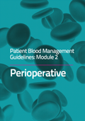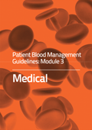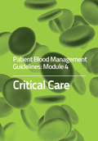

Every ONE matters
Recommendations from the National Blood Authority

Viral transmission is only part of the risk profile associated with red blood cell transfusion. Other risks include effects on the immune system, TACO, and haemolytic reactions.
For further information refer to:
- National Blood Authority Patient Blood Management Guidelines: Modules 2,3,4.
- Koch CG, Li L, Duncan AI et al. Morbidity and mortality risk associated with red blood cell and blood-component transfusion in isolated coronary artery bypass grafting. Crit Care Med 2006, 34:1608-1616.
- Hajjar LA, Vincent JL et al. (2010). Transfusion requirements after cardiac surgery: the TRACS randomised controlled trial. JAMA, 304:1559-1567.
- Hofmann A, Farmer S, Shander A (2011). Five Drivers Shifting the paradigm from Product-focused Transfusion Practice to Patient Blood Management” The Oncologist;16(suppl 3):3-11
- Hofmann, A et al. (2012). Strategies to preempt and reduce the use of blood products: an Australian perspective. Curr Opin Anesthesiol , 25:66-73

