Single Unit Blood Transfusion
Only ONE unit of blood should be ordered if the inpatient does not have clinically significant bleeding
Each unit transfused is an independent clinical decision
Every ONE matters
Second unit can be requested after
patient has been assessed and
remains symptomatic

Indications for a second
unit:
- Active blood loss
- Ongoing symptoms of
anaemia

For more information on patient blood management visit www.blood.gov.au/pbm-guidelines to access the latest guidelines.
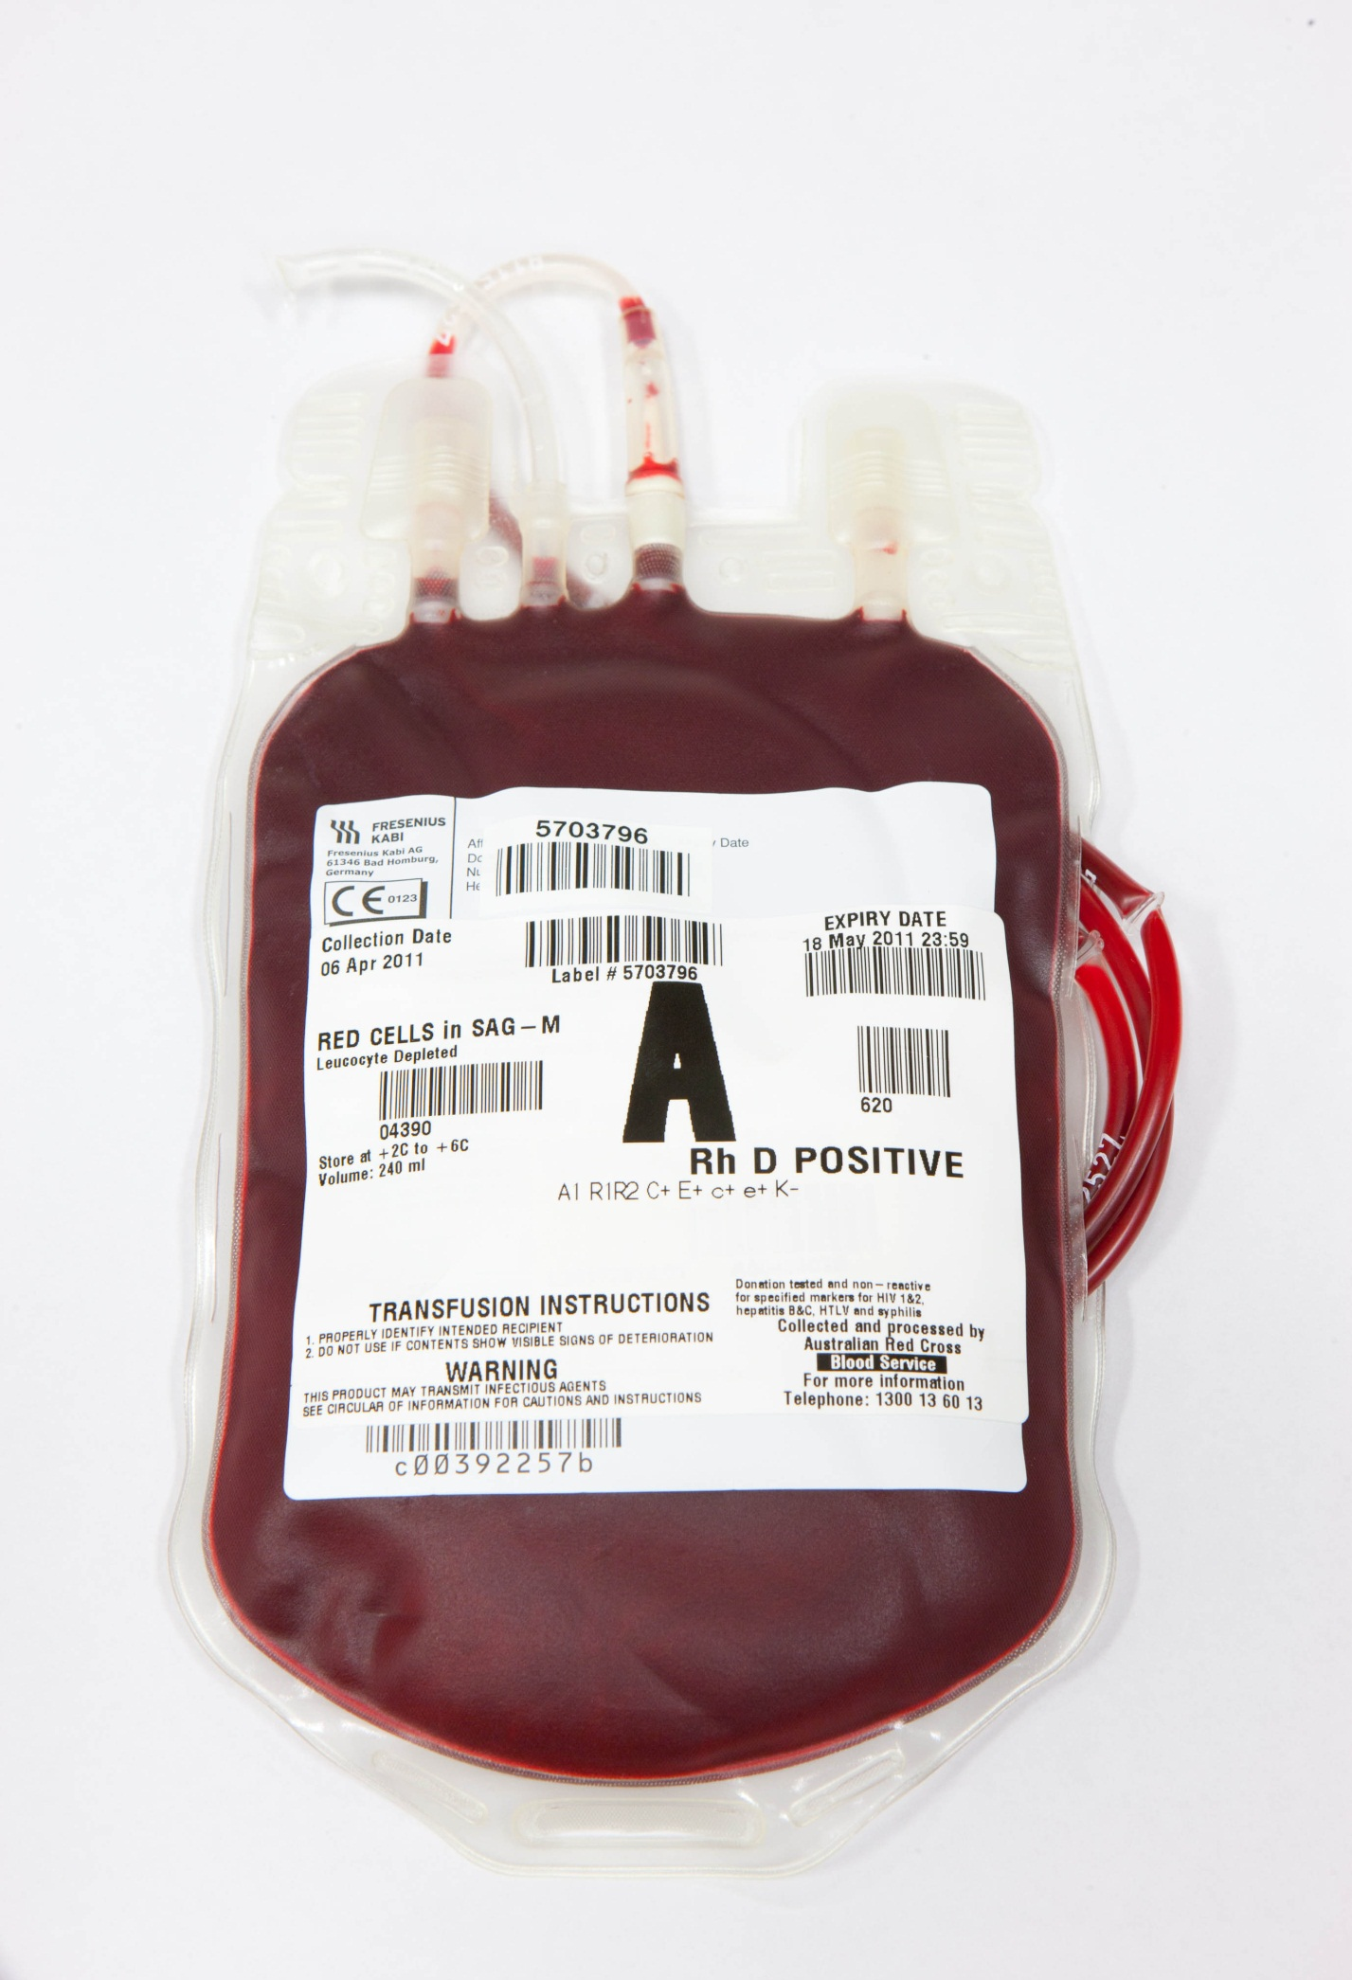
Single Unit Blood Transfusions
In accordance with the Patient Blood
Management Guidelines:

- Prescribe ONE unit only for the symptomatic, non-bleeding patient

- Reassess the patient before
requesting a second unit

- Each unit transfused is
an independent clinical
decision

Every ONE matters
For more information on patient blood management
visit www.blood.gov.au/pbm-guidelines to access the latest guidelines.
Single Unit Blood Transfusions
In accordance with the Patient Blood
Management Guidelines:
- Prescribe ONE unit only for the symptomatic, non-bleeding patient
- Reassess the patient before
requesting second unit
- Each unit transfused is
an independent clinical
decision

Transfusion risks may
be dose dependent

ONE bag is best -
then reassess
For more information on patient blood management
visit www.blood.gov.au/pbm-guidelines to access the latest guidelines.

