



Fresh Component  
Health Provider Discard  
FATE007e

Report Specification

Version Control

| **Version** | **Revision Date** | **Revision Description** |
| --- | --- | --- |
| 0.1 | 19 Aug 2013 | Initial Draft. |
| 0.2 | 26 Aug 2013 | Incorporate Sandra’s confirmation of the data extract mocks, and based this specification on these confirmed mocks. |
| 0.3 | 27 Aug 2013 | Incorporate Pete’s feedback. |
| 0.4 | 05 Sep 2013 | Incorporate Pete’s feedback. |
| 0.5 | 06 Sep 2013 | Ensure that all report items in all worksheets use the same terminology for consistency. |
| 0.6 | 11 Sep 2013 | Pete added source data in Section 3.4. |
| 1.0 | 11 Sep 2013 | Approved by Peter O’Halloran. |
| 1.1 | 13 Sep 2013 | From Amit’s testing, amend the following:   * Column heading to be displayed as Cost Group Code; * Update Summary worksheet mock to show the right ordering of the columns Group DAPI followed by Benchmark. * Bring back Donation Number into the Discards worksheet. * Added ‘Episode Number’ into the ‘Discards’ and ‘Issues and Transfers’ worksheets. * Move ‘Expiry Date’ from the ‘Discards’ worksheet to the ‘Issues and Transfers’ worksheets. * Added ‘Days to Expire’ to the ‘Issues and Transfers’ worksheet. * Reordering report items into more logical groupings for the ‘Discards’ and ‘Issues and Transfers’ worksheets. * Rename Unit Cost to Unit Price. * Incorporate source data for Episode number. * Incorporate updated report samples. |
| 2.0 | 13 Sep 2013 | Approved by Peter O’Halloran. |

Document Review and Approval

| **Version** | **Approval Date** | **Name and Position** | **Comments** |
| --- | --- | --- | --- |
| 1.0 | 11 Sep 2013 | Peter O’Halloran Executive Director, Health Provider Engagement | Approved. |
| 2.0 | 13 Sep 2013 | Peter O’Halloran Executive Director, Health Provider Engagement | Approved. |
|  |  |  |  |

**Creative Commons**

cid:image001.jpg@01CE6288.815B9460

With the exception of any logos and registered trademarks, and where otherwise noted, all material presented in this document is licensed by the NBA under a Creative Commons Attribution 3.0 Australia (<http://creativecommons.org/licenses/by/3.0/au/>) licence. In essence this licence allows you to copy, communicate and adapt the work, as long as you attribute the work to the National Blood Authority and abide by the other licence terms.

The details of the relevant licence conditions are available on the Creative Commons website (accessible using the links provided) as is the full legal code for the CC BY 3.0 AU licence (<http://creativecommons.org/licenses/by/3.0/au/legalcode>).

The content obtained from this document or derivative of this work must be attributed as the *National Blood Authority BloodNet Fresh Component Health Provider Discard Report Specification.*

Contents

1 Introduction 5

1.1 Purpose 5

1.2 Document Audience 5

1.3 Related Documents 6

2 Report Details 7

2.1 Description 7

2.2 Business Rules 7

2.3 Report Sample 11

3 Report Content 14

3.1 Title 14

3.2 Description 14

3.3 Parameters 15

3.4 Report Field Description 16

4 Glossary 24

# Introduction

## Purpose

The purpose of this document is to describe the functional specification for the Data Extract that can be used by states and territories.

The purpose of the report is to produce extracts to provide discard values (cost and unit quantities) for fresh components over a given time period for the selected health provider.

Below is a matrix which identifies which reporting system and by which audiences, the report can be generated.

| **Reports Generated By** | **BloodNet Reports** | **Jurisdictional Reporting** | **NBA Internal Reports** | **Report Subscriptions** |
| --- | --- | --- | --- | --- |
| Facility Administrators | **✓** |  |  | **✓** |
| Facility User | **✓** |  |  | **✓** |
| Jurisdictional Blood Committee Members |  | **✓** |  | **✓** |
| Jurisdictional Blood Committee Proxies |  | **✓** |  | **✓** |
| NBA Staff | **✓** | **✓** | **✓** | **✓** |
| Blood Service Staff |  |  |  |  |
| State/Territory Government Staff |  | **✓** |  | **✓** |

## Document Audience

This document should be used by:

* The Architect - to ensure this report fit into the NBA framework and meets all the essential core design features and elements of NBA systems.
* The Database Administrator – to form the design of the BloodNet reports database.
* The Developers - to form the basis of the development of BloodNet reports.
* The System Tester - to create the system test plan and system test cases.
* The Systems Support Team – to develop an understanding of the BloodNet reports to support users.
* The Business Stakeholders - to confirm that their requirements have been properly understood and approve the report specification.
* The Project Manager - to obtain project requirements/design signoff from the stakeholders and to assist in detailed task estimation and refinement of the project schedule and milestones.

## Related Documents

* BloodNet Reporting Requirements;
* Report Register;
* BloodNet User Manual; and
* Jurisdictional Reports – Security Matrix SM.01 Functional Specification

# Report Details

## Description

The Fresh Component Health Provider Discard report is comprised of the following extracts:

1. Summary Data Extract – summary view that is based on each fresh component cost group for the entire reporting period;
2. Discards Data Extract – detailed view of discards for the reporting period;
3. Issues and Transfers Data Extract – detailed view of issues for the reporting period; and
4. Benchmarks Table.

The report is primarily designed to be exported into Excel for subsequent manipulation.

## Business Rules[1]

This report is based on the following rules:

1. This report extracts data that is entered into BloodNet.
2. Date and time fields will be displayed for the local time zone of the Health Provider, where applicable.
3. Report is based on a date range using start date and end date parameters[2].
   1. All components[3] that have a Discard Date[4] (ie. when the discard took place) within the date range will be displayed in the Discard Data Extract; and
   2. All components[5] that have an Issue Date and Time (ie when the Issue Note was created by Blood Service) within the date range will be displayed in the Issue Data Extract.
4. The report includes the following issues statuses:

* Unreceipted;
* Receipted; and
* Partially receipted.  
  The report excludes “Cancelled” issue notes.

1. Orphaned issue notes (ie. issues notes for health providers that are not ordering through BloodNet) that exist in the BloodNet database matching on AHP code are included in the results by default[6].
   1. Orphaned issue notes will be linked to a state/territory based on the first number of the AHP code (please refer to table below). For example, an AHP code of **2**7ZCSL would refer to the state of NSW (because the first number of this code is “2”, and this refers to the state of “NSW”, as per table below.

| **StateID** | **CountryID** | **StateCode** | **StateName** |
| --- | --- | --- | --- |
| **1** | 1 | ACT | Australian Capital Territory |
| **2** | 1 | NSW | New South Wales |
| **3** | 1 | VIC | Victoria |
| **4** | 1 | QLD | Queensland |
| **5** | 1 | SA | South Australia |
| **6** | 1 | WA | Western Australia |
| **7** | 1 | TAS | Tasmania |
| **8** | 1 | NT | Northern Territory |

1. The issues and discard figures in the report are based on these figures having issue date, transfer date and the discard date that falls within the reporting period.

For example, say for a health provider, a quantity of Fresh Component Z was:

* Issued on 20th June 2012;
* Transferred on 30th June 2012 (as transfer in occurs at exactly the same date/time as the transfer out, both the transfer in and transfer out dates will be 30th June 2012); and
* Discarded on 12th July 2013.

If the reporting period was set for 1st July 2013 to 30th June 2014, then only the quantity of fresh component discarded will be included, as this date falls within the reporting period.

1. When considering transfers, the report will include:
2. Transfers Out of health providers to other health providers, distribution sites and/or custom locations[7] (as this reduces the stock levels of facilities); and
3. Transfers In to health providers from another health provider.

This report cannot report on any of the corresponding ‘Transfers In to’, and ‘Transfers Out from’ distribution sites and custom locations.



1. Below is the benchmark table, which will determine the Benchmark DAPI in the Section 1 – Summary Table:

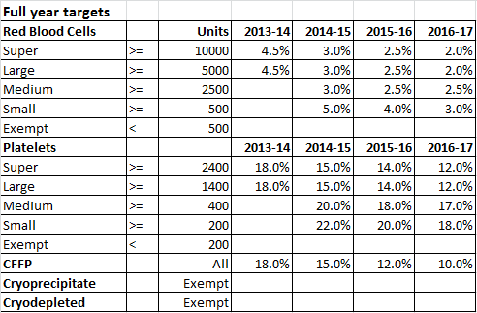

1. The year is based on the financial year (ie. 2013-14 implies July 1st 2013 to June 30th 2014);
2. The Units (ie. Net issued qty) is based on a full year period (365 days), but pro-rata on a daily basis depending on the reporting period (ie. the number of days (inclusive) between start and end date). For example, if the reporting period is from 1st July 2014 to 5th July 2014, and we are looking at red blood cells for a super group, then the number of units issued will be 137 for the reporting period of 5 days ((10,000 units x 5 days)/365 days));
3. The benchmark percentage will populate the applicable cells in the Summary Table, depending on which Component Group, Group, and Start Date[8]. The Benchmark percentage is fixed (ie. is not pro rata based on the reporting period like the Units).  
   For example, a “Red Cell” Component Group for a “Super” Group where the reporting period is from 1st May 2015 to 18th July 2015, will have a start date of 1st May 2015 which corresponds to the 2014-15 column. Matching this for the Red Cell Component Group and Super Group, means that the benchmark will be 3.0%.
4. If the group is exempt, then there are no benchmarks.

## Report Sample

Below are samples of the Fresh Component Health Provider Discard extracts once it is exported to Excel. The Excel will be made up of primarily 5 worksheets/tabs as follows:

**1st worksheet - Header –** displays the NBA logo, report title, description and selected parameters.

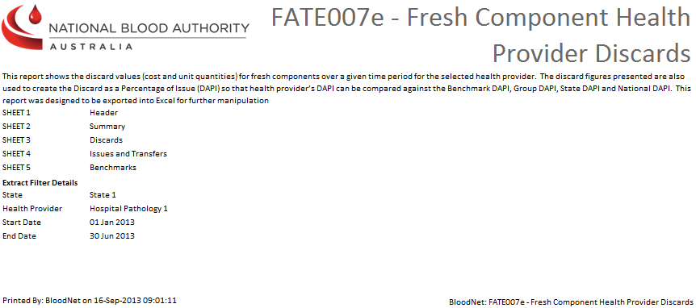

**2nd worksheet – Summary Worksheet** – displays a summary view that is based on each fresh component cost group for the entire reporting period.

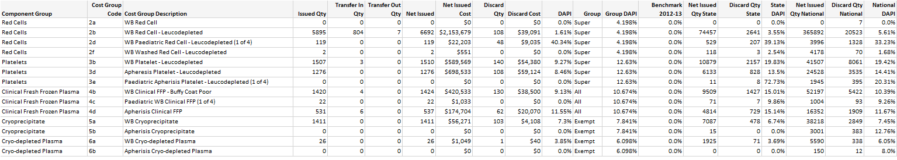

**3rd worksheet – Discards Worksheet** – detailed discard view based on each discard date event.

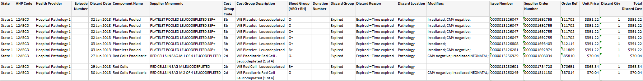

**4th worksheet – Issues and Transfers Worksheet** – detailed issue view based on each issue date event.

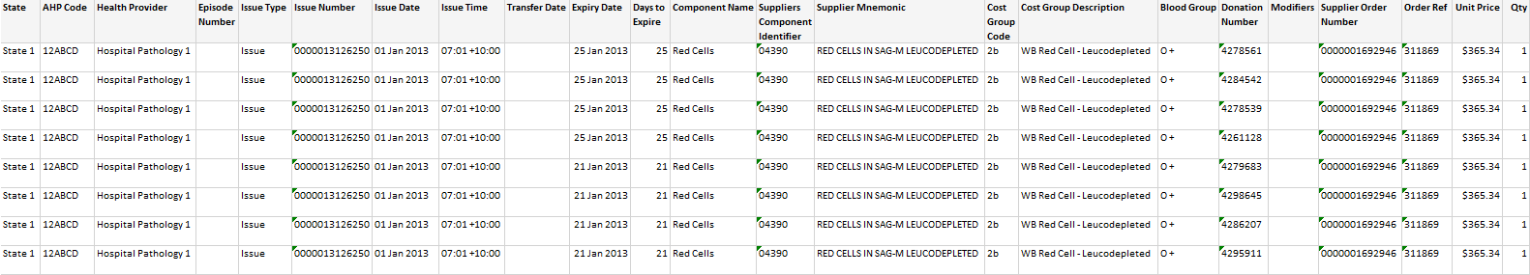

Note that Excel 2003 has a limitation of been able to display 65,000 rows when exporting the data to Excel. When this happens, there may be multiple Excel worksheets for “Discards Data Extract” and “Issues and Transfers Data Extract” (where each worksheet can hold a maximum of 65,000 rows). Hence the worksheet order will be: 1st worksheet is the header, the 2nd worksheet will be the summary data extract, and the subsequent sheets will cover the discards and issues and transfers data extracts, followed by the benchmarks worksheet.

**5th worksheet – Benchmarks Worksheet** – the benchmark level set as the comparison between hospitals that are categorised in the same peer group.

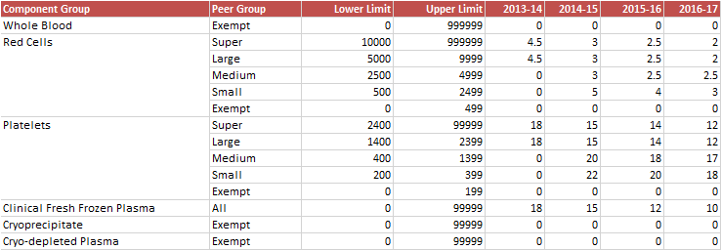

# Report Content

## Title

The report title is: Fresh Component Health Provider Discard Report.

The Report ID is: FATE007e

This report title and Report ID will be seen consistently on the NBA internal site and also within the extract.

## Description

The following report description will display on the report:

“This report shows the discard values (cost and unit quantities) for fresh components over a given time period for the selected health provider. The discard figures presented are also used to create the Discard as a Percentage of Issue (DAPI) so that health provider’s DAPI can be compared against the Benchmark DAPI, Group DAPI, State DAPI and National DAPI. This report was designed to be exported into Excel for further manipulation.”

## Parameters

The following parameters[9] will be available:

| **Name** | **Mandatory** | **Description** | **Control Type** | **Values/Value List** | **Default Value** |
| --- | --- | --- | --- | --- | --- |
| **State** | Yes | The state will filter all the applicable health providers that will be considered for the selected state(s). | Drop Down | All States ACT NSW NT QLD SA TAS VIC WA | All States |
| **Health Provider** | Yes | The selected health provider determines all the fresh components that are issued/discarded by the selected health provider. | Drop down | A list of all the current health providers filtered by the State selected. | <Select a Value> |
| **Start Date** | Yes | The starting date of the range for the report (inclusive). | Date Picker | Any valid date | <Select a Value> |
| **End Date** | Yes | The end date of the range for the report (inclusive) | Date Picker | Any valid date | <Select a Value> |

This report is designed be exported to Excel. The following rules apply on the report outputs (noting that the display is not optimised for a screen):

1. Worksheet 1 displays the NBA Logo, report title, description and selected parameters.
2. Worksheet 2 displays the Summary table.
3. Worksheet 3 displays the Discards table.
4. Worksheet 4 displays the Issues and Transfers table.
5. Worksheet 5 displays the Benchmarks table.
6. Where the selected criteria returns no results, a message is displayed on the relevant page:

For Summary table:

“No Summary is available using the selected parameters.”

For Discard table:

“No Discards were found using the selected parameters.”

For Issue table:

“No Issues were found using the selected parameters.”

## Report Field Description

1. **Summary Table** - data is displayed as a table with the following columns.

| **Data Item** | **Description** | **Source Data** |
| --- | --- | --- |
| Component Group | The description of a fresh component at a high level (ie. whole blood, red cell, platelet, clinical fresh frozen plasma, cryoprecipitate, cryo-depleted plasma, and other. | BloodNet_Reporting.dbo.ComponentGroup.ComponentGroupName |
| Cost Group Code | Used to describe the logical grouping of components into pricing brackets. For example a cost group code of 2a is WB Red Cell, 2b is WB Red Cell - Leucodepleted. | ComponentCostGroup.GroupingCode |
| Cost Group Description | The name of the logical grouping used to describe the fresh components grouped in the price bracket. | ComponentCostGroup.Description |
| Issued Qty | The number of units issued by the Blood Service Distribution Centre to the selected Health Provider. Note: Issued Qty does not take into account of transfers in/out quantities. | ConsignmentNoteLine.Qty |
| Transfer In Qty | The number of units transferred into the selected Health Provider from other Health Providers. | ConsignmentNoteLine.Qty |
| Transfer Out Qty | The number of units transferred out of the selected Health Provider to other Health Providers/Blood Service Distribution Centre or Custom Locations | ConsignmentNoteLine.Qty |
| Net Issued | The number of units issued taking into account of the transfers in/out quantities for the selected Health Provider. ie. Net Issued = Issues + Transfers IN – Transfers OUT | Calculated using fields above |
| Net Issued Cost | The total net issued cost at the time of issued. As unit cost may vary during a reporting period, this report will take into account any unit cost change within the reporting period. | ComponentUnitCost.PublishedPrice * Net Issued |
| Discard Qty | The number of units discarded by the selected Health Provider. | count(DiscardEpisodeComponent) |
| Discard Cost | The total cost of discards for each cost group for the selected Health Provider. | DiscardEpisodeComponent.PublishedPrice |
| DAPI | The number of Discards As a Percentage of Issued (DAPI) for each cost group, for the selected Health Provider. This is based on the reporting period.  DAPI for each Cost group: ( DiscardQty ) / (Net IssuedQty) x 100 | Derived |
| Group | The Group DAPI is where any Health Provider that has a matching group and matching cost group (ie. belongs to a large group, and for cost group (ie. 2a – WB Red Cell)) will have its discard and net issue quantities counted towards the group average. This is based on the reporting period.  [Average of ∑ (DiscardQty) / Average of ∑ (NetIssuedQty)] x 100  **Filter:** Component & Facility.PeerGroupId = @PeerGroupId  For a specific cost group, obtain a list of all health providers’ net issued and discard quantities.  Then from this list, filter out all the health provider that has a net issued quantity that is between the limits stated in the Benchmark Table (Section 2.2).  For example, for a Red Blood Cell, the limits are:   * 0 to 499 – Exempt; * 500 to 2,499 - small; * 2,500 to 4,999 - medium; * 5,000 to 9,999 - large; * >=10.000 - super.   If there are 5 health providers that have net issued quantities of 500, 550, 1000, 2000, and 2499 (ie. all in the small group), and their corresponding discard quantities are 1, 2, 3, 4, and 5 , then these health providers would be filtered to determine the group average for this specific fresh component and for a small group.  Hence sum the net issued quantities and divide by 5 health providers to obtain the “sum net issued average” (ie. (500 + 550 + 1000 + 2000 + 2499)/5 = 1310) and sum the discard quantities and divide by 5 health providers to obtain the “sum discard average” ((1 + 2 + 3 + 4 + 5)/5 = 3).  Then divide the sum discard average by the sum net issued average, multiply by 100 (ie. 3/1310 x 100 = 0.23%).  0.23% will then be the group average for a small group, and for this specific cost group. |  |
| Group DAPI | Any Health Provider that has a matching group and matching fresh component (ie. belongs to a large group, and for component group (ie. all 2’s (Red Cells), 3’s (Platelets), etc, will have its discard and net issue quantities counted towards the Group DAPI. This is based on the reporting period.  [Average of ∑ (DiscardQty) / Average of ∑ (NetIssuedQty)] x 100  **Filter:** Component & Facility.PeerGroupId = @PeerGroupId  For a specific fresh component, obtain a list of all health providers’ net issued and discard quantities.  Then from this list, filter out all the health provider that has a net issued quantity that is between the limits stated in the Benchmark Table (Section 2.2, BR10).  For example, for a Red Blood Cell, the limits are:   * 0 to 499 – Exempt; * 500 to 2,499 - small; * 2,500 to 4,999 - medium; * 5,000 to 9,999 - large; * >=10.000 - super.   If there are 5 health providers that have net issued quantities of 500, 550, 1000, 2000, and 2499 (ie. all in the small group), and their corresponding discard quantities are 1, 2, 3, 4, and 5 , then these health providers would be filtered to determine the group average for this specific fresh component and for a small group.  Hence sum the net issued quantities and divide by 5 health providers to obtain the “sum net issued average” (ie. (500 + 550 + 1000 + 2000 + 2499)/5 = 1310) and sum the discard quantities and divide by 5 health providers to obtain the “sum discard average” ((1 + 2 + 3 + 4 + 5)/5 = 3).  Then divide the sum discard average by the sum net issued average, multiply by 100 (ie. 3/1310 x 100 = 0.23%).  0.23% will then be the group average for a small group, and for this specific fresh component. | Derived |
| Benchmark <FY> | The benchmark is set by NBA annually. There is a benchmark table that can be updated easily. Refer to Section 2.2 for the Benchmark table. | Reference.componentGroupPeerBenchmark.BenchmarkPercent |
| Net Issued Qty State | The number of units issued taking into account of the transfers in/out quantities for all the Health Providers in the selected State.  Note that if “All States” is selected, then this field will remain blank. | ConsignmentNoteLine.Qty |
| Discard Qty State | The number of units discarded for the selected Health Provider. Note: The state is determined by the selection of the Health Provider (and which state this Health Provider is located). This report is for a single Health Provider. | count(DiscardEpisodeComponent) |
| State DAPI | The number of Discards As a Percentage of Issued (DAPI) for each cost group, for the selected state. This is based on the reporting period.  State DAPI for each Cost group: (DiscardQty State) / (Net IssuedQty State) x 100 | Derived |
| Net Issued Qty National | The number of units issued taking into account of the transfers in/out quantities for all the Health Providers for all states and territories. | ConsignmentNoteLine.Qty |
| Discard Qty National | The number of units discarded for all the Health Providers for all states and territories. | count(DiscardEpisodeComponent) |
| National DAPI | The number of Discards As a Percentage of Issued (DAPI) for each cost group, for all states/territories. This is based on the reporting period.  National DAPI for each Cost group: (DiscardQty National) / (Net IssuedQty National) x 100 | Derived |

1. **Discards Table** - data is displayed as a table with the following columns.

| **Data Item** | **Description** | **Source Data** |
| --- | --- | --- |
| State | The state/territory to which this report will be based upon. Determines the list of health providers available for selection. | BloodNetReporting.Facility.State |
| AHP Code | This Approved Health Provider (AHP) code identifies the Health Provider that has discarded or been issued components. It should be noted that each Health Provider has a unique AHP code and in some instances, one large hospital may have multiple facilities (ie. Pathology facility, Pharmacy facility, Oncology facility), and all these facilities will have its own unique AHP code. | Facility.HealthProviderCode |
| Health Provider | The AHP Name of the Health Provider receiving the components. | Facility.FacilityName |
| Episode Number | A BloodNet generated number which relates to one discard incident, or one transfer incident. Hence, for the ‘Issues and Transfers’ worksheet, an episode number will only be displayed when the Issue Type = Transfer In or Transfer Out. For the ‘Discards’ worksheet, an episode number should be displayed.  Note that one discard/transfer incident can relate to discard of one or many components. | TransferEpisode.TransferEpisodeid  Or  DiscardEpisode.DiscardEpisodeId |
| Discard Date | This is the date the discard took place. The format is dd-Mmm-yyyy.  Note: There is a field in BloodNet called discard date that the user can enter – this is the date that is used for this report. | DiscardEpisode.DiscardDateTime |
| Component Name | Component Name is what is ordered (ie. platelet pooled, platelet apheresis, etc).  Note that this is totally different from Component Group (ie. platelet) which deals with what was issued. | Component.ComponentName |
| Supplier Mnemonic | The mnemonic used by the supplier to indicate a product. Used on packaging slips and consignment notes. | SupplierComponent.SupplierMnemonic |
| Cost Group Code | The code used to describe the logical grouping of components into pricing brackets. For example a cost group code of 2a is WB Red Cell, 2b is WB Red Cell - Leucodepleted. | ComponentCostGroup.GroupingCode |
| Cost Group Description | The name of the logical grouping used to describe the fresh components grouped in the price bracket. | ComponentCostGroup.Description |
| Blood Group (ABO + RH) | Any one of the various groups into which human blood is classified on the basis of its agglutinogens. Also called blood type. | consignmentNoteLine.group |
| Donation Number | The donation/lot number of the unit so it can be traced back to the donor of manufacturing batch and printed on the individual issue note line items. | ConsignmentNoteLine.DonationNoLot |
| Discard Group | Discard group has been created so that discard reasons can be grouped manageably. Discard groups include: Expired, Damaged, Clinical, Recall, Storage, Transport and Other. | DiscardGroup.DiscardGroupName |
| Discard Reason | Each discard group is broken down into its discard reasons. Discard reasons are entered into BloodNet during a discard. For example, the Expired discard group will show discard reasons such as: Extended life plasma; Thawed cryoprecipitate; Thawed FFP; and Time expired. | DiscardReason.DiscardReasonName |
| Discard Location | The location where the discard of the component took place. | Location.Location |
| Modifiers | The text from the Modifiers field printed on the individual issue note line items. This is a list of mnemonics that represent the changes/additions applied to the original component during manufacture. Examples include Irradiated, Washed or Phenotyped. | ConsignmentNoteLine.Modifiers |
| Issue Number | The issue note number is used by the Red Cross Blood Service and printed on the top of their issue note. | ConsignmentNote.IssueNumber |
| Supplier Order Number | An order number generated by the supplier. Used to hold the issue note numbers from Blood Service if available when creating the order. | ConsigmentNote.SupplierOrderNumber |
| Order Ref | This is the BloodNet order number. | ConsignmentNote.OrderRef |
| Unit Price | The cost of the discard on the date the component was issued. | ComponentUnitCost.PublishedPrice |
| Discard Qty | This discard quantity will always be 1 because users discard by donation number | Count(DiscardEpisodeComponent) |
| Total Discard Cost | This is the total discard cost for the component on the discard date (ie. unit cost x discard qty). | Sum(discardEpisodeComponent * PublishedPrice) |

1. **Issues and Transfers table** - the data is displayed as a table with the following columns

| **Report Item** | **Description** | **Source Data** |
| --- | --- | --- |
| State | The state/territory to which this report will be based upon. Determines the list of health providers available for selection. | BloodNetReporting.Facility.State |
| AHP Code | This Approved Health Provider (AHP) code identifies the Health Provider that has discarded or been issued components. It should be noted that each Health Provider has a unique AHP code and in some instances, one large hospital may have multiple facilities (ie. Pathology facility, Pharmacy facility, Oncology facility), and all these facilities will have its own unique AHP code. | Facility.HealthProviderCode |
| Health Provider | Depending on the Issue Type, the Health Provider value listed here will have different meanings.  If Issue Type = Issue, then this is the Health Provider receiving the components (ie. the health provider you are reporting on);  If Issue Type = Transfer Out, then the Health Provider displayed will be the Health Provider where the components are transferred to; and  If Issue Type = Transfer In, then the Health Provider displayed will be the Health Provider where components have come from (and transferred into your selected Health Provider). | Facility.FacilityName |
| Episode Number | A BloodNet generated number which relates to one discard incident, or one transfer incident. Hence, for the ‘Issues and Transfers’ worksheet, an episode number will only be displayed when the Issue Type = Transfer In or Transfer Out. For the ‘Discards’ worksheet, an episode number should be displayed.  Note that one discard/transfer incident can relate to discard of one or many components. | TransferEpisode.TransferEpisodeid  Or  DiscardEpisode.DiscardEpisodeId |
| Issue Type | The type of issue. Can be either Issue, Transfer In, or Transfer Out. | Derived |
| Issue Number | The issue note number is used by the Red Cross Blood Service and printed on the top of their issue note. | ConsignmentNote.IssueNumber |
| Issue Date | The date the issue note was created by the Blood Service Distribution Centre. The format is dd-Mmm-yyyy. | ConsignmentNote.OrderDateTime |
| Issue Time | The local time the issue note was created by the Blood Service Distribution Centre. The format is hh:mm:tt. The time is in 24hr format, and tt represents the different time zones for the different states and territories. | ConsignmentNote.OrderDateTime |
| Transfer Date | The date the fresh component was transferred. Note that transfer in occurs at exactly the same date as transfer out). | TransferComponent.TransferDate |
| Expiry Date | The expiry date (ie. component shelf-life) on the item. | ConsignmentNoteLine.ExpiredOn |
| Days to Expire | The number of days to expiry from the issue date/transfer date. Note that if the issue date/time is 19th August 11:59pm, we will still count this as one day. | Derived |
| Component Name | Component Name is what is ordered (ie. platelet pooled, platelet apheresis, etc).  Note that this is totally different from Component Group (ie. platelet) which deals with what was issued. | Component.ComponentName |
| Supplier Component Identifier | The code used by the supplier and manufacturer to identify the product. Often printed as a barcode on the product. | ConsignmentNoteLine.SupplierComponentIdentifier |
| Supplier Mnemonic | The mnemonic used by the supplier to indicate a product. Used on packaging slips and consignment notes. | SupplierComponent.SupplierMnemonic |
| Cost Group Code | The code used to describe the logical grouping of components into pricing brackets. For example a cost group code of 2a is WB Red Cell, 2b is WB Red Cell - Leucodepleted. | ComponentCostGroup.GroupingCode |
| Cost Group Description | The name of the logical grouping used to describe the fresh components grouped in the price bracket. | ComponentCostGroup.Description |
| Blood Group (ABO + RH) | Any one of the various groups into which human blood is classified on the basis of its agglutinogens. Also called blood type. | ConsignmentNoteLine.Group |
| Donation Number | The donation/lot number of the unit so it can be traced back to the donor of manufacturing batch and printed on the individual issue note line items. | ConsignmentNoteLine.DonationNoLot |
| Modifiers | The text from the Modifiers field printed on the individual issue note line items. This is a list of mnemonics that represent the changes/additions applied to the original component during manufacture. Examples include Irradiated, Washed or Phenotyped. | ConsignmentNoteLine.Modifiers |
| Supplier Order Number | An order number generated by the supplier. Used to hold the issue note numbers from Blood Service if available when creating the order. | ConsignmentNote.SupplierOrderNumber |
| Order Ref | This is the BloodNet order number. | ConsignmentNote.OrderRef |
| Unit Price | The published price for the cost group on the date the component was issued (ie. issue date). | ComponentUnitCost.PublishedPrice |
| Qty | For fresh components, the quantity will always be one (or -1 for transfer out), because a transfer always relates to a single donation number. | ConsignmentNoteLine.Qty |

# Glossary

| Term | Definition |
| --- | --- |
| AHP | Approved Health Provider, normally referred to as a ‘Health Provider’. Also known as facility. |
| Benchmark | The level set as the comparison between hospitals that are categorized in the same peer group. |
| BloodNet | Operated by the NBA, BloodNet is Australia’s national online ordering and inventory management system, enabling staff in pathology laboratories to place orders online for blood and blood products, record inventory levels, and to record the final fate of each unit. |
| Blood Service | Australian Red Cross Blood Service. |
| Component | Known as Fresh Components within BloodNet. Also, commonly referred to as Fresh Blood Products within the blood sector.  The most common fresh components are:   * 1. Red Cells   2. Platelets   3. Clinical Fresh Frozen Plasma   4. Cryoprecipitate |
| Component Group | This is the higher level description of the Fresh Component Group. Examples of Component Groups are: Whole Blood, Red Cell, Platelet, Clinical Fresh Frozen Plasma, Cryoprecipitate, Cryo-depleted plasma, and Other. |
| Cost Group | When you combine Fresh Component Cost Group Code and Fresh Component Cost Group description together (ie. 2a – WB Red Cell). |
| Custom Location | This is a location that was entered by a BloodNet user using the free text box entry when performing a transfer in BloodNet. |
| DAPI | Discard as a Percentage of Net Issue. This is based on the reporting period. |
| Discard Cost | The cost of the quantity discarded for each component/manufactured product (ie. discard cost = unit price x quantity discarded).  The unit cost for the cost group on the date the component was issued. |
| Discard quantity | The number of units of blood and blood products that are discarded. |
| Extract | The process of retrieving data out of data sources for further data processing or data storage (data migration). |
| Episode Number | A BloodNet generated number which relates to one discard incident, or one transfer incident. One discard/transfer incident can relate to discard of one or many components. |
| Facility | Also known as an Approved Health Provider (AHP) or Health Provider. It should be noted that each Facility has a unique AHP code and that in some instances, one Health Provider may be comprised of multiple facilities using BloodNet (eg Pathology and Pharmacy). |
| Facility user | General users of BloodNet to order, receive and fate blood and blood products. |
| Facility administrator | Users of BloodNet with administrator rights which gives the ability to approve users, change templates and add new items. Once approved facility administrators will also be automatically granted facility user access to the facility indicated.  Facility administrator can be a lab manager, scientist in charge (SIC) or second in change (2IC). |
| Cost Group Code | This is the 2 alphanumeric code that corresponds to a Fresh Component Group. Examples of Fresh Component Cost Groups include: 1a, 1b, 2a, 2b, 2c etc |
| Group Description | Also known as Components. Also, commonly referred to as Fresh Blood Products within the blood sector. The components referred to in this report are issued fresh components, not ordered products. Some of the examples are: Whole Blood; Whole Blood – Leucodepleted; WB Red Cell; WB Red Cell – Leucodepleted; WB Red Cell - Buffy Coat Poor; WB Paediatric Red Cell - Leucodepleted (1 of 4) etc. |
| Group | The health provider is categorised into groups depending on their size and the number of fresh components and manufactured products issued to them. This category will be used to group health providers of similar size together to allow comparison. |
| Group Average | The discard average rate across the same group.  Any Health Provider that has a matching group and matching fresh component (ie. belongs to a large group, and for specific “2b – WB Red Cell – Leucodepleted” fresh component), will have its discard and net issue quantities counted towards the group average. This is based on the reporting period. |
| Health Provider | A health provider is an individual or an institution that provides preventive, curative, promotional, or rehabilitative health care services in a systematic way to individuals, families or communities. Please refer to AHP. Also known as facility. |
| Inventory | Refers to the stock kept and maintained by the laboratory, and can be entered into BloodNet as stock on hand. |
| Issue note | An issue note is sent out with the order to the Health Provider both in hard copy format within the box sent from the Blood Service, and within the facilities BloodNet site. The issue note will contain information like the issue number, the date time of the issue, which Blood Service site made the issue, the issued quantity, total issue price and the order number. Issue note can have different statuses such as active, completed (when the issue note is 100% receipted) and cancelled. |
| Issued quantity | The number of units issued by the Blood Service Distribution Centre. |
| Modified components | Changes or additions to the original component. Examples include Irradiated, Washed or Phenotyped. |
| NBA | National Blood Authority |
| Net Issued Cost | The total net issued cost at the time of issued. As unit cost may vary during a reporting period, this report will take into account of any unit cost change within the reporting period. For each date within the reporting period and for each cost group, it will calculate the “net issued qty x unit cost = net issued cost”. |
| Null | Blank. No data. |

1. Note: The business rules for Fate007e are mostly the same as Fate007. It is only the output format that is different.
2. If for example, issue note was created by the Blood Service Distribution Centre on the 30th June (issue date), and the components within the issue note was discarded on 1st July (discard date), and you want to see all these data in Fate007e, then you need to ensure that your report start and end date will cover these period (ie. from 30th June to 1st July).
3. BR3a holds true, pending that the health provider matches what was selected.
4. There is no DiscardTime within BloodNet.
5. BR3b holds true, pending that the health provider matches what was selected.
6. Any issue data not recorded prior to the Health Provider using BloodNet will be included.
7. This is a location that was entered by a BloodNet user using the free text box entry when performing a transfer in BloodNet.
8. Note that it is the Start Date parameter that sets the comparison with the specific benchmark financial year.
9. Note: The parameters will come from FATE007. There will be a link on FATE007 for data extract, which will redirect you to FATE007e, with the parameters selected that were chosen in FATE007.