



National Health Provider  
Inventory Level Report  
INV001

Report Specification

Version Control

| **Version** | **Revision Date** | **Revision Description** |
| --- | --- | --- |
| 1.0 | 29 May 2013 | Updates after feedback from internal team members and approved by Peter O’Halloran. |
| 2.0 | 02 Jul 2013 | Updates on the following sections:   * Section 1.1 and 3.2 – Added comments for confirmation that this report does not display components broken down by modifier and/or unit size. * Section 2.2 – For BR6 and 7, change “specific stock order” to “particular stock order”, and added an “and” condition to the business rule. * Section 3.1 – State where the report title will be displayed. * Section 3.2 – Detail where the report description will be displayed on the external site. * Section 3.4 – Added additional report output rules depending on whether “All States” or specific state is chosen. * Section 3.5 – Added extra report item (State), and footnote to explain how the grouping level would be impacted if “All States” is chosen. * Global changes to ensure all tables have ‘repeat header rows’. * Global changes to ensure all table row header shading are consistent in colour. * Redo Roles and Permission table to have a check mark (tick). * Updates to Section 3.4, rule 2 to state that the report title will also be displayed in the footer, and the format required. * Section 3.4 – BR3 – the report description has been amended to be located below the red line. * Section 3.5 – For Last Updated report item, add TAS. * Added Inv and Max to Section 3.5 and 3.6. * Amended the Report description in Section 1.1 and 3.2. * Amend Section 3.4 and 3.5 to reflect that “state” is now the primary grouping. * Section 3.5 - Added the source data for State report item. * Replaced document disclaimer with Creative Commons statement. * BR3 – Added additional rules to state that we are not considering other variations of the 5 main components (ie. red cells paediatric etc). * Altered report sample by adding dummy data. |

Document Review and Approval

| **Version** | **Approval Date** | **Name and Position** | **Comments** |
| --- | --- | --- | --- |
| 1.0 | 03-June-2013 | Peter O’Halloran Executive Director, Health Provider Engagement | Approved after incorporating all of Peter’s feedback into Version 1.0. |
| 2.0 | 02-July-2013 | Peter O’Halloran Executive Director, Health Provider Engagement | Approved after incorporating all the minor changes and providing dummy data in the report sample. |

**Creative Commons**

cid:image001.jpg@01CE6288.815B9460

With the exception of any logos and registered trademarks, and where otherwise noted, all material presented in this document is licensed by the NBA under a Creative Commons Attribution 3.0 Australia (<http://creativecommons.org/licenses/by/3.0/au/>) licence. In essence this licence allows you to copy, communicate and adapt the work, as long as you attribute the work to the National Blood Authority and abide by the other licence terms.

The details of the relevant licence conditions are available on the Creative Commons website (accessible using the links provided) as is the full legal code for the CC BY 3.0 AU licence (<http://creativecommons.org/licenses/by/3.0/au/legalcode>).

The content obtained from this document or derivative of this work must be attributed as the *National Blood Authority BloodNet National Health Provider Inventory Level Report Specification.*

Contents

1 Introduction 5

1.1 Purpose 5

1.2 Document Audience 6

1.3 Related Documents 6

2 Report Details 7

2.1 Description 7

2.2 Business Rules 8

2.3 Report Sample 10

3 Report Content 11

3.1 Title 11

3.2 Description 11

3.3 Parameters 12

3.4 Report Output Filter Criteria 13

3.5 Report Field Description/Calculations 15

3.6 Report Output Fields Grouping 17

3.7 Notes 19

4 Glossary 20

# Introduction

## Purpose

The purpose of this document is to describe the functional specification for the National Health Provider Inventory Level Report.

The purpose of the National Health Provider Inventory Level Report is to identify both the nominated maximum inventory levels for each component and blood group as well as the available inventory for issue (also known as Stock on Hand) by health providers.

Below is a matrix which identifies which reporting system and by which audiences, the report can be generated.

| **Reports Generated By** | **BloodNet Reports** | **Jurisdictional Reporting** | **NBA Internal Reports** | **Report Subscriptions** |
| --- | --- | --- | --- | --- |
| Facility Administrators | ✓ |  |  |  |
| Facility User | ✓ |  |  |  |
| Jurisdictional Blood Committee Members |  | ✓ |  |  |
| Jurisdictional Blood Committee Proxy’s |  | ✓ |  |  |
| NBA Staff | ✓ | ✓ | ✓ | ✓ |
| Blood Service Staff |  |  |  | ✓ |
| State/Territory Government Staff |  |  |  | ✓ |

This document represents the ideal case for NBA reports. The delivery of functions identified herein will be prioritised based on their benefits realisation and relative importance. It should be recognised that as situations change over time, that this report will be periodically reviewed to confirm its continued relevance.

## Document Audience

This document should be used by:

* The Architect - to form the design of the BloodNet.
* The Database Administrator – to form the design of the BloodNet reports database.
* The Developers - to form the basis of the development of BloodNet reports.
* The System Tester - to create the system test plan and system test cases.
* The Systems Support Team – to develop an understanding of the BloodNet reports to support users.
* The Business Stakeholders - to confirm that their requirements have been properly understood.
* The Project Manager - to obtain project requirements/design signoff from the stakeholders and to assist in detailed task estimation and refinement of the project schedule and milestones.

## Related Documents

* BloodNet Reporting Requirements;
* BloodNet Internal and External Reports;
* Report Register; and
* BloodNet User Manual.

# Report Details

## Description

This report shows the latest inventory for each facility reflecting components submitted as stock-on-hand during the ordering process and/or via the LIS interface. It also shows the maximum stock that has been identified by each facility.

The report can be filtered by individual states or nationally and a date range. The report also displays 3 stock alert levels which the user can change from the default setting.

The National Health Provider Inventory Level Report provides the following information for each component:

1. The number of stock on hand (inv) for each blood group by facility;
2. The maximum stock (max) for each blood group by facility;
3. A total number of stock on hand (inv) for each blood group (row total);
4. A total number of maximum stock (max) for each blood group (row total);
5. A total number of stock on hand (inv) for each facility (column total);
6. A total number of maximum stock (max) for each facility (column total);
7. A total number of stock on hand (inv) for all blood groups and for all facilities;
8. A total number of maximum stock (max) for all blood groups and for all facilities;
9. Stock alert level when the stock on hand (inv) is greater than maximum stock (max) (in blue) – optional display;
10. Stock alert level when the stock on hand (inv) is less than 60% of the maximum stock (max) (in amber) – can be changed from the default 60; and
11. Stock alert level when the stock on hand (inv) is less than 30% of the maximum stock (max) (in red) – can be changed from the default 30.

## Business Rules

This report is based on the following rules:

1. User has entered, saved and/or sent the stock on hand levels into the BloodNet system;
   1. User includes the following: Facility user and Facility administrator.
2. The following users can generate this report: NBA user (generates and sends reports as subscriptions or produced on demand), Facility user, Facility administrator and LIS administrator.
3. The following components are reported:
   1. Red Cells
   2. Platelets Pooled
   3. Platelets Apheresis
   4. Fresh Frozen Plasma
   5. Cryoprecipitate

There components not listed above (ie. red cells paediatric, platelets pooled paediatric, platelets apheresis, fresh frozen plasma paediatric, cryo-depleted paediatric, and cryoprecipitate apheresis). These components are excluded from the report as they exist in small quantities.

1. Does not take into account modifiers of the components.
   1. If stock-on-hand was entered for specific modified components, group these totals into the parent component (with no modifier).
   2. Takes into account all order statuses (ie. unsent[1], sent, dispatch and finalise), except cancelled[2].
2. The report will show the **latest** stock-on-hand count for each component that BloodNet has obtained through the order process or LIS data interface :
   1. This may involve taking stock on hand count for a facility across multiple orders, or using a mixture of order and LIS data;
   2. The latest stock on hand count for each component is determined by looking at the latest order date (that is within the “previous days to check” period):
      1. That has a value (ie. not null). This value is then used as the latest stock on hand count[3];
      2. If there are no values (ie. all nulls), then the result value used will remain a null.
   3. The “Last Updated” date/time is determined by the OrderDateTime of the latest order/LIS feed that has contributed at least one stock on hand count. If there are no latest order/LIS feed within the “previous days to check” period, then the “Result” row will not display (ie. the facility will not appear).

The example below shows the logic of the (simplified) selection process to determine the latest Stock-on-hand counts for each of the component (this is displayed in the “Result” row). The “Result” row is ultimately displayed on the report. Note: A value of LIS in the OrderID cell indicates data was returned from LIS data.

| **OrderID** | **OrderDateTime** | **Red Cells** | **Platelets pooled** | **Platelets APH** | **FFP** | **Cryo** |
| --- | --- | --- | --- | --- | --- | --- |
| 21099 | 20130425 17:00 |  |  | 7 | 5 | 2 |
| 22101 | 20130430 11:20 | 5 | 6 |  | 6 | 1 |
| LIS | 20130430 11:25 |  |  | *4* |  |  |
| 22125 | 20130430 12:00 | 0 |  |  | 7 |  |
| LIS | 20130430 13:01 |  |  |  |  | ***2*** |
| Result | **20130430 13:01** | **0** | **6** | ***4*** | **7** | ***2*** |

1. If there are no LIS data available, for any particular stock order (ie. OrderID) and if a user has **not entered stock on hand for a *specific component*** after the cut-off date, the component will be shown as no data (ie. blank/null).
2. If there are no LIS data available, for any particular stock order (ie. OrderID) and if a user has **not entered stock on hand for all *specific components*** after the cut-off date, that facility will not appear in the report.
3. The report will always show the latest data entered - whether that be via LIS or the BloodNet order process. If the data shown in the report is LIS data, it will be displayed in *italics.*
4. For a single facility/component/blood group combination, the report with show *either* the LIS data or Order data, not both. This makes it possible for a single row to display a mix of LIS and Ordered data

Eg. In sample above, RedCells, Platelets Pooled and FFP are from Ordered data, whereas Platelets APH and Cryo are from LIS data and therefore shown in *italics*.

## Report Sample

Below is the National Health Provider Inventory Level Report generated for NSW:

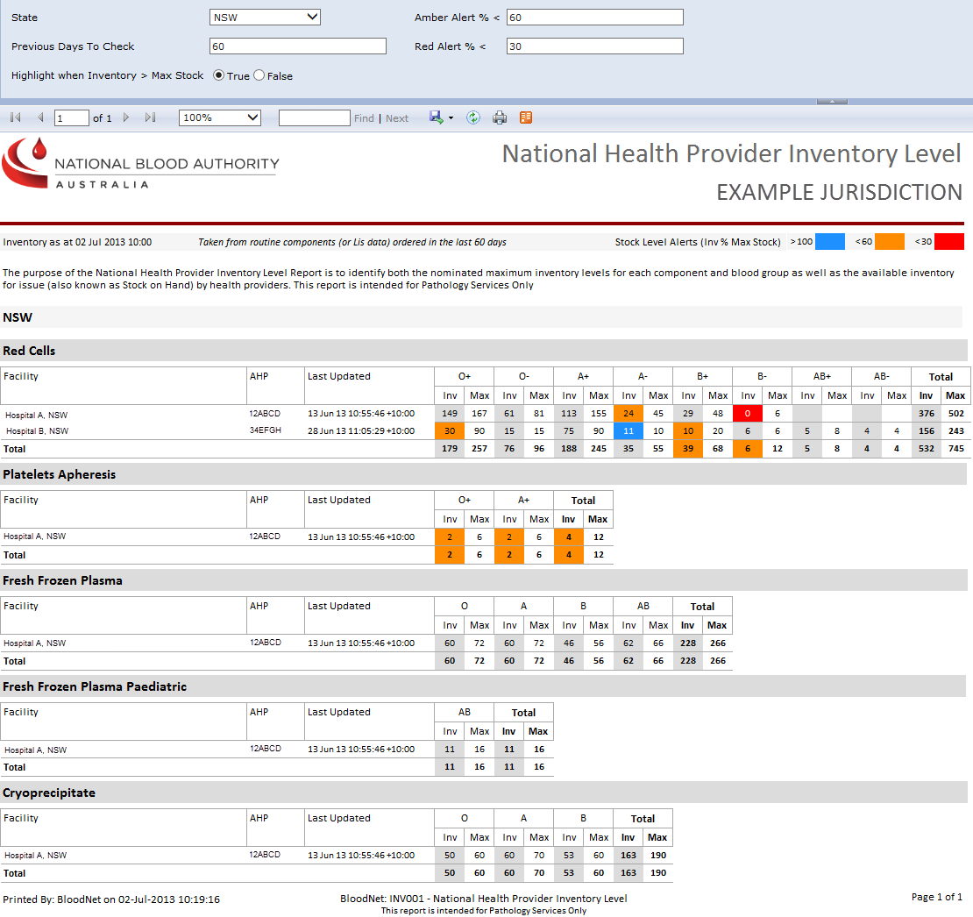

# Report Content

## Title

The report title is: National Health Provider Inventory Level Report.

This report title name will be seen consistently on the external site and also within the report.

## Description

The following report description will display on the external site (ie. on the Report page within the BloodNet Information Module – located under the report title) and also within the report:

“The purpose of the National Health Provider Inventory Level Report is to identify both the nominated maximum inventory levels for each component and blood group as well as the available inventory for issue (also known as Stock on Hand) by health providers.”

## Parameters

The following five parameters will be available:

| **Name** | **Mandatory** | **Description** | **Control Type** | **Values/Value List** | **Default Value** |
| --- | --- | --- | --- | --- | --- |
| **State** | Yes | The state will filter all the applicable facilities that will be considered. | Drop down | All States ACT NSW NT QLD SA TAS VIC WA | All States |
| **Previous Days To Check** | Yes | This parameter determines the reporting period in which to check for all the stock on hand counts that happen within the default 30 days (inclusive) prior to today’s date (ie. cut-off date = today’s date – “previous days to check”). (21st April 2013 = 20th May 2013 – 30 days). Hence the cut-off date is 21st April 2013 if today’s date is 20th May 2013 and the previous days to check is set to default of 30 days. | Input field | N/A | 7 |
| **Highlight when Inventory > Max Stock** | Yes | Will Highlight the stock entry in LightBlue if StockOnHand > MaxStock (ie > 100%) | Radio button | True False | True |
| **Amber Alert % <** | Yes | Will highlight the stock entry in Amber if the % of StockOnHand over MaxStock falls below the value set. | Input field | N/A | 60 |
| **Red Alert % <** | Yes | Will highlight the stock entry in Red if the % of StockOnHand over MaxStock falls below the value set. | Input field | N/A | 30 |

## Report Output Filter Criteria

The report output is filtered on the following conditions:

| **Name** | **Filter Criteria** |
| --- | --- |
| **State** | State relates to one of the values selected in the State parameter. The selected state is displayed in the report header (under the report title).  If “All States” has been selected in the State parameter, then “ALL STATES” is displayed in the report header (under the report title).  Note that the facilities listed will be dependent on the state selected. |
| **Facility** | Only include facilities in the report that are located in the state selected and:   * have placed an order with Stock-on-hand information in the last x days (as entered in the “Previous Days to Check” field”); or * the LIS feeds has updated the Stock on hand in the last x days (as entered in the “Previous Days to Check” field”). |
| **Previous Days To Check** | Only consider Inventory counts and it corresponding Maximum Stock for a component for a facility in the report if:   * the user has placed an order with Stock-on-hand information in the last x days (as entered in the “Previous Days to Check” field”); and/or * the hourly LIS feeds has updated the counts in the last x days (as entered in the “Previous Days to Check” field”). |
| **Highlight when Inventory > Max Stock** | If the stock-on-hand > max stock (at the time of order/LIS feed) – highlight the entry in Blue. |
| **Amber Alert % <** | If Stock on hand is less than 60% of Max Stock (at the time of order/LIS feed) – highlight the entry as Amber. |
| **Red Alert % <** | If Stock on hand is less that 30% of max (at the time of order/LIS feed) – highlight the entry in Red. |

The following rules apply on the report outputs:

1. All the selected parameters are displayed in the report output
2. Display Title (Section 3.1) in the report header (right hand side) and the footer (ie. ‘BloodNet –Report ID / Report Ttitle’).
3. Display Description (Section 3.2) between the report title/state and the table (ie. below the red horizontal line).
4. Where the selected query criteria returns no results, a message is displayed (as per below):

“No data was returned using the criteria provided. Please try different criteria.”

1. If all states are selected, the report will display all the facilities grouped by state. The states will be displayed in the following alphabetical order: ACT, NSW, NT, QLD, SA, TAS, VIC and WA. All the facilities that are applicable for that state are displayed under the component groupings. Each worksheet should also be labelled for the individual states.
2. If one State is selected in the State parameter, then the chosen State is displayed in the report header. The selected state will be the primary grouping, and component the secondary grouping. All the facilities that are applicable for the chosen state are displayed under the component groupings.
3. If there are multiple pages, ensure that the NBA logo, report title, report parameters, column headings, and the legend key for the stock alerts are displayed on all pages.

## Report Field Description/Calculations

The report is displayed as a table with the following columns, rows and related data: Calculations are included where applicable.

| **Report Item** | **Grouping Level** | **Description** | **Source Data** |
| --- | --- | --- | --- |
| State | 0 | State relate to one of the values selected in the State parameter. | Facility.State |
| Component | 1 | There are 5 components listed in this report: Red cells, Platelets Pooled, Platelets Apheresis, Fresh Frozen Plasma and Cryoprecipitate. | Component.ComponentName |
| Facility | 2 | The Approved Health Provider (AHP) where their current inventory level is been monitored. | Facility.FacilityName |
| Health Provider Code | N/A | This AHP code identifies the facility. | Facility.HealthProviderCode |
| Last Updated | N/A | The Date of Last Order (the latest date at which inventory was entered or when the LIS feed occurs). The format is dd-Mmm-yy hh:mm:ss:tt. The time is in 24hr format, and tt represents the different time zones for the different states and territories. For example: +08:00 – WA; +09:30 – NT and SA; and +10:00 – ACT, NSW, QLD, TAS and VIC. | Order.OrderDatetime;  Or  Labsystem.InventoryItem.LastUpdated |
| BloodGroup | 3 | Various groups into which human blood is classified based on the presence or absence of specific antigens on red blood cells.  For red calls, platelets and platelets apheresis: O+, O-, A+, A-, B+, B-, AB+, AB-  For fresh frozen plasma and cryoprecipitate: O, A, B, AB | ABO.ABO + RoutineComponent.Rh |
| Inventory (Inv) | 4 | The number of components that a facility has reported as been available at a particular time. | Labsystem.InventoryLevel.Quantity  Or  OrderRoutineComponent.StockOnHand |
| Maximum stock (Max) | 4 | This is the set maximum stock that a particular facility can hold at any one time. | FacilityRoutineComponent.MaxStock |
| Inventory Total (row total) | 4 | Sum of all the stock on hand counts for each blood group for all listed facilities. | N/A |
| Maximum stock (row total) | 3 | Sum of all the maximum stock counts for each blood group for all listed facilities. | N/A |
| Total Inventory (column total) | 2 | Sum of all the stock on hand counts for all blood groups for each listed facility. | N/A |
| Total Maximum stock (column total) | 2 | Sum of all the maximum stock counts for all blood groups for each listed facility. | N/A |

## Report Output Fields Grouping

The primary grouping of the report is Component. There are 5 Components displayed: red cells, platelets pooled, platelets apheresis, fresh frozen plasma and cryoprecipitate. For each Component, show the following

1. Facility;
2. Health Provider Code;
3. Last Updated – The latest date of Last Order (the latest date at which inventory was entered) or the latest date provided by last LIS feed – whichever date is the latest whether it is “order” or “LIS feed” will be the Last Updated date.
4. **For each Blood Group** within a component , show the following using the latest stock on hand data:
   1. Stock on hand quantity (Inv) for each facility (will show in *italics* for LIS data);
   2. Maximum stock quantity (Max) for each facility;
   3. Total stock on hand quantity for all facilities listed (row total); and
   4. Total maximum stock quantity for all facilities listed (row total).
5. **For each Facility** within a component, show the following using the latest stock on hand data:
   1. Stock on hand quantity (Inv) for each Blood Group (will show in *italics* for LIS data) – the same as 5.1;
   2. Maximum stock quantity (Max) for each Blood Group – the same as 5.2;
   3. Total stock on hand quantity for all Blood Groups (column total); and
   4. Total maximum stock quantity for all Blood Groups (column total).
6. Total stock on hand quantity for all Blood Groups and for all facilities.
7. Total maximum stock quantity for all Blood Groups and for all facilities.

The report output is grouped and sorted as below:

| **Grouping Level** | **Column Name** | **Sort Direction** | **Totals** |
| --- | --- | --- | --- |
| 0 | Component | Red cells, Platelets Pooled, Platelets Apheresis, Fresh Frozen Plasma and Cryoprecipitate. | N/A |
| 1 | Facility | Ascending | N/A |
| 2 | BloodGroup | For red calls, platelets and platelets apheresis: O+, O-, A+, A-, B+, B-, AB+, AB-…  For fresh frozen plasma and cryoprecipitate: O, A, B, AB | N/A |
| 3 | Inventory (Inv) | N/A | Sum of all the stock on hand counts for each blood group for all listed facilities. |
| 3 | Maximum stock (Max) | N/A | Sum of all the maximum stock counts for each blood group for all listed facilities. |
| 2 | Total Inventory | N/A | Sum of all the stock on hand counts for all blood groups for each listed facility. |
| 2 | Total Maximum stock | N/A | Sum of all the maximum stock counts for all blood groups for each listed facility. |

## Notes

There may be a situation where the LIS data and the ordered data do not match. This may impact on the accuracy of the report.

For example, on 30th April 2013, at 11:30am, an order was submitted where the Platelets APH’s stock on hand count = 10.

At 1:01pm, an hourly LIS feed override this data and claim that there is a Platelets APH stock on hand count of 4. This then becomes the result.

At 1:30pm, another order was submitted, and the facility user notice that the stated Platelets APH’s stock on hand count of 4 is incorrect, as he counted they have 10 in hand. So the facility user corrects this count to 10.

At 2:01pm, an hourly LIS feed override the correction that the facility user had updated at 1:30pm, and changes the Platelet APH count back to 4.

| **OrderID** | **OrderDateTime** | **Red Cells** | **Platelets pooled** | **Platelets APH** | **FFP** | **Cryo** |
| --- | --- | --- | --- | --- | --- | --- |
| 22101 | 20130430 11:20 | 5 | 6 | 10 | 6 | 1 |
| LIS | **20130430 13:01** |  |  | *4* |  |  |
| Result | **20130430 13:01** | **5** | **6** | ***4*** | **6** | **1** |

| **OrderID** | **OrderDateTime** | **Red Cells** | **Platelets pooled** | **Platelets APH** | **FFP** | **Cryo** |
| --- | --- | --- | --- | --- | --- | --- |
| 22104 | **20130430 13:30** |  |  | 10 |  |  |
| Result | **20130430 13:30** | **5** | **6** | **10** | **6** | **1** |

| **OrderID** | **OrderDateTime** | **Red Cells** | **Platelets pooled** | **Platelets APH** | **FFP** | **Cryo** |
| --- | --- | --- | --- | --- | --- | --- |
| LIS | **20130430 14:01** |  |  | *4* |  |  |
| Result | **20130430 14:01** | **5** | **6** | ***4*** | **6** | **1** |

This is the nuance of this report that we need to be aware of, and potentially need to consider how to resolve this issue for more accurate reporting.

# Glossary

| Term | Definition |
| --- | --- |
| AHP | Approved Health Provider, normally referred to as a ‘Health Provider’. Also known as facility. |
| Cut off date | The cut-off date = today’s date – “previous days to check”).  For example, 21st April 2013 = 20th May 2013 – 30 days. Hence the cut-off date is 21st April 2013 if today’s date is 20th May 2013 and the previous days to check is set to default of 30 days. |
| Facility | Also known as an Approved Health Provider (AHP) of Health Provider. It should be noted that each Facility has a unique AHP code and that in some instances, one Health Provider may be comprised of multiple facilities using BloodNet (eg Pathology and Pharmacy). |
| Facility user | General users of BloodNet to order, receive and fate blood and blood products. |
| Facility administrator | Users of BloodNet with administrator rights which gives the ability to approve users, change templates and add new items. Once approved facility administrators will also be automatically granted facility user access to the facility indicated.  Facility administrator can be a lab manager, scientist in charge (SIC) or second in change (2IC). |
| Component | Known as Fresh Components within BloodNet. Also, commonly referred to as Fresh Blood Products within the blood sector.  The most common fresh components are:   * 1. Red Cells   2. Platelets   3. Clinical Fresh Frozen Plasma   4. Cryoprecipitate |
| Inventory | Refers to the stock kept and maintained by the laboratory, and can be entered into BloodNet as stock on hand. |
| LIS | Laboratory Information System – a software-based laboratory and information management system that support a modern laboratory’s operations. |
| Maximum Stock | This is the set maximum stocking point that a particular AHP aims to hold at any one time, noting that many can often go somewhat higher when required or desired. |
| Modified components | Changes or additions to the original component. Examples include Irradiated, Washed or Phenotyped. |
| NBA | National Blood Authority |
| Null | Blank. No data. Where there are no data for a specific component, this means that there has been no entered stock on hand for a specific component after the cut-off date. |
| Previous days to check | This parameter determines the reporting period in which to check for all the stock on hand counts that happen within the default 30 days (inclusive) prior to today’s date.  (ie. cut-off date = today’s date – “previous days to check”).  (21st April 2013 = 20th May 2013 – 30 days). Hence the cut-off date is 21st April 2013 if today’s date is 20th May 2013 and the previous days to check is set to default of 30 days. |
| Stock alert levels | A percentage of the Stock on hand over Maximum Stock. |
| Stock on hand | The number of components that an AHP has available for issue (ie not reserved for use by a specific patient) at a particular time.  Also known as Inventory. |

1. Unsent orders are included because during previous activations of the National Blood Supply Contingency Plan (NBSCP), stock on hand data was entered frequently into the stock order template form (within BloodNet) to know a facility’s inventory without them submitting an order through to the Blood Service.
2. Cancelled orders are not included as it is assumed that when an order is cancelled, there is something incorrect with the order.
3. For example, if inventory counts are entered on one day for red cells and another day for platelets, it will show these counts as inventory as long as they are the most recent for that component.