



Issues Report  
INV002

Report Specification

Version Control

|  |  |  |
| --- | --- | --- |
| **Version** | **Revision Date** | **Revision Description** |
| 1.0 | 17 July 2013 | Updates after feedback from internal team members and approved by Peter O’Halloran. |

Document Review and Approval

|  |  |  |  |
| --- | --- | --- | --- |
| **Version** | **Approval Date** | **Name and Position** | **Comments** |
| 1.0 | 18 July 2013 | Peter O’Halloran Executive Director, Health Provider Engagement | Approved after incorporating all of Peter’s feedback into Version 1.0. |
|  |  |  |  |

**Creative Commons**

Creative Commons

With the exception of any logos and registered trademarks, and where otherwise noted, all material presented in this document is licensed by the NBA under a Creative Commons Attribution 3.0 Australia (<http://creativecommons.org/licenses/by/3.0/au/>) licence. In essence this licence allows you to copy, communicate and adapt the work, as long as you attribute the work to the National Blood Authority and abide by the other licence terms.

The details of the relevant licence conditions are available on the Creative Commons website (accessible using the links provided) as is the full legal code for the CC BY 3.0 AU licence (<http://creativecommons.org/licenses/by/3.0/au/legalcode>).

The content obtained from this document or derivative of this work must be attributed as the *National Blood Authority BloodNet Issues Report Specification*.

Contents

1 Introduction 4

1.1 Purpose 4

1.2 Document Audience 4

1.3 Related Documents 5

2 Report Details 6

2.1 Description 6

2.2 Business Rules 6

2.3 Report Sample 9

3 Report Content 10

3.1 Title 10

3.2 Description 10

3.3 Parameter 11

3.4 Report Output Filter Criteria 12

3.5 Report Field Description/Calculations 14

3.6 Report Output Fields Sorting 17

4 Glossary 18

# Introduction

## Purpose

The purpose of this document is to describe the functional specification for the Issues Report.

The purpose of the Issues Report is to provide a historic view of the number of units issued and receipted and the costs involved for fresh components and manufactured products.

Below is a matrix which identifies which reporting system and by which audiences, the report can be generated.

| **Reports Generated By** | **BloodNet Reports** | **Jurisdictional Reporting** | **NBA Internal Reports** | **Report Subscriptions** |
| --- | --- | --- | --- | --- |
| Facility Administrators | ✓ |  |  | ✓ |
| Facility User | ✓ |  |  | ✓ |
| Jurisdictional Blood Committee Members |  | ✓ |  | ✓ |
| Jurisdictional Blood Committee Proxy’s |  | ✓ |  | ✓ |
| NBA Staff | ✓ | ✓ | ✓ | ✓ |
| Blood Service Staff |  |  |  |  |
| State/Territory Government Staff |  |  |  | ✓ |

## Document Audience

This document should be used by:

* The Architect - to form the design of the BloodNet.
* The Database Administrator – to form the design of the BloodNet reports database.
* The Developers - to form the basis of the development of BloodNet reports.
* The System Tester - to create the system test plan and system test cases.
* The Systems Support Team – to develop an understanding of the BloodNet reports to support users.
* The Business Stakeholders - to confirm that their requirements have been properly understood.
* The Project Manager - to obtain project requirements/design signoff from the stakeholders and to assist in detailed task estimation and refinement of the project schedule and milestones.

## Related Documents

* BloodNet Reporting Requirements;
* BloodNet Internal and External Reports;
* Report Register;
* BloodNet User Manual; and
* Jurisdictional Reports – Security Matrix SM.01 Functional Specification

# Report Details

## Description

This report shows a historic view of the number of units issued and receipted and the costs involved for fresh components and manufactured products.

If the report is a NBA internal report/report subscription, then this report is filterable by state, health provider and month/year. If this report is a jurisdictional report, then the states/health providers available to the jurisdictional users are limited to their permissions on the jurisdictional application. If this report is a BloodNet report, then this report is filtered by a Month/Year combination. The user has the option to pick multiple month years.

## Business Rules

This report is based on the following rules:

1. User has entered and saved the issued and receipted quantities into the BloodNet system;
   1. User includes the following: Facility user and Facility administrator.
2. The report can be generated by the following users::
   1. Facility user in BloodNet;
   2. Facility administrator in BloodNet;
   3. JBC members and their proxies in Jurisdictional Reporting;
   4. NBA staff in the internal reporting; and
   5. Support team in managing subscription reports.
3. If this report is:
   1. Accessed through the BloodNet, only the month/year parameter will be available. There will be no state or health provider parameters available to the user. The state/health provider is set by BloodNet as the health provider that the user is logged in as/belongs to. This would be applicable to the listed users in BR2a and 2b.
   2. Accessed through the jurisdictional reporting tool, then all parameters (ie. state, health provider and month/year) will be available. However, the ‘State’ and ‘Health Provider’ values available to the jurisdictional users will be limited to their permissions on the jurisdictional application. Hence, the state and health provider will be pre-populated into the state and health provider parameters respectively based on the permissions of the user. This would be applicable to the listed users in BR2c.
   3. Accessed as an NBA internal reporting or subscription report, then all parameters (ie. state, health provider and month/year) will be available. This would be applicable to the listed users in BR2d and 2e.
4. The report displayed issued fresh components, and the breakdown is based on the ComponentCostGroup description. They are as follows:

| **Cost Group** | **Cost Group Description** |
| --- | --- |
| 1a | Whole Blood |
| 1b | Whole Blood - Leucodepleted |
| 2a | WB Red Cell |
| 2b | WB Red Cell - Leucodepleted |
| 2c | WB Red Cell - Buffy Coat Poor |
| 2d | WB Paediatric Red Cell - Leucodepleted (1 of 4) |
| 2e | WB Washed Red Cell |
| 2f | WB Washed Red Cell - Leucodepleted |
| 2g | Apheresis Red Cell - Leucodepleted |
| 3a | WB Platelet |
| 3b | WB Platelet - Leucodepleted |
| 3c | WB Platelet - Buffy Coat Poor |
| 3d | Apheresis Platelet - Leucodepleted |
| 3e | Paediatric Apherisis Platelet - Leucodepleted (1 of 4) |
| 4a | WB Clinical FFP - Standard |
| 4b | WB Clinical FFP - Buffy Coat Poor |
| 4c | Paediatric WB Clinical FFP (1 of 4) |
| 4d | Apherisis Clinical FFP |
| 5a | WB Cryoprecipitate |
| 5b | Apherisis Cryoprecipitate |
| 6a | WB Cryo-depleted Plasma |
| 6b | Apherisis Cryo-depleted Plasma |
| 7a | Autologous Donation |
| 7b | Directed donation complying with AHMAC Guidelines |
| 7c | Therapeutic Venesections for WB for Discard |
| 7d | Serum Eye Drops |
| 7e | Granulocytes |

1. The report will only display issued fresh components/manufactured products, if there are any issued quantity or received quantity within the reporting period.
   1. If for a specific month year and for **a specific** fresh component/manufactured product, there are no issued quantity and/or received quantity, then the report will display this as blank[1].
   2. If for a specific month year and for **all** fresh components/manufactured products, there are no issued quantity and/or receiving quantity, then the report will still display the month year column, but there will be no data (ie. blank).
2. The report includes the following issue statuses:
   * Unreceipted;
   * Receipted;
   * Partially Receipted; and

The report excludes “Cancelled” issue notes.

1. The month year for a fresh component falls into the month of the issued[2] date time. If the Blood Service issued the fresh components on the 30th June and the pathology labs received the fresh components on the 1st July – the whole Issue/Receipts would be counted in the June period.

## Report Sample

Below is a sample of the Issues Report generated for the month year of June 2013 and July 2013.

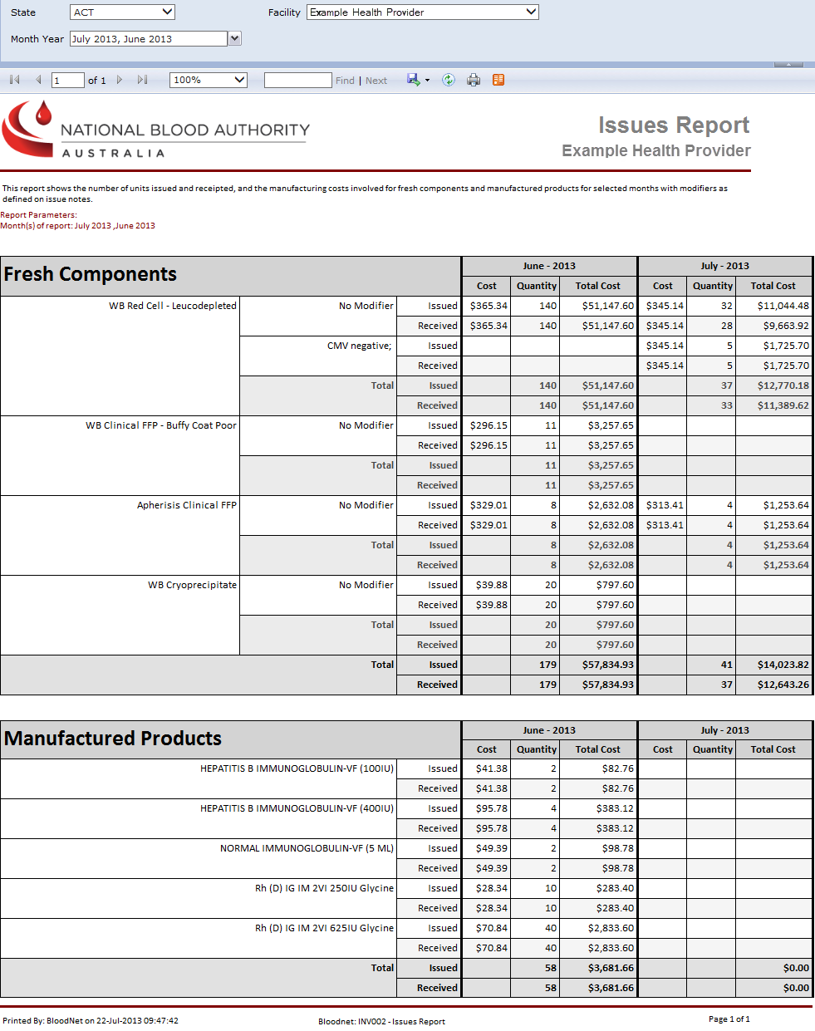

# Report Content

## Title

The report title is: Issues Report.

The report ID is: INV002.

This report title name will be seen consistently on the external site and also within the report.

## Description

The following report description will display (ie. on the Report page within the BloodNet Information Module – located under the report title) and also within the report:

“This report shows the number of units issued and receipted, and the manufacturing costs involved for fresh components and manufactured products for selected months with modifiers as defined on issue notes.”

## Parameter

The following parameters may be available, pending where this report is accessed from as per Business rule 3 (refer to Section 2.2, BR3).

|  |  |  |  |  |  |
| --- | --- | --- | --- | --- | --- |
| **Name** | **Mandatory** | **Description** | **Control Type** | **Values/Value List** | **Default Value** |
| **State** | Yes | The state will filter all the applicable health providers that will be considered for the selected state(s). | Drop down | All States ACT NSW NT QLD SA TAS VIC WA | All States |
| **Health Provider** | Yes | The selected health provider(s) determines all the fresh components and manufactured products that are receipted by the selected health provider(s). | Drop down | (Select All) A list of all the current Health Providers related to the State(s) selected. | <Select a Value> |
| **Month Year** | Yes | The selected month determines all the issue notes that are Issued, where the Issued date time (based on local time of the health provider) falls within the selected month.  Then it will roll up all issued and received quantities for each fresh component’s modifier sub group and manufactured products. | Drop down multi-select checkbox | (Select All)  A list of all month year combinations from the current month/year to the earliest available month year combination. | No default |

## Report Output Filter Criteria

The report output may be filtered on the following conditions:

|  |  |
| --- | --- |
| **Name** | **Filter Criteria** |
| **State** (only for jurisdictional reporting tool, or internal reporting[3]) | State relates to one of the values selected in the State parameter. The selected state is displayed in the report header (under the report title).  If “All States” has been selected in the State parameter, then “ALL STATES” is displayed in the report header (under the report title).  Note that the health providers listed will be dependent on the state selected. |
| **Health Provider** (only for jurisdictional reporting tool, or internal reporting) | Health provider relates to the value(s) selected in the Health Provider parameter. The selected health provider(s) are displayed in the report parameters listing (under the red line).  Only consider issue notes receipted by the selected Health Provider(s). |
| **Month Year** | Only consider the issued and received quantity from issues notes where their Issue date time falls within the selected month(s). |

The following rules apply on the report outputs:

1. As stated in BR3b and 3c (Section 2.2), for jurisdictional reporting and internal reporting, there will be 3 parameters available (State, Health Provider and Month Year). As stated in BR3a, for BloodNet report, there will be only one parameter, Month Year. All the selected parameters will be displayed in the report output.
2. Display Title (Section 3.1) in the report header (right hand side) and the footer (ie. ‘BloodNet: Report ID - Report Title’).
3. Display Description (Section 3.2) between the report title/state and the table (ie. below the red horizontal line).
4. Where the selected query criteria returns no results, a message is displayed (as per below):

“No Fresh Component data to display.” and/or “No Manufactured Product data to display.” respectively.

1. If there are multiple pages, ensure that the NBA logo, report title, report parameters and column headings are displayed on all pages.
2. There are two tables (Fresh Components and Manufactured Products).
3. Display each month year in a separate column. For each month year, there are three sub-columns (Cost, Quantity and Total Cost).
4. For the Fresh Components table, display each fresh component in each row.
   1. For each fresh component, there may be one or more modifier sub group(s).
   2. For each modifier sub group, there will be the following counts:
      1. Unit Cost for the selected month year (for both Issued and Received);
      2. Quantity Issued per month year;
      3. Total Cost of Issued items per month year;
      4. Quantity Received per month year; and
      5. Total Cost of Received items per month year.

For the Fresh Components table, display each fresh component in each row.
a. For each fresh component, there may be one or more modifier sub group(s).
b. For each modifier sub group, there will be the following counts:
i. Unit Cost for the selected month year (for both Issued and Received);
ii. Quantity Issued per month year;
iii. Total Cost of Issued items per month year;
iv. Quantity Received per month year; and
v. Total Cost of Received items per month year.
c. Totals for Issued and Received Quantity are provided for each fresh component and for all fresh components for each month year.

* 1. Totals for Issued and Received Quantity are provided for each fresh component and for all fresh components for each month year.

1. For the Manufactured Products table, display each manufactured product in each row.
   1. For each manufactured product, there will be the following counts:
      1. Unit Cost for the selected month year (for both Issued and Received);
      2. Quantity Issued per month year;
      3. Total Cost of Issued items per month year;
      4. Quantity Received per month year; and
      5. Total Cost of Received items per month year.

9. For the Manufactured Products table, display each manufactured product in each row.
a. For each manufactured product, there will be the following counts:
i. Unit Cost for the selected month year (for both Issued and Received);
ii. Quantity Issued per month year;
iii. Total Cost of Issued items per month year;
iv. Quantity Received per month year; and
v. Total Cost of Received items per month year.
b. Totals for Issued and Received Quantity are provided for all manufactured products for each month year.


* 1. Totals for Issued and Received Quantity are provided for all manufactured products for each month year.

1. For both Fresh Components and Manufactured Products table:
   1. Where there are no issued/received quantity counts for a specific fresh component or manufactured product, then the leave these cell(s) blank. As a result, the cost for the issued/received quantity cells will also be blank.
   2. For a specific month/year, where there are no issued/received quantity counts for all fresh components or manufactured products , then all cells in the quantity and cost columns for this specific month/year will be blank, but the month/year column will still display. Note that this is pending there are counts for the other month/year columns in this report, else follow output rule 4.

## Report Field Description/Calculations

The report is composed of 2 tables (Fresh Components Table and Manufactured Products Table) with the following columns, rows and related data: Calculations are included where applicable.

**Table 1 – Commons Table**

Report items that are seen in both the Fresh Components and Manufactured Tables.

| **Report Item** | **Grouping Level** | **Description** | **Source Data** |
| --- | --- | --- | --- |
| Month Year | 0 | Report broken into monthly totals as specified in the parameters. | ConsignmentNote.OrderdateTime |

**Table 2 – Fresh Components Table**

| **Report Item** | **Grouping Level** | **Description** | **Source Data** |
| --- | --- | --- | --- |
| Fresh Component | 1 | The fresh components referred to in this report are issued fresh components, not ordered products. Some of the examples are: Whole Blood; Whole Blood – Leucodepleted; WB Red Cell; WB Red Cell – Leucodepleted; WB Red Cell - Buffy Coat Poor; WB Paediatric Red Cell - Leucodepleted (1 of 4) etc. | SupplierComponentCostGroup.Description |
| Modifiers | 2 | Changes or additions to the original fresh component. Examples include Irradiated, Washed or Phenotyped. | ConsignmentNoteLineModifier.Description |
| Unit Issued Cost | 3 | This is the current published unit price for each of the modifier sub group. | ComponentUnitCost.PublishePrice |
| Issued Qty | 3 | The number of units issued by the Blood Service Distribution Centre. | ConsignmentNoteLine.Qty |
| Total Issued Cost | 3 | The cost of the total number of units issued for each modifier sub group. | ConsignmentNoteLine.Qty *  ComponentUnitCost.PublishePrice |
| Unit Received Cost | 3 | This is the current publish unit price for each of the modifier sub group. | ComponentUnitCost.PublishePrice |
| Received Qty | 3 | The number of units received by the laboratory. | ConsignmentNoteLine.ReceivedQty |
| Total Received Cost | 3 | The cost of the total number of units received for each modifier sub group. | ConsignmentNoteLine.ReceivedQty *  ComponentUnitCost.PublishePrice |
| Sub-total Issued Qty |  | For each fresh component, this is the sub-total of the Quantity Issued for all modifier sub groups. | N/A |
| Sub-total Issued Cost |  | For each fresh component, this is the sub-total of the cost of Issued items for all modifier sub groups. | N/A |
| Sub-total Received Qty |  | For each fresh component, this is the sub-total of the Quantity Received for all modifier sub groups. | N/A |
| Sub-total Received Cost |  | For each fresh component, this is the sub-total of the cost of Received items for all modifier sub groups. | N/A |
| Total Issued Qty |  | This is the total of the Quantity Issued for all fresh components. | N/A |
| Total Issued Cost |  | This is the cost for all issued fresh components. | N/A |
| Total Received Qty |  | This is the total of the Quantity Received for all fresh components. | N/A |
| Total Received Cost |  | This is the cost for all received fresh components. | N/A |

**Table 3 – Manufactured Products Table**

| **Report Item** | **Grouping Level** | **Description** | **Source Data** |
| --- | --- | --- | --- |
| Manufactured Products | 1 | These are blood products that are manufactured from non-human components using genetic engineering. These are also called recombinant products and are alternatives to some fractionated plasma products. | Product.ProductName |
| Unit Issued Cost | 2 | This is the current published unit price for each manufactured product. | ProductUnitCost.PublishedPrice |
| Issued Qty | 2 | The number of units issued by the Blood Service Distribution Centre. | ConsignmentNoteLine.Qty |
| Total Issued Cost | 2 | The cost of the total number of units issued for each manufactured product. | ConsignmentNoteLine.Qty *  ProductUnitCost.PublishedPrice |
| Unit Received Cost | 2 | This is the current publish unit price for each manufactured product. | ProductUnitCost.PublishedPrice |
| Received Qty | 2 | The number of units received by the laboratory. | ConsignmentNoteLine.ReceivedQty |
| Total Received Cost | 2 | The cost of the total number of units received for each modifier sub group or manufacture product. | ConsignmentNoteLine.ReceivedQty *  ProductUnitCost.PublishedPrice |
| Total Issued Qty |  | This is the total of the Quantity Issued for all manufactured products. | N/A |
| Total Issued Cost |  | This is the cost for all issued manufactured products. | N/A |
| Total Received Qty |  | This is the total of the Quantity Received for all manufactured products. | N/A |
| Total Received Cost |  | This is the cost for all received manufactured products. | N/A |

## Report Output Fields Sorting

The report output is sorted as below:

| **Column Name** | **Sort Direction** | **Totals** |
| --- | --- | --- |
| Fresh Component | Sorted based on the National Supply Budget Plan and Blood Grouping. Will be sorted based on the Cost Group (ie. 1a, 1b, 2a, 2b, 2c, etc) in ascending order. Refer to Section 2.2, BR4. | Sum of all the issued quantity for all Fresh Components for a specific month year combination.  Sum of all the issued cost for all Fresh Components for a specific month year combination.  Sum of all the received quantity for all Fresh Components for a specific month year combination.  Sum of all the received cost for all Fresh Components for a specific month year combination. |
| Modifier | Only for the Fresh Components table. Sort order will be: “No Modifier” first, followed by all the other modifiers in ascending alphabetically order.  (ie. No Modifier, CMW negative, “CMV negative; Irradiated; NEONATAL”, “Irradiated; CMW negative”). | N/A |
| Manufactured Products | Sorted alphabetically in ascending order. | Sum of all the issued quantity for all Manufactured Products for a specific month year combination.  Sum of all the issued cost for all Manufactured Products for a specific month year combination.  Sum of all the received quantity for all Manufactured Products for a specific month year combination.  Sum of all the received cost for all Manufactured Products for a specific month year combination. |

# Glossary

| Term | Definition |
| --- | --- |
| AHP | Approved Health Provider, normally referred to as a ‘Health Provider’. Also known as facility. |
| Fresh Component | Known as Components within BloodNet. Also, commonly referred to as Fresh Blood Products within the blood sector. The components referred to in this report are issued components, not ordered products. Some of the examples are: Whole Blood; Whole Blood – Leucodepleted; WB Red Cell; WB Red Cell – Leucodepleted; WB Red Cell - Buffy Coat Poor; WB Paediatric Red Cell - Leucodepleted (1 of 4) etc. |
| Cost | The current published unit price for each modifier sub group/manufactured product. |
| Facility | Also known as Health Provider. It should be noted that each Facility has a unique AHP code and that in some instances, one Health Provider may be comprised of multiple facilities using BloodNet (ie. Pathology and Pharmacy). |
| Facility user | General users of BloodNet to order, receive and fate blood and blood products. |
| Facility administrator | Users of BloodNet with administrator rights which gives the ability to approve users, change templates and add new items. Once approved facility administrators will also be automatically granted facility user access to the facility indicated.  Facility administrator can be a lab manager, scientist in charge (SIC) or second in change (2IC). |
| Health Provider | A health provider is an individual or an institution that provides preventive, curative, promotional, or rehabilitative health care services in a systematic way to individuals, families or communities. Please refer to AHP. Also known as facility. |
| Inventory | Refers to the stock kept and maintained by the laboratory, and can be entered into BloodNet as stock on hand. |
| Issue note | An issue note is sent out with the order to the facility. The issue note will contain information like the issue number, the date time of the issue, which blood service made the issue, the issued quantity, total issue price and a link to the order number. Issue note can have different statuses such as active, completed (when the issue note is 100% receipted) and cancelled. |
| Issued quantity | The number of units issued by the Blood Service Distribution Centre. |
| JBC | Jurisdictional Blood Committee |
| Manufactured products | This group of products contains all Fractionated plasma, Immunoglobulin, Clotting factor and other products. Some examples are Albumex, Normal Immunoglobulin and Concentrated coagulation factor VIII. |
| Modifier | Changes or additions to the original fresh component. Examples include Irradiated, Washed or Phenotyped. |
| NBA | National Blood Authority |
| Received quantity | The number of units receipted by the health provider into BloodNet. |
| Total Cost | The manufacturing cost of the quantity received/issued for each modifier sub group/manufactured product (ie. cost = unit price x quantity received/issued). |

1. Note: A blank in this report means zero (0). This definition applies throughout for this report.
2. The logic for this is based on the same logic applied for the IDMS (Integrated Data Management System).
3. Note: The state and health provider parameter is not available for subscription reports. There are no real subscription reports – they are subscriptions of the internal report. The subscriptions set the parameters and send out the resultant reports on a schedule.